

3 rounds of 5-Handed
Called-Ace Sheepshead

Cash Prizes–1st ($100) 2nd ($75) 3rd ($50)

Beverages Included
Lunch Available for Purchase

50/50 Raffle during each Round
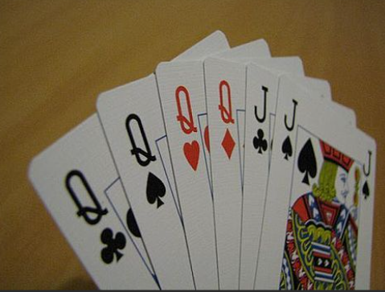
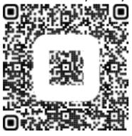

DATE: Saturday, February 1, 2025
TIME: Registration – 10:00am
Play Begins – 11:00am
PLACE: Greenfield Community Center
7215 W. Cold Spring Road, Greenfield
FEE: $25.00 In Advance; $30.00 Day of Event
Fee Enclosed: $________
-------------------------------------------------------------------------------------
SHEEPSHEAD REGISTRATION FORM (Please Print Clearly)

Name: _________________________________________ Phone: _________________________

Address: _______________________________________ Email: __________________________

Make Checks Payable To: Whitnall Park Rotary
Mail To: Whitnall Park Rotary, P.O. Box 62, Hales Corners WI 53130

