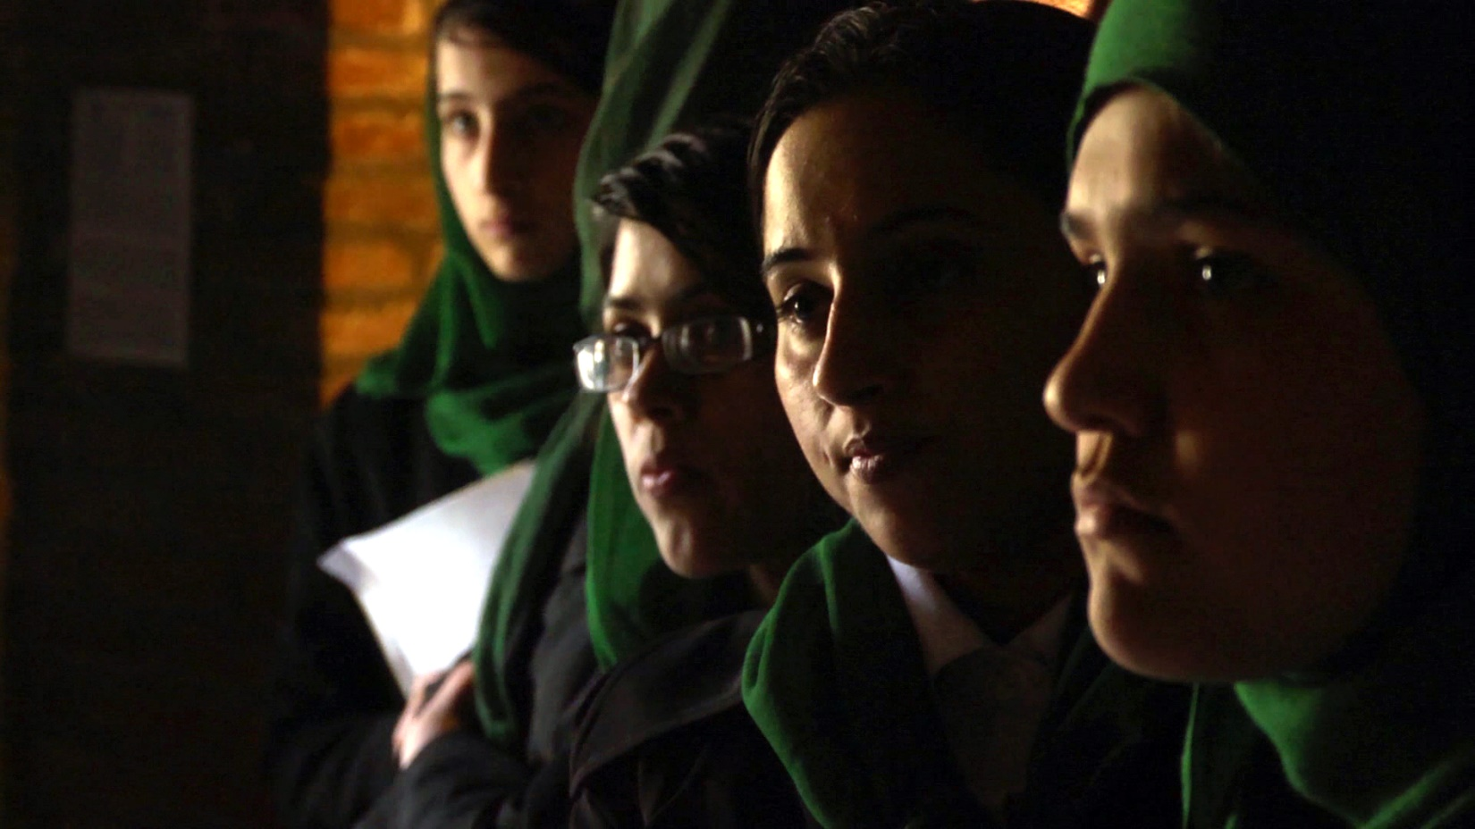

**Join Our Rotary International Global Grant!**

**The Rotary Club of Nashoba Valley is looking for partner clubs   
and individuals to join us in an exciting new service project**

**GRANT AMOUNT: $58,000**

**PROJECT: The Razia Jan Institute Midwifery Program**

**LOCATION: Deh’Subz, Afghanistan**

**BENEFICIARIES: Young women and their community**

**INTERNATIONAL CLUB: Rotary Club of Nashoba Valley**

**HOST CLUB: Rotary Club of Kabul City**

**Our Project**

This project will support the Razia Jan Institute (RJI) in Deh’Subz, Afghanistan, a post-secondary educational facility emphasizing the importance of maternal and infant healthcare through a midwifery program and the first local clinic. The new facility will include a medical clinic where midwifery students will train alongside doctors, nurses and midwives. This project will provide medical equipment in conjunction with education and training for future maternal and child health professionals and skilled birth attendants. It will also provide transportation for the staff. The clinic and the trained midwifes will have an enormous impact on a severely medically underserved area, reducing the maternal and infant mortality rates. It will also offer the midwifes a professional career path. This program is being carried out by Razia’s Ray of Hope Foundation as a follow on to the already highly successful Zabuli Education Center for Afghan girls, which opened in 2008 and graduated its second high school class in December, 2016. See [www.raziasrayofhope.org](http://www.raziasrayofhope.org) for more information.

**Contact Ray Pfau at** [**ray.pfau@alum.mit.edu**](mailto:ray.pfau@alum.mit.edu) **or Karin Gaffney at** [**karin.gaffney@rocklandtrust.com**](mailto:karin.gaffney@rocklandtrust.com) **for more information**