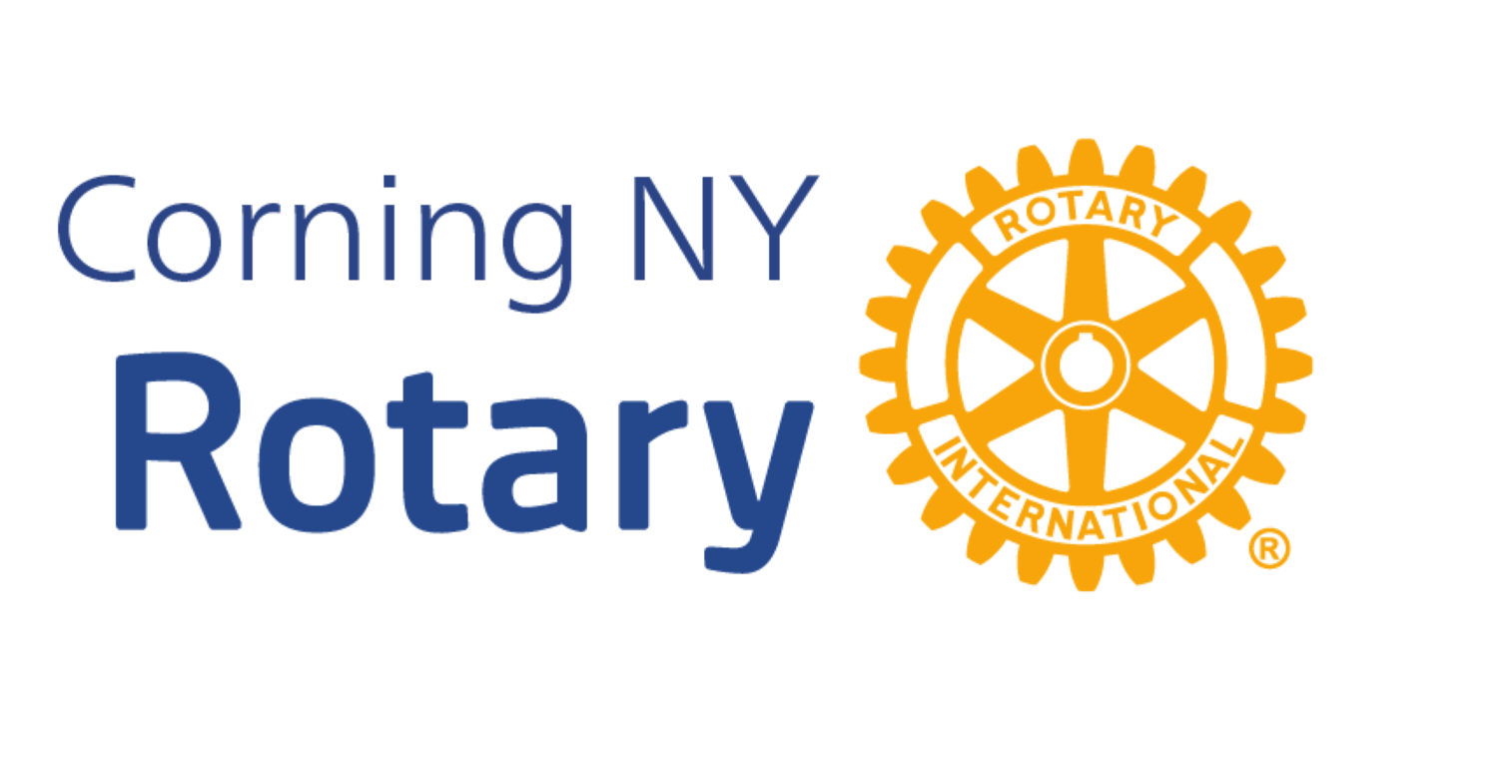
Rotary Club Community and District Grant Application

Date:

1. Applicant Information
Organization Name:
Mailing Address:
City / State / ZIP:
Website:
Primary Contact Name & Title:
Email Address:
Phone Number:

2. Organizational Status
Organization Type (501(c)(3), School, Municipal, Other):
Federal Tax ID (EIN), if applicable:
Years in Operation:

3. Project Overview
Project Title:
Brief Project Summary:

4. Community Need
Describe the community need this project addresses:

5. Project Description
Describe the proposed project and activities:

6. Alignment with Rotary Priorities
The focus areas of Corning Rotary are literacy, youth leadership and growth, community health and safety, and hunger. Explain how this project aligns with Rotary values and priorities:

7. Project Timeline
Proposed Start Date:
Proposed Completion Date:
Key milestones:

8. Project Budget
Total Project Cost:
Amount Requested from Rotary:
Other Funding Sources:

9. Sustainability & Impact
How will the project be sustained and evaluated?

10. Rotary Involvement
Describe potential Rotary member involvement:

11. Reporting & Recognition
Applicants agree to provide a completion report and acknowledge Rotary support.

12. Certification
Authorized Signature:
Printed Name & Title:
Date:

