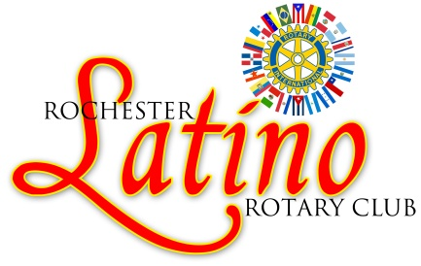

You are invited to join us in honoring our
BILINGUAL TEACHER ASSISTANTS/PARAPROFESSIONALS

Wednesday, January 9, 2019

6:00 pm – 7:30 pm

Irondequoit Library Room 115

1290 Titus Ave

Rochester, New York 14617

Dinner Ticket Reservation Form

_______ # of Tickets X $20 per ticket =________ Total amount Due

Name _____________________________________________________________

Email address _______________________________________________________

Mail form and payment to:
Rochester Latino Rotary Club
PO Box 12562
Rochester, New York 14612

For additional information and/or questions email
Miriam Vázquez at vazquez@rochester.rr.com

Reservations due by January 2, 2019.

