

In this issue

* School bags and books distribution
* Garden clean-up project
* Rotary International focus on polio
* Masquerade Ball cancelled
* Members contributions in the times of Covid
* Voter registration drive
* Virtual Rotary District 7120 Assembly
* Focus on membership
* Jazmin Ruiz received Paul Harris Award
* Meetings
* The Four Way test
* Board of Directors
* Object of Rotary
* The Rotary Foundation programs
* Quotes

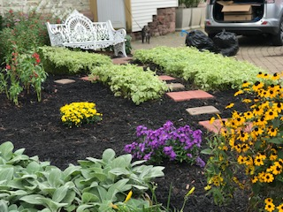

**Elisa DeJesús, Orlando Rivera, Luisa Baars helped to distribute books**

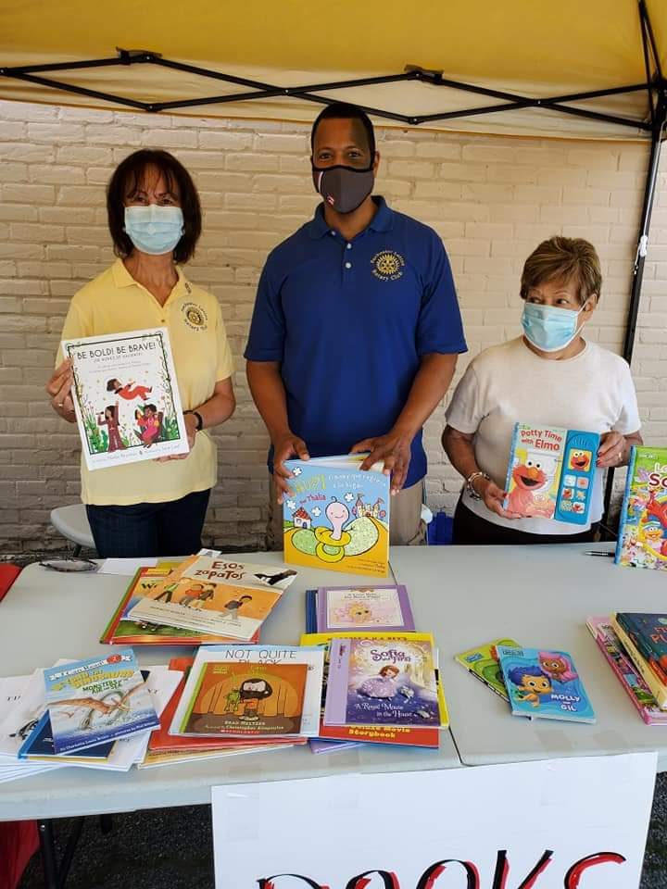

**School bags and books distributed**

Thanks to the initiative of Al Burgos, from Al Burgos Income Tax and former member of the Rochester Latino Rotary Club, 50 children walked out with brand new school bags and books. He obtained the donated bags from his son, and asked the club to help obtained books. Several club members as well as community members donated books.

The event was held on the 22nd of September in the parking lot adjacent to the Father Laurence Tracy Advocacy Center on N. Clinton Avenue in Rochester.

An open tent was set up with tables to protect from the heat. Parents came with the children who were able to pick up the bags and the books. There were books appropriate for different age groups. It was a great event for all concerned. The area where the event took place is in a disadvantaged part of the city. The situation for many parents has been impacted by the economic downturn due to the pandemic. Thus, not having to invest in the purchase of a bag is a bug help. The children benefited by having access to books, thus advancing their literacy skills.

A big debt of gratitude is owed to Al Burgos for leading this effort. Al has been for many years connected to the Hispanic Youth Baseball League. His support of events benefiting children is well known in the community. In fact, the RLRC has been sponsoring a team participating in the summer baseball games for many years. Thus, this partnership between Al and the club continues.

**Garden clean-up project**

As is customary, club members and volunteers took care of the meditation garden adjacent to St. Michael Church on N. Clinton Avenue in Rochester. This garden was dedicated to Fr. Laurence Tracy in November 2012 for his dedication over 40 years serving the Latino community. On that occasion he received the Luisa Baars Service Above Self Award.

Take action, visit: www.latinorotary.com Facebook: Rochester Latino Rotary Club

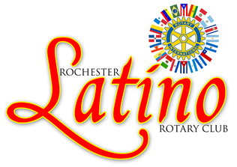

**Spring is in the air**

* Rotary Convention

# Rochester Latino ROTARY CLUB La Rotariana

**School bags**

AG Paul Minor visit

**August-September, 2020**

**ACTION:** wwwlatinorotary.com

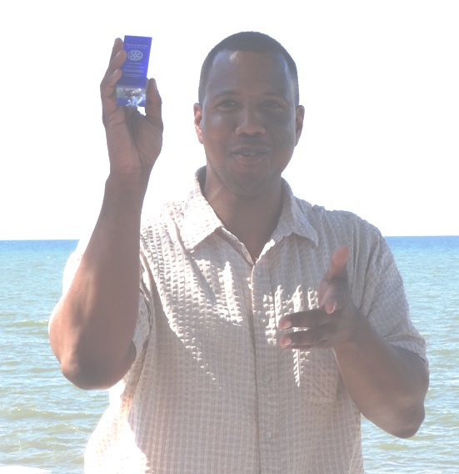

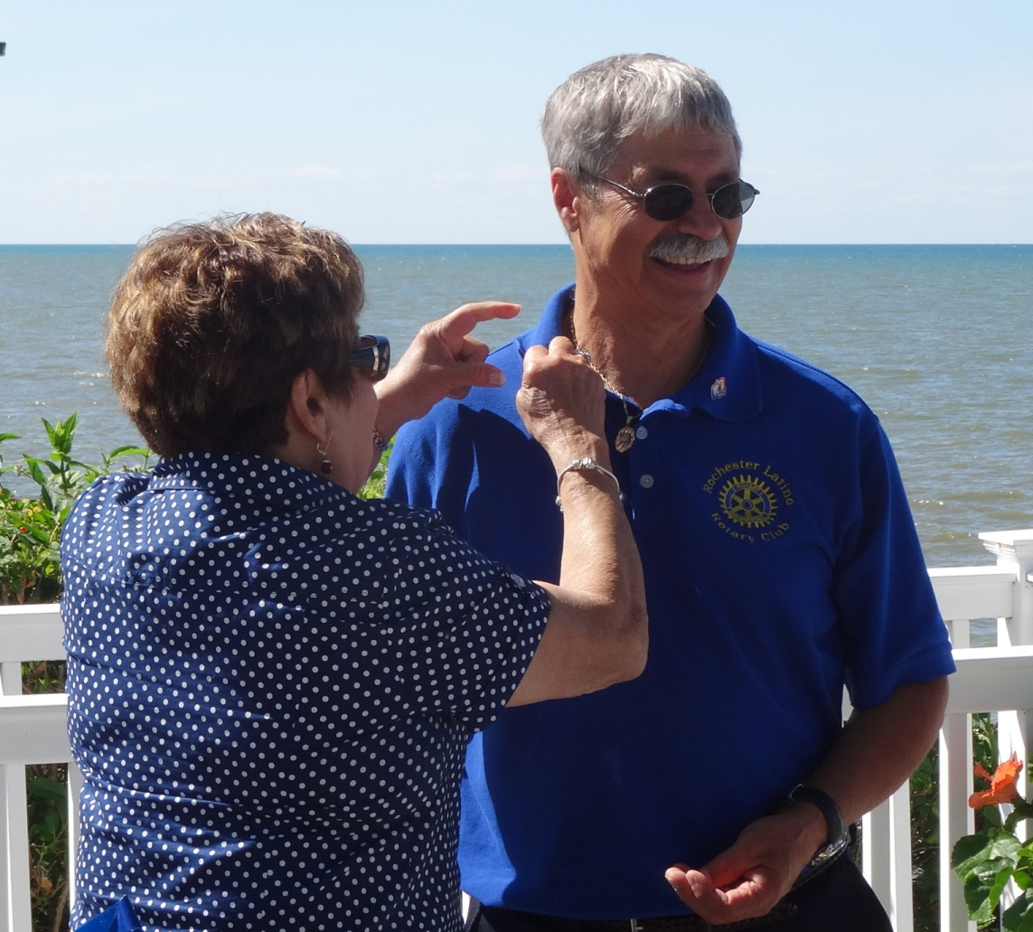

**2016**

C

**Rotary International focus on polio**

What is Polio? Why is RI continuing its efforts to eradicate this disease? According to RI website, “Polio, or poliomyelitis, is a paralyzing and potentially deadly infectious disease that most commonly affects children under the age of 5. The virus spreads from person to person, typically through contaminated water. It can then attack the nervous system.”

RI, as a partner of the Global Polio Eradication Initiative, has contributed to the reduction of 99.9 percent since its first project to vaccinate children in the Philippines in 1979.

Over the years, Rotarians have contributed more than $2.1 billion and countless volunteer hours to protect nearly 3 billion children in 122 countries from this paralyzing disease. Rotary’s advocacy efforts have played a role in decisions by governments to contribute more than $10 billion to the effort. It is estimated that “if all eradication efforts stopped today, within 10 years, polio could paralyze as many as 200,000 children each year”, as stated in the RI website. Today, polio remains endemic only in Afghanistan and Pakistan. Many factors contribute to this situation, including the wars and distrust of western workers attempting to vaccinate children and beliefs that vaccines may cause diseases.

Thus, efforts to eradicate this disease continue to be a priority of RI and the many clubs and their members who continue to donate resources and time to finish the work started so many years ago.

It is important to remember that even though polio is endemic in only 2 countries in the world, it still affects children around the world. RI encourages Rotarians to spread the word and hold events to inform their communities.

As a person who saw the effects of polio on children, I urge everyone to contribute to this effort. As a physical therapy student in 1959 in Puerto Rico, I worked with the children who were in the iron lung. They were in pain and the exercises needed to maintain their residual movements in the extremities were difficult for them. Children recovering from polio needed braces and the use of walkers or crutches in order to walk; the paralysis affecting their legs and/or arms.

**Masquerade Ball cancelled**

Given the concerns regarding the COVID-19 pandemic, the decision was made to cancel the 2021 Masquerade Ball. This is the main fundraising event of the club. Even though this was a difficult decision, the safety of the community and the club members was a main factor in reaching it. Several ideas were discussed including holding virtual events. A committee led by Migdalia Concepción will meet to discuss ideas for them virtual and other events. Stay tuned for announcements from the committee and be prepared to contribute ideas and financial support.

**Members contributions in the times of Covid**

Since the club meetings are being conducted via Zoom, club members are encourage to make their contributions for polio eradication and happy/sad dollars via checks that can be sent to the treasurer, Idalia Chang. Happy dollars have been shared regarding the weather, good health of the members and their families, the ability to continue meeting via Zoom, the service projects done by the club, and many other happy events in the midst of the pandemic. On the other hand, sad dollars for the pandemic, the people who have lost jobs, families who are struggling to feed their children and so many lives impacted negatively by the pandemic.

**Voter registration drive**

A voter registration drive will take place on October 3rd from noon to 4:00 pm at the Fr. Laurence Tracy Advocacy Center in Rochester. The center is located in the center of a large Latino community. Several members volunteered to work this event recognizing the importance of having the Latino community exercise this important right.

**Virtual Rotary District 7120 Assembly** Janet Reno, District Governor Elect, has indicated that we should continue planning for a virtual assembly that will take place over a period of Saturdays instead of just one Saturday. Jazmin Ruiz and Orlando Rivera have been talking with other clubs in the Rochester area to co-host the event. As details are worked out, further information will be provided to club members.

**TAKE ACTION, VISIT:** wwwlatinorotary.com



**La Rotariana** 2  **August-September, 2020**

From top right, Elisa DeJesús, Migdalia Concepción, group, and Abdiel DeJesús

worked to clean, plant, and apply mulch to garden

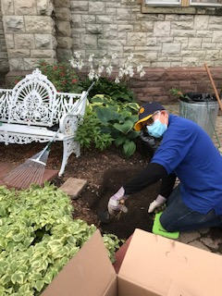

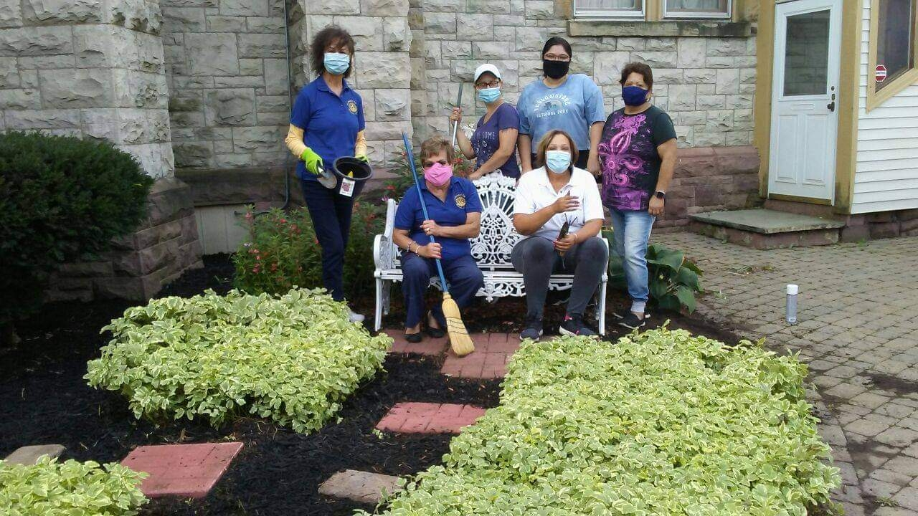

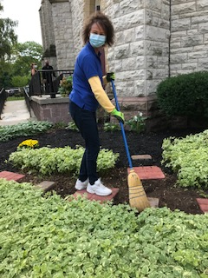

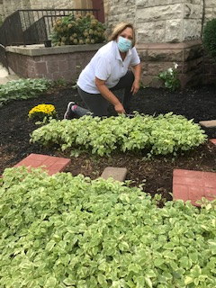

Jazmin Ruiz, recipient of a Paul Harris Award and valued member of the RLRC

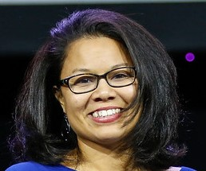

Elisa DeJesús and Orlando Rivera are working hard to attract potential members interested in helping the Latino community. They have invited friends to join the virtual meetings in order to get familiarized with the club’s projects and impact in the community.

Members are encouraged to invite and friends, family members, and colleagues to explore the Rotary world. A good source of information is the Rotary International website. Here, there are stories of Rotarians from around the world doing good even when facing the Covid-19 challenges. The work of Rotary continues!

**Jazmin Ruiz received Paul Harris Award**

Jazmin is a Regulatory Affairs Manager at Honeywell.  This is a role where she can bring together her interests in toxicology, public health, and business.  Jazmin holds a doctorate degree in Population Health/Environmental Toxicology and a Masters in Public Health.

She moved from Houston to Rochester, NY in 2016.  She currently lives in Buffalo with her husband. Explaining where she is from is not a simple answer because she comes from a military family. She was born in Germany, grew up in Texas, and her family is from Colon, Panama.

Jazmin is dedicated to giving back to the community no matter where she lives.  She has volunteered for various local organizations in the Rochester area including the YWCA, the City of Rochester’s Pillars of Hope, and Grupo Cultural Latinos in Rochester.  She was recognized for her contribution to the Rochester community in 2019 by the Rochester Business Journal with their Forty under 40 Award.

Jazmin became a Rotarian and a member of the Rochester Latino Rotary Club in 2017.  She served as President 2018-2019 and has served as Secretary and the Fundraising Chair these past 2 years.   Despite living in Buffalo, she continues to serve as a member of the Rochester Latino Rotary

The RLRC has been the beneficiary of Jazmin’s work and dedication. Her service to the club and the community has earned her our appreciation and gratitude, thus presenting her with the PHA on August 5th. Congratulations Jazmin!

**Look for the club on Facebook at Rochester Latino Rotary Club**

**Focus on membership**

La Rotariana 3 **August-September, 2020**

The Object of Rotary is to encourage and foster the ideal of service as a basis of worthy enterprise and, in particular, to encourage and foster:

1. The development of acquaintance as an opportunity for service;
2. High ethical standards in business and professions; the recognition of the worthiness of all

useful occupations; and the dignifying of each Rotarian’s occupation as an opportunity to serve society;

1. The application of the ideal of service in each Rotarian’s personal, business, and community life;
2. The advancement of international understanding, goodwill, and peace through a world fellowship of

business and professional persons united in the ideal of service.

La Rotariana 4 August-September, 2020

**Meetings**

The RLRC continues holding meetings via ZOOM. This is a safe way to conduct business while following rules that limit in person gatherings. One other advantage of this format is that attendees can do so from the comfort of their home. Meetings are held the first Wednesday and third Monday of the month at 5:30 p.m. October meetings will be on the 7th and 19th.

**“So often in life things that you regard as an impediment turn out to be great good fortune”.**

From: The late Justice Ruth Bader Ginsburg

**THE FOUR WAY TEST**

Of the things we think, say, or do

1. Is it the TRUTH?

2. Is it FAIR to all concerned?

3. Will it build GOODWILL and BETTER FRIENDSHIPS?

4. Will it be BENEFICIAL to all concerned?

Rotary makes amazing things happen, like:

**Reducing HIV infection:** In Liberia, Rotary members are helping women get tested for HIV early in their pregnancies. They used prenatal care to reduce new HIV infections in children by 95 percent over two years.

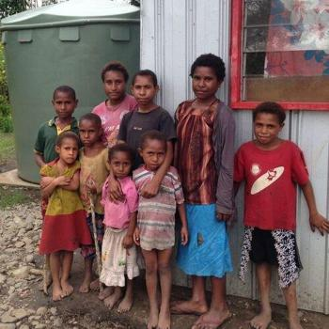

**Club Board of Directors**

President – Elisa DeJesús

Immediate Past President – Migdalia Concepción

President Elect – Aida Veras

Treasurer – Idalia Chang, Miriam Vázquez

Secretaries – Jazmin Ruiz

Luisa Baars

Club Service Co-Chairs - Aida Veras

Charol Ríos-Davis

International Service Chair – Luisa Baars

Membership Chair – Orlando Rivera

Foundation Chair – Julio Vázquez

Literacy Co-Chairs –Miriam Vázquez

Julio Vázquez

Club Webmaster – Jazmin Ruiz, Orlando Rivera

Bulletin Editor - Luisa Baars

Program Chair – ElisaDeJesús

Fund Raising – Jazmin Ruiz

Sergeant-At-Arms - To rotate among directors

**The Object of Rotary**

Rotary clubs partnered with local organizations to install a rainwater harvesting and distribution center for 4,000 people in Madan, India.

**“ Be the change that you wish to see in the world.”** From: Mahatma Gandhi