* New board installed
* Challenges continue
* Migdalia Concepción biography
* Elisa takes over presidency
* The Rotary Foundation programs
* Well project is Adjuntas, Puerto Rico
* Meetings
* The Four Way Test
* Board of Directors
* The Object of Rotary
* Quotes

*Being a Rotarian is not an obligation, it is a privilege. Join Rotary to enjoy the fellowship and joy of serving others.*

In this issue

**President Elisa DeJesús**

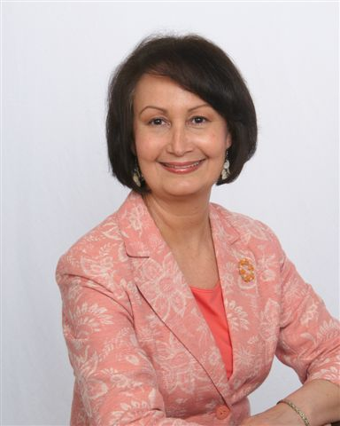

On July 1st the new board of directors of the Rochester Latino Rotary Club was installed via ZOOM. Elisa DeJesús who was the second president of the club, took over the presidency for the Rotary year 2020-2021.

It so happened this was also Elisa’s birthday. Congratulations Elisa. Her husband, Abdiel, was able to pin the Club President pin on Elisa. At last, something that was not done via ZOOM.

Immediate past president Migdalia Concepción was presented with a plaque recognizing her work as club president and the past president pin via ZOOM.

Congratulations to all directors as well as gratitude for their dedication and willingness to serve in the different positions and committees. Their names are listed on page 4, and Elisa’s bio is on page 3.

**Challenges continue**

As we begin this year with so many challenges impacting the club’s work, it is of utmost importance to remain focused on the local community’s needs as well as the needs of the international communities.

Rotary clubs around the world are faced with the need to cancel fundraising events and the service projects funded by such events. There are also challenges related with carrying out projects that require close contact with the individuals served.

Notwithstanding the challenges, club members have engaged in service projects related to literacy. They distributed books to parents who were able to pick up the books at the Zimbrich St. location of the Eugenio María de Hostos Charter School. Iris Alvarado and Charol Ríos were able to distribute the books. For parents unable to go to the school, members will deliver the books to their homes. The club has over the years emphasized literacy projects for students at all levels, from kindergarten to high school. It is strongly felt that being proficient in reading and writing is essential for education and work.

Another project that can be carried out is the maintenance of the relaxation garden at St. Michael Church in Rochester. It requires weeding and mulching. Tasks can be carried out by small groups taking the precautions of wearing facemasks and keeping social distance. It also requires collecting the needles that are left behind by drug addicts.

Club members are donating books to fill backpacks that were donated to Al Burgos, a former member of the club. He would like to have books for students at all levels of school.

Take action, visit: www.latinorotary.com Facebook: Rochester Latino Rotary Club





**Spring is in the air**

* Rotary Convention

# Rochester Latino Rotary CLUB La Rotariana

**New board installed**

AG Paul Minor visit

**July, 2020**

**ACTION:** wwwlatinorotary.com

Outgoing President Orlando Rivera shows paperweight with the Rotary logo and the Four Way Test inscription (left) and Luisa Baars pins incoming President Julio Vázquez with the President pin during the change over picnic on July 1oth.

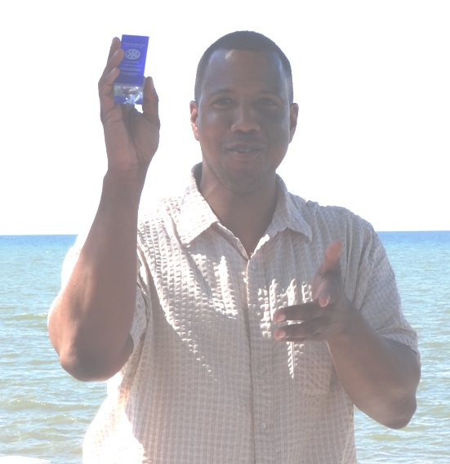

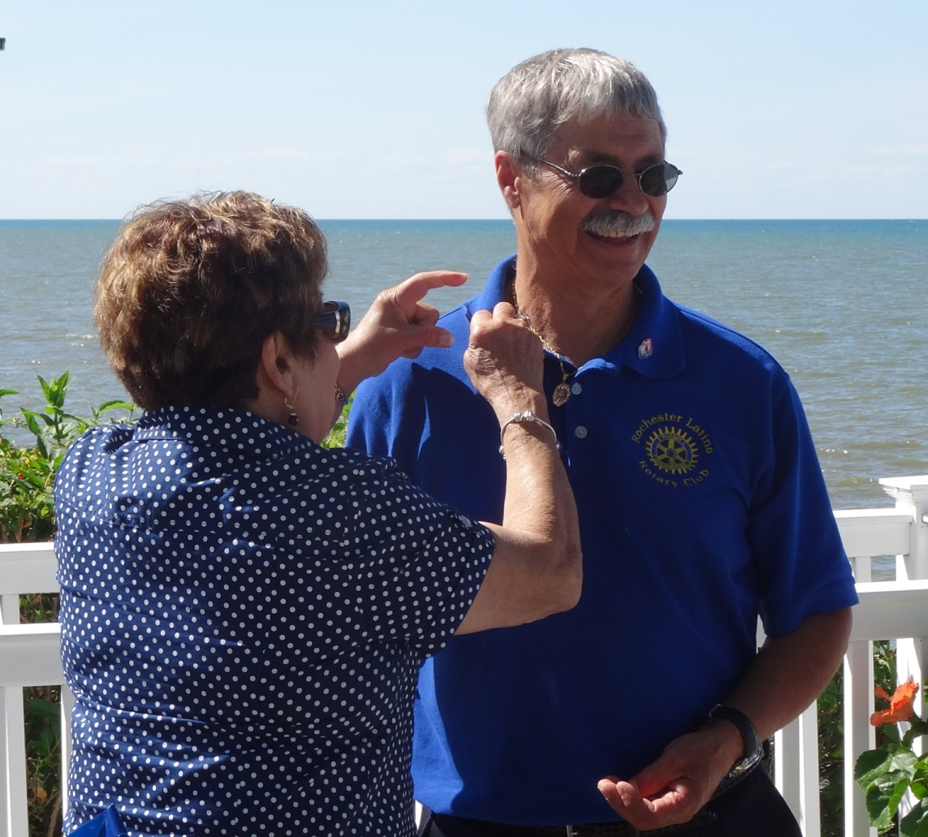

**2016**

C

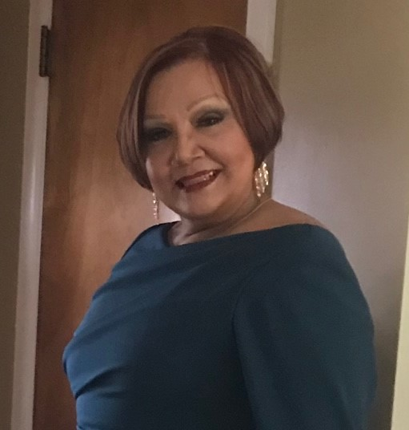

**Miggie’s biography**

The following statement by Miggie gives an insight into her approach to life. She states “I begin each day with God in my mind and heart and with a passionate sense of pride and inspiration knowing that every day I am helping more people achieve the dream of home ownership.”

Arriving from Puerto Rico in 1986 with 3 children, she settled in Rochester and began building a new life. With a bachelor’s degree in Business from the University of Puerto Rico, she started working as an accountant with different not-for-profits agencies that gave her the foundation and the tools to succeed as an accountant. In 1992 she started as a Mortgage Consultant at M&T Bank. She quickly took an active role in furthering M&T’s commitment to enrich the community by becoming aware of mortgage programs available for low and moderate income families as well as housing counseling agencies, and city and county grant funds that could benefit her clients.

Miggie has received numerous awards for her outstanding work at the bank. She is active on many community organizations and board of directors. In addition to her community involvement with M&T she also has volunteer with School #8 to help reading books to kindergarten students. She has participated in the Hispanic Leadership Program of United Way, Hispanic Business Association, Latinas Unidas, and United Way.

She has been teaching religion for the past 25 years at St. Michael’s Church to second graders preparing to receive the First Communion. She is also the President of Father Tracy Advocacy Center board, and she serves as Chair of the Finance Committee and Trustee of St. Frances Xavier Cabrini Parish.

A testimony of her dedication and willingness to serve the community is the way she became President of the Rochester Latino Rotary. Miggie had been a club member for a few short months when the President Elect had to resign due to work conflict. Miggie was nominated for the position, and without hesitation she accepted.

Then, the pandemic happened, the ZOOM meetings began, and the club had to cancel events, and modify service projects. Miggie took it all in stride, and the club continues operating.

**TAKE ACTION, VISIT:** wwwlatinorotary.com



**Rotary International 2020-21 theme**

Rotary International President Holger Knaack introduced his theme for the 2020/2021 Rotary year in January at the International Assembly as “Rotary Opens Opportunities”

He said “Rotary is not just a club that you join.  It is an invitation to endless opportunities. It opens opportunities to serve in a project as big as END POLIO NOW and also in a small community project where you plant a tree. Everything we do opens another opportunity for someone somewhere.”

As the current pandemic shows the resilience of the virus, the bigger opportunity that clubs encountered is to be creative. It will present the opportunity to deliver service using unconventional means. Whether the use of social media, service to smaller groups at a time, or the use of the mail, clubs need to adapt to the new realities. When communities around the world are facing unexpected difficulties and needs, clubs may find themselves lacking the means to satisfy these.

  Clubs need to find ways to raise the necessary funds. The RLRC is no exception. It had to cancel both the 2020 and the 2021 Masquerade Ball, the main fundraising event held every year in April. Many ideas were presented at the first meeting in July, including a virtual event.

**Migdalia Concepción biography**

**Immediate club past president Miggie**

Migdalia (Miggie) Concepción after a challenging year passed the club presidency to Elisa DeJesús, virtually, of course.

**La Rotariana** 2  **July, 2020**

**The Rotary Foundation programs**

The Rotary Peace Fellowship is designed for leaders with work experience in peace and development. Our fellows are committed to community and international service and the pursuit of peace. Each year, [The Rotary Foundation](https://www.rotary.org/en/about-rotary/rotary-foundation) awards up to 50 fellowships for master’s degrees and 80 for certificate studies at premier universities.

1. **Master’s degree programs**

Accepted candidates study peace and development issues with research-informed teaching and a diverse student body. The programs last 15 to 24 months and include a two- to three-month field study, which participants design themselves.

1. **Professional development certificate program**

During the one-year program, experienced peace and development professionals with diverse backgrounds gain practical skills to promote peace within their communities and across the globe. Fellows complete field studies, and they also design and carry out a social change initiative.

**Well project in Adjuntas, P.R.**

For over two years, the RLRC has collaborated with the Greece Rotary Club and the San Juan Rotary club to provide a working well in a community of Adjuntas, Puerto Rico.

After many obstacles, all the necessary permits and funds required have been obtained. The digging for the well is scheduled to start in August. This 800 member community is getting water from a 35 years old well that was affected by Huricane María.

**Look for the club on Facebook at Rochester Latino Rotary Club**

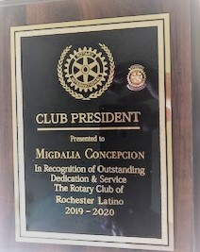

**Immediate past president recognized**

Miggie received a plaque and a pin recognizing her labor as president of the RLRC during the 2019-2020 Rotary year. Of course this was done safely via ZOOM.

Each year has challenges, but none at this one with the restrictions imposed by the pandemic. Yet, our labor continues as we modify the way things are done. Miggie, thanks for your guidance. and may you enjoy many blessings.

Elisa DeJesús attended the University of Puerto Rico where she earned a Bachelor in Human Services and did graduate work in Social Work and Public Administration. She has a Master of Science in Marriage and Family Therapy from the University of Rochester. She is certified as an Associate Trainer by the International Board of Certified Trainers. Elisa currently works at the Ibero-American Action League, Inc. as Director of Diversity and Language Services. She has over 30 years of experience implementing and supervising programs in the human services field and community engagement in Rochester, New York.

Elisa is a charter member and past president (2010-2011) of the Rochester Latino Rotary Club as well as a founder member of Latinas Unidas of Greater Rochester.

Among her areas of professional interest are issues related to child, family and seniors services, community social issues, family relationships, Latino culture, cultural diversity and cultural competence.

Since becoming a member of the RLRC, Elisa has been hosting District Governors Elect from around the world, particularly from Latin America and the Caribbean. They come to Rochester every year to participate in the Mitt Mathews Hospitality Program that was initiated over 45 years ago to provide DGEs the opportunity to stay with Rotarian Families and get to know our community.

Elisa is a dedicated and organized person who quietly and calmly leads the club. This was confirmed during her first term as President (the second one) after being a Rotarian for just one year.

She is active in her church with her husband Abdiel. Elisa and Abdiel are an excellent example of what a loving couple is.

The club is looking forward to continued growth under her leadership in spite of the challenges imposed by the COVID-19 pandemic.

**Elisa takes over the presidency**

La Rotariana 3 **July, 2020**

**Object of Rotary**

The Object of Rotary is to encourage and foster the ideal of service as a basis of worthy enterprise and, in particular, to encourage and foster:

1. The development of acquaintance as an opportunity for service;
2. High ethical standards in business and professions; the recognition of the worthiness of all

useful occupations; and the dignifying of each Rotarian’s occupation as an opportunity to serve society;

1. The application of the ideal of service in each Rotarian’s personal, business, and community life;
2. The advancement of international understanding, goodwill, and peace through a world fellowship of

business and professional persons united in the ideal of service.

La Rotariana 4 July, 2020

**Meetings**

The RLRC continues holding meetings via ZOOM. This is a safe way to conduct business while following rules that limit in person gatherings. One other advantage of this format is that attendees can do so from the comfort of their home. Meetings are held the first Wednesday and third Monday of the month at 5:30 p.m.

**“You have brains in your head. You have feet in your shoes. You can steer yourself any direction you choose. You’re on your own. And you know what you know. And YOU are the one who’ll decide where to go…”**

From: Oh, the Places You’ll Go! Dr Seuss

**THE FOUR WAY TEST**

Of the things we think, say, or do

1. Is it the TRUTH?

2. Is it FAIR to all concerned?

3. Will it build GOODWILL and BETTER FRIENDSHIPS?

4. Will it be BENEFICIAL to all concerned?

**Club Board of Directors**

President – Elisa DeJesús

Immediate Past President – Migdalia Concepción

President Elect – Aida Veras

Treasurer – Idalia Chang, Miriam Vázquez

Secretaries – Jazmin Ruiz

Luisa Baars

Club Service Co-Chairs - Aida Veras

Charol Ríos-Davis

International Service Chair – Luisa Baars

Membership Chair – Orlando Rivera

Foundation Chair – Julio Vázquez

Literacy Co-Chairs –Miriam Vázquez

Julio Vázquez

Club Webmaster – Jazmin Ruiz, Orlando Rivera

Bulletin Editor - Luisa Baars

Program Chair – ElisaDeJesús

Fund Raising – Jazmin Ruiz

Sergeant-At-Arms - To rotate among directors

**The Object of Rotary**



***“Whenever you feel like criticizing anyone … just remember that all the people in this world haven’t had the advantages that you’ve had*.”**

From: The Great Gatsby, F. Scott Fitzgerald