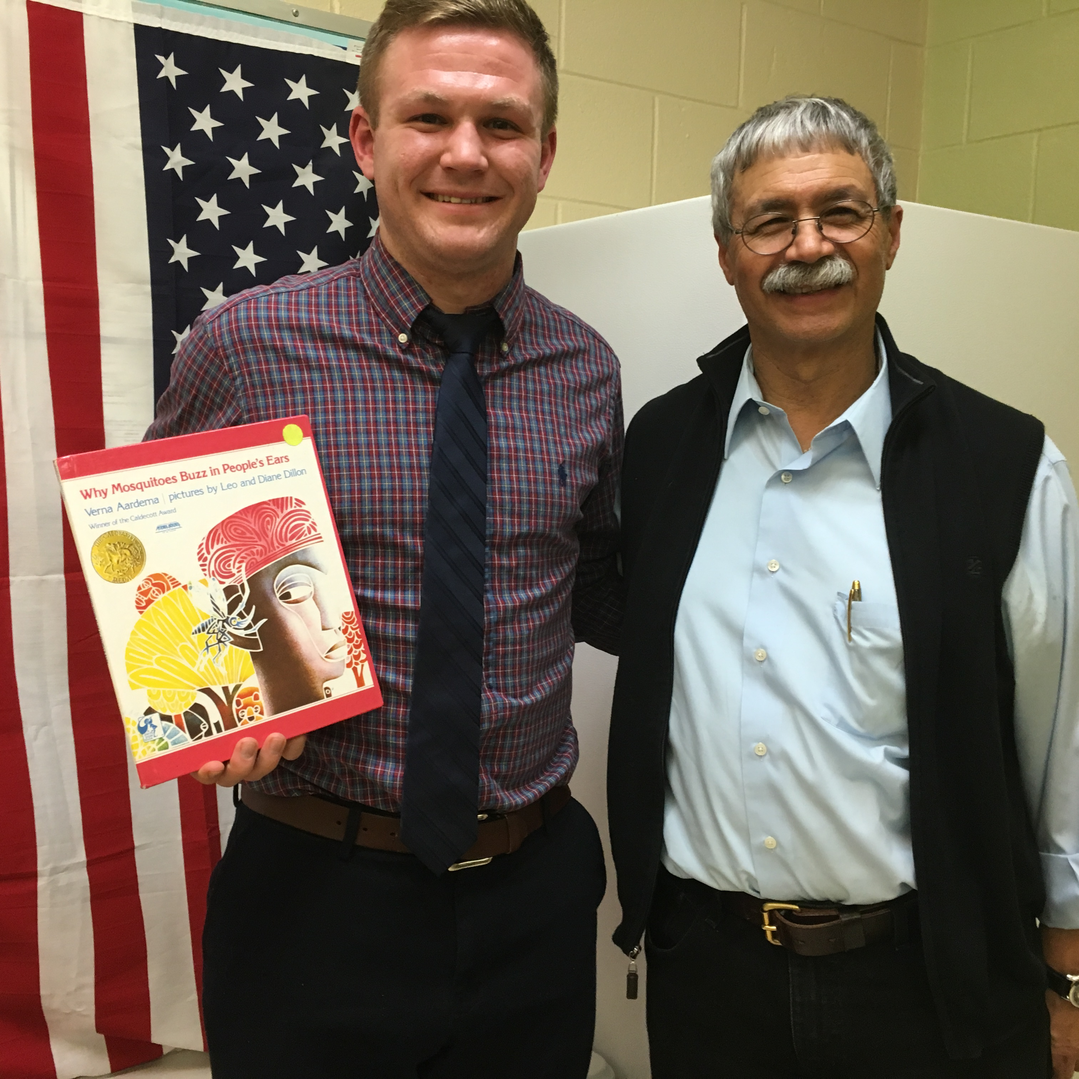
In this issue

…

Club honors Latinos during 8th anniversary
On the 26th of April the Rochester Latino Rotary Club (RLRC) celebrated its eight anniversary at the Diplomat Banquet Center. Over 125 guests helped celebrate the eight year of service to the local and international Latino community.
The event was an opportunity to recognize Latino individuals who have been giving back to the community for many years. Even though they are not Rotarians, they certainly embody the principles that rule Rotarians behavior around the world.
The Luisa Baars Service Above Self Award was given to two individuals whose work in the community is well known. For the first time, the club recognized several unsung heroes of the Latino community with the Serving Humanity Award.
The honorees were as follows:

- Club honors Latinos
- Short Bios of Latino Honorees
- Board of Directors
- Photos
- Object of Rotary

This was the third year that the annual anniversary celebration included a masquerade ball. A silent auction and drawing of the winner of the 50/50 raffle helped the fundraising aspect of the event. This is the main raising event of the club, and it allows the club to carry out its many service projects.
The club salutes the many friends who have been loyal supporters over the years. Without their support and encouragement it would be impossible to fulfill the mission of the club: to serve Latinos here and abroad.

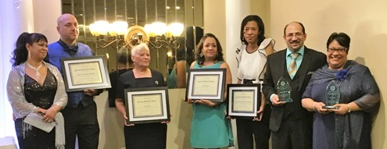
Honorees posed with certificates recognizing their contributions to the community. From left,
Magaly and Anthony Santiago, Irma Laboy, Angélica Pérez, Kary Elyssa Cepero, Ángel Lebrón, Ida Pérez

Ida Pérez was recognized with the “Luisa Baars Service Above Self Award” for her dedication in helping others better their quality of life. She has initiated and has been involved in many projects. Her most recent initiative has been organizing her neighbors on Scranton Street to do something about the crime and drugs in the neighborhood. Her leadership in this effort has resulted in new lights

and speed bumps on the streets. Working together the neighbors are keeping the street clean of needles and drug users. However, she didn’t stop there. She felt a need to help the people on drugs by providing them with resources through the radio program on Poder 97.1 “Su Hora Informativa”. She directs the Early Childhood Center at Ibero American Action League

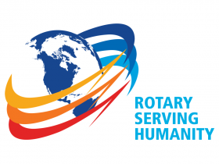

Rochester Latino Rotary CLUB La Rotariana
ACTION: wwwlatinorotary.com

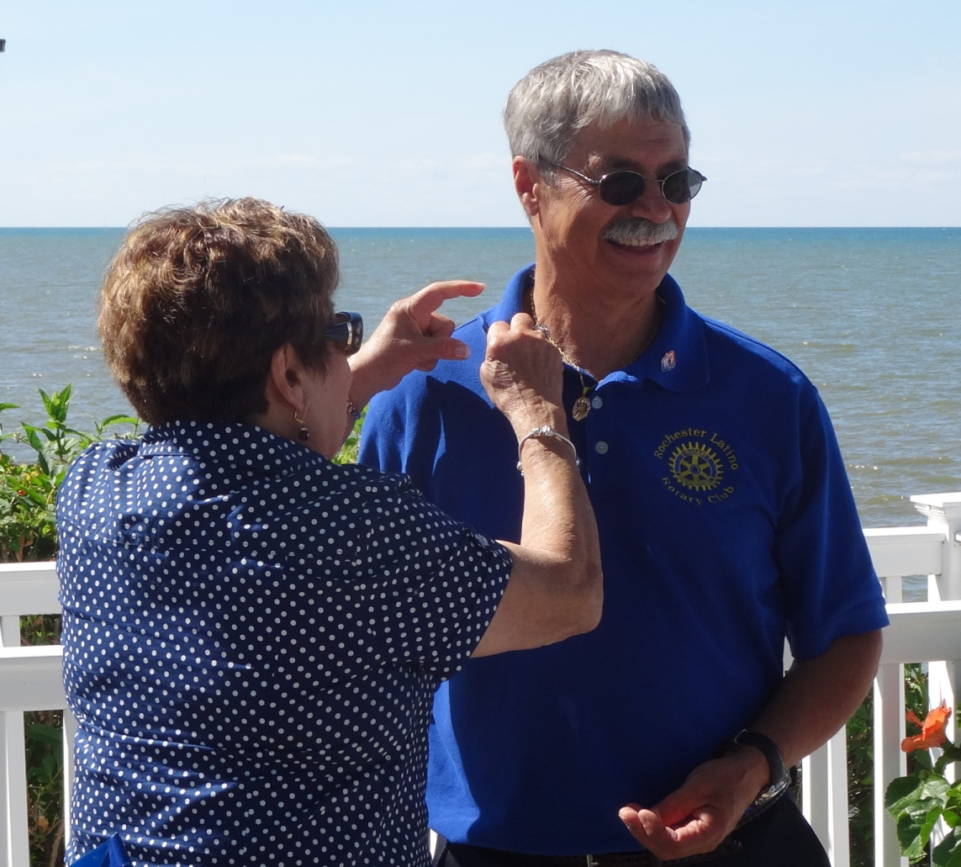
2016
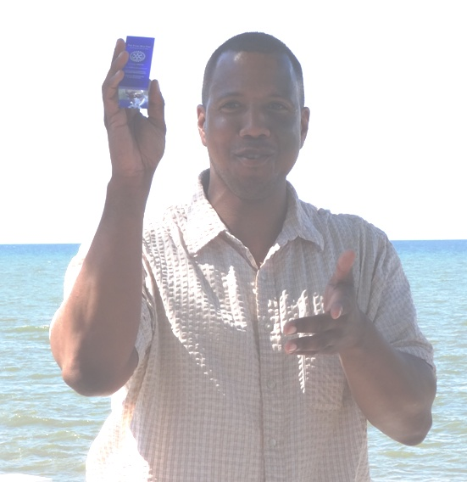

Outgoing President Orlando Rivera shows paperweight with the Rotary logo and the Four Way Test inscription (left) and Luisa Baars pins incoming President Julio Vázquez with the President pin during the change over picnic on July 1o^{th}.

Take action, visit: www.latinorotary.com Facebook: Rochester Latino Rotary Club
April, 2017

La Rotariana 2 April, 2017

Club honors Latinos, Cont.
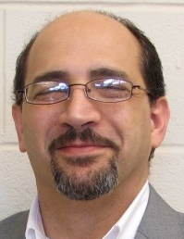

Latino Rotary Serving Humanity Award

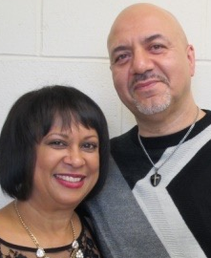

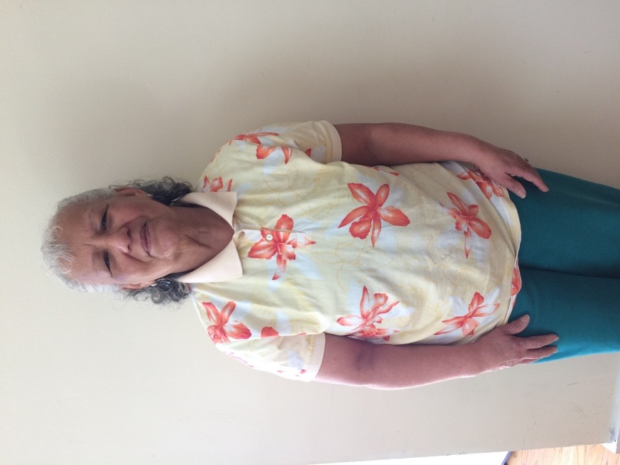



TAKE ACTION, VISIT: wwwlatinorotary.com

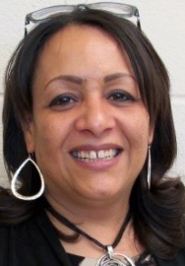

Angélica Pérez is passionate, driven, persistent, forward thinking, resilient and compassionate. She is actively involved in advocacy with the Rochester Poverty Initiative and Social-Emotional Task Force. Her major role is to be the voice for those that don’t have one. She makes sure she connects people with resources they need. She also serves as a board member of several community agencies with the role of advocate for healthy community resources for minorities.

Angel Lebrón is being recognized with the “Luisa Baars Service Above Self Award” for dedicating his time to assisting high school drop outs obtain their GED. He also volunteers his time to helping recent arrivals learn English through Ibero’s ESL program. His focus and major goal is to serve the community, by connecting families with community resources and providing life skills training.

Anthony and Magaly Santiago, a couple that invests their time and resources in helping others in need. They have devoted their lives to sharing their faith, their material possessions and their income with those in need. They spend countless number of hours visiting the sick and the lonely. They guide and mentor young people, young married couples, and help those that are hurting find healing through faith in God.

Irma Laboy has consistently demonstrated passion for serving others. She visits nursing homes, transports people to and from appointments, takes them to pick up medications, and food shopping. She visits those that are too ill to come to church and brings them communion. She attends funerals and offers grief support to families. She also participates in a jail ministry. She does all these things without ever asking for anything in return.

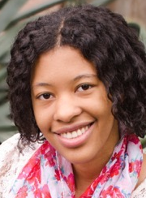
Kari-Elyssa Cepero, at a very young age took the initiative to volunteer her time and share her expertise in urban gardening and botany with young children, youth, and adults in the Rochester Community. She freely gave her time, treasure, and talent to establish sustainable organic vegetable gardens for the Ibero-American Action League and also the Heart & Soul Free Methodist Church in the Upper Falls Neighborhood. At the church she donated earth grow boxes, soil, and seedlings. She is a sweet spirit and a cause-driven leader who passionately cares about the health and well-being of the community.

Entertainment
A performance by TRU Art, a group of dancers with the director and choreographer Jayme Bermúdez performed for the delight of attendees. This group of young dancers from the City of Rochester has an extensive repertoire including modern dances that require flexibility and the ability to perform difficult jumps and body poses that seem very difficult to the spectators.

Photos

Board of Directors

President – Julio Vázquez
Immediate Past President – Orlando Rivera
President Elect – Dr. Miriam Vázquez
Treasurer – Idalia Chang
Secretaries – Wim Baars
Luisa Baars
Club Service Co-Chairs - Aida Veras
Charol Ríos-Davis
Vocational Service Chair - Dr. Constantino Fernández,
Dr. Timothy Malia
International Service Chair – Luisa Baars
Membership Chair – Orlando Rivera
Foundation Chair - Elisa DeJesús
Literacy Co-Chairs – Dr. Miriam Vázquez
Julio Vázquez
Club Webmaster – Orlando Rivera
Tera Rivera
Bulletin Editor - Luisa Baars
Program Chair – Orlando Rivera
Julio Vázquez
Fund Raising – Dr. Miriam Vázquez
Sergeant-At-Arms - To rotate among directors

Object of Rotary

The Object of Rotary is to encourage and foster the ideal of service as a basis of worthy enterprise and, in particular, to encourage and foster:

- The development of acquaintance as an opportunity for service;

- High ethical standards in business and professions; the recognition of the worthiness of all useful occupations; and the dignifying of each Rotarian’s occupation as an opportunity to serve society;

- The application of the ideal of service in each Rotarian’s personal, business, and community life;

- The advancement of international understanding, goodwill, and peace through a world fellowship of business and professional persons united in the ideal of service.

La Rotariana

La Rotariana 3 April, 2017

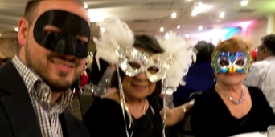
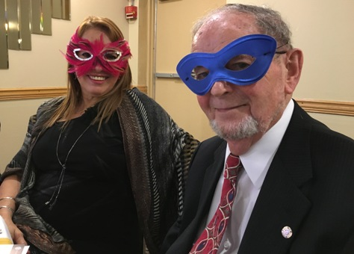

Top left: Luis Baars, María Martínez, Vicky Martínez, and Carmen Hernández (right) posed with their colorful masks.

