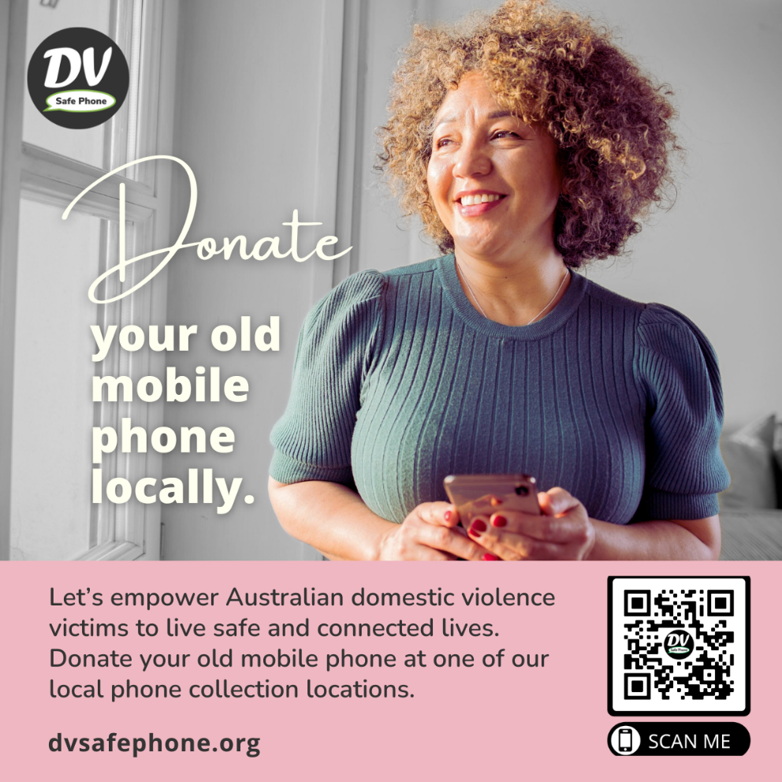

33,571
The number of donated phones since we began.
Note: Any phones that don't pass our tests are recycled and/or used for parts.﻿

12,141
The number of Australian domestic violence victims supported with a DV Safe Phone

426﻿
The number of agency partners across Australia helping connect victims with a safe phone

1,082
The number of phone drop partners across Australia where you can donate your phone

Rotary SAFE Families supports DV Safe Phones and they support Rotary SAFE Families
Stopping Abuse in Families Everywhere

