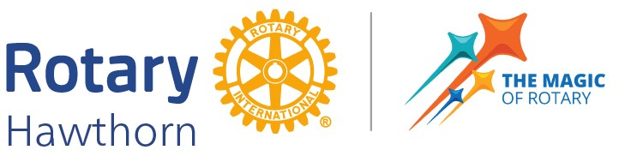

Annual Service to Senior’s Award

**Call for Nominations**

Rotary Hawthorn recognises the contribution of those who provide outstanding service in a voluntary capacity to older members of our Boroondara community.

Would you like to nominate someone for our

**Annual Service to Senior’s Award**?

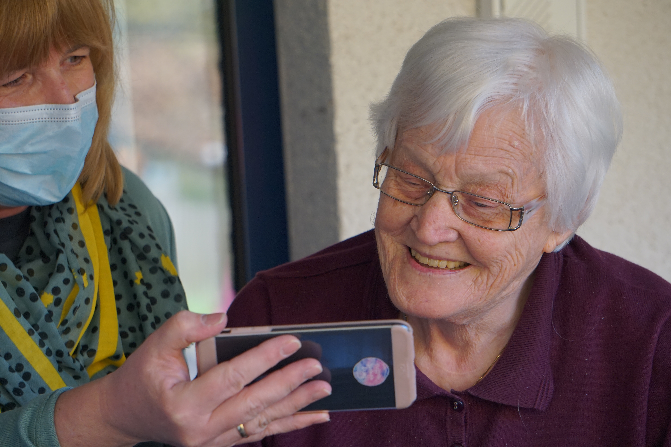

The Nominee needs to be an adult living and/or working in Boroondara.

Show commitment to making a difference for a senior by

using empathy, respect, knowledge, training and experience.

Be a role model for volunteers working with seniors.

Be available to receive award and share their story at Rotary Hawthorn

12.30 pm Tuesday, 1 April 2025 at Kooyong Lawn Tennis Club.

Nominations need to be received by 5.00 pm Friday, 14 March 2025

Nomination form can be downloaded from

<https://www.hawthornrotary.org.au/>