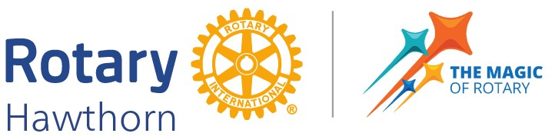

**2025 VOLUNTEERS’ SERVICE TO SENIOR’S AWARD NOMINATIONS**

Rotary Hawthorn is recognising the contribution of a volunteer person who has given or continues to give outstanding service in a voluntary capacity to older members of our Boroondara community. We are seeking your help for nominations for the 2025 Service to Senior’s Award. This award is open to a volunteer person who meets the following criteria.

The Nominees shall:

* be an adult over 18 years of age, living and/or working in Boroondara.
* be available to attend a lunch meeting of Rotary Hawthorn to receive the award in person.
* satisfy the Rotary principle of Service above Self.
* be committed to making a difference for seniors by utilising their time voluntarily and conveying empathy, care, knowledge, training, and experience.
* be a role model for volunteers working with or for seniors.
* enhance respect for older people.

The Nominee may be, but need not necessarily be, a Rotarian. The service we are seeking to acclaim can be anyone, Rotarian or non-Rotarian, who fits the criteria above.

The award consists of a Trophy and Certificate of Recognition which will be presented at a lunch meeting at Kooyong Lawn Tennis Club. The awardee is invited to tell their story in a short address to the Club on Tuesday, 1 April 2025.

Download the Nomination Form here: [Nomination Form.docx](Nomination%20Form.docx)

**Nominations must be received by 5.00 pm*,* Friday 14 March 2025**by completing the nomination form. Please send your form, along with a profile or CV of the nominee, by email to Secretary Rotary Hawthorn: <secretary@hawthornrotary.org.au>

Or post to: Secretary, Rotary Hawthorn, PO Box 33, Hawthorn, 3122

With thanks,

**President Rotary Hawthorn**