More from Katrina Flinn and the Small Comforts Care Bags
After completing our task, we assisted Kaylene in sorting items in DIK’s medical aisle.
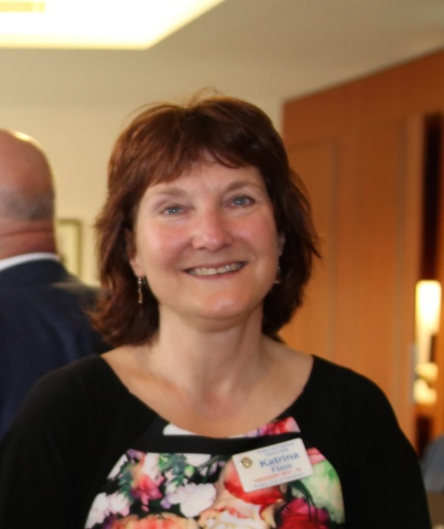
On March 25th, volunteers from Hawthorn, Glenferrie, and Port Phillip worked together at Notting Hill to pack over 200 care bags for delivery to The Alfred, Upton House (Box Hill) & St Vincents which should cover approximately three months' worth of supplies. A big thank you to Barry from the Rotary Club of Malvern for providing space in his premises for both the stock and packed care bags. Thanks to all the volunteers, it is amazing how many bags we can pack in around 2 hours.
The Alfred Hospital receives a fortnightly deliver of 35 care bags and Katrina delivered 20 care bags to Upton House in Box Hill, along with their monthly supply of clothing. In addition, there were lots of extras, including puzzle books, reading glasses, herbal tea bags, and sanitary pads. Katrina also delivered sports balls and pouches for sensory packs for the Adolescent Inpatient Unit (AIPU) and ingredients for their weekly basic cooking class. (The extras being supplied to Upton House and Alfred Hospital Psychiatric Unit are separate from the core project and are funded by a donation from Aveo for attending Sackville Grange.)
Next week, we will deliver care bags to St Vincent’s Melbourne MHU.
Please note: Another care bag packing session is currently scheduled for 24 June 2025.
I am also looking for a new supplier of moisturiser as our donated product has almost run out. Ari and Richard have been donating tooth paste and toothbrushes and are adding to the bags for Upton House, when we have the stock. Thanks Ari and Richard!
Our next step will be to hold a packing day or days at Donations in Kind to sort new clothing into delivery boxes, including t-shirts and track pants. (These sessions will take place on Tuesdays or Thursdays in June/July.)
In addition to the SCFC project, there’s always work to be done at DIK. Would it be possible for our club to schedule regular volunteer days every couple of months at DIK?
Not only would this support our Small Comforts project, but greater engagement with DIK—by providing much-needed volunteers—would make our Club’s involvement more hands-on. This would also allow members to gain a better appreciation of what DIK does and possibly come up with ideas for leveraging DIK resources to create additional club projects.

Katrina Flinn
Project Lead-Small Comforts from Community Service

