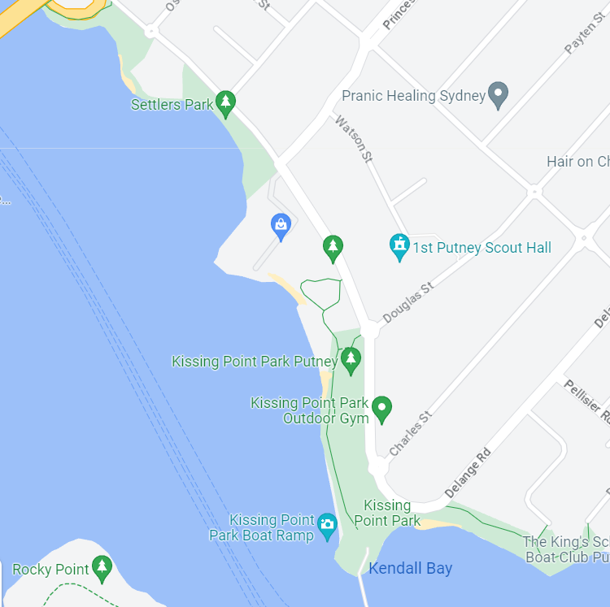
Walking Route or find a nice spot with a BBQ if needed.

The Rotary Club of North Ryde would like to invite you to a gathering at Kissing Point Park, Putney to celebrate the launch of our North Ryde eFun-Run/walk for Youth Mental Health ,2023.
Assemble for a 2km walk at the boat ramp. 3:00pm, on Sunday 30 April 2023.
If you do not want to walk, that’s fine, come for the fellowship.
We ask you to bring an afternoon tea with you, and a picnic chair/mat. Of course, bring your stories as well. Facilities include BBQ’s and toilets.
As the facilities close at sunset, it will not be a big afternoon.
Looking forward to seeing you there.
No need to RSVP, just turn up. Please wear your Rotary shirt +/- hats/caps.

Thank you.
The team from The Rotary Club of North Ryde eFun-Run 2023 committee.
Bernie Mason

