ROTARY CLUBS 2025 CHRISTMAS PUDDINGS
We are supporting “Books in Homes” at Moree East Public School

Ording, payment and collection details:

- CLOSING DATE FOR ORDERS:
FRIDAY 28TH NOVEMBER 2025

- ORDERING:
Please email the order form (below) to Bob at peternathan64@gmail.com

- PAYMENT
**Preferred option: Direct deposit to North Ryde Rotary: BSB 633 000 A/c 126363779 (include your name and “Puds”
(Or by mail: order form and cheque (“Rotary Club of North Ryde”) to PO Box 6171 North Ryde 2113)

- COLLECTION OF PUDDINGS (new this year!)
Orders through Rotary Clubs are to be collected from Bob Selinger at 4 Sheehan St Eastwood (0403 003 257)

Individual orders: where possible, we will deliver to you

Thank you to:


On offer this year:
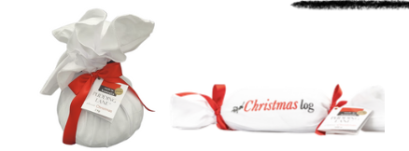

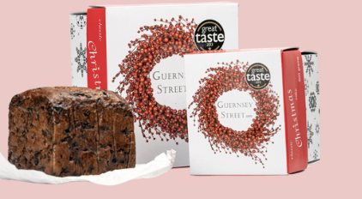













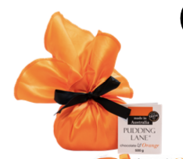


Type into this form and attach it to an email to peternathan64@gmail.com. If relevant, please include the name of the Rotary Club.

Full Name
Contact Address
Contact Phone Numbers | (H) |  |  | (M)
Email
Type | Shape | Servings | Unit Price |  | Qty | Sub Total
Classic Christmas Pudding | 500g Round | 4 - 5 | $38.00
Classic Christmas Pudding | 1kg Round | 6 - 8 | $59.00
Classic Christmas Pudding | 1.5kg Round | 10 - 12 | $83.00
Classic Christmas Pudding | 2kg Round | 12 - 16 | $98.00
Classic Christmas Pudding | 3kg Round | 20 + | $123.00
Classic Christmas Pudding | 500g Log | 5 - 6 | $39.00
Classic Christmas Pudding | 1kg Log | 8 - 10 | $60.00
Classic Christmas Cake | 600gm |  | $38.00
 | 1.4 kg |  | $69.00
Macadamia & Brandy | 500g Round | 4 - 5 | $39.00
Macadamia & Brandy | 1kg Round | 6 - 8 | $59.00
Macadamia & Brandy | 500g Log | 5 - 6 | $40.00
Macadamia & Brandy | 1kg Log | 8 - 10 | $61.00
Gluten Free | 500g Round | 4 - 5 | $39.00
Gluten Free | 1kg Round | 6 - 8 | $59.00
Gluten Free | 500g Log | 5 - 6 | $40.00
Gluten Free | 1kg Log | 8 - 10 | $61.00
Plant Based | 500g Log | 5 - 6 | $40.00
 | 1kg Log | 8-10 | $61.00
Rum & Plum | 500g Log | 5 - 6 | $39.00
Mango & Brandy | 500g Log | 5 - 6 | $39.00
Date & Toffee | 500g Log | 5 - 6 | $39.00
Date & Toffee | 1kg Log | 8 -10 | $60.00
triple Chocolate | 500g Round | 5 - 6 | $38.00
triple Chocolate | 500g Log | 5 - 6 | $39.00
triple Chocolate | 1kg Log | 8 -10 | $60.00
chocolate & Orange | 500g Round | 5 - 6 | $38.00
chocolate & Orange | 500g Log | 5 - 6 | $39.00
chocolate & Orange | 1kg Log | 8 -10 | $60.00
chocolate Rum & Raisin | 500g Round | 5 - 6 | $38.00
chocolate Rum & Raisin | 500g Log | 5 - 6 | $39.00
chocolate Rum & Raisin | 1kg Log | 8 -10 | $60.00
 |  |  | TOTAL |  |  | $

