ROTARY CLUB OF TERRIGAL
ANNUAL REPORT 2020-2021

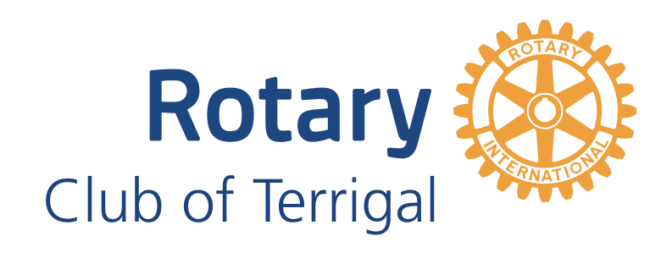

Board Members
President Mary Crammond
President Elect Mark Reynolds
Secretary Andrew Ratcliff
Treasurer Robyn Ratcliff
Director Community Mark Reynolds
Director Youth Lynne Wilson
Director Membership Lyn Davies
Director Vocational Anne Cantrill
Director International Jill Hamilton
Director Foundation Gina Growden

ROTARY CLUB OF TERRIGAL – PRESIDENT’S REPORT 2020-2021

Fellow Rotarians and Friends,
The Presidential Year of 2020/2021 “Rotary Opens Opportunities” commenced on 1st July 2020. On 25 June 2020 the Club held their Changeover and finale to the 2019/2020 Rotary Year.
With Covid 19 restrictions still dictating our lives, our Club’s Changeover was held on Zoom with DG Kalma McClennan, DGED Lindsey May, ADG David Rivett and our ADG’s and various PDG attending. Our twin Club PDG Graham Money also attended.
Our Board remained much the same with PDG Gina Growden taking over as Foundation Chair and Mark Reynolds as President Elect. President Awards were given to Pia Mylan, Ben Brown, David Mylan, Stewart Whyte and Jill Hamilton. President Mary Crammond received a Paul Harris Fellowship Award.
Speakers for the first quarter were Suzie Miller from Opportunity Collective, Haran Ramachandran from Rotary Foundation, Adam Crouch,our Member for Terrigal, and David Mylan from Max Potential. We also had a social Sunday out at Gosford Waterfront.
We held two evening meetings a month on Zoom, one with a speaker and one for business and two coffee mornings a month often at a member’s house or at Aromas by the Sea. All were well attended. Board meetings were on Zoom.
Our visit by DG David Clark was held as a Zoom meeting being a joint Terrigal/Erina/Kincumber (TEK) meeting chaired by DG Assistant, David Rivett.
A couple of new partnerships were introduced Bringing Business Together, BBX and Terrigal Neighbourhood Centre.
We sold Covid face masks made by Glenhaven Rotary Club. Anne Cantrill started a fund raising market stall at Terrigal’s monthly markets.
The Shelterbag Committee met on Zoom with Bas Timmer, Shelterbags Designer. Coast Shelter were shown our Shelterbag and they are keen to receive some of these for rough sleepers.
The second quarter speakers included David Egan of Adelaide Rotary Club introducing Rotary Regional Pilot Project, Anna Duggan from Central Coast Council Bush Care Team, Tony Castley OAM talking about his project Sewaid, The Polio Dinner hosted by PDG Gina Growden, PDG Susan Hayward from Dress for Success, and Rabi Barel from Nepal.
Inclement weather saw our planned Terrigal/Erina/Kincumber (TEK) Polio Plus picnic cancelled. However, a successful TEK movie fund raiser was held. The Ronald McDonald House (RMH) Raffle, which we sponsored, was successfully held at Breakers and the money donated to RMH.
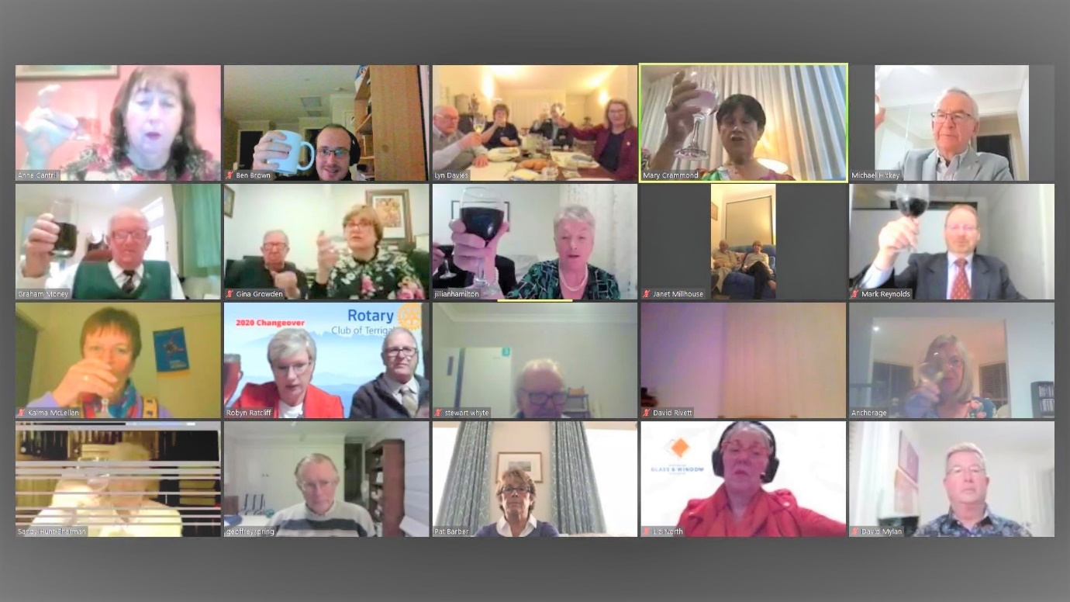

Coffee mornings and Zoom business meetings continued. We held a successful Book Fair with all members contributing. A wonderful lunch BBQ was held in Janet and John Millhouse’s garden and new member David Boyd was inducted at a meeting held at President Mary’s home.
Our AGM was held on Zoom on 10 December 2020. Club surveys were held deciding the Xmas Party, Return to Rotary Party, and future meetings.
Janet and Mary attended a function at the Glen. The Glen for Women has been approved. We demonstrated to them our Shelterbag which was warmly received by a worker from Barang Regional Alliance. Anne held her Terrigal market stall with proceeds awarded to Coast Shelter.
About 36 members, guests and friends attended our Xmas Party outside at Fortune Lane Chinese Restaurant. The Return to Rotary Party had to be cancelled because of Covid 19 restrictions.
Speakers for the first three months of 2021 included Corrine Hodson from Barang Regional Alliance, launching our first F2F meeting in approximately a year. This was a TEK at Breakers. Marie James from Central Coast Council Neighbourhood Centre Program. Speaker Nikki Wilmett from St Vinnies Woy Woy cancelled and was replaced by Robyn Ratcliff.
President’s meetings, District Assembly, District Conference and Board Meetings remain on Zoom. Our meeting schedule is now first and third Thursday evening at Breakers – one business and one speaker meeting. One coffee morning at 11am in Aromas and our dinner out in a restaurant meeting - chosen by a member.
The first of these was chosen by David Boyd and was held in January at Trojans Restaurant. Lynne Wilson chose our second restaurant visit treating us to Lebanese food in Terrigal and Anne Cantrill then chose Boon Thai in Green Point for our next gathering. All well attended and enjoyed.
Our Shelterbag Project was official launched to our Club members and PE Mark Reynolds made a promotional video. Our Shelterbag Project was reviewed and advertised on Rotary Matters Radio Program. The Shelterbag Project Committee is applying for every grant it comes across as well as approaching Service Clubs, Banks and Corporates. We also held fun raising stands at Erina Fair. We honoured Stephen Gittoes from Gittoes Real Estate with a meal and a certificate of appreciation for their donation of $5000 to our Shelterbag Project. We also acknowledge the generosity of all the Coast Bendigo Banks, Country Women’s Association, Mingara Club, Central Coast Council, Rotary Club of Wyong, Rotary Club of The Entrance and Rotary Club of Umina for their generosity.
During this quarter, we had disappointing news from South Africa regarding our Shelterbags for the Homeless/Seamstress Training Program. Sheltersuit SA Foundation are no longer making the bags at The Ark Refuge but have opened their own factory premises. Therefore, the Seamstress Training section of our proposed program was not able to go ahead. We continue with providing Shelterbags for the Central Coast Homeless and have obtained a RABS grant of $10,000 toward our first shipment.
Terrigal Neighbourhood Centre launched its food program but our assistance is not needed until they build up clients. Ben Brown launched his Walk for Cambodia fund raising event. We attended the opening of the new wing of the ET Australia school whom we sponsor a student scholarship. We also attended and presented the 40 th Anniversary certificate to Terrigal Probus Club whose charter Terrigal Rotary Club sponsored.
Our April Book Fair was as successful as our November Fair. A wonderful effort by every member and especially John, Harley and Janet.
Our final quarter of the year was extremely exciting with our first Hybrid meeting featuring guest speaker PRIP Ravi Ravindran. We had 46 guests at Breakers including our DG, DGED, ADGs and past DGs as well as zoom guests from South Africa, England and New Zealand. A few technical glitches but a great evening with a wonderfully compassionate speaker.
Celebrating 100 years of Rotary in Australia included Central Coast Rotary taking a decorated Red Bus around the Coast and a Plaque unveiling at Mt Penang Gardens was held by Kariong Club. Again, a number of our members attended.
We registered a new project with RAWCS through RABS where we partner with Regional Youth Support Services through Star 104.5 FM. Clubs NSW Central Coast is also involved in this fund raising. Our partners aim to raise $80,000 by September and will then hold an amazing light show on the Terrigal Haven. The Rotary Club of Terrigal are featured on all their advertising, media and fund raising.
Throughout the year Gina Growden has published a brilliant fortnightly Terrigal Times. Thank you Gina.
Our last speaker was Rafaele Joudry, a Sound Therapist.
Our Changeover Hybrid meeting is on 24 June 2021 and we shall also induct Maggie Vincent into our Club. DG David Clark, DGE Lindsay May, DGED Christine Owen, ADGs will attend plus a number of guests on Zoom including PDG Graham Money from our Twin Club, Helderberg Sunrise in the Cape Province of South Africa.

Mary Crammond – PRESIDENT 2020-2021
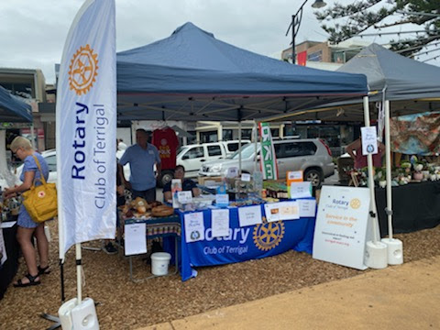

SECRETARY REPORT
The Rotary Club of Terrigal currently has 18 active members and 3 honorary members.
There were 10 Ordinary Board Meetings held this year. The commencement time for Board meetings of 7.00pm is working satisfactorily and allows for effective meetings to be held within the time frame permitted.
Following the introduction of COVID -19 rules during early 2020, our Board meetings began to be held on-line and this year all the Board meetings have continued to be held on-line as it has been found to be a more efficient method.
There were a number of Business Meetings held during the year to give all members the opportunity to gain more knowledge of the club’s projects, contribute to the development of projects and activities, discuss other initiatives and provide feedback.
The Annual General Meeting was held on 10 December 2020, at which time the incoming Board were elected and President Elect Mark Reynolds was confirmed as President for 2021-2022 and President Elect for 2022-2023.
A Social Committee has been formed and whist COVID-19 rules have interrupted planned events, these will continue to be arranged for next year.
I hold the Club credit card that can be used for approved purchases.
I am the nominated Public Officer for the Club with NSW Fair Trading. The Club’s financial return for 2019-2020 has been completed and sent to the Department of Fair Trading with the appropriate fee for lodgement following the Annual General Meeting.
The Club holds a valid Charitable Fundraising Authority.
The Club has completed the Insurance Compliance Declaration forms and submitted them to the District Insurance Officer. Special events are subject of notification to the District Insurance Officer and risk assessments are completed and submitted as required.

Andrew Ratcliff – SECRETARY

TREASURER REPORT
Full financial reporting will be finalised after the end of the financial year and reports distributed to members at the Annual General Meeting.
Donations made from 1/7/20 up to and including 22/6/21:
Rotary Foundation $2500
Shelter Bags $7500
MUNA $250
Australian Rotary Health $1000
Barang Regional Youth Sponsorship $500
African Feeding Program $5500
Quirindi Rotary $750
School of Life $750
ET Australia student sponsorship $750
Symphony Central Coast $2000

Robyn Ratcliff – TREASURER

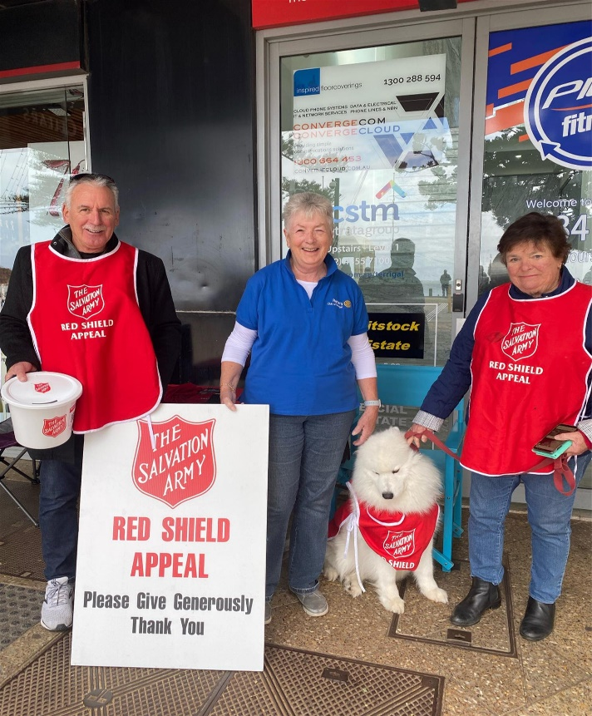

COMMUNITY REPORT

The ongoing Covid situation had an effect on various face to face community projects in the first half of the year, but restrictions started to ease in the second half which allowed us to move forward once again.
Below is a brief summary of the year that was:
July
Retaining wall at Terrigal Rotary Hall completed and the Rotary plaque commemorating the Rotary Club of Terrigal’s involvement with the Hall has been imbedded into the wall.
Preparations for November Book Fair commenced.
Terrigal Rotary Facebook page goes live.
August
‘Shelterbags for the homeless’ project commences and a new committee is formed.
A Shelterbag sample and pattern sent from our friends in Helderberg Sunrise Club arrives.
Covid masks produced by Glenhaven were arranged by Mary to raise funds.
September
Anne Cantrill commences preparations for a Club stall at Terrigal markets. The first market day was to be 7 November 2020.
A new Rotary table cloth and banners arranged by Jill will complement the Club’s community awareness at these markets and other events.
October
Shelterbag committee are hard at work on fundraising initiatives.
November
Another successful Book Fair with over $8,000 raised in spite of the added challenge of making it a Covid safe venue. Congratulations to John and Janet and a huge thank you to all the members and the many friends who contributed.
The first Terrigal market was a great success. Congratulations to Anne for arranging the stall and Lyn Davies for arranging the rosters and compliance documents.
Polio fundraiser at Avoca Theatre screening ‘I am Woman.’
December
The Board agreed to accept Shelterbags for the homeless as the Club’s major project.
Anne arranged another stall at the Terrigal markets, raising $640 which was donated to Coast Shelter. Well done Anne and all the volunteers who gave up their time to assist.
The Club sponsored the Ronald McDonald Family Room Christmas Raffle at Breakers Club raising over $2,000. Mary and Mark attended to assist in distributing the prizes to the winning children.
The end of year Christmas Party was held at Fortune Lane Restaurant Terrigal attended by 30 people.
January
Shelterbag fundraising activities in full swing.
February
The April Book Fair preparations are underway.
Terrigal market stall raised $200 for Shelterbag project.
Our Club is supporting the Terrigal Neighbourhood Centre’s Food Pantry Morning.
March
Terrigal markets stall raised $206 for Shelterbags and an additional $242 from anonymous donors who paid money directly to the RAWCS account.
A Rotary District Appeal fund was setup to assist flood effected people.
April
Another successful Book Fair raising close to $10,000. Well done once again to all those involved.
The Cancer Council’s Rotary Bowelcare program commenced. Mark delivered testing kits to 7 local Chemists.The promotion runs for 2 months. This is a community service provided by Rotary Clubs to raise awareness of the need for early detection.
Shelterbag fundraising and promotion continued with Mary arranging a stand at Erina Fair.
We have also been fortunate to receive some large corporate donations this month.
A community raffle was promoted through the Club by Honorary Member Ben Brown to raise funds to support the Human and Hope Association who support the needy in Cambodia. Ben is a very passionate ambassador and has raised quite a lot of funds himself. Congratulations Ben!!!

May
On Sunday 1 May 2021 the Rotary 100 Years Bus toured the Central Coast to raise awareness of Rotary’s 100 years in Australia.The bus travelled through Rotary areas from Umina to Toukley and stopped at The Entrance for lunch.
The Bush Care Group participated in planting trees and native grasses in our designated regeneration area. The plants have been supplied through the Bendigo Bank’s Green Fleet Program which funds the provision of native trees and shrubs across Australia, improving water quality, reducing soil segregation and providing essential habitat for native wildlife.
Work continued on the Shelterbag project with Mary actively presenting to other Rotary Clubs and community clubs and also business networking groups raising thousands of dollars. Mary was also interviewed for an article in the local newspaper.
Another stand at Erina Fair generated an additional $532.
The Club supported the fundraising efforts of the Salvation Army’s Red Shield Appeal at Terrigal over a weekend raising over $1800.
June
The unveiling of the R100y Plaque at Mt Penang Festival Gardens took place on Wednesday 2 June 2021 at The Waterfall Café Kariong.
Anne Cantrell held another market stall in Terrigal.
400 Shelterbags are ready for shipment from Cape Town.

Mark Reynolds – DIRECTOR COMMUNITY

BOOK FAIRS 2020-2021
The November Book Fair went ahead, our first for 2020, with strict COVID safe precautions. We were limited in the number of people allowed in the Scout Hall (38) and safe social distancing required a rethink of table arrangements and entry and exit points. Customers were greeted on entry, registered as per Covid requirements and the ‘pay’ table was moved outside under a marquee.
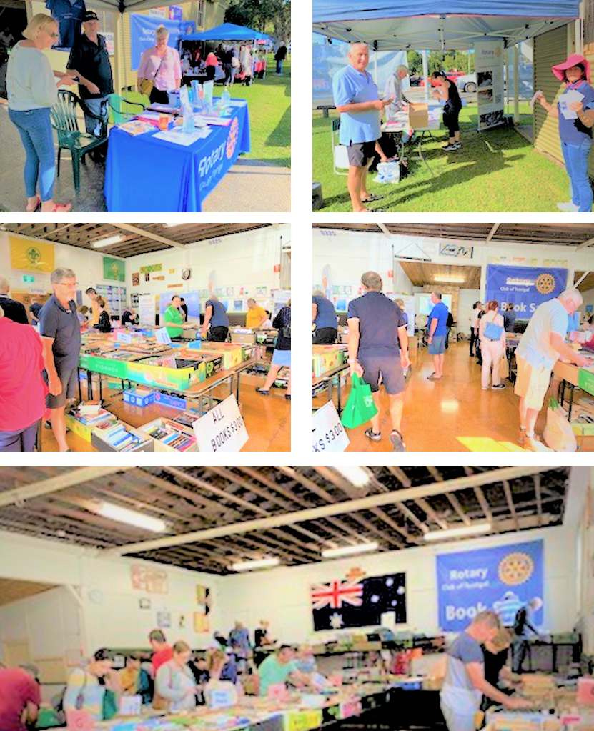

Whilst numbers were down slightly, over all the Fair was a success and changes forced on us by Covid worked well. Feedback from members rostered on was positive and the new arrangements will become permanent, particularly having the point of sale outside.
Special thanks goes to Past President Harley Newham who arranged for the purchase of a second hand flexible roller conveyor which sped up the removal of boxes from the container into the truck and at the other end allowed quick off loading with reduced handling.
Our April Book Fair was held under similar conditions to the November Fair and went smoothly. All Rotarians and friends who volunteered to help are familiar with the work required and are well practised in meeting the Covid safe requirements.
The book buying public were supportive as always and numbers appeared to be up on the previous Fair. Once again the flexible roller conveyor proved it’s worth and arrangements were approved by the Board for the purchase of another. This has since arrived and is being repaired and modified by PP Harley Newham. A further thanks should go to PP Newham for his continued support throughout the year particularly in the provision of display boxes.
A special thanks to all Rotarians, ex members and volunteer friends of Terrigal Rotary who turned up when rostered and worked to make the Book Fairs a success. Once again our fundraising is dependent upon the continued flow of donated books from Central Coast residents. It is worth noting that many donors are regular contributors and most come to us through word of mouth or via the internet, particularly through our active FaceBook presence.
John Millhouse – COORDINATOR BOOK FAIRS

YOUTH REPORT
RYPEN 2021
This year, seventy five students registered for RYPEN from our Rotary District 9685 held in February.
Two Year 10 students from Terrigal High School, Erica Fondales and Ben Heginbotham were chosen by their teachers to participate and were sponsored by our Club.
Students participated on ZOOM which was a huge task for the organisers prior to the weekend. By all accounts the entire enrichment program was most successful.
Students were organised into groups and completed a range of leadership development activities followed by a challenge. The focus was on design thinking. The task was to individually build solar lights which Ben and Erica completed. The lights have now been sent to Cambodia to communities with no electricity.
The two students presented their follow up report at a recent Rotary meeting. They were warmly received and congratulated on their participation and achievement.
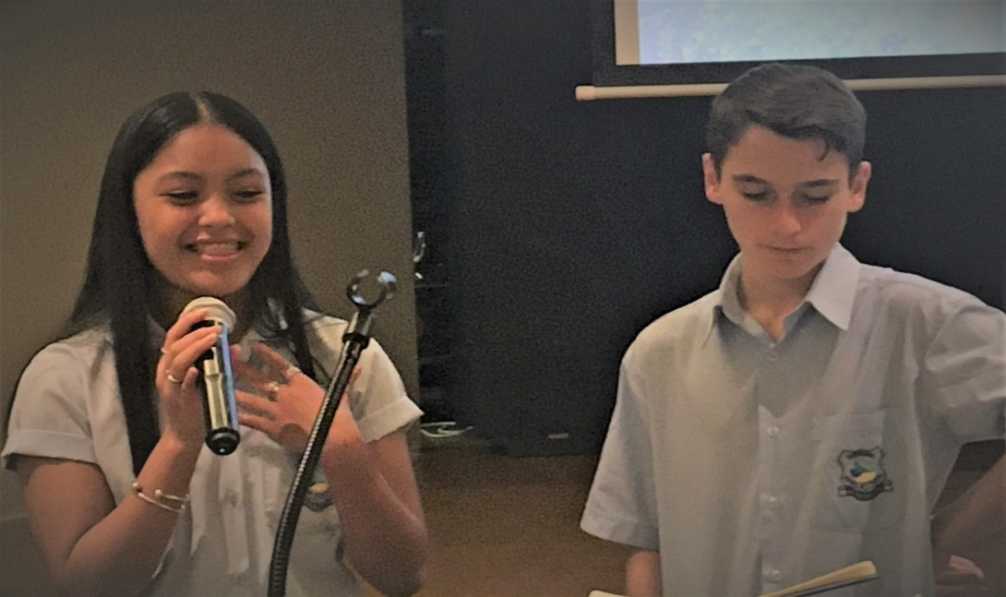
MUNA
The Model United Nations Assembly took place at Erina Fair in May. MUNA is part of a Rotary International project to educate senior high school students on the United Nations organisation and its vital commitment to world peace, health and living standards across the world.
The Rotary Club of Terrigal did not have a formal role on the day but President Mary and I were in attendance to witness the high standards of performance in public speaking and debating by students from our local high schools.
Lynne Wilson – DIRECTOR YOUTH

MEMBERSHIP REPORT
The strategies we have in place and our new look after the impact of COVID19 is so positive. We are attracting more interest in membership, family members and associates. Our activities are the things that attract!
Membership statistics from our ClubRunner: Total 21 with 18 active Members and 3 Honorary Members. We also have 3 active Family Members.
New members: Maggie Vincent will be inducted at the Changeover meeting of 24 June 2021.
Several other interested people are not ready to join us but remain our friends.
Welfare of Members
Thank you to the members who have assisted with moving and transport to meetings and social events. Cards and some flowers have been sent to members during this year. Please continue to share if there is anything I should know in terms of member’s welfare.
Activities
* Small Business Networking Group each month on Fridays - Breakfast meetings at East Gosford Art Gallery Cafe. Representatives attend each meeting. The links and Public Image aspects of this relationship are invaluable. We are invited to post on the FaceBook page e.g.Markets and Book Fairs.
* Market Stall - Our next Market is next week on Saturday 3 July 2021 - Put your name on the roster if you would like to participate by calling Anne directly or send me an email. NOTE: Anne requested NO Market then until November 2021.
* Coffee mornings and monthly dinners are a great innovation and ensure we are seen out and about in the community.
Please let’s all keep inviting people, using the Rotary Public Image process (website and Facebook ) and also making all our invited visitors welcome.

PP Lyn Davies – DIRECTOR MEMBERSHIP

INTERNATIONAL REPORT
Our major project this 2020 – 2021 year has been Shelterbag. Sourcing from South Africa these weatherproof mattressed sleeping bags for use in Australia.
This has had the added benefit of helping to employ South Africans in manufacturing the bags and arranging for shipment to Australia. Originally promoted through The Rotary Club of Helderberg Sunrise, and The Ark Refuge Centre, the manufacture has been transferred to a Sheltersuit franchised factory on the outskirts of Cape Town, where local previously unemployed workers continue to be trained and develop the ability to earn a living.
Prompted by the dire situation of COVID in South Africa, this year our main International recipient was Helderberg Sunrise South African Feeding programme.
Our link organiser, Chris van de Liej of Helderberg Sunrise Rotary Club, was helping schools fund and deliver food to their pupils and families and people in South African Townships because of the Covid-19 virus.
Millions of people in Africa are starving.
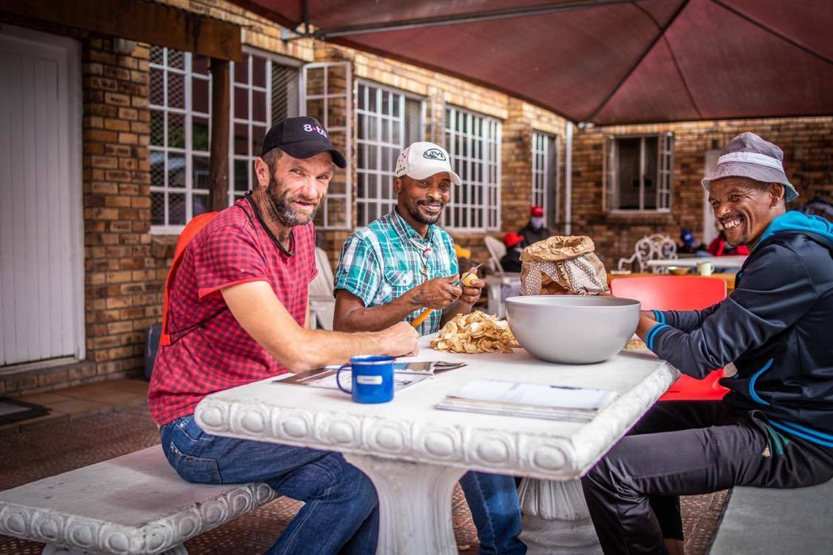

Helderberg Sunrise Rotary Club, our Twin Club normally run educational and social programs in their local African Townships. All programs have ceased because of Covid-19 and because of lock down, all work has also ceased.
The people now need food and warmth and our Twin Club is doing their best to supply these to the townships in their area. Food costs money and together with Helderberg Sunrise we raised funds to help feed these people. Not everybody can be saved but if the people normally supported by Helderberg Rotary can be helped, it will be a step in the right direction.
The Western Cape is colder than here in the winter and to think of how much colder one feels with an empty stomach is so distressing. We applied and received a District Matching Grant,which we funded $6000 from our Club funds over 2 years.
Our on-going International project continues to be School for Life, Uganda. This Rotary funded school was founded by Annabel Chauncey together with David Everett, Australians, in 2008, as a response to her vision of world class education for the rural poor in Uganda.
Rotary has been a major partner from the beginning,and fund raising is always needed to keep the school running, and supporting vocational development in the immediate village, Katuuso.
We donated almost $700 this year, supporting one child for a year. Teachers have been ferrying schoolwork to their pupils while the country has been in COVID lockdown, and have recently used their village training facility for adults, to make masks for villagers.

Jill Hamilton – DIRECTOR INTERNATIONAL

FOUNDATION REPORT

Early in the year we finalized our District Covid Grant of $10,000 for the South African Feeding Program. The Shelterbag Committee then commenced their application to Rotary Foundation for a US$30,000 grant for our Shelterbag/Seamstress Training Program. Unfortunately, Covid caused changes at The Ark, City of Refuge in South Africa, who were partnering us through our Twin Club, Rotary Club of Helderberg Sunrise, and this application needed to be postponed for the time being.
However, we raised another Rotary grant in the amount of $10,000 to bring Shelterbags into Australia through Rotary Australia Benevolent Society.
During the Rotary Year, we donated $2,500 to our Foundation. The importance of members supporting our Foundation was promoted to our members fortnightly for two months. Haran Ramachandran, Foundation Grants Subcommittee Chair addressed our Club. Haran also kindly attended a meeting on the Central Coast with our Shelterbag Committee.
We have just registered another RABS project where we partner with Regional Youth Support Services through Star 104.5FM to fund raise for a fully equipped bus to the value of $80,000.
Once the business of year end is over, the Shelterbag Committee will apply for another District Grant for our next shipment of Shelterbags.
A highlight of our Foundation year was a Zoom visit by Foundation Chair, Ravi Ravindran where DG’s, (including the DG of our Twin Club), DGED, ADGs, many PDG’s and PP plus members of District 9685 either attended Ravi’s talk in person or via Zoom.

Gina Growden – DIRECTOR FOUNDATION

VOCATIONAL REPORT
There has been very little to report in the past year because of Covid restrictions. Hopefully things will improve in the next Rotary year.
Thanks for your support,
Anne Cantrill – DIRECTOR VOCATION

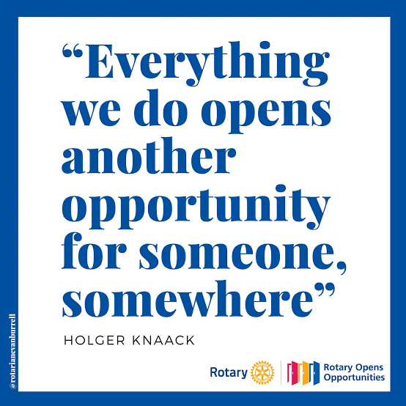

Rotary Club of Terrigal Past Presidents

1974 K Galbraith 1999 G Kirk
1975 B. Hines 2000 B Hall
1976 T Waterhouse 2001 B Hall
1977 L Cameron 2002 J Spath
1978 G Dobson 2003 G Mackie et al
1979 L. Cameron 2004 S Muter
1980 F Parker 2005 P Henry
1981 G Gibson 2006 S Whyte
1982 A Raymond 2007 I Kilpatrick
1983 B Claydon 2008 G Growden
1984 T Fitzgerald 2009 L Davies
1985 R Lee 2010 D Button
1986 M. Ellis 2011 C Tyler
1987 V Selig 2012 G Growden
1988 S Graham 2013 D Waterhouse
1989 K Howard 2014 R Header
1990 T Woods 2015 J Hamilton
1991 T Woods 2016 D Mylan
1992 G Lehner 2017 H Newham
1993 B Freeman 2018 G Hooper
1994 C Wallace 2019 M Crammond
1995 D. Hall 2020 M Crammond
1996 G Beckers
1997 G Bell
1998 R Pulatti

Paul Harris Fellows currently in Terrigal Rotary Club
The Paul Harris Fellow recognizes a person who demonstrates significant support of and
exceptional service for the wonderful work of the Rotary Foundation.

Peter Halliday, Don Hall, Gina Growden, Lyn Davies, Bill Boag, Norma Boag
Michael Hickey OAM, John Millhouse, Jill Hamilton, Geoffrey Spring, Mary Crammond.

