The History of the Terrigal Rotary Hall

By Peter Halliday

After Charter in 1974 Terrigal Rotary Club operated as a normal Rotary Club, meeting in the function room of Cobb & Co Motel, Terrigal. Later the Country Comfort Motel. Now, the Elysium complex.

In 1979 we had trouble with the venue, the Funxtion Room, not always being available. Various venues were tried such as Terrigal Surf Club, The Florida Hotel, , now Crowne Plaza. We finished at Terrigal Wamberal Memorial Country Club on Dover Road Wamberal. The venue was unsatisfactory too noisy and had no privacy. The proposal that build our own venue as a Community Hall was put forward by President George Gibson, who was also Deputy Shire President on Gosford Shire Council.

Through George Gibson the land was granted to Terrrigal Rotary on a care and maintenance basis.

A bank loan of $40.000 was arranged through Rtn. Graham Pelley, Manager of the ANZ Bank in Terrigal, with 5 members acting as Guarantors.

A Building Committee was formed with Rtn. Don Moore acting as the Builder. The building commenced on 7th June 1980.

The Following members contributed their skills with the help of other members, all labour was voluntary, with the Club only paying for materials.

Plans: Bob Hines from Robert R Hines and Associates

Earthworks: Tom Waterhouse Waterhouse Excavations

Concrete: Kevin Tattersal Owner/Driver Pioneer Concrete

Bricks: Jim Bond Owner/Driver Brick Cartage

Plumbing: Geoff Lehner Geoff Lehner Plumbing

Electrical: Jim Riches J N Riches Electrician

Sound System: George Mackie

Framework and Tresses + Windows
Hardie Plank supplied by Sterland Bros Pty at cost

Interior Lining: Gosford Plasterworks through owner Don Legget, Gosford Shire President and member of Woy Woy Rotary Club at cost..

The Building opened on 18th April 1982.

Outside Maintenance: Until 1994, when the Council took over, Peter Halliday mowed the back 5 acre grass paddock with his tractors, with the help of John Beckers, who transported the Tractor and Mower from Matcham to Terrigal on his tilt tray trucks.
The hand mowing around the hall was done by other members.

Kitchen: Each meeting was catered for by 8 members on rota, providing steak and chips each Thursday night.
Managers Kevin Tatteral, Tom Fitzgerald, Tom Woods, were helped by George Mackie, Don Moore, Peter Halliday, Steve Muter, Phil Henry. Manager

From Opening, in 1982, George Mackie set the tables each week, until he resigned in 2008, except og special nights when the Director organizing the function usually set the Hall.

Hall Bookings: Tom Fitzgerald, Garry Kirk, Geoff Lehner, Geoff Workman, Gina Growden, Derek Button.

In 1984 the interest rates were 17%. We were not making much progress paying off the loan. President Tom Fitzgerald raised $30,000 Interest Free Loans from members, enabling us to pay the Bank Load off. We were able to pay members within a few years and become debt free.

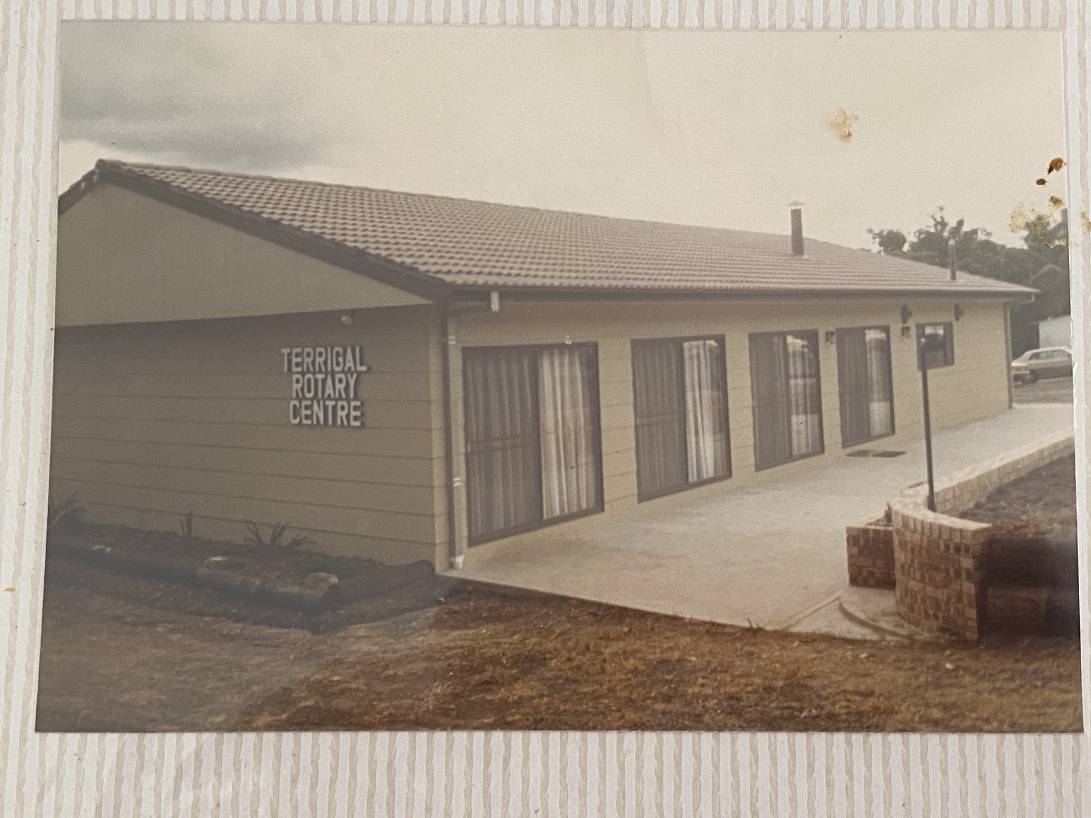

In 1988 a new kitchen was built with the old kitchen becoming the storeroom. Plans were drawn up by Vic Selig
Builders were Don Moore and Jim Flint.

In 2005, the patio was built with John Spath being the major contributor with Steel Work.

Since joining in 1985, Jim Flint was in charge of maintenance with the help of members. Apart from the normal meetings and lettings, other Fund Raising Activities were

Ken Galbraith’s daughter’s wedding with members dressed as waiters and stewards.

District Presidents’ Meetings

Magic Night – by Colin Pakmer, known professionally as Dexter the Magivian

Melbourne Cup Days

Art Shows and Trivia Nights.

