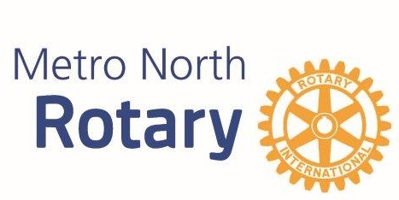

Metro North Rotary
Grant Application
Metro North Rotary has established the following objectives for its “Giving Guidelines”
- Serve disadvantaged children in our community and/or internationally
- Demonstrates “service above self”
- Demonstrates the rotary four way test
  - Is it the truth?
  - Is it fair to all concerned?
  - Will it build goodwill and better friendships?
  - Will it be beneficial to all concerned?
Groups or individuals are required to answer the attached grant application questions. We ask you to be as precise as possible in letting us know your exact needs, the amount you are requesting, and how it will be used.
The grant committee meets on a semi-annual basis to discuss grant applications. Grant application deadlines are April 30 & October 31 by 4:00 PM. The application is to be no longer than two typed double-spaced pages and requests are to be no more than $1,000. Groups or individuals may only request funding once per calendar year. After reviewing your application, we will notify you of the result of your application via email.
Please send questions and grant applications to MetroNorthRotaryCR@gmail.com.
Thank you!

Metro North Rotary Grant Committee

Metro North Rotary Grant Application
Date: Click here to enter text.
Name of Organization: Click here to enter text.
Address: Click here to enter text.
City, State, Zip: Click here to enter text.
Contact Person: Click here to enter text.
Title: Click here to enter text.
Phone: Click here to enter text.
Request Amount: Click here to enter text.
Total Budget of Project or Request: Click here to enter text.
Please Provide a Proposal Summary Statement (2-3 Sentence max): Click here to enter text.

- What is your organization’s mission statement and programs that you offer? If this is an individual request, please tell us about yourself and your connection to the project with which you are requesting funding. Click here to enter text.

- Please describe your project or request Click here to enter text.

- What specifically will these grant dollars be used for? Click here to enter text.

- Are any Metro North Rotarians involved with your project? Click here to enter text.

- What is the projected timeline of the project? Click here to enter text.

- How does the project meet the Metro North Rotary giving guidelines? Click here to enter text.

