HOST FAMILIES NEEDED
Rotary Adventure in Citizenship Program
Would you consider billeting Canada’s Future Leaders for 4 days?
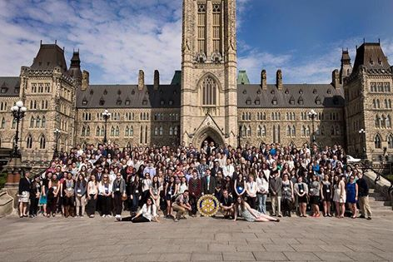
The 4 day program is designed to develop the leadership potential of outstanding senior high school students (16 – 18 years of age) from across Canada. Students have been carefully selected and sponsored by their local Rotary Clubs.
Saturday, April 29, 2017 – Wednesday, May 03 2017
The Host Family’s responsibility is to provide BED AND BREAKFAST for TWO OR MORE guests and to ensure that your guests are transported to the morning assembly point (8:00 -- 8:30 a.m. at a downtown location) and picked up in the evening (9:00 -10:00 p.m. at a downtown location). We can provide transportation assistance if required. The students arrive from all across Canada during the day of Saturday, April 29th.
If you would like to learn more about this opportunity, please see our website www.rotaryottawa.com under the Adventure in Citizenship tab, or email admin@rotaryottawa.com. 613-850-1521
(All Host families will need to provide personal references and have valid police checks.)
Our program is supported by Heritage Canada – Exchanges, Citizenship & Immigration Canada and Elections Canada, to name a few.

ROTARY ADVENTURE IN CITIZENSHIP
BILLETING OVERVIEW
The Rotary Club of Ottawa’s Adventure in Citizenship 4-day program is designed to develop the leadership potential of outstanding senior high school students. It is an exceptional opportunity for the students to explore our Canadian identity, shared values and the implications of the freedoms we all enjoy as Canadians. While the program is focused on governmental processes and institutions at the federal level, it rests on the premise that the most important attributes of citizenship emerge from Canadians individually and collectively.

The Billeting Experience: For over sixty years, over one hundred homes in Ottawa are opened to participants of Adventure in Citizenship. The Host Families learn about youth from different parts of Canada, the leadership potential of our young Canadians and Rotary’s efforts to develop this leadership potential. Host Families continue to enjoy their experience and they support and praise the program. The Rotary Club of Ottawa is dedicated to continuing the billeting of students in order that they learn more about the citizens of Ottawa while enjoying our warm hospitality.

Our Philosophy: The Rotary Club of Ottawa has established a reputation as a community service organization, which sets high standards for its members and leaders. Additionally, the club pursues high standards in the programs and services it delivers. In an effort to ensure these standards are maintained, we introduced the “buddy system”, a minimum of two same sex students in each Host Home. It is our aim to protect and encourage the development of youth and the good image of The Rotary Club of Ottawa. We hope you will join us in our endeavor by fully completing the registration form!

The Host Families Responsibilities: The main responsibilities of a Host Family are to provide bed and breakfast and to ensure that your guests are transported to the morning assembly point and are picked up in the evening. If transportation assistance is required, please call Margot Nicholls, Program Coordinator, at (613) 860-1521 or email admin@rotaryottawa.com
We would ask your consideration of the following items:

- ensure transportation is available at the beginning and end of the day’s events and ensure that the students know that they are expected at your home shortly after the events finish;
- a separate bed, sleeping bag, etc. should be available for each student;
- ensure adult supervision when the student is in your home and also during any limited extra-curricular activities you may plan that involve the students;
- please consult with your students and be mindful of activities that might be considered unsuitable by the students’ parents - for example, please be sensitive to the religious orientation of the student;
- please notify Margot Nicholls, if any student expects to visit relatives or other friends in this area while staying with you. Note that the students have been asked to arrange such visits before or after the program.

The students have a full, enjoyable and demanding program and extra-curricular activities may diminish their attention to the program. Students are requested to restrict themselves to the program activities while in the nation’s capital. Your assistance in limiting extra curricular and unsupervised activities is requested.
Thank You!
Host Families are an essential part of our Rotary Adventure in Citizenship program! To welcome students into your home is a very generous gesture and we thank you! In appreciation for your participation as a Host Family, we cordially invite you to attend, as our guests, the closing luncheon at the new Ottawa Convention Centre on the final day of the program. We also thank you for your time in completing the enclosed registration and making our Rotary Adventure in Citizenship program as safe as possible.

