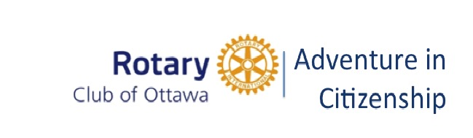

January 04, 2024

Margot Nicholls
Rotary Club of Ottawa
Email: margot@margotnicholls.com

REGISTRATION #: 2

For Word version of this email click here. Pour voir la version française de la lettre, cliquer ici.
We are pleased to confirm that your Club has been assigned one of our 150 placements. Here are your next steps and the forms you will need to proceed.

STUDENT SELECTION - DEADLINE MARCH 31, 2024

We encourage all participating Rotary Clubs to continue to give special attention to the selection of their representatives. Strong candidates contribute to the overall experience of everyone involved

Selection Criteria: CLICK HERE.

Advertising Poster: CLICK HERE

STUDENT REGISTRATION FORM

Please have your candidate complete each item on the form and obtain the parental signature required. In the interest of clarity, the use of the fillable pdf version is preferred. The registration is then returned to you for completion of the Transportation section.

Student Registration Form: click here.

TRAVEL ARRANGEMENTS - Sponsoring clubs are solely responsible for travel costs.

Transportation Form: CLICK HERE

Group Air Travel Form: CLICK HERE

If your student will be travelling by air, we encourage you to use our centralized travel agency where we can better manage student arrival and departures. However, your Club can book your own air travel while respecting our arrival and departure times. All other types of travel (i.e., train, bus, car) are to be arranged by the sponsoring club.

REFUNDS: If you are unable to find a participant, we will accept cancellations with a full refund up until March 15, 2024. After that, we will not be obligated to refund as financial commitments have been made based on registrations.

All forms are available for download from our website www.rotaryottawa.com.

Thank you for participating in the Rotary Adventure Program and for your investment in Canadian Youth.

Margot Nicholls
Program Coordinator
2024 Rotary Adventure in Citizenship Program
613-869-4200 aicrotaryottawa@gmail.com

