An invitation to visit
The team will be led by the RPTLE team leader Max Bird
Suggested Itinerary will be as follows
Costs are estimated only at this stage and may vary at time of travel; it is suggested a maximum of 15 /20 pax’s only Itinerary as at 20/02/2019
Day 1 Monday
Travel from Perth to Timor-Leste via Darwin - Accommodation @ Beachside Hotel Dili
Day 2 Tuesday
Visit Sol’s 24/7 Where Rotary have installed 200 plus computers, visit Sister Evangelina @ Balide
Attend Rotary Club of Dili Meeting - Accommodation @ Beachside Hotel Dili
Day 3 Wednesday
Depart Dili for Baucua, Inspect East Timor-Roofing Factory at Baucau and water system at Gari-Uai
Accommodation - Baucau
Day 4 Thursday
Commence the laying of Poly Pipe line to the village of Soru-Toi, then onto the village of Larisidi approx. 4.5 kilometres
Accommodation - Baucau
Day 5 Friday
Finish laying poly pipe to Larisdi
Accommodation - Baucau
Day 6 Saturday
Connect stand pipes to the new tanks installed at Soru-Toi and Larisdi
Accommodation - Baguia
Day 7 Sunday
Visit Samalari school where Rotary have installed a water system to the school kitchen and ablution block, also visit Nuniro school, the first rain water system Rotary carried out many years ago.
Accommodation - Laga
Day 8 Monday
Inspect RPTLE works @ Laga High School, Lega Parish and Laga markets.
Accommodation - Laga
Day 9 Tuesday
Visit Quelicai and inspect a new proposed water harvesting system that RPTLE may initiate, requirements of 100,000 litres of water storage plus guttering to six buildings.
Accommodation - Laga
Day 10 Wednesday
Depart Laga after breakfast for Baguia. Inspect RPTLE works at the Maternity Hospital, Baguia High School. Baguia Orphanage and the village water supply. Inspect RPTLE works at Larasuil School and Babuha School.
Accommodation - Baguia
Day 11 Thursday
Depart Baguia after breakfast for Dili Accommodation Beachside Hotel Dili
Day 12 Friday
Free Day Dili Accommodation Beachside Hotel Dili
Day 13 Saturday
Depart Dili QF 374 for Perth via Darwin QF 374 at 8.05am

For further information contact: PDG Bruce Lynch email: bruce@salaman.com.au or 0419 927 712
PP Max Bird email: maxbird@bigpond.com or 0419 045 835

Approx. Cost P/P $3,000.00
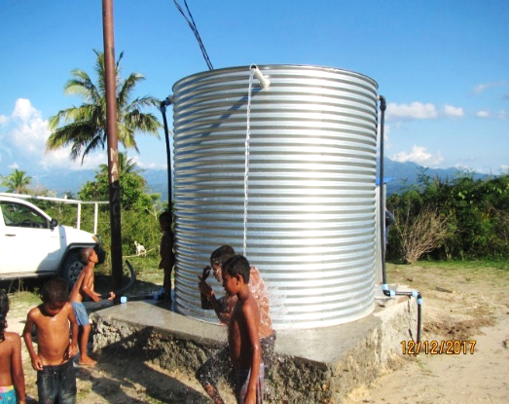
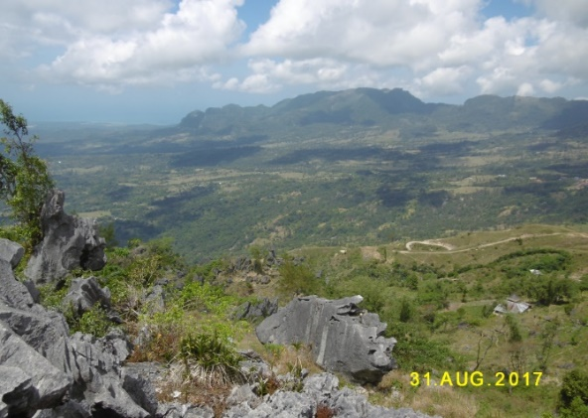
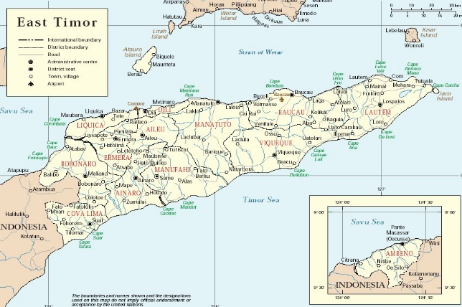

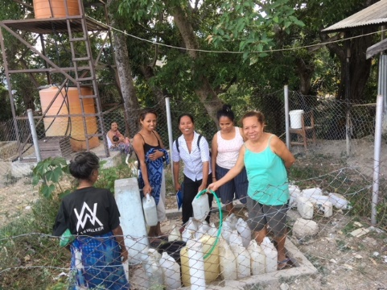

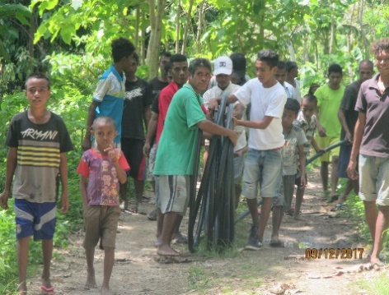
Access clean water
Help
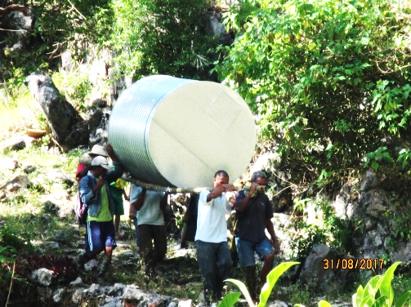
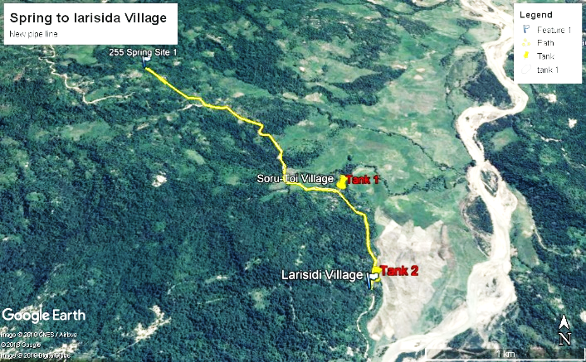

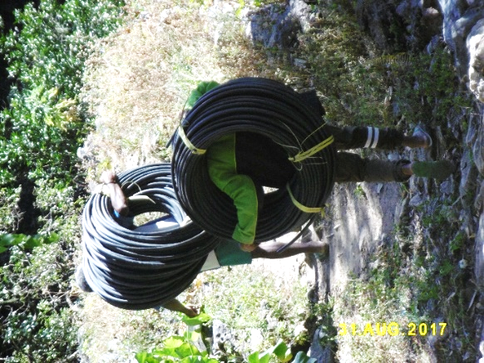

Donations or Sponsorship gladly accepted, please contact the organizers or Payment can be made by Direct Debit, to the Bendigo Bank Kwinana – ‘Timor Leste Water Project Account’:
BSB: Account #

