Opportunity to be involved
To bring clean - fresh water to children, families and health facilities in regional areas of Timor Leste. A rotary humanitarian program proudly coordinated by Kwinana Rotary lead by project manager Max Bird.
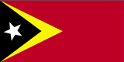
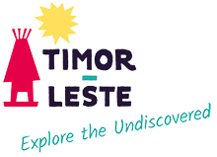
Rotary Club of Kwinana Inc.

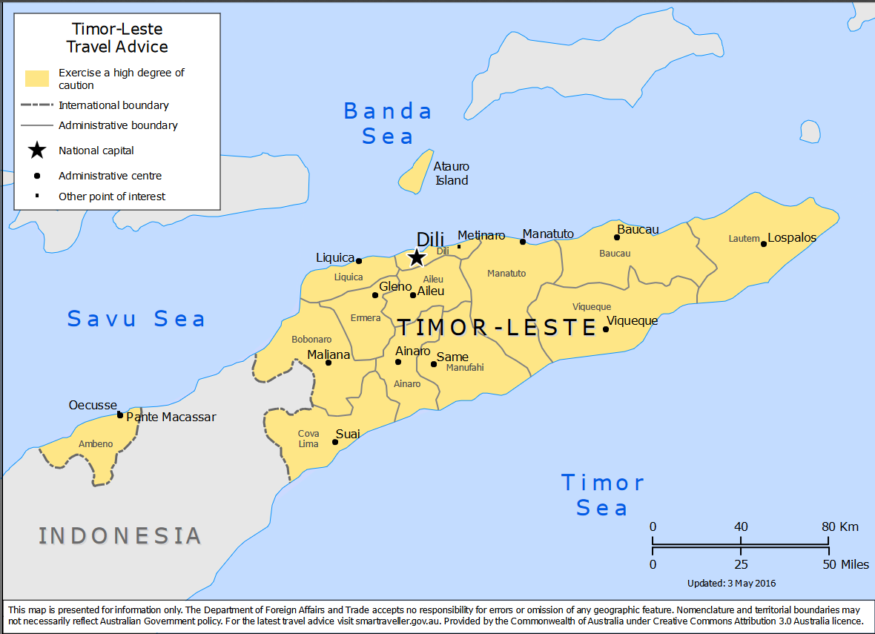

Clean water saves lives !
Timor-Leste country brief
Overview
The Democratic Republic of Timor-Leste is situated on the island of Timor, approximately 700km northwest of Darwin. The capital of Timor-Leste is Dili.
Australia and Timor-Leste are close neighbors, with a shared history and strong people-to-people links. Australia has been at the forefront of international support for Timor-Leste since its independence in 2002, and remains Timor-Leste’s largest partner in development and security. Many Australians are actively engaged with Timor-Leste through Australian state, territory and local governments, non-government organizations, the private sector, learning institutions and friendship groups.
Timor-Leste has a population of around 1.3 million. The official languages of Timor-Leste are Tetum and Portuguese, while English and Indonesian are working languages. Approximately 95 per cent of Timorese are Catholic.
Timor-Leste, also known as East Timor, is not too far from Australia yet feels like a completely different world. And as one of the world’s newest countries (Timor-Leste became the first new sovereign state of the 21st century on 20 May 2002 when it achieved independence from Indonesia) its tourism industry is still in its infancy.
Timor-Leste is predominantly a subsistence farming culture and the road is dotted with pigs, goats, chickens and dogs (and an abundance of piglets, kids, chicks and puppies). Fencamines are carefully woven together by pieces of palm frond and wood, with no need for joins. The houses are simple, mostly thatched, surrounded by carefully swept yards. On the way we stopped at a bustling outdoor covered food market selling garlic bundles, pyramids of potatoes, trays of dried fish, bunches of green bananas and smaller piles of ginger and turmeric.
Political overview
Timor-Leste achieved formal independence on 20 May 2002. Timor-Leste's independence resulted from the August 1999 UN-sponsored referendum.
Economic overview
With two-thirds of its 1.3 million population living on less than US$2 a day, Timor-Leste remains one of the poorest countries in the region. Most of Timor-Leste’s population live in rural areas and are heavily reliant on subsistence agriculture with little or no access to markets.
Travel warning
The Australian government says to exercise a high degree of caution in Timor-Leste because of the uncertain security situation. However Team Manager Max Bird has been travelling to Timor Leste for the past 10 years within incident plus Rotary is a well-respected voluntary organization in this country.
Check Smart Traveller for updates.
Flight
Airnorth operates one flight daily between Darwin and Dili that departs Darwin at 5.45am. The return flight costs about. Qantas Airlines departs Perth airport to Darwin NT on a regular basis.
Currency
US dollars.
Vaccines
Malaria is present in Timor-Leste. It is recommended to take anti-malarial’s, alternatively rely on long pants and shirts at the dusk and dawn mosquito hours. Please consult your Doctor for further advise.

Remember - Clean water saves lives !

