ROTARY CLUB OF APPLECROSS COMMUNITY AND BUSINESS AWARDS FOR 2016

The Rotary Club of Applecross presented awards on the 5th April to individuals and organisations that have provided exceptional service in the local community or local business environment.

COMMUNITY AWARDS were awarded to:
PETER HERNE, a teacher at Applecross Primary;
ANITA PERCUDANI who established the Realmark Community Connect;
COLIN PRIOR, for his skills as a Quiz Master;
RICHARD RENNIE of the Wireless Hill Museum and City of Melville Local History Team;
ANTONELLA SEGRE, CEO Connect Group;
SWAN ESTUARY RESERVES ACTION GROUP;
RUTH STYLES for 50 years of service to local community music programs;
MELVILLE FRIENDS OF HATOLIA.
BUSINESS AWARDS were awarded to:
THE MELTING POT in Kearns Crescent, Applecross;
LURES FISH AND CHIPS in Canning Highway, Applecross;
JESTERS in Parry Ave, Bull Creek;
INTENSE HEALTH in Riseley St, Booragoon.

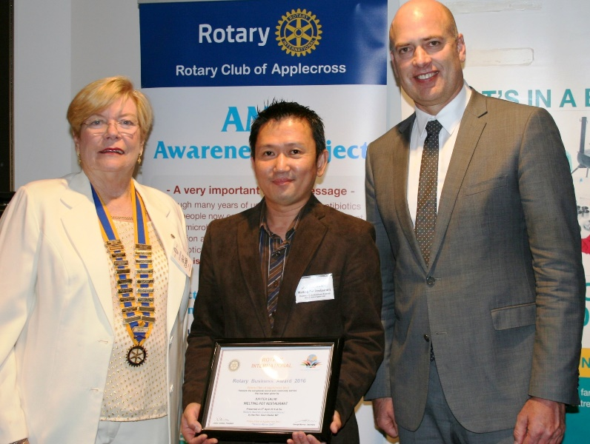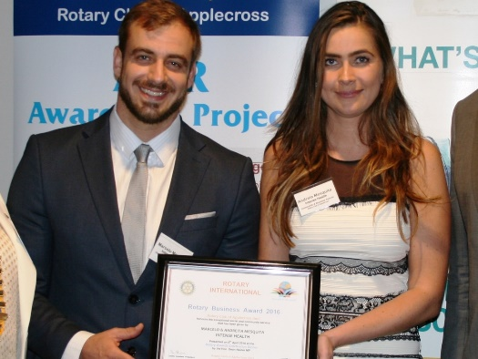
Applecross Rotary President, Lesley Combes, Awardees Marcelo and Andria Mesquita
Jupitor Salim from Awardee, The Melting Pot in from Intense Health in Booragoon
Applecross and Local Member Hon. Dean Nalder
More details can be found on the Applecross Rotary Community Projects in the link Applecross Projects at the top of the page.

