AUSTRALIAN CHARITIES- SNAPSHOT

- There were approximately 51000 registered charities in Australia in 2015.

- Australian Charities’ income was approximately $134.5 billion in 2015.

- Over half of all charities went to Religious Groups (28.5%), Education and Research (18.6%) or Social Services (9.9%).

- The vast majority of charities (over 85%) are based in the Eastern States.

- On average, charity income grew about 2% between 2014-15. 42% of charities shrank and 3% stayed the same.

- Charity income does not include the very fast-growing area of Go Fund Me and other online personal fundraising accounts.

- Go Fund Me and online personal fundraising accounts are fundamentally unregulated.

- Charities of all sizes receive nearly half of their income from sources other than government grants and donations.

- On average, the larger the charity the greater the proportion is spent on employee expenses and less on grants made to others.

- Charities employ over 1.2 million staff and nearly 3 million volunteers.

- The net contribution of volunteers to Australia’s GDP is estimated at $200 billion a year. This includes all forms of volunteering such as sporting clubs, schools’ P&F’s for example, that support charities, non-charity groups, schools and clubs. This figure is more than the contribution of mining in Australia.

- Charities in Australia are on average, 32 years old. 6% are over 100 years old.

ISSUES
Some examples along a continuum:
- Cure Brain Cancer Foundation spent 65% of its charity income on administration
BIG charities in Australia are spending up to 98 per cent of donations on themselves instead of their causes, says Professor Charlie Teo. The globally renowned neurosurgeon walked away from the brain cancer charity he set up in 2003, because of the huge amount of money spent on administration.
- National Heart Foundation raised $51 million in 2012 and spent $20 million on fundraising ($8 million more than on research). Other revenue went into health programs.
- World Vision spent 11c in the dollar on fundraising
- McGrath Foundation spent 9c in the dollar
- Red Cross spent 4c in the dollar (rated #1 in Australia for over three decades)
Some of Australia's biggest charities are spending nearly half their donations on fund-raising. (Fairfax Media)
Analysis of the performance of 15 well-known charities shows some are spending up to 40¢ in every donated dollar on fund-raising, while others are spending less than 5¢.
But there are few guidelines in a sector facing significant uncertainty as the Coalition dismantles the former government's Australian Charities and Not-for-profits Commission, which was intended to be a charities watchdog in favour of a ''centre for excellence''.
The Make-A-Wish Foundation of Australia received more than $12.8 million in donations last year but spent $5.2 million, or 41¢ in the dollar, on fund-raising, marketing and communications. After other expenses, only 54¢ in the donated dollar went to granting the wishes of sick children.
Chief executive Gerard Menses said the charity's financial position had improved and it had granted 501 wishes in 2013.
''We do aim to keep the cost of fund-raising as low as possible to ensure the maximum amount can be spent on life-changing wishes,'' Mr Menses said.
The National Heart Foundation raised more than $51 million in 2012, but spent more than $20 million on fund-raising, $8 million more than it put towards research. Other revenue went towards health programs.
At the opposite end of the spectrum, global charity World Vision spent 11¢ in the dollar on fund-raising, the McGrath Foundation spent 9¢ and the humanitarian arm of the Red Cross spent 4¢.
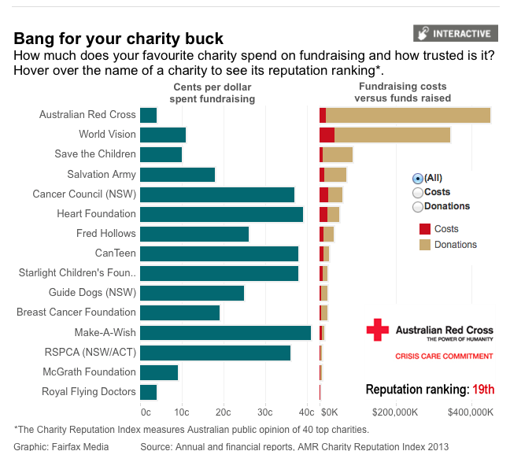

The big differences in the costs of fundraising are partly the result of no clear accounting guidelines as to which costs should be classified as fundraising expenses and administration.
Make-A-Wish, for example, includes marketing as part of the cost of fund-raising whereas the National Breast Cancer Foundation includes marketing, communications and speakers as a separate category, not included in its fund-raising costs. It spent an additional $1.05 million on these costs in the year to June.
In addition, larger charities may also be able to share costs across different branches. Philanthropy Australia chief executive Louise Walsh said not all charities were transparent with their financial data, putting the onus on donors to do their own research.
''A lot of annual reviews and annual reports are not as strong as they should be and not all of them are user friendly,'' she said. ''We would like to see a lot more information on the public record, particularly around the financial side of it.''
In many cases, detailed data on a charity's performance, including spending on executive pay, can be obtained only by paying for reports filed with the Australian Securities and Investments Commission.
CanTeen, which supports young people with cancer, raised $24 million in the year to March 31 and spent 38¢ in the dollar on fundraising. But the charity said that for every $1 it invested in its regular giving program, it got $3 back over three years. Peter Orchard, CanTeen's chief executive, said the charity was reviewing its internal operations to cut costs. He made 16 people redundant when he took over the top job last March.
''It is … important to compare charities that do similar work,'' he said. ''CanTeen, for example, delivers services in Australia, which involves very different costs to that of a charity funding overseas aid.''
The chief executive of the Fundraising Institute of Australia, Rob Edwards, said donors chose to support charities ''for the difference they can make to their beneficiaries, not how little they spend achieving it''.
''There are currently no clear definitions to guide charities on which costs should be classified as service-related or administration and the sector is working with government to introduce an agreed accounting standard,'' Mr Edwards said.
The Ice Bucket Challenge for Motor Neurone raised $115 million in the US. $47 million was spent on research because the disease is 100% fatal.
___________________________________________________________________________
Read more: http://www.theage.com.au/national/charities-fundraising-costs-swallow-millions-in-donations-20131220-2zqyw.html#ixzz2xmrXq19z

