CHARITIES

HOW MUCH IN EACH DOLLAR IS USED?
_________________________________________________
Some of Australia's biggest charities are spending almost half their donations on fund-raising, a Fairfax Media investigation has revealed.
Analysis of the performance of 15 well-known charities shows some are spending up to 40¢ in every donated dollar on fund-raising, while others are spending less than 5¢.
But there are few guidelines in a sector facing significant uncertainty as the Coalition dismantles the former government's Australian Charities and Not-for-profits Commission, which was intended to be a charities watchdog in favour of a ''centre for excellence''.
The Make-A-Wish Foundation of Australia received more than $12.8 million in donations last year but spent $5.2 million, or 41¢ in the dollar, on fund-raising, marketing and communications. After other expenses, only 54¢ in the donated dollar went to granting the wishes of sick children.
Chief executive Gerard Menses said the charity's financial position had improved and it had granted 501 wishes in 2013.
''We do aim to keep the cost of fund-raising as low as possible to ensure the maximum amount can be spent on life-changing wishes,'' Mr Menses said.
The National Heart Foundation raised more than $51 million in 2012, but spent more than $20 million on fund-raising, $8 million more than it put towards research. Other revenue went towards health programs.
At the opposite end of the spectrum, global charity World Vision spent 11¢ in the dollar on fund-raising, the McGrath Foundation spent 9¢ and the humanitarian arm of the Red Cross spent 4¢.
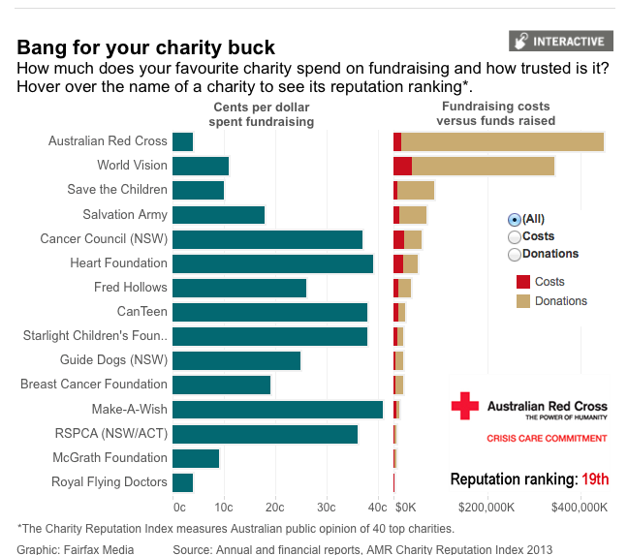

The big differences in the cost of fund-raising are partly the result of no clear accounting guidelines as to which costs should be classified as fund-raising expenses and administration.
Make-A-Wish, for example, includes marketing as part of the cost of fund-raising whereas the National Breast Cancer Foundation includes marketing, communications and speakers as a separate category, not included in its fund-raising costs. It spent an additional $1.05 million on these costs in the year to June.
In addition, larger charities may also be able to share costs across different branches.
Philanthropy Australia chief executive Louise Walsh said not all charities were transparent with their financial data, putting the onus on donors to do their own research.
''A lot of annual reviews and annual reports are not as strong as they should be and not all of them are user friendly,'' she said. ''We would like to see a lot more information on the public record, particularly around the financial side of it.''
The federal government failed in its bid to delay the introduction of the Charities Act this month, with the new laws to take effect on January 1.
The act provides a new definition of a charity, which is not required to pay income tax.
Social Services Minister Kevin Andrews will begin consultations over the repeal of the Australian Charities and Not-for-profits Commission in February, a move that has already met resistance from the charity sector and the Greens.
Linda Lavarch, chairwoman of the Not-For-Profit Sector Reform Council, said the abolition of the ACNC and potential repeal of the Charities Act would result in less accountability.
In many cases, detailed data on a charity's performance, including spending on executive pay, can be obtained only by paying for reports filed with the Australian Securities and Investments Commission.
CanTeen, which supports young people with cancer, raised $24 million in the year to March 31 and spent 38¢ in the dollar on fund-raising. But the charity said that for every $1 it invested in its regular giving program, it got $3 back over three years.
Peter Orchard, CanTeen's chief executive, said the charity was reviewing its internal operations to cut costs. He made 16 people redundant when he took over the top job last March.
''It is … important to compare charities that do similar work,'' he said. ''CanTeen, for example, delivers services in Australia, which involves very different costs to that of a charity funding overseas aid.''
The chief executive of the Fundraising Institute of Australia, Rob Edwards, said donors chose to support charities ''for the difference they can make to their beneficiaries, not how little they spend achieving it''.
''There are currently no clear definitions to guide charities on which costs should be classified as service-related or administration and the sector is working with government to introduce an agreed accounting standard,'' Mr Edwards said.

Read more: http://www.theage.com.au/national/charities-fundraising-costs-swallow-millions-in-donations-20131220-2zqyw.html#ixzz2xmrXq19z

