Report 26.08. - 01.09.24
In our Friday Scotch Assembly the School Vice captain of Operations is always announcing the highlight of the round. It is always a mixture of teamwork, pride and impact on the subsequent worldwide events.
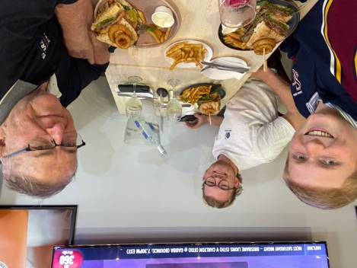
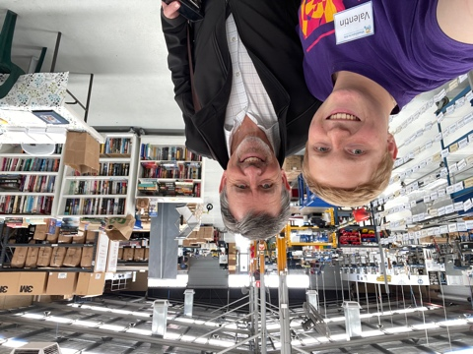
Wheelchair for Kids, a project which only works with everyone in the Team. It does matter if you are volunteering, engage yourself in the process of building, setting it together or to make sure in the end every Box has everything it needs. All this just works with outstanding Teamwork. Everyone I have been working with, in the Factory is proud on what he is doing. This year WCFK celebrated their 60.000 Wheelchair build for Kids in need all over the world. It made me proud to be a part of an impactful worldwide organisation, which creates beneficial communities on both sides of the line. Here in Perth more the 300 people are working in the Factory throughout the week. Friendships are made and a community is formed. On the other Hand people from all over the world are getting more included in their community as they are mobile now.
Wheelchair for Kids is my Highlight of the round, being a benefit for community building all around the world.
Big Thank you to Greg Hebble and all the volunteers at Wheel Chair For Kids.
(Little video: WCFK_Valentin-Vorholz.MP4 )
One Day before, on Wednesday, Ian and Connor, my mentors took me out for dinner to get the experience of the Best Steak sandwich at Carrinton’s Bar and Grill and yes it was a fabulous meal. We where reflecting on my whole year here in Perth and what I’m going to expect when back home in Germany, to specific in Bavaria ;-). It is great to have Connor as former Exchange student as mentor as well, as he understands the the Exchange life to 100%.
On Friday afternoon we had our Interschool test Carnival against Aquinas and Guilford. I was nominated for Discus and I’m really happy about it and being able to finally get to use my skills again. For myself this experience showed me that I need to have a go again and see how much I’ve enjoyed throwing Discus. During the Pandemic I was doing triple throw plus Hammer throwing in a club and stopped when we were fully able to play Handball again, as it is in the Gym. I’m looking forward to perhapes try it at home again.

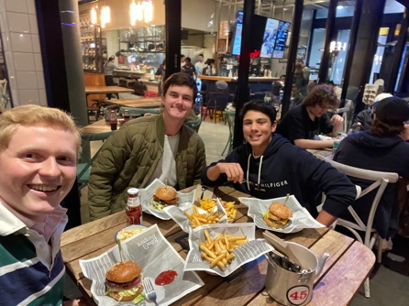
Being able to leave Australia, knowing you have great friends is the best gift you can have. On the weekend I was enjoying the Time with my Scotchmates Dhilan and Noah. It is good to get out, hang out and build the friendship. I’ve been enjoying Australia and I’m looking forward to spend a week in Yallingup with Hunter, a fantastic friend, who I got to known at scouts.

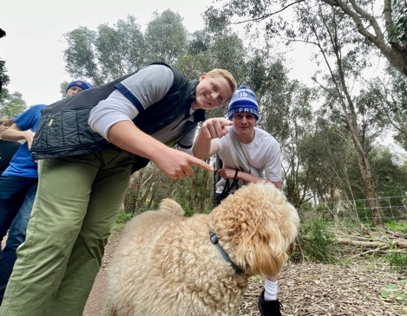
My Sunday was packed with community Service, and Birthdayparty.
We had a service fundraiser at Scotch with our House, Shearer. The event was focussed on raising awareness and donations for MND. We kicked the event of with a 5km walk around lake Claremont and a welcoming breakfast afterwards.
We as Shearerhouse would highly appreciate a donation. (https://support.fightmnd.org.au/fundraisers/valentinvorholz/challenge-27)
Speaking of Friendship, me, Alfy and Chalrie

In the Evening I joined my little Sister Leandra on her ongoing Birthday celebrations. We had a lovely time hanging out together, celebrating her and in general catching up with the Clarksons.
I can’t believe it’s nearly two and a half Month ago since I left then and moved to Margot and Keith.
My Exchange is coming to an End and I’m looking back to a outstanding time and forward towards all the adventures I’ll experience.

See you and Cheers for now
Valentin

