EFFF 2021
Food Vendor Site allocations

F11 | Doughnuts | Doughnuts
F1 | Rotary Club of Esperance | Fish Van
F2 | Kool Kones | Ice Cream Van
F3 | Acai Buddies | Smoothie/Fruit Bowls
F4 | Scotty's Coffee | Coffee
F5 | Chippy Connoisseurs | Chip on a stick(Potato)
F6 | Etty's Spring Rolls | Spring Rolls
F7 | Esperance Sri Lankan Taste | Sri Lankan Food

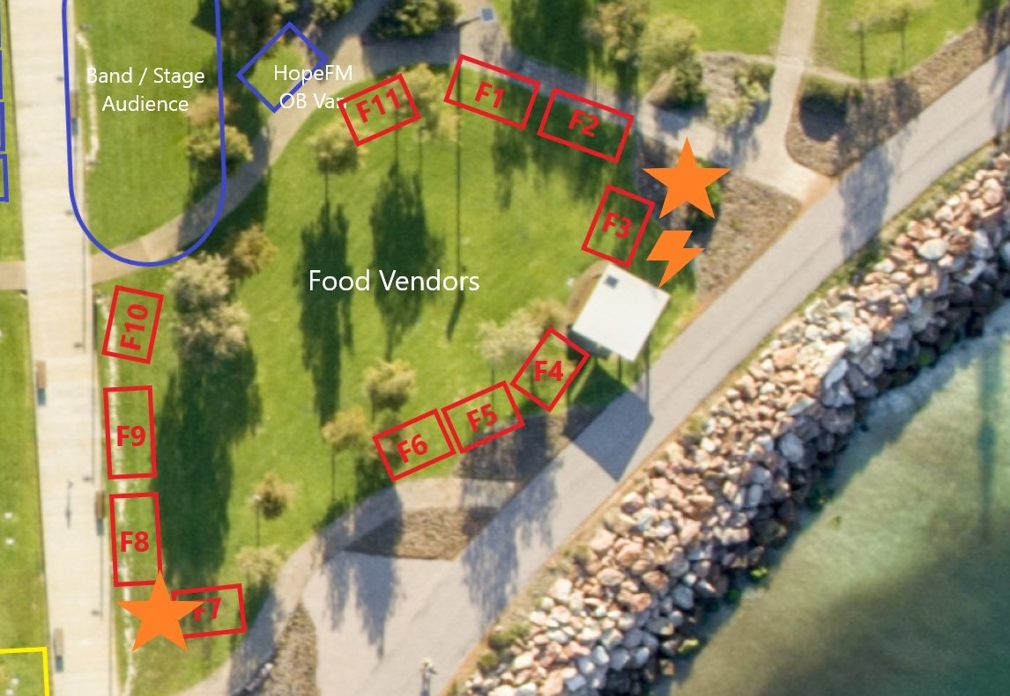
Note: Sites F7 to F10 are not occupied.
Access to sites is via the sealed pathway along the foreshore wall from the northern Jetty car park.

