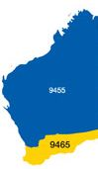


The Rotary Club of Kwinana Inc.

District 9465 Western Australia

Chartered: 22 April 1971

Team 2019-20

President
Wendy Cooper

Secretary
Diane Brown

Treasurer
Bob Cooper

Attendance this week

Total Members 26 Apologies 3
Make-up 1 Attended 21
Honorary Member 1
LOA 1
Guests 3
Visitors
Partners 10
88.0 %

Facts & Figures
Raffle
Lyn B & Barry W
Bob C & John I

Heads & Tails
Lee D & Sam C

Birthdays:
Norm Mc. 3rd

Anniversary:

Club Anniversary:

If you had any we hope you had a good day

Meets Monday
6 for 6.30pm
At Rotary Hall
Brownell Crescent, Medina

Visitors always welcome



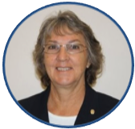
Bulletin

President Wendy
No 16 28th Oct. 2019

Official visit by District 9465 District Governor Wayne and Suzanne Milnes.
Wayne and I go back to 2005/6, the days of the Rotary Club of Safety Bay where Wayne at the time was president and I was the group Assistant Governor, our paths crossed many times. The Safety Bay club although very enthusiastic and active, unfortunately had diminishing membership issues and eventually handed in their Charter, most members then opted to continue supporting Rotary and transferred to the Rotary Club of Rockingham, Wayne’s home club today.

At the start of our meeting President Wendy has a quizzical surprise, selected members were asked to partially unwrap a parcel, after each layer of paper was removed a message was revealed and read out, culminating in Suzanne Milnes announcing that Rtn. Lee Davis had been awarded a PHF by our club, the award was subsequently presented by DG Wayne to a very surprised Lady.
Congratulations Lee, honored to have you join the Kwinana Rotary Club PHF’s

Big couple of days this week, Kwinana’s Rotary Club Golf Day, kicks off 11am. Friday, and an all day Saturday commitment at at Bunnings hosting a sausage sizzle, a big thank you to the volunteers supporting both events.
The Māori Hangi was a huge success last Saturday, great time had by all.

District Governor
9465

2019/20

Wayne Milnes

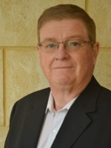
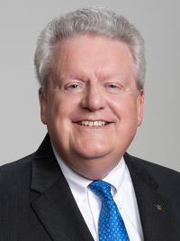
Rotary International President
2019/20

Mark Daniel Maloney

Rotary Club of East Nassau


Coming Events November 2019
Rotary Foundation Month
Nov 2019
Fri. 1st Kwinana Rotary Golf Day. 11am start.
Sat 2nd Bunnings Sausage Sizzle

Mon 4th Club Meeting

Mon 11th Club Meeting

Mon 18th Club Meeting

Mon 25th Club Meeting

Attendance Officer:
Greg Williams 0435 083 069
Apologies by Saturday pm please







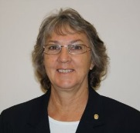
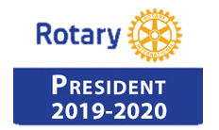

Wendy Cooper

President’s Pen

28th OCTOBER 2019

Where do I start on an action packed week for the Kwinana Rotary Club? Maybe the beginning!

What a wonderful treat the HANGI was. From start to finish it was full of fun and laughter and talent and more talent and haka after haka. We were so impressed I’m pleased to announce that the board has agreed to donate $500 to the Ngaru Pou towards their trip to Canberra.

Last night the fun continued with the annual visit of
the District Governor Wayne Milne and his wife
Suzanne. Words of wisdom were shared by
Wayne on behalf of the World President,
Mark Daniel Moloney and the District.

At the end of his talk Wayne asked me to select a
business card from a bag of cards from all over the
world collect in San Diego during training.
(approximately 525 cards) The purpose was for me
to then communicate with the person whose card I
drew. So today I have emailed Jonathan King in
Wroxham, Norwich, Norfolk, U.K., sending your
best wishes and photos of the meeting last night.
I look forward to hearing from him in return.

Celebrations added an extra buzz with the announcing
of our newest PHF, Lee Davis and the wedding of
Mike and Lee. So happy for you all.

But we didn’t stop there. Veronica Burns joined us for
her 4th visit and is on the brink of being our newest
member.
We welcome you with open arms Veronica and
thank you for choosing us.

Here we are at the end of another month and to get it
started we have the Golf Day. Well done to the team
who have worked tirelessly to bring it to fruition. Rain, rain go away, we don’t need you on Fri-day! May all the participants enjoy the golf!

As Remembrance Day approaches I would like to request that those who have service medals proudly wear them to our meeting on the 11th November.

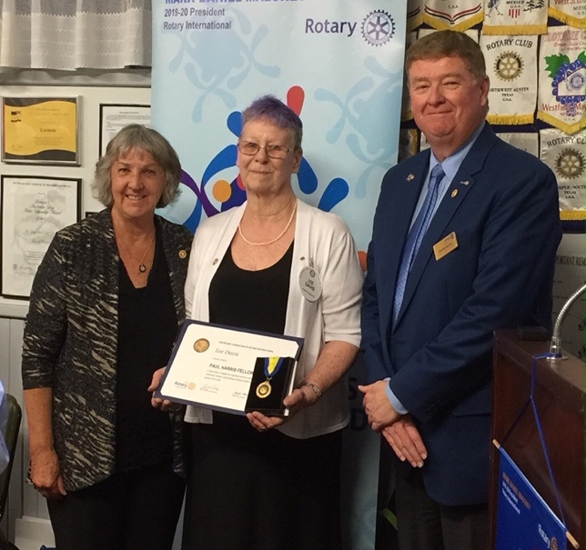

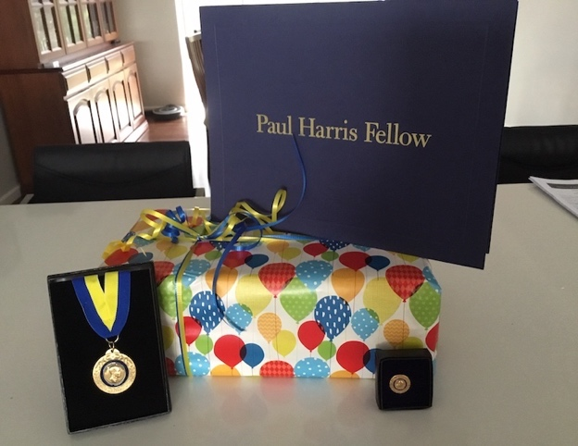




President 2020/21 PE John Iriks

Club Service report. 28th October 2019

- Christmas Meeting to be held 16/12/19 at Bowling Club

- Ngaru Pou Hangi Saturday 26/10/19 $25 adults $15 children under 16 at Rotary Hall Grounds. Fantastic evening had by all.

- District Governor’s meeting scheduled for Monday 28 October.
The Board met with the DG at 5pm.

9465 District Governor 2019/20 Wayne Milnes summarises the great contribution Lee Davis has made to the Rotary Club of Kwinana preceding presenting Lee with the award.

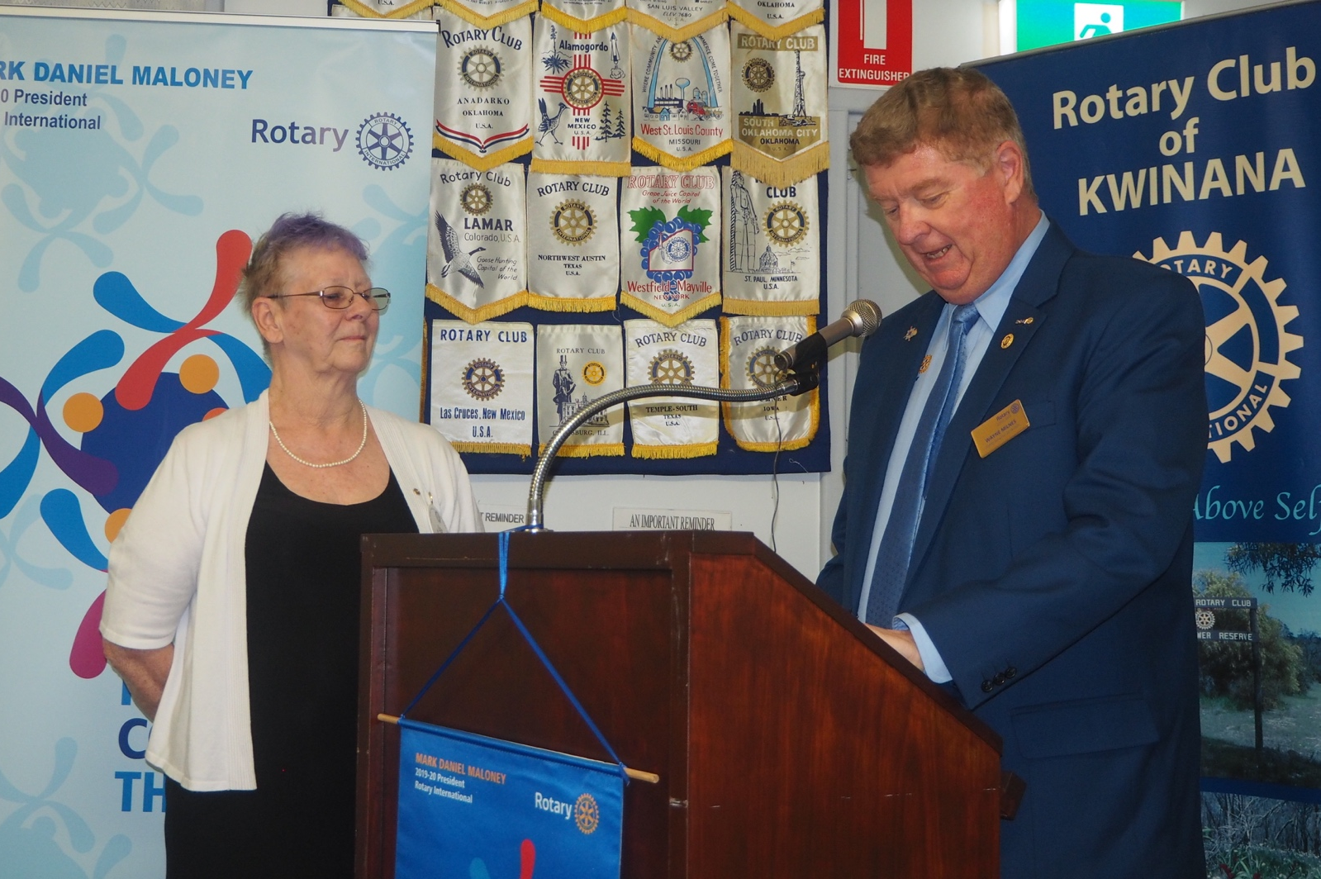

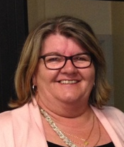

Rtn Diane Brown

no report this week

Inward Correspondence.

Outward Correspondence.

Would members please note that any correspondence received or posted by yourself, please ensure a copy is forwarded to your Secretary.





PDG Bob Cooper
Bills paid, money in the bank.
Bob encouraged members to get behind Mike and Stephen and offer to help. Venture has the potential to be a good money earner, beats smelling like a sausage.
The club Profit & Loss Statements are available for members to view on ClubRunner. See Club Documents.
Members are requested to ensure they contact PP Greg Williams by Sunday am with any apology for the next meeting. We are having to pay for meals ordered for you and not used because of non-attendance.

Treasurer: PDG John Iriks
- Money in the Bank. Bills paid
- Financial Report to May 30th prepared for inclusion in our Annual Report, financials to June end will then be completed ready to be audited.

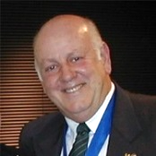

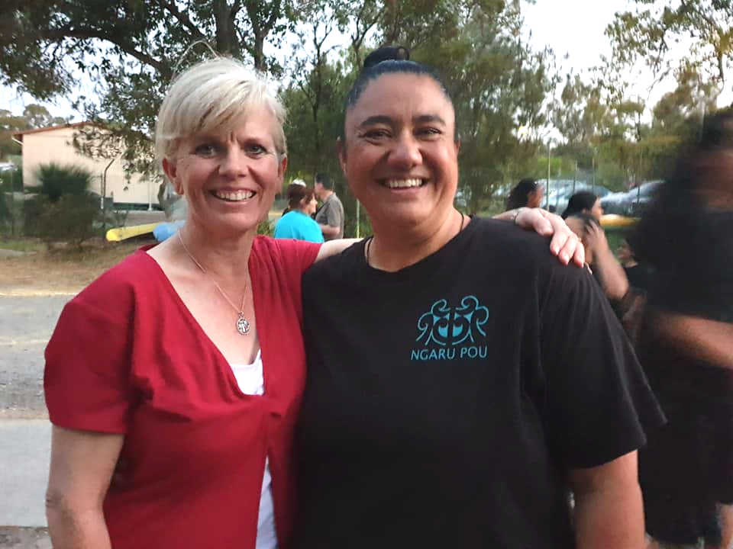

Last Saturday night club members, families and friends enjoyed a fabulous evening of food and fellowship together with local Maori cultural group Ngaru Pou.

After a delicious hangi meal cooked and presented by the ladies of Ngaru Pou, we were entertained by a performance of cultural singing and dancing by their children. The highlight of the night was the sight of our menfolk attempting to learn the Haka!

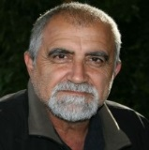
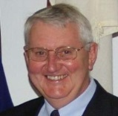
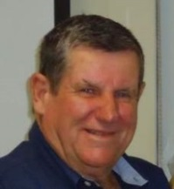
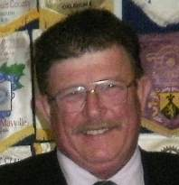

PP James Sharkey
Public Relations Dir.

PP Edd Samut
Membership Dir.
PP Max Bird
Foundation Dir.

Projects Director
PP Mike Nella

Project Director’s Report.
Golf Match confirmed for 01/11/2019
50th Anniversary of Inaugural Kwinana Industries Cup.

Gentle Road premises now open for business, business steady.

First Lolly-Run meeting at the COK September 17th will be meeting monthly till Christmas.

Public Relations:
We continue to receive exposure on Rotary Out West.
Please continue to advise James of any stories or activities within our club which may be submitted to the local media.
We have a number of Bunnings BBQ’s scheduled over the next 5 months.
Sat. 2nd Nov. Thu. Nov 28th , Sat. Dec 21st plus Jan TBA

Membership:
Welcome back to Veronica Burns.

Community:
Golf Day Project progressing well, Friday 1st November, 10 teams reg. volunteers required to cook sausages and king prawns from 11am till 12 noon.

Vocational:
District Final of the Four Way Speech comp. scheduled for Tuesday 29th October.
State Final for Four Way Speech comp. scheduled for Sunday 10th November.
Both these events will be held at Mandurah Baptist College.

International:
Plan to hold a Rotary Foundation Function in the not too distant.
Latest meeting minutes available to view on ClubRunner.

Youth:
Actively looking for participants for RYPEN, RYLA and Handicamp.
We have a candidate for RYLA, this young lad is an active member of the Kwinana Youth Advisory Council.
Investigating options for a Handicamp candidate.
Exercise program at Banksia Village still on-going.

- Visit your club webpage.

http://www.clubrunner.ca/Portal/Home.aspx?accountid=8106

or type Kwinana Rotary Club into ‘Search’

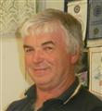

Rtn. Norm Mulcahy
Community

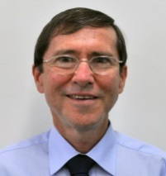

PP Bob Thompson
Vocational

PP. Max Bird
International

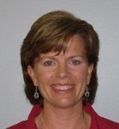
PP Genevieve Carr
Youth



Fine Session: Sgt. Cyril Bennett
Deputy Bill Rowe.

.

.

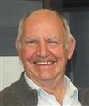

Rugby Eng vs NZ: Norm and Greg ‘Backed the Poms’

Chris O: The All Blacks LOST.

The Kwinana gents who ‘tried’ to do the ‘Haka’ last Saturday night.

The Kwinana partners who tried to play the ‘Pom Pom’s’ Cathy, Wendy, Jo, Chris, Colleen etc.

Mike N & John I: Locked up Gentle Road gate with the wrong lock!!

DG Wayne M: Came without his ‘phone’ told the story about the stolen gavel and it’s travels around the country.

Chris O: Kiwi’s had a bad weekend, they lost everything they played in.

Cyril B: Gate crashed the DG’s wife’s afternoon tea.

Stephen C: Trying to maximize the Haka call, almost dislocated his tongue.

Bob C: Interpreted a tattoo on Cyril’s daughter as a ‘vacuum cleaner’

Diane B & Colleen: Wearing the same top!!!!

Norm Mc: In need of an interpreter to decipher his Scottish vernacular.

All those who failed to attend the Māori Hangi were fined because they missed a fantastic night.

Wendy C: Fined because she lost her ‘Chain of Office’ turned out Bob stole it and passed on to the sergeant.

What’s a ghost’s favourite dessert? I scream.
How do you make a skeleton laugh? Tickle his funny bone.
Where did the ghost go on holiday? The Boohamas.
How can you tell that vampires love baseball? They turn into bats every night.
Where does Dracula keep his money? In a blood bank.
What does a skeleton order at a restaurant? Spare ribs.

Polio This Week 28th October 2019

- Wild poliovirus type 3 (WPV3) has been declared as globally eradicated.

- At an event held on World Polio Day 2019, Professor David Salisbury, chair of the independent Global Commission for the Certification of Poliomyelitis Eradication (GCC), presented the official certificate of WPV3 eradication to WHO Director General Dr Adhanom Ghebreyesus.

- Polio eradication efforts do not only involve providing vaccines. For one Abdullahi Mahamed Noor, basketball is his way of bringing people together to raise awareness about the devastating disease. Read about his journey on using the sport to combat polio in Somalia.

- Summary of new viruses (AFP cases and ES positives) this week:
- Afghanistan— two WPV1 cases and six positive environmental samples;
- Pakistan— four WPV1 cases and six WPV1-positive environmental samples;
- Nigeria— two cVDPV2 positive environmental samples. Chad— one cVDPV2 case;
- Benin— one cVDPV2 case;
- the Democratic Republic of the Congo— one cVDPV2 case;
- Ghana— one cVDPV2 case and three cVDPV2 positive environmental samples;
- Ethiopia— one cVDPV2 case:
- Togo— one cVDPV2 case:
- Zambia— one cVDPV2 case.








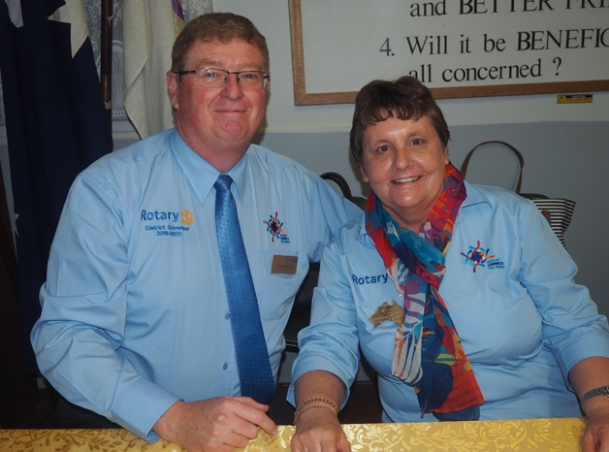

Guest Speaker: Wayne Milnes District Governor 9465 2019/20
DG Wayne’s address is reproduced below

DG Wayne and Suzanne Milnes

Rotary international President Mark Maloney has chosen the Theme Rotary Connects the World as he believes Members of Rotary connect with their families their communities and via projects the world.

Mark Maloney has 4 Priorities for 2019-20

- Increase our Impact

- 9 November 2019 – Rotary Day at the United Nations, New York,
- 4 Presidential Conferences
- 28 February 2020 – Santiago, Chile
- 28 March 2020 – Paris, France
- 7-8 May 2020 – Rome, Italy
- 5 June 2020 – Honolulu, Hawaii, USA

- Expand our Reach by growing Rotary

- Retain / Engage Members
- New Members
- New Clubs
- Look at all alternatives

- Enhance Participant Engagement

- Be more family friendly
- Welcome children to our activities

- Increase our ability to adapt

- New approaches to our Organising principals do not threaten our sense of who we are, but can enhance who we are.
- Rotary Leadership should not be a Full Time Job and was never intended to be this way.

Now

- We are one of the largest services organisations in the world with over 1.2 m members and yet unless you have been involved with Rotary at some point in your life, Rotary is virtually unknown to the general population.

- We have over 1.2 million members with over 33,000 clubs worldwide.

- A conservative estimate say each club contributes $30,000 per year into their local and international communities. This would mean that Rotary directly inputs in excess of $1.0 billion dollars per year into the world economy.

- Let's say each member gives 2 hours per week to Rotary over and above their meetings, this would equate to 120 million hours of service to the world each year.

- Now imagine if the Rotary International Leadership could go to some of the biggest companies in the world, Coca Cola, Apple, Ford and say we contribute over $1.0 billion and over 120 million hours of service to the world would you like to partner us in our next big project

- Now on a District level we have close to 50 clubs this would give us $1.5 million dollars and with 1250 members over 125,000 hours per year to the community. So imagine the strength that would give the District and clubs in negotiating a partnership with local council or large business enterprise like BHP or Fortescue.

- However we can say all this but we can't prove it. That is where and on a worldwide basis we are asking clubs to input their goals for 2019-20 into Rotary Central so the club, District and Rotary International have a record to allow us to tell the world.

- At a District Level via Project Director Max Bird and with the input, help and the assistance of the District Chairs. The Clubs within the District will be requested to complete a spreadsheet to build a data base for our District of projects our clubs do in the areas of International, Youth, Vocational and Community.

- This data basis will assist District in enabling us to know the amount our clubs contribute to the world.

- But even more important it will allow clubs to access projects within our District that they themselves may wish to do with contact points, thus enabling clubs to Connect with other clubs and ultimately via the projects Connect with their communities and the World.

Now imagine a world where

- A 38 YO Wife and mother of 2 primary school children who works fulltime as a Financial Controller at a Transport company, but is now ready to give back to the community.

- a 50 YO married man who is a FYFO worker on a 3 on 1 off roster whose wife works fulltime and finds himself bored at times during his week off and is seeking something more.

- a couple in their mid 60's retired for about 2 years and have done the bulk of their traveling now want to contribute to an overseas community they visited on their travels.

- a 30 year old Physio who has commenced their own practice in a country town, but is seeking to get to know the local community and also contribute.

- 58 YO single professional woman looking towards retirement and is concerned about how she will fill her time and meet like-minded people.

- All of these people have needs that could be met by joining a Rotary Club but how do they find out about this.

Now image if in one week these people hear and see the following.

- Walking after work they go to a park and find a new children's playground and in a big sign next the playground it advised all this was a Local Rotary Club Project.

- They then read the local paper and find the Rotary Club has an article with photos of an overseas project that was funded by the local Rotary club and the Rotary Foundation.

- They are listening to the radio and find the Local Rotary Club is running a community concert to raise funds for a recent natural disaster.

- Then at a local shopping centre they are given flyer on meeting the community and mental health that will be run by the local Rotary club.

- Some look at Facebook at find projects that Rotary has run.
Would this not give us a better chance of the general community understanding us and perhaps joining us.

So I ask that at every opportunity lets tell our story and
Connect with the World.

Thank you
Wayne Milnes

The Official visit to our club by the District Governor
Just a few of the smiling faces present.
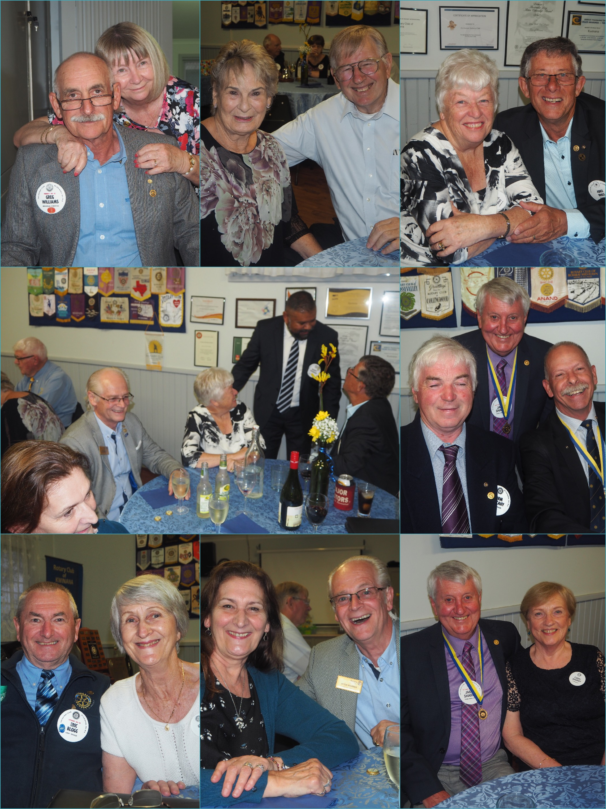

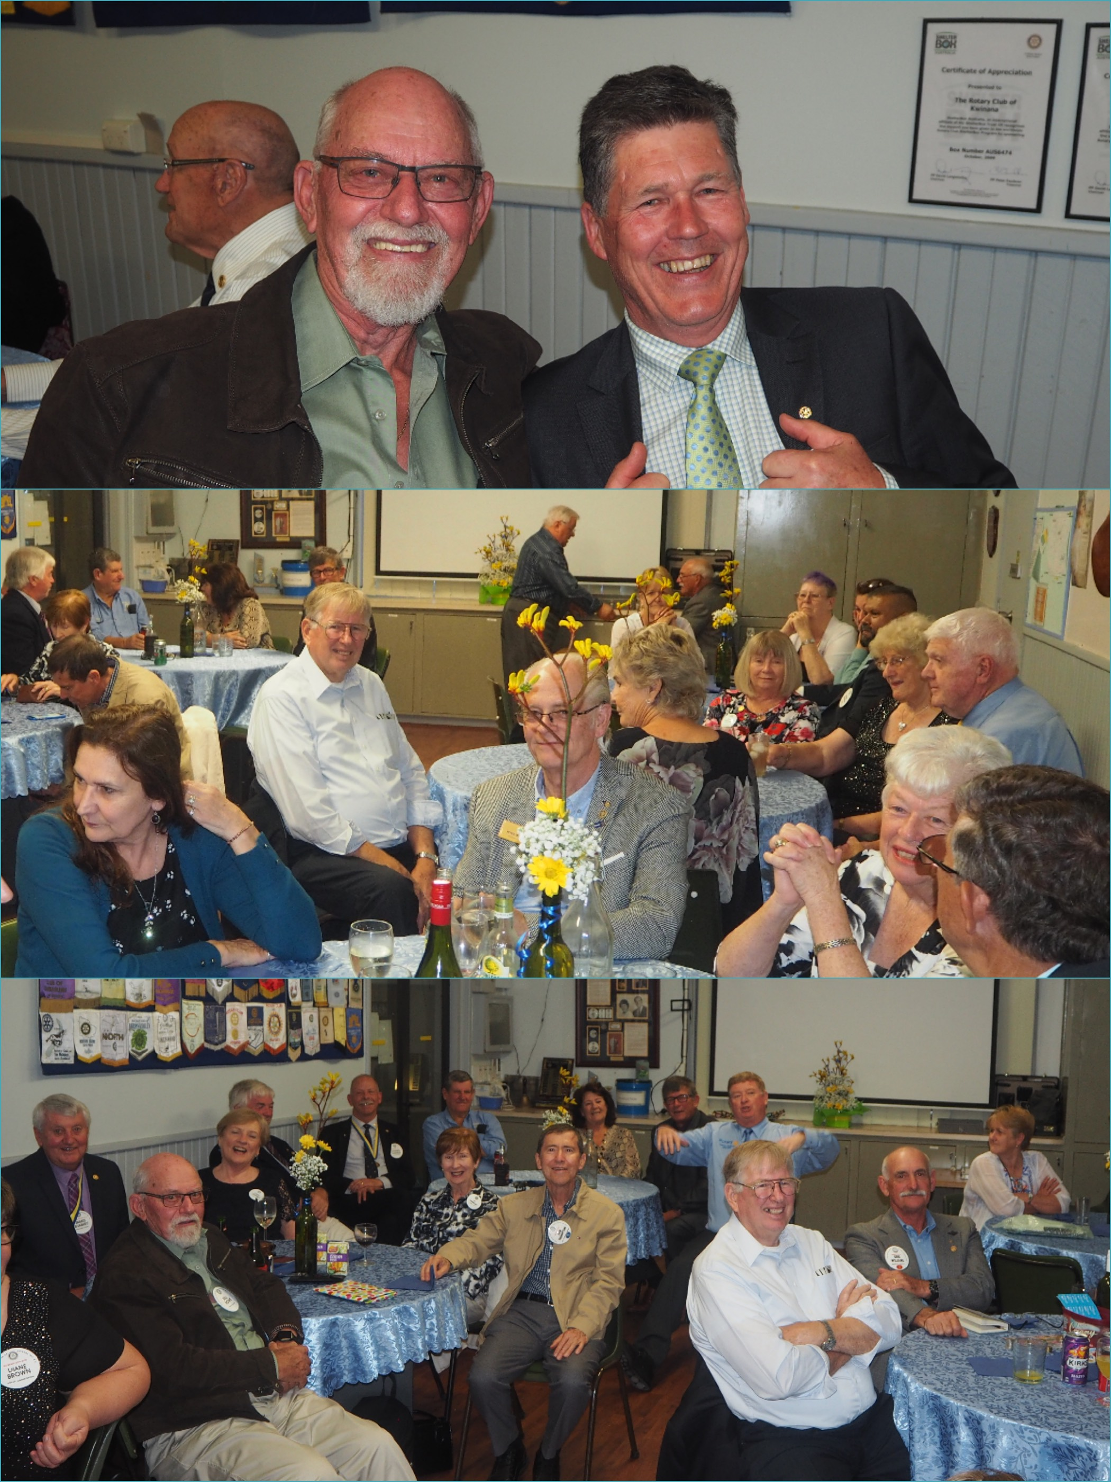

THE BIG Brexit deadline is looming fast and while there are plenty out there would rather politicians "just get on with it" there's a sneaking suspicion in some quarters that the fiasco is far from over - Ireland being one of them.
With the ongoing issue of the "Irish border" yet to be resolved, the general consensus is that things could be about to get a whole lot worse before they get better.
I'm going to go on a Brexit diet The pounds will drop fast.
There’s gonna be a 50p coin commemorating Brexit. It’s nearly done. They just can’t decide what to do with the border.
An Englishman, an Irishman and a Scotsman walk into a bar. But the Englishman wanted to leave so everybody had to
What did Britain say to its trade partners? See EU later
Nigel Farage goes into his pub and asks for a pint. The barman draws it & throws it into his face. “Why did you do that?” Nigel asks.“ 'You asked for a pint,” the barman says. “But you didn't say how you wanted it delivered. ”Farage replies: “Okay, I’ll have a pint in a pint glass” “No. You can't ask again.,” the barman says. “Why not?” Farage asks. “Democracy,” the barman replies.

Halloween
What happened to the man who didn't pay his exorcist? His house was repossessed.
Where do baby ghosts go during the day? Dayscare centres.
What do birds say on Halloween? Twick or tweet.
What is a witch's favourite class? Spelling.
What do mummies listen to on Halloween? Wrap music.
Why didn't the skeleton go to prom? He had no body to go with.


Media Release

For further information please contact
Marketing and Communications on 08 9439 0435

Makeup opportunities

Rockingham Monday 6pm for 6.30 Rockingham RSL Club
Palm beach Wednesday 6pm for 6.30 Ocean Clipper Inn
Baldivis 1st & 3rd Mon 6.30pm for 7.00 Peel Manor House
Cockburn Thursday 7.15am for 7.30 Cockburn Seniors Centre
Byford & Districts Monday 6.15pm for 6.45 Byford Tavern, South W Hwy

Rotary Club of Kwinana Contributions welcome: eblogg@bigpond.com

