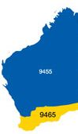


The Rotary Club of Kwinana Inc.

District 9465 Western Australia

Chartered: 22 April 1971

Team 2019-20

President
Wendy Cooper

Secretary
Diane Brown

Treasurer
Bob Cooper

Attendance this week

Total Members 26 Apologies 4
Make-up 4 Attended 19
Honorary Member 1
LOA 1
Guests
Visitors 1
Partners
92.0 %

Facts & Figures
Raffle
Bob C & Bob T

Heads & Tails
Stephen C

Birthdays:

Anniversary:

Club Anniversary:

If you had any we hope you had a good day

Meets Monday
6 for 6.30pm
At Rotary Hall
Brownell Crescent, Medina

Visitors always welcome



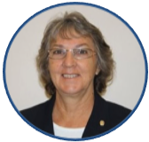
Bulletin

President Wendy
No 17 4th Nov. 2019

Quiet meeting tonight, President Wendy was delayed by council business and attended later, also one of our ‘no guest speaker’ nights.

Recent Saturday Bunnings Sausage Sizzle was a great success, reward for effort is very good. James informs me that we have 2 dates allocated for 2020.
Sunday 9th February and Saturday 21st November, both should be very good weather wise, it has taken us a while to break-in to the weekend spots as these are very much sought after by many other deserving community groups. In recent years we have only been able to secure a Thursday time slot on a regular basis, which understandably is not as profitable as a Saturday or Sunday

PP Ian Critchley has just returned from trip to the UK, he sent me a picture of the Rotary Club of Penzance, Rotary Shop. Penzance is situated in the South Western UK County of Cornwall. The club opened their shop in 2014 as a joint venture between the 2 local Rotary Clubs, they recently held their 5th Birthday celebrating having raised over £100,000 ($187,000) for their local community.
President Wendy at the request of DG Wayne has sent an email to DG Johnathon King, Rotary District 1080 East Anglia, which comprises of 1700 men and women in 67 clubs spanning the counties of Norfolk, Suffolk, a large part of Cambridgeshire and a small part of Essex. (Wayne received business cards from many fellow DGE’s while training in San Diego, USA)

District Governor
9465

2019/20

Wayne Milnes

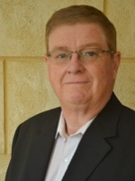
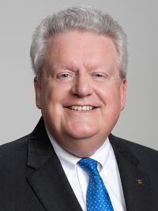
Rotary International President
2019/20

Mark Daniel Maloney

Rotary Club of East Nassau


Coming Events November 2019
Rotary Foundation Month
Nov 2019

Mon 4th Club Meeting

Mon 11th Club Meeting

Mon 18th Club Meeting. Fun Debate Meeting.

Mon 25th Club Meeting

Attendance Officer:
Greg Williams 0435 083 069
Apologies by Saturday pm please






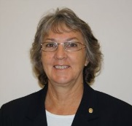


Wendy Cooper

President’s Pen

04th November 2019

- Thank you to John Iriks and the team for the enormous amount of preparation that went in to organising the Golf Day. I know from speaking with the contestants that the day was enjoyed and the after game fellowship allowed for sharing of on-course stories.

- Partner’s on Debate Day 18th November. Chris Oughton has gathered a group together to have a bit of fun in the form of a debate so bring your partner along to watch the antics.

- To date I have not received a reply to my email sent to DG Jonathan King in Norfolk UK as requested by DG Wayne.

- As it is Armistice Day next week the 11th November Service personel are invited to wear any Service medals to the meeting.

- Diane is currently collecting agenda items for next week’s, 14th November, Meeting.

Golf Day. ‘The Winners’

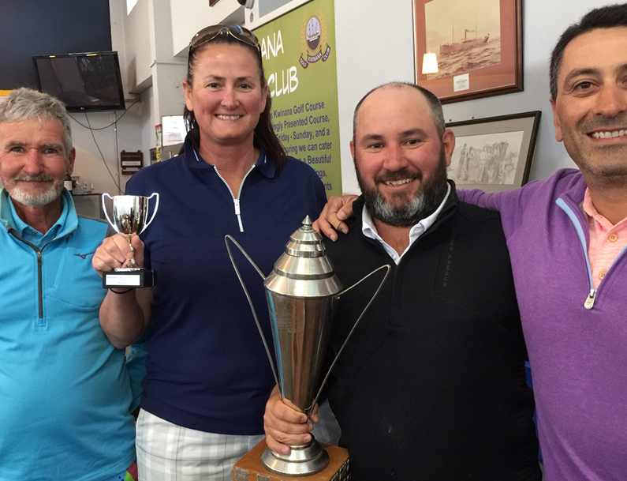

Golf Day Second place

Golf Day Third place

Thank you to those that joined in the fun of the day.

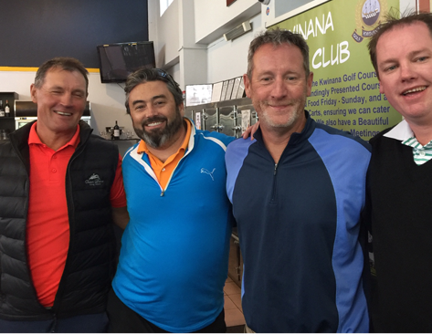

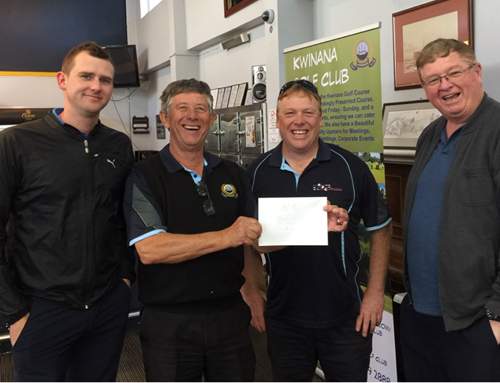


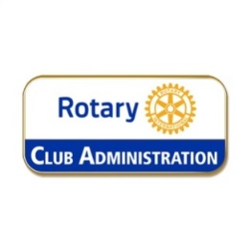

President 2020/21 PE John Iriks

Club Service report. 04th November 2019

Club Service Committee meeting 14th November 2019

Committee considered Information sent out to committee members.

- Suggest a family Christmas format with members invited to bring family members along including children.
- Suggest meal price for children under 15 to be 50% of adult price
- Suggest we invite widows of former members and indicate the cost of meals to them (most widows are pensioners but then again so are many of our members, I have canvassed this suggestion with one of them and she agrees)
- Suggest that we use one or two of the longer term child attendees to help Santa distribute the gifts to the ladies who remain seated at their place. This involves the children and saves the embarrassment of those no longer wanting to sit on Santa's knee.
- Suggest that everyone buy a small present for their own children/grandchildren attending.

Committee resolution.

- Resolved to have a family Christmas format with members invited to bring family members along including children.
- Resolved that meal price for children under 15 to be 50% of adult price with price set to cover both.
- Resolved to invite widows of former members and indicate the cost of meals to them on the invitation. Members noted that this has been the norm for some time.
- Resolved that Rotarians purchase a gift not to exceed $15 for their own partners and the children they are bringing labelled for those persons.
- Resolved that we use one or two of the longer term child attendees to distribute the gifts to the ladies and children who remain seated at their place. Santa will be busy that night and will not attend.

Other Business

- Children’s party – looking for committee of volunteers if not forthcoming maybe we could donate to the Frank Konecny Children’s Christmas Party being held on 14th December 2019.
  - Resolved that this matter be referred to the Board
- Car rally moved into the early part of 2020
- Guess who is coming to dinner 2020
- Progressive dinner 2020
- Club audit completed by 31st October 2019 to satisfy Charitable Collections Act.
- AGM and election of Office Bearers for 9th December 2019. Club Service Director to work with Secretary Diane to follow the process as outlined in the Club Constitution, By-Laws and the Manual of procedure


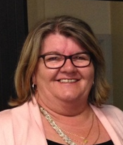

Rtn Diane Brown

no report this week

Inward Correspondence.

Outward Correspondence.

Would members please note that any correspondence received or posted by yourself, please ensure a copy is forwarded to your Secretary.


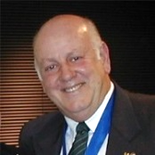

PDG Bob Cooper
Bills paid, money in the bank.
Bob encouraged members to get behind Mike and Stephen and offer to help. Venture has the potential to be a good money earner, beats smelling like a sausage.
The club Profit & Loss Statements are available for members to view on ClubRunner. See Club Documents.
Members are requested to ensure they contact PP Greg Williams by Sunday am with any apology for the next meeting. We are having to pay for meals ordered for you and not used because of non-attendance.

Treasurer: PDG John Iriks
- Money in the Bank. Bills paid
- Financial Report to May 30th prepared for inclusion in our Annual Report, financials to June end will then be completed ready to be audited.

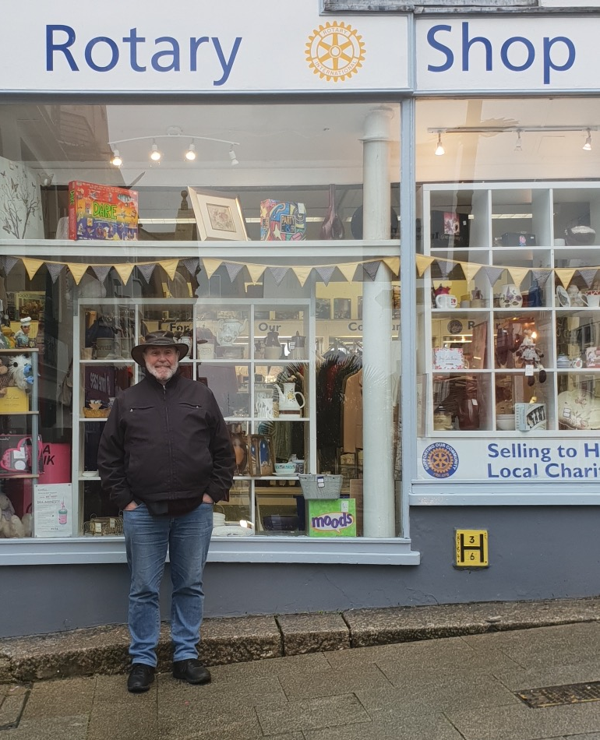
PP Ian Critchley on his recent trip to the UK,
spotting the Rotary Shop in Penzance, Cornwall, UK

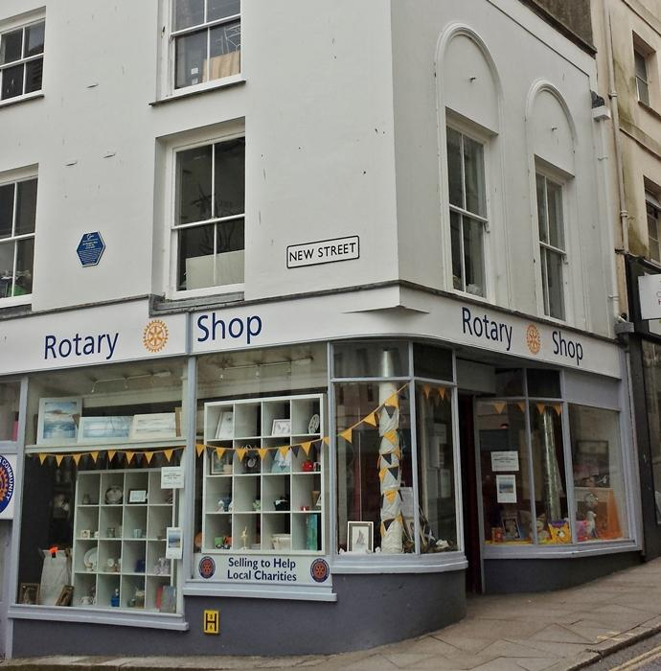

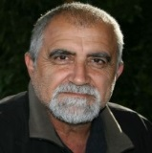
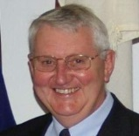
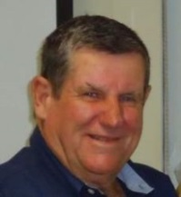
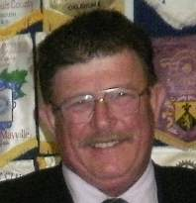

PP James Sharkey
Public Relations Dir.

PP Edd Samut
Membership Dir.
PP Max Bird
Foundation Dir.

Projects Director
PP Mike Nella

Project Director’s Report.

Gentle Road premises now open for business, business steady.

First Lolly-Run meeting at the COK September 17th will be meeting monthly till Christmas.

Public Relations:
We continue to receive exposure on Rotary Out West.
Please continue to advise James of any stories or activities within our club which may be submitted to the local media.
We have a number of Bunnings BBQ’s scheduled over the next 12 months.
Thu. Nov 28th , Sat. Dec 21st
Future dates: Sunday 9th February 2020 & Saturday 21st November 2020

Membership:
Welcome back to Veronica Burns.

Community:
Golf Day completed, thanks to everyone concerned.

Vocational:
State Final for Four Way Speech comp. scheduled for Sunday 10th November.
Will be held at Mandurah Baptist College.

International:
Plan to hold a Rotary Foundation Function in the not too distant.
Latest meeting minutes available to view on ClubRunner.

Youth:
Actively looking for participants for RYPEN, RYLA and Handicamp.
We have a candidate for RYLA, this young lad is an active member of the Kwinana Youth Advisory Council.
Investigating options for a Handicamp candidate.
Exercise program at Banksia Village still on-going.

- Visit your club webpage.

http://www.clubrunner.ca/Portal/Home.aspx?accountid=8106

or type Kwinana Rotary Club into ‘Search’

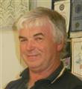

Rtn. Norm Mulcahy
Community



PP Bob Thompson
Vocational

PP. Max Bird
International

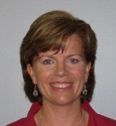
PP Genevieve Carr
Youth



Fine Session: Sgt. Cyril Bennett
Deputy Bill Rowe.

.

.



James S: Lost his keys !!

Stephen C: Left half of the bread in his car!!

Norm Mc: Judging by the shirt Norm was wearing tonight, there is a possibility he cut up one of his kilt’s to make it ??

Chris O: Actually backed the Poms the win the World Cup.

Bevan & Bob C: Wearing the same shirt, well almost, one was long sleeve and the other short sleeve.

Brian & Eric: Part of the original A Team at Bunnings, Stephen & Veronica had to assimilate.

Stephen C: Drove past John and Chris I the other day, they were walking, fined for not even stopping to see if they would like a lift !!!!

Greg W: Found a Past President’s lapel badge on a chair recently, trying to find a home for it, is it yours.

Cyril B: Was in a ‘panic’ Monday morning, forgot to deliver the bread to Gilmore College for the Breakfast Club, luckily they had enough.

A guy was driving past a farm one day when he noticed a beautiful horse stood in one of the fields.
Hoping to buy the horse, the guy stopped and offered the farmer $500 for it.
The farmer said, "Sorry, he's not for sale. He doesn't look too good."
The guy said, "He looks just fine. Tell you what, I'll give you $1,000 for him."
The farmer again said, "Sorry, he's not for sale. He doesn't look too good."
The guy now really wanted the horse and so increased his offer to $1,500.
The farmer said, "Well, he doesn't look so good but if you want him that much he's yours."
So the guy bought the horse and took him home.
The next day he returned to the farm, hopping mad. He shouted at the farmer, "Hey, you cheated me! You sold me a blind horse!"
The farmer calmly said, "I told you he didn't look too good, didn't I?"

Polio This Week 30th October 2019

With less than a month left to the GPEI pledging event in Abu Dhabi, G20 Health Ministers gathered in Okayama, Japan, on 19 – 20 October 2019 to address major global health issues where they maintained their commitment to eradicating polio.
Following the certification of eradication of WPV3, WHO Director General Dr Adhanom Ghebreyesus expressed his gratitude to all who made the achievement possible and called on all stakeholders to continue with the fight to eradicate WPV1.
The effects of polio hit hard. The disease not only causes pain and suffering to the victim and the family, but also forces relatives to quit their income-generating activities, to provide care to the afflicted child.
Get up-to-date on the different aspects of GPEI’s status of work in 2018 through the newly released 2018 annual report.
Summary of new viruses this week (AFP cases and ES positives):
Afghanistan— one WPV1 case;
Pakistan— one WPV1 case and 12 WPV1-positive environmental samples;
Central African Republic— three cVDPV2 cases and one cVDPV2 positive environmental sample.
Angola— 11 cVDPV2 cases;
Philippines— one cVDPV2 case, one cVDPV1 and two cVDPV2 positive environmental samples.







What sickness do horses hate the most? (Hay fever!)
What do you call a horse that lives next door? (A neigh-bor!)
A horse walks into a bar, Bartender says "what can I get you? And why the long face?"
What's black and white and eats like a horse? A zebra.
What do racehorses eat? Fast food.
Did you hear about the depressed horse? He told a tale of whoa.





The Melbourne Cup
2004 Prizemoney $4.6 million
2019 prizemoney $8 million
The Melbourne Cup is Australia's most famous annual Thoroughbred horse race. It is a 3200-metre race for three-year-old’s and over, conducted by the Victoria Racing Club on the Flemington Racecourse in Melbourne, Victoria as part of the Melbourne Spring Racing Carnival.
It is the richest "two-mile" handicap in the world, and one of the richest turf races. The event starts at 3 pm on the first Tuesday of November and is known locally as "the race that stops the nation”
The Melbourne Cup has a long tradition, with the first race held in 1861. It was originally over two miles (3.219 km) but was shortened to 3,200 metres (1.988 mi) in 1972 when Australia adopted the metric system. This reduced the distance by 18.688 metres (61.312 ft), and Rain Lover's 1968 race record of 3:19.1 was accordingly adjusted to 3:17.9. The present record holder is the 1990 winner Kingston Rule with a time of 3:16.3.
The race is a quality handicap for horses 3 years old and over, run over a distance of 3200 metres, on the first Tuesday in November at Flemington Racecourse. The minimum handicap weight is 50 kg. There is no maximum weight, but the top allocated weight must not be less than 57 kg. The weight allocated to each horse is declared by the VRC Handicapper in early September.
The Melbourne Cup race is a handicap contest in which the weight of the jockey and riding gear is adjusted with ballast to a nominated figure. Older horses carry more weight than younger ones, and weights are adjusted further according to the horse's previous results.
Weights were theoretically calculated to give each horse an equal winning chance in the past, but in recent years the rules were adjusted to a "quality handicap" formula where superior horses are given less severe weight penalties than under pure handicap rules.
After the declaration of weights for the Melbourne Cup, the winner of any handicap flat race of the advertised value of A$55,000 or over to the winner, or an internationally recognised Listed, Group, or Graded handicap flat race, shall carry such additional weight (if any), for each win, as the VRC Handicapper shall determine.

Entries for the Melbourne Cup usually close during the first week of August. The initial entry fee is $600 per horse. Around 300 to 400 horses are nominated each year, but the final field is limited to 24 starters. Following the allocation of weights, the owner of each horse must on four occasions before the race in November, declare the horse as an acceptor and pay a fee. First acceptance is $960, second acceptance is $1,450 and third acceptance is $2,420. The final acceptance fee, on the Saturday prior to the race, is $45,375. Should a horse be balloted out of the final field, the final declaration fee is refunded.
The race directors retain the absolute discretion to exclude any horse from the race or exempt any horse from the ballot on the race, but in order to reduce the field to the safety limit of 24, horses are balloted out based on a number of factors which include: 1000 prize money earned in the previous two years, 9 wins or placings in certain lead-up races 3 allocated handicap weight. The winners of many prominent national and International races are exempt from the ballot.

Melbourne Cup Trivia

The prize for the first Melbourne Cup was a gold watch and 710 pounds (or was it?).
Seventeen horses contested the first Melbourne Cup in 1861, watched by a crowd of 4000.
The oldest winners of the Melbourne Cup were 8yo's Toryboy in 1865 and Catalogue in 1938.
In 1870, the track was so waterlogged that it was deemed unsafe to ride. It was postponed till one week later. In 1916, the running of the Cup was also postponed by due to rain, and held 5 days later.
The first cup races were originally run on a Thursday. The race was first run on a Tuesday in 1875, and has done so ever since (except The Melbourne Cup was run on Saturdays during the war years 1942-1944).
In 1877, the first Tuesday in November was declared a public holiday in Victoria (and is still).
The 1880 Cup was the first Melbourne Cup to attract 100,000 spectators.
The winner in 1890 was Carbine. As a sire, his descendants have won over 30 Melbourne Cup races. Carbine's descendants include Phar Lap and Makybe Diva.
Phar Lap's win in 1930 was the only odds on winner in history (8-11), and was also the shortest-priced favorite in Cup history.
There have been no dead heats for first, but Topical and Gaine Carrington (1933) and Lahar and Zazabelle (1999) have tied for third.
The first camera photo finish was in 1948 when 80/1 shot Rimfire controversially beat Dark Marne (12/1). Although the rider of Dark Marne, Jack Thompson, was sure he had won, the camera said otherwise. However, it was later found out that the camera was out of alignment, and was corrected before the next race.
In 1954, 'Rising Fast' won the Caulfield Cup, Cox Plate and Melbourne Cup treble.
Arwon, the 1978 Cup winner, was from the town of Nowra, as was the first cup winner Archer (1861). In fact, Arwon is Nowra spelt backwards.
In 2002, Jockey Damien Oliver won on Media Puzzle, a week after his brother Jason was killed in a riding fall.
Bart Cummings has trained 12 Melbourne Cup winners (as of 2014).
In 2016 jockey Kerrin McEvoy had his second Cup triumph, with a record 16 years between wins.
In 2017, the first three horses across the line were trained in Ireland.

I tried water polo the other day.
My horse drowned.

A white horse walks into a pub one day and asks the bartender for a whisky.
The bartender says: "Hey, we've got a whisky named after you."
The horse replies, "What, George?"

I had a bet on a horse yesterday. It came in so late they had to pay the jockey overtime.
Black Beauty... Now there's a dark horse.

What's a horse's favourite sport? Stable tennis.

A jockey is riding the favourite in a big horse race one day and is well ahead of the field. Suddenly he's hit on the head by a turkey and a string of sausages. He somehow manages to keep control of his horse and pulls back into the lead once more, only to then be hit by a box of Christmas crackers and a dozen mince pies. Using all his ability, he manages to steer his horse back into the lead as he goes over the last fence and into the run-in. But then he's struck on the head by a bottle of sherry and a Christmas pudding. This time, despite all his best efforts, he can't regain the lead and only manages to finish second. He immediately goes to the stewards and complains that he has been seriously hampered.

What kind of bread does a racehorse eat? Thoroughbred.
Why couldn't the pony sing? Because he was a little horse.


Media Release

For further information please contact
Marketing and Communications on 08 9439 0435

Makeup opportunities

Rockingham Monday 6pm for 6.30 Rockingham RSL Club
Palm beach Wednesday 6pm for 6.30 Ocean Clipper Inn
Baldivis 1st & 3rd Mon 6.30pm for 7.00 Peel Manor House
Cockburn Thursday 7.15am for 7.30 Cockburn Seniors Centre
Byford & Districts Monday 6.15pm for 6.45 Byford Tavern, South W Hwy

Rotary Club of Kwinana Contributions welcome: eblogg@bigpond.com

