

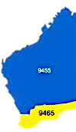

Team 2022-23

President
James Sharkey

Secretary
Genevieve Carr

Treasurer
Stephen Castelli

Facts & Figures

Attendance this week

Rotary
The Rotary Club of Kwinana

District 9465 Western Australia

Chartered: 22 April 1971

Bulletin

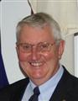

No 17 21/11/2022

President James
Rotary Club of Kwinana is 51 years’ old 1971/2022

Guest speaker tonight was a family affair, mum, dad and daughter accompanied guest speaker Tamar Oakden from Reach Kwinana, a NFP organisation helping children participate in a healthy community.

On a sad note, PP Michael Nella told us late in our meeting that news was coming through from Jakarta that a major earthquake had occurred in West Java and many victims are thought to be children, a school that the team worked on is thought to be involved.

PDG Bob Cooper was here tonight looking a bit worse for wear after an altercation with a bbq pit fire down south last week, looks bad but could have been a whole lot worse, he’s on the mend.

PDG John and Chris accompanied PP Bevan Piper to Kings Park last Sunday, where Bevan attended the annual wreath laying ceremony for the 2/2 Commando Association.

After our planned Sunday lunch date at Lavoro’s was cancelled in October, Stephen has again booked for 40 at Lavoro’s for Sunday 11th December for lunch.

Next week’s meal: Roast

Total Members 27 Apologies
Make-up 3 Attended 19
Hon. Member
LOA 4
Guests 5
Visitors
Partners

91.1%

Raffle
Bob T & Mike

District Governor
9465

2022/23

Ric McDonald

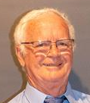
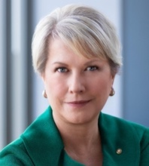
Rotary International President
2022/23
Jennifer E Jones

Rotary Club of Windsor-Roseland

Ontario Canada. 6400

Heads & Tails
Terry E



November 2022: Rotary Foundation Month



Meets Monday
6 for 6.30pm
At Rotary Hall
Brownell Crescent, Medina

Visitors welcome
contact us



Attendance Officer:
Paul Durant 0402 794 323
Apologies by Saturday 4 pm please

Mon 7th Club Meeting Club Forum

Sat 12th Kwinana Community Fair

Mon 14th Club Meeting Salvation Army Kwinana Corps, Jodie Jones

Mon 21st Club Meeting Tamar Oakden Reach Kwinana

Mon 28th Club Meeting

James Sharkey
President’s Pen
21st November 2022

Next week’s meal (Roast Beef)

Kwinana Inaugural Silent March
The Rockingham Kwinana Safe family Alliance would like to invite all community members to a remembrance event to raise awareness of the issue of violence against women and children in the community.
The event will take place on Wednesday 30th November from 10.00am to 1.00pm starting at Chisham Square, 2 Robbos Way, Kwinana Town Centre.
The program starts at 10.00am with Welcome to Country followed by a guest speaker.
At 10.45 a memorial to pay respect and remember those whose lives have been lost as a result of domestic violence.
On completion the Kwinana Inaugural Silent March will start, finishing at Calista Oval.
The Lions Club of Kwinana will provide lunch.

Our Club has been asked two provide two water serving stations.
We will have one water station setup at the start of the event and one set up at the area near the Adventure Playground at Calista Oval.
The City of Rockingham is supplying water bottles.
Our Rotary Club have been asked to provide
- Eskies and ice
- Gazebos and tables.

Guest Speaker Programs Manager
Please contact Grace with any possible guest speaker contacts.

Ceremony commemorating the 2/2 Commando Squadron
Well done Bevan on representing our Rotary Club at
The above ceremony at Kings Park on Sunday 20th November. We could not have chosen a better representative.
Also, thanks to Chris and John for assisting with the transport arrangements.

Frank Konecny Community Centre
The board has authorized and funded Chris O to form a small team to work at the Community Centre to assist with the Centre’s garden reticulation system.

James Sharkey
President 2022/23

Rotary Meeting Monday 21st November 2022

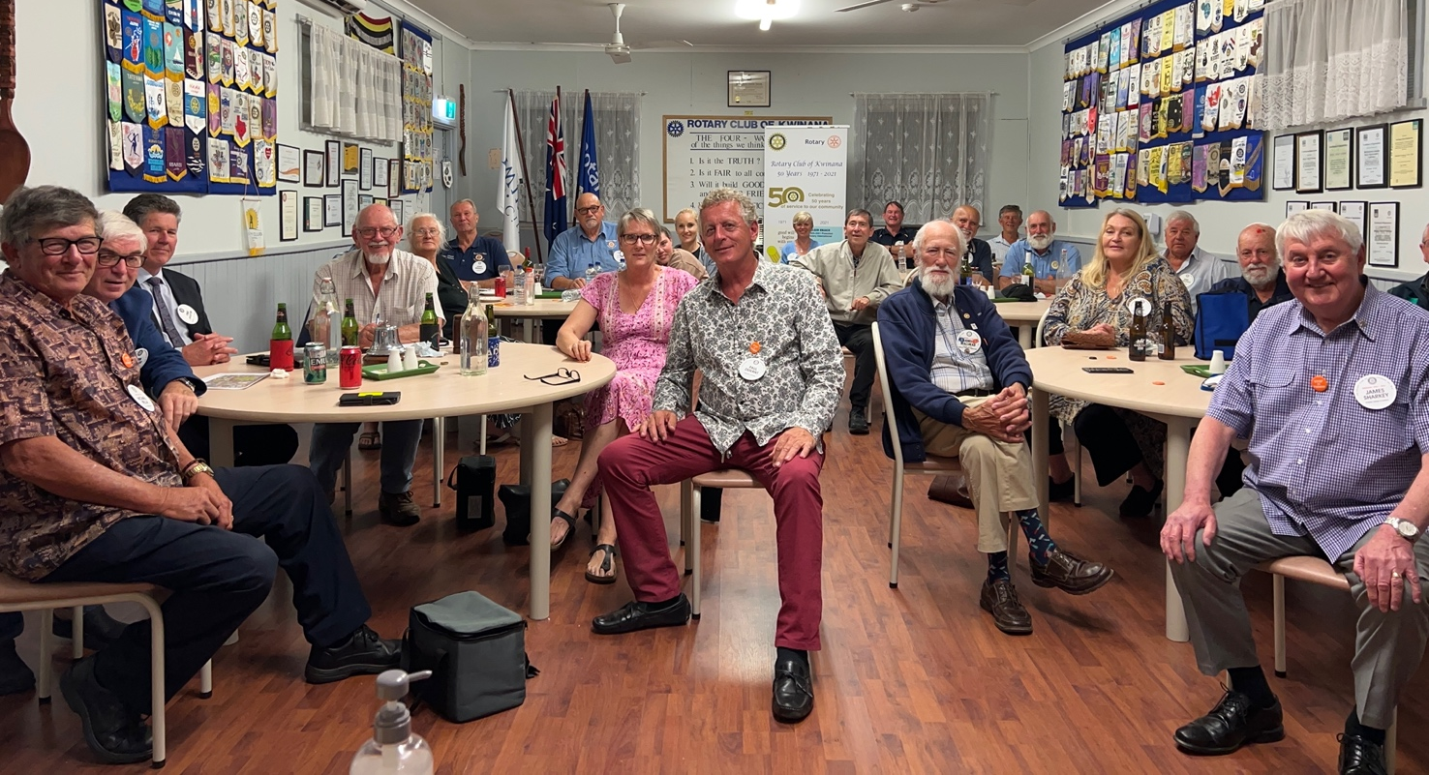


Club Service
President 2023/24 Looking for a candidate?

Attendance Officer
A reminder to text Paul’s mobile prior to our next meeting if you have any problems attending.

Next social event planned Christmas Lunch at ‘Lavoro’s’ at Rockingham Beach.
Sunday 11th December 2022
The basic arrangement will be that you order off the menu and pay for what you order.
https://lavoroitaliano.com.au/ Booked for 40


21st November 2022

2022/23 PP Genevieve Carr
Inward Correspondence.
- Message from All Saints Church Kwinana regarding donation for Christmas hampers
- Invitation to Year 6 Graduation Ceremony from Wellard Primary School
- Invitation to Year 6 Graduation Ceremony from St Vincent’s Primary School
- Information regarding ‘Ride for Rotary’ in India
- Rotary Leader
- Information for Club Leaders regarding upcoming training
- Acceptances of invitation to Christmas function from Colleen McCallum, Olive Lovitt
- RYLA invoice
- Rotary Out West

Outward Correspondence
None this week

Would members please note that any correspondence received or posted by yourself, please ensure a copy is forwarded to your secretary.



2022/23 PP Stephen Castelli
Bills paid, money in the bank.

Treasurer: PDG John Iriks
- Money in the Bank. Bills paid
- Financial Report to May 30th prepared for inclusion in our Annual Report, financials to June end will then be completed ready to be audited.

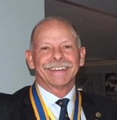

Rotary Down Under Magazine now comes to you electronically.
Bring your empty drink containers, we have collection bins.



2022/23 PP Genevieve Carr

Youth Services Report 21st November 2022

1. RYLA: Our candidate Ashton Jose is very enthusiastic to attend!

2. Year 6 Primary School Graduation Ceremonies: Thank you to all those members who have volunteered to represent our Club at these upcoming events. Still looking for a representative to attend the Bertram Primary School graduation ceremony on Monday 12 December at the Kennedy Baptist College in Murdoch.

3. Camp Inspiration: Will be speaking with coordinator from Activ Industries in Rockingham this week.



Click on the link to read the latest report from Timor-Leste East Project.

https://clubrunner.blob.core.windows.net/00000008106/en-ca/files/homepage/rotary-project-timor-leste-east-report/31-9-2022-final-report-september-2022-rev-2.pdf

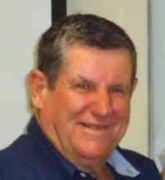
Foundation Director
International Service Manager: PP Max Bird

Guest Speaker Tamar Oakden from ‘Reach Kwinana’ with President James
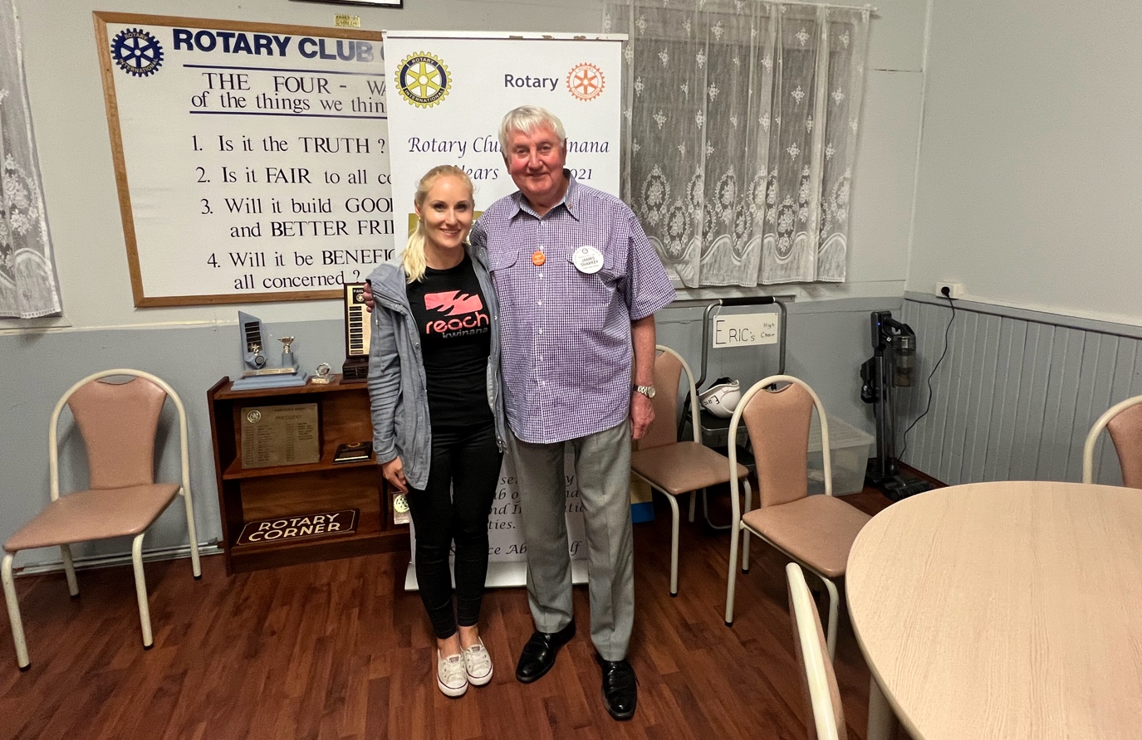



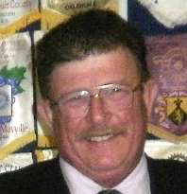

Kim Beciri
Public Relations Dir.

PDG John Iriks
Membership Dir.
PP Max Bird
Foundation Dir.
Projects Director
PP Mike Nella

Project Director’s Report.
Furniture-0n-Line, 2022 going really well, my sincere thanks to all who are assisting.
Club members encouraged to assist any time, see Mike for info.
Had 2 students on work experience.
Friday 9th December, cooking 1k sausages at Gilmore College,



Public Relations:
We continue to receive exposure on Rotary Out West.
Kim is promoting our club on Facebook.

Kertrina Riordan
Community

Membership:
PDG John Iriks is Membership Director
Committee: Bob Thompson, Ed Samut and Eric Blogg.
Still the best option to invite new members, “ask someone”

Need to review the requirements regarding introducing prospective members and the procedures that need to be followed to complete the process. This is referred to in detail in our Standing Orders document.

PDG John is looking for us to sponsor a Satellite Club, usually consists of a younger demographic group who meet just once a month, part of the Jennifer Jones Challenge.

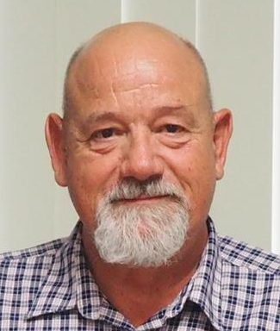

Peter Schulz
Vocational

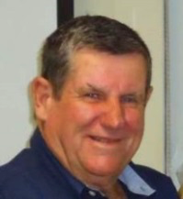
Community:
Bread Program, ongoing. All welcome to assist.
Breakfast Club always in need of more assistance, see Mike if you can help.

PP. Max Bird
International

International: See latest report above.

Youth: Report above.

Genevieve, currently looking at putting together a First-Aid course for members and Partners, will be a day-time project at approx. $65 pp if interested speak to Genevieve

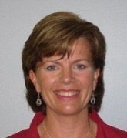
- Visit your club webpage.

http://www.clubrunner.ca/Portal/Home.aspx?accountid=8106

or type Kwinana Rotary into ‘Search’




Tamar spent the last 12 years working in education, running intervention classes at Orelia Primary School with children who are not coping at school, have learning difficulties or who have experienced trauma.

10 years ago, she started outreaching to teenagers in Kwinana, involving them in healthy youth activities. This grew to also outreaching to primary aged children, and young women, as well as whole family units. In 2018/2019 Tamar came together with some other people, and they set up REACH Kwinana as a not-for-profit association.

Over the years of running youth and children’s outreach, including regular outings, groups and camps, they have also been able to support children getting their medical needs met, and help engage families with emergency accommodation and rehabilitation programs.

This is when the idea of Flourish Community Development came in. Tamar and her colleagues are now working with students from Gilmore College off site, providing a safe and nurturing learning environment, where basic life skills are taught

Outreach has a team of 14 volunteers who have qualifications in teaching, youth work, social science, counselling, education support with special needs and learning difficulties, nursing, nutrition, and disabilities.

This is the second term Outreach Kwinana has been running the Flourish program, and the team are seeing incredible results in the children’s mental health and participation. Gilmore College has noted the improvements the program has made for the students involved.

In 2022, REACH Kwinana started an initiative called Flourish Community Development. It is an interactive, hands-on learning program designed to help primary school students who are not coping at school.
Many of the children we have worked with over the years have had learning difficulties, poor school attendance or trauma, leading to huge gaps in learning. As a result, we have seen children suffer and feel humiliated at school, and they often find it difficult to form and maintain healthy relationships.
Eventually we started to see more students dropping out of school or engaging with antisocial behaviours. It became apparent that early intervention is crucial; therefore, Flourish Community Development was established to help meet this pressing need in the community.
Through meaningful relationships, evidence-based teaching strategies and life skills training our hope is to see young people flourish, not only in their personal lives but also in the community around them. We believe this holistic approach to education will help young people develop the resilience, self-control, confidence, knowledge, and empathy needed for a positive sense of self and the world around them.
https://reach.red/

Guest Speaker: Tamar Oakden from Reach Kwinana





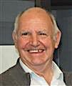
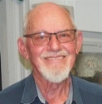
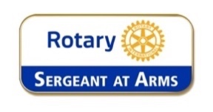
Fine Session: Sergeant Cyril Bennett

Stand-in: Norm
Deputy Bill Rowe.

Bob C: Showing off his new head decoration.

Kim B: Table hopping.

Edd S: Welcome home the ‘Caravaner’

Sam C: Never gets fined, pay up just because.

Norm Mc: Been to the doctor today, told to slow down or retire, maybe just an excuse?

James S: Took the ‘lucky last’ raffle ticket, didn’t win anyway.

Pres James: Messing up the important meeting formalities.

Norm Mc: Stuffing up the ‘Loyal toast’

Visitors: We love collecting ‘foreign money’ or whatever you have.

James: Turning into a ‘serial snogger’ with the ladies.

James: Not 1 but 2 phone calls!!

Pres James: No chain of office around his neck?

Birthdays and Anniversaries November 2022

Birthday Congratulations:

Norm Mulcahy 3rd
Morgan Schulz 9th
Bill Rowe 13th





Wedding Anniversary’s
None listed

Club Anniversaries.

Edd Samut 16th 24 years
Genevieve Carr 29th 23 years

Polio this week
16th November 2022
What is the real context of this year’s various global detections to the worldwide eradication effort?
In this editorial published in International Health, Aidan O’Leary, Director of the Global Polio Eradication Initiative, offers some answers…
GPEI midterm evaluation of Gender Equality Strategy published. Click here for more.

Summary of new polioviruses this week:
Afghanistan: two WPV1 positive environmental samples
DR Congo: six cVDPV1 cases and 17 cVDPV2 cases
Nigeria: three cVDPV2 positive environmental samples
Yemen: four cVDPV2 cases

Rotary has contributed more than $2.6 billion to fight polio, including matching funds from the Gates Foundation, and countless volunteer hours since launching its polio eradication program, PolioPlus, in 1985.

In 1988, Rotary joined in partnership with the World Health Organization, UNICEF, and the U.S. Centers for Disease Control and Prevention to form the Global Polio Eradication Initiative.
The Gates Foundation and Gavi, the Vaccine Alliance later joined.
When the initiative launched, there were 350,000 cases of polio every year. Today the incidence of polio has plummeted by more than 99.9 percent.
While only Afghanistan and Pakistan continue to report cases of wild poliovirus, the remaining challenges to global eradication—like difficulty reaching children amid insecurity and conflict and weak health systems—have proven to be the most difficult. To meet these challenges head-on and ensure the continuation of program efforts, funding and support from donors and world governments are imperative.











Nov 20th to Nov 26th

20th
1815: Russia, Prussia, Austria and England sign Alliance "for the maintenance of peace in Europe"
1866: French inventor Pierre Lallement patents rotary crank bicycle
1888: Willard Bundy patents timecard clock
1931: Rolls Royce acquisition of Bentley Motors is announced

21st
1834: HMS Beagle anchors at Bay of San Carlos, Chile
1837: Thomas Morris of Australia skips rope 22,806 times
1905: 1st match ever played in the Australian National Tennis Championships
1977: First flight of Concorde (London to New York)

22nd
1497: Portuguese navigator Vasco da Gama rounds Cape of Good Hope
1924: Britain orders Egyptians out of Sudan
1932: Pump patented that computes quantity and price delivered
1962: 7th British Empire Games and Commonwealth Games open in Perth, Australia

23rd
1863: Patent granted for a process of making colour photographs
1869: The clipper Cutty Sark is launched In Dumbarton, Scotland, and the only one still surviving
1889: Debut of 1st jukebox (Palais Royale Saloon, San Francisco)
1942: Japanese bombing of Darwin, Australia

24th
1434: River Thames in London freezes over
1642: Dutch explorer Abel Tasman discovers Van Diemen's Land (Tasmania)
1715: London's Thames River freezes over
1859: English naturalist Charles Darwin publishes "On the Origin of Species"

25th
1715: First English patent granted to an American, for processing corn
1783: Britain evacuates New York city, its last military position in the United States
1792: Benjamin Banneker first publishes his Farmer's Almanac
1947: New Zealand accedes to Statute of Westminster, becomes a dominion

26th
1716: 1st lion exhibited in America in Boston
1778: Captain James Cook is the first European to visit Maui in the Sandwich Islands (now Hawaii)
1842: The University of Notre Dame is founded
1865: "Alice in Wonderland" by Lewis Carroll is published in America



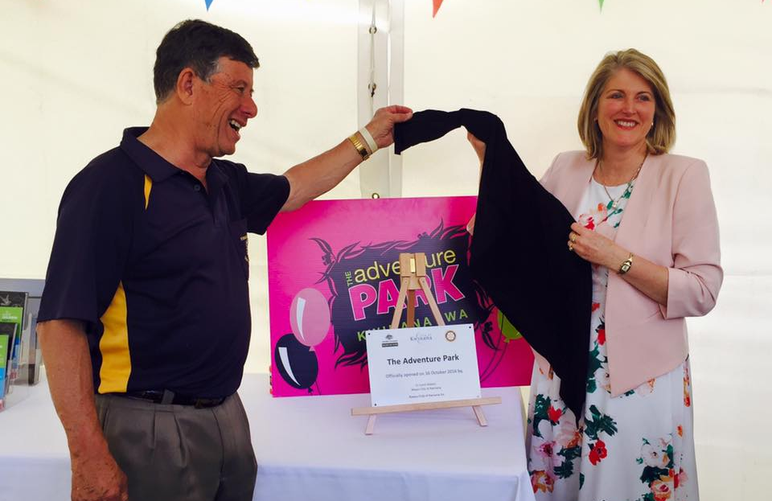
Blast from the Past Opening of the Kwinana Adventure Park 16th October 2016

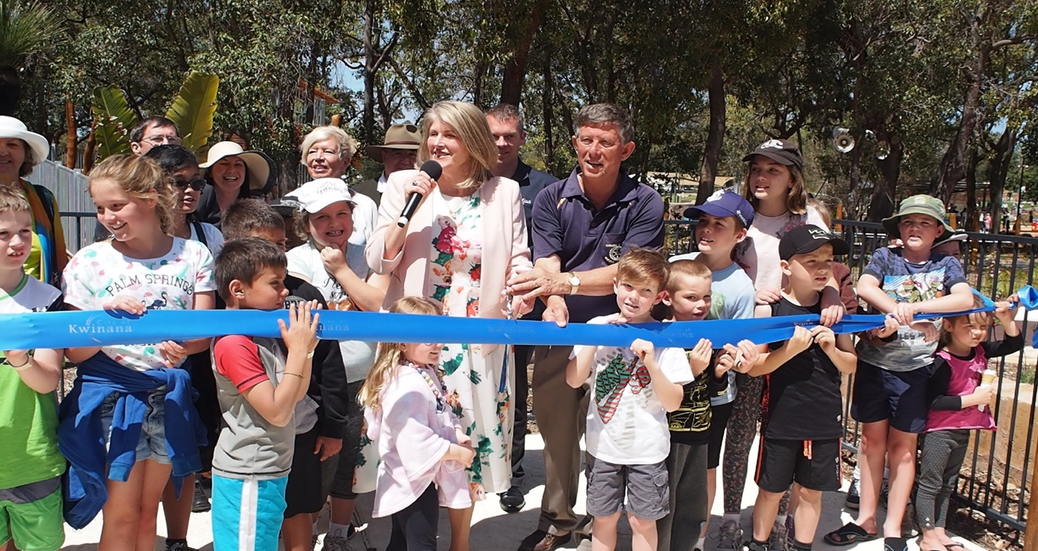

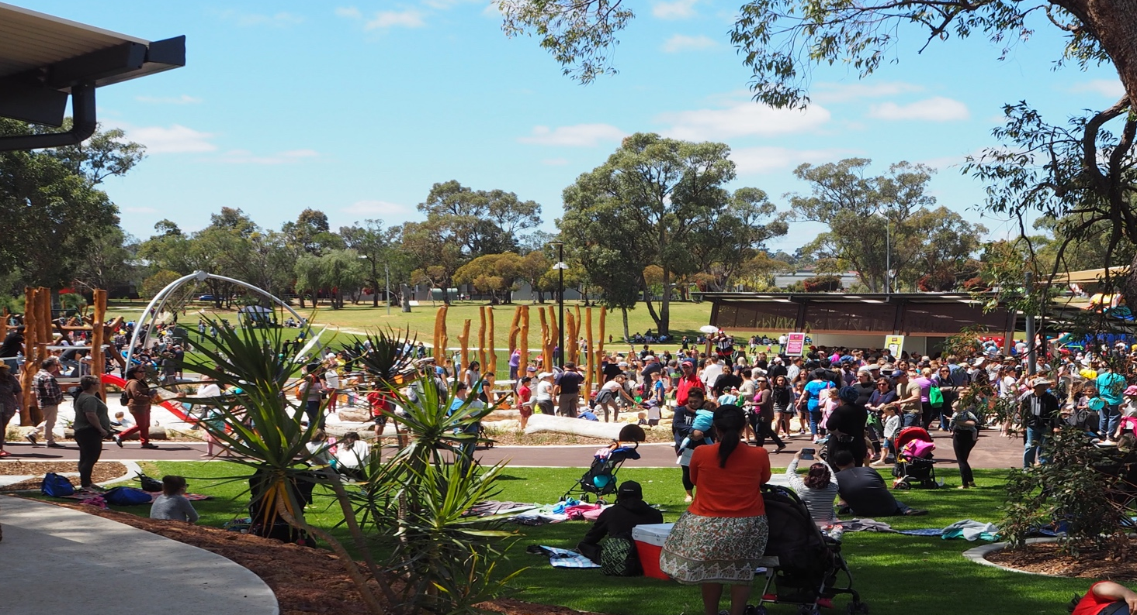










Rotary Club of Kwinana Contributions welcome: eblogg@bigpond.com

Makeup opportunities

Rockingham Monday 6pm for 6.30 Rockingham RSL Club
Palm beach Wednesday 6pm for 6.30 Ocean Clipper Inn
Baldivis Mon/Fortnightly 6.30pm Peel Manor House
Cockburn Thursday 7.15am for 7.30 Cockburn Bowling & Rec. Club
Byford & Districts Monday 6.45pm for 7.15 Byford Tavern, South W Hwy

