

The Rotary Club of Kwinana

District 9423 Western Australia

Chartered: 22 April 1971

Bulletin

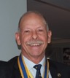
Team 2025/26

President
Stephen Castelli

Secretary
Genevieve Carr

Treasurer
Karen Zabiela

Facts & Figures

No 19 10/11/2025

Rotary Club of Kwinana is 54 years’ old 1971/2025

Kwinana Community Fair 2025, done and dusted. Congratulations and many thanks to everyone involved in making 2025 another successful event.
Very special thanks must go to PDG John Iriks and Chris who played such a big part in organising and setting-up for the day.
A highlight this year was the photographic images provided by a drone, photos from this device can be seen on our website, front page, under ‘Photo Albums’

A significant milestone has been achieved in relation to ‘End Polio Now’
Two billion doses of novel oral polio vaccine type 2 (nOPV2) have now been administered to children around the world.
Since 1998 GPEI has reduced Polio Cases by 99.9%. 20 million people are walking today who would have otherwise been paralysed by Polio.
The GPEI is a public-private partnership led by national governments with six core partners – the World Health Organization (WHO), Rotary International, the US Centres for Disease Control and Prevention (CDC), UNICEF, the
Gates Foundation and Gavi, the Vaccine Alliance.
20 million health workers and volunteers worldwide help tackle Polio.

Attendance this week
Total Members 26 Apologies
Make-up 2 Attended 12
Guests 1
Visitors
Partners
58.3%

District Governor 9423
2025/26

Veronica Lawrance

Rotary Club of Mill Point

Rotary International President
2025/26

Francesco Arezzo

Rotary Club of Ragusa, Italy



Raffle

Heads & Tails


November 2025 – Rotary Foundation Month

Mon 3rd Club Meeting Club Forum

Mon 10th Club Meeting Club Forum (follow-up)

Mon 17th Club Meeting Zoom with Rtn Tony Miller

Tues 25^{h} Club Meeting with Mandurah Districts

Attendance: Members respond via ‘WhatsApp’



Meets on Monday
6:00 for 6:30 pm
At Rotary Hall
Brownell Crescent
Medina

Visitors are welcome
Contact
0400 837 603







President’s Pen November 10th 2025

Tonight was a continuation of the Club Forum night with a number of issues to discuss:

Membership Fees:
A suggestion was made that the club looks at ways to change the fact that members pay to be volunteers.
The RC Harvey does not charge its members, as they raise the monies to cover the fees elsewhere.
The suggestion was met with only positive comments.
The club currently conducts 2 Bunnings BBQ’s a year to subsidise the fees by 50%. If we were able to conduct 4 BBQs, then that should cover the approx. $7,500 required to pay for the membership fees for 25 members.
We were reminded that we can’t just throw the doors open, and we need quality over quantity as Rotary’s reputation is at stake.
This will be further discussed at a board meeting.

Calendar of Events:
There are quite a number of events coming up over November & December.

Wed 12/11 – Wayfairer Program - 9:30 @ Darius Wells for anyone interested. ps Alan Johnson is a member of the Wayfairer Program. Stephen and Bob T attended.

17/11 – Guest speaker will be our own Tony Miller from Vietnam. Tony will be giving a “Me Talk”.

18/11 – And & Rita Valk Scholarship Presentations at Gilmore College.

24/11 – No Meeting. Feedback on review of Standing Orders closes.
25/11- International Services night with Mandurah Club. Stephen will be presenting the Club’s Indonesian School Renovation Project.

26/11 November Board Meeting

03/12 – Sundowner Night for Kwinana Community Groups

11/12 – ARHRF Dinner ion Perth.

13/12 - Providence Permaculture School fete from 2pm to 6pm. During the fete, an official opening of the Greenhouse structure that was funded by the Rotary Club and Bendigo Bank. If you are interested in going, please advise.

14/12 Rotary Club of Kwinana Christmas Party at the King Rd Brewery. Please advise Genevieve of numbers.

Monday 22/12 – No meeting as the Irik’s have invited us to their house for a Christmas Sundowner Evening.

There have been expressions that the club needs to be doing more “local” projects, so if anyone has any projects that they are sitting on, then please bring them to Projects Director PP James Sharkey.

PDG Bob Cooper advised the club that Bevan Piper’s medals that were left to the club have been passed onto the Fremantle War Museum. This was unanimously accepted. Further to this, a suggestion has been made that the club remembers Bevan via some sort of plaque or suchlike.

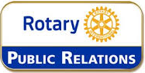

Public Relations Report

PP Bob Thompson

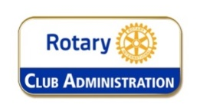

Genevieve Carr President 2026/27

November 3rd 2025

- International Dinner on Tuesday 25 November 2025
To be held at Mandurah Country club
Marsh Place, Halls Head WA
6pm for 6.30pm start
$25 per head; includes 2-course dinner

*Need to finalise numbers attending ASAP

- Christmas function at Golden Ponds Bistro on Sunday 14 December, commencing 12pm
Need to finalise numbers as soon as possible

- John and Chris Iriks have kindly invited members and partners to their home on Monday 22 December for a sundowner gathering instead of the usual club meeting. More details to follow

PE Genevieve Carr

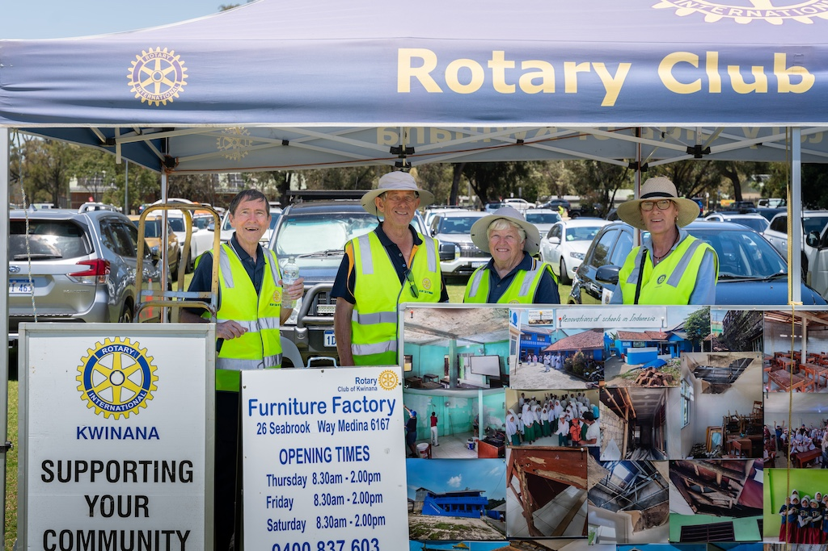

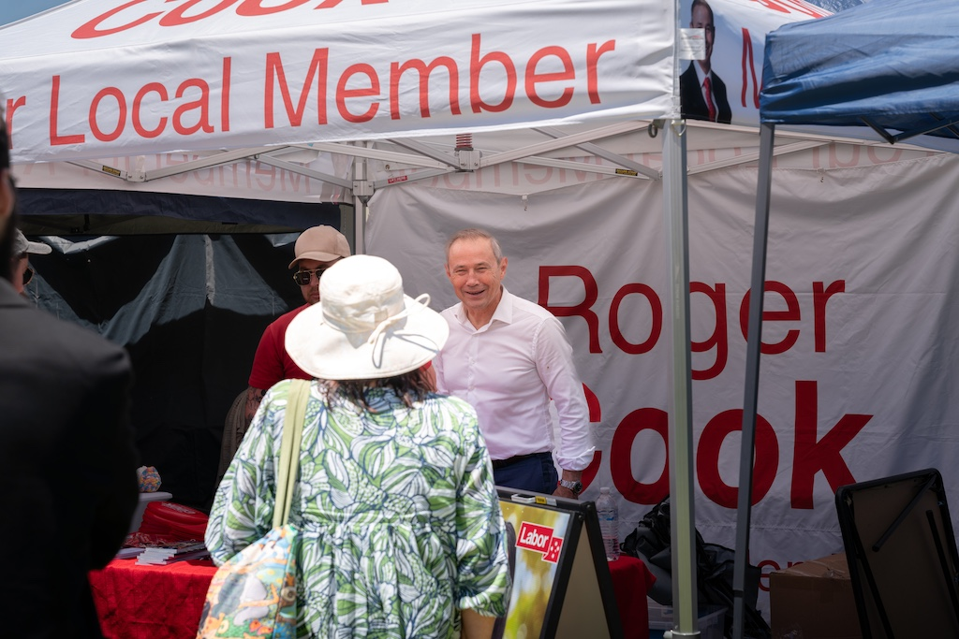

Outward Correspondence:
None

- Rotary Down Under magazine (nov/Dec)
- ShelterBox newsletter
- Notification regarding Australian Rotary Health Indigenous Health Scholarship program
- RDU Supplies update
- Notification regarding access to photos from Kwinana Community Fair
- Invitation to webinar re PolioPlus update
- ROMAC communication
- RDU.One
- Invitation to Peter Carnley Anglican Community School Senior School Awards event on Thursday 4 December
- Invitation to be part of next project team for Timor-Leste
- Letter of thanks from Margaret Court Community Outreach

Inward Correspondence.

PP Genevieve Carr 27th October 2025

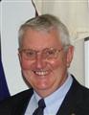

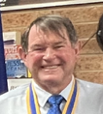


Foundation Dir.
PDG John Iriks

Project Director
PP James Sharkey
Treasurer
Karen Zabiela
Vice Pres.
Terry Evans

Team 2025/26


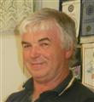

Events Manager
PDG John Iriks

Public Relations
PP Bob Thompson

Membership Dir.
Norm Mulcahy



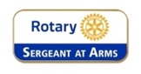

Fine Session: Sergeant Norm Mulcahy
PP Chris Oughton standing-in for Norm
- Partners Night on Monday 28 July: John and Chris Iriks will be guest speakers, speaking about their recent experiences in Timor

- Christmas in August: further details to be provided by President Steve

- Monday 15 September: District Governor’s visit. This will be a partner’s night.

- Sunday 21 September: Brunch with members and partners of the Rotary Club of Harvey (Peter Schulz’s club) at the Curious Cockatoo café in Harvey.

- Friday 24 October: Polio train ride. Good to see that a number of Club members intend of participating. Please ensure that you register via the TryBooking link in order to be covered by Rotary Insurance.

- Sunday 14 December: Looking to have Christmas function at King Road Brewing Company. This is to be confirmed, as the venue will not accept bookings for Christmas until September 2025 onwards.

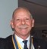
PP Stephen Castelli
stand-in when required.

The ‘Sergeant’ had a night-off

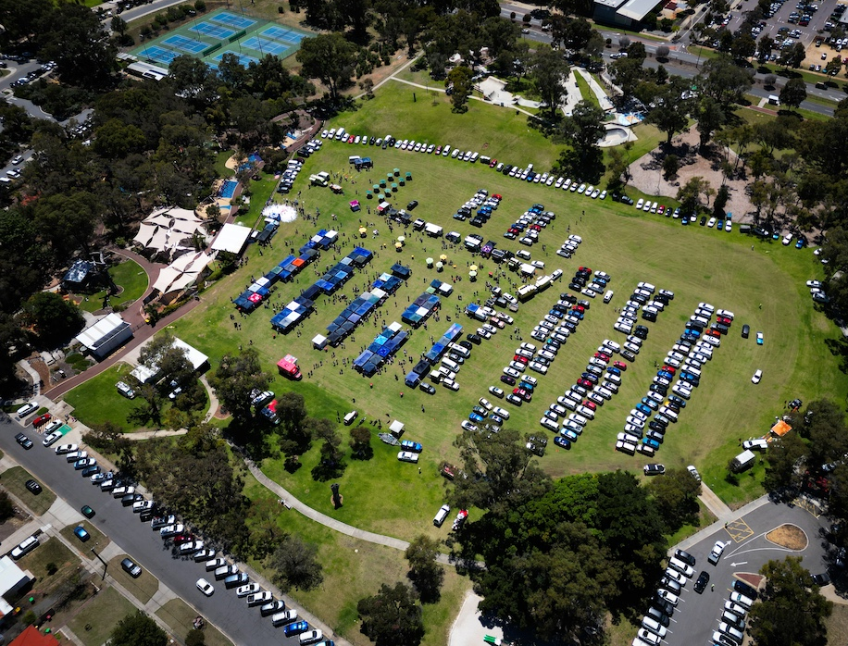

Polio This Week 10th November 2025

Gender champions lead the way in polio eradication

Senator Ayesha Raza Farooq, Prime Minister’s Focal Person for Polio Eradication in Pakistan, and Baroness Jenny Chapman of Darlington, UK Minister for International Development and Africa, are the latest GPEI Polio Gender Champions, committing to support the GPEI Gender Equality Strategy as a concrete effort to highlight the role of gender in polio eradication.

Two billionth dose of nOPV2 administered
Marking a landmark achievement, two billion doses of novel oral polio vaccine type 2 (nOPV2) have now been administered to children around the world, as part of intensified efforts to curb circulating type 2 variant poliovirus outbreaks (cVDPV2).

Summary of new polioviruses this week:

- Pakistan: 29 WPV1-positive environmental samples
- Algeria: one cVDPV2-positive environmental sample
- Djibouti: one cVDPV2-positive environmental sample
- Nigeria: one cVDPV2 case
- Papua New Guinea: one cVDPV2 case


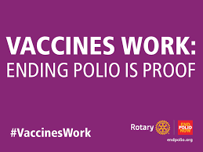


"If you live up to be 84 years old, you've spent roughly 28 years sleeping."

"Oxford University is older than the Aztec Empire."

"Greenland Sharks can live up to 500 years."
"They don’t reach sexual maturity until they are over 100 years old. When they get pregnant, gestation lasts up to 18 years."

"A million seconds is 12 days; a billion seconds is 31 years. That's the difference between a millionaire and a billionaire."

"It was only 66 years from the Wright brothers' first flight to Armstrong walking on the moon."

And finally...."If you earned 5000 dollars an hour, 24 hours a day, from when the pyramids in Egypt were constructed until today, the world's richest man would still have more money than you."

Birthdays and Anniversaries November 2025

Birthday Congratulations:

Norm Mulcahy 3rd
Soren Houlberg 5th
Bill Rowe 12th


.


Wedding Anniversaries

Club Anniversaries:

Edd Samut 16th 27 years
Genevieve Carr 29th 26 years

Congratulations

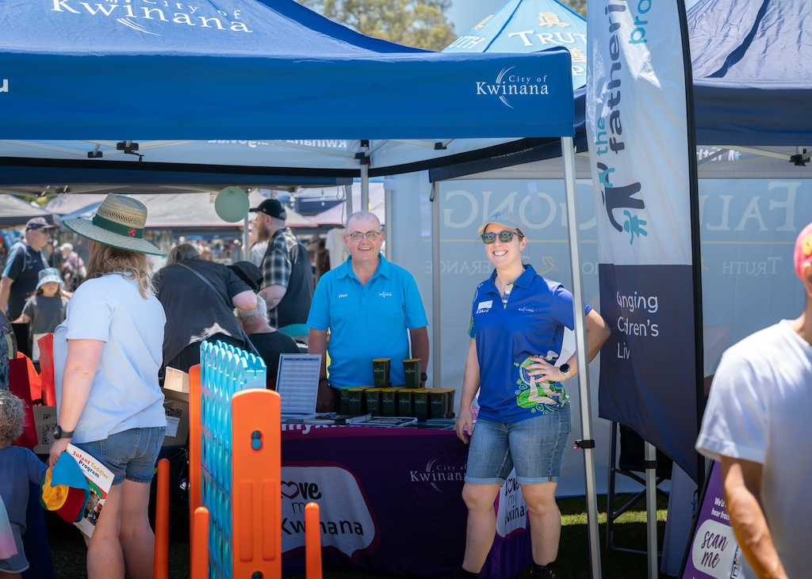





Nov. 10th to Nov. 16th

10th
1674: Dutch formally cede New Netherlands (New York) to the English
1793: France ends forced worship of God
1885: German engineer Gottlieb Daimler unveils the world's first motorcycle
1908: 1st Gideon Bible put in a hotel room

11th
1620: Mayflower Pilgrims, their 1st landing in America, at Provincetown Harbor, Massachusetts
1790: Chrysanthemums are introduced to England from China
1851: Alvan Clark patents telescope
1880: Australian Bushranger and outlaw Ned Kelly is hanged at Melbourne Gaol

12th
1439: Plymouth, England, becomes the first town incorporated by the English Parliament
1847: Sir James Young Simpson, a British physician, is the first to use chloroform as an anaesthetic
1912: British explorer Robert Falcon Scott's diary & body found in Antarctica
1919: Ross & Keith Smith start a 1-month flight from London to Australia

13th
1673: Christopher Wren is appointed architect for the rebuilding of St Paul's Cathedral in London
1789: Benjamin Franklin writes "Nothing certain ---- but death & taxes"
1851: Telegraph connection between London-Paris linked
1952: False fingernails 1st sold

14th
1666: Samuel Pepys reports on 1st blood transfusion (between dogs)
1856: American Gail Borden is issued a patent for technology for his invention of condensed milk
1883: "Treasure Island" by Robert Louis Stevenson is first published as a book by Cassell & Co.
1910: 1st airplane flight from deck of a ship, Norfolk, Virginia

15th
1492: Christopher Columbus notes 1st recorded reference to tobacco
1777: Articles of Confederation, the first constitution of the United States, is approved
1835: Charles Darwin reaches Tahiti on board HMS Beagle,
1837: Isaac Pitman introduces his shorthand system of writing, Pitman shorthand

16th
1824: New York City's Fifth Avenue opens for business
1840: New Zealand officially becomes a British colony
1871: National Rifle Association is first chartered in the State of New York
1920: Australia's Qantas airways founded in Winton, Queensland as Queensland and Northern Territory Aerial Services Limited



I told my wife she should embrace her mistakes. She gave me a hug.

Why don't eggs tell jokes? They might crack up!

What did the big flower say to the little flower? "Hi, bud!"

What did the grape say when it got stepped on? Nothing, it just let out a little wine

.I used to have a job at a calendar factory, but I got fired because I took a couple of days off.

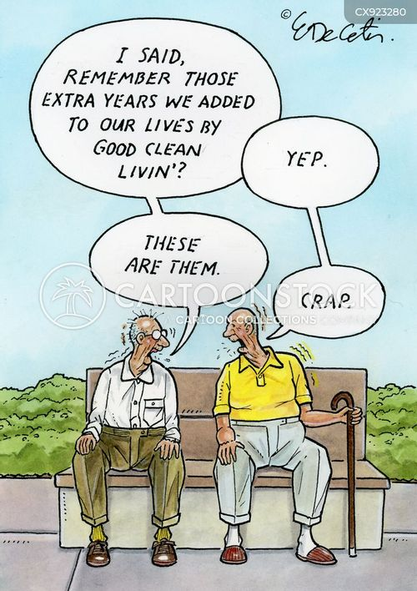
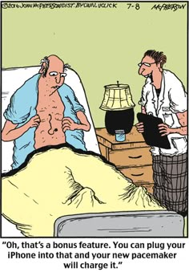
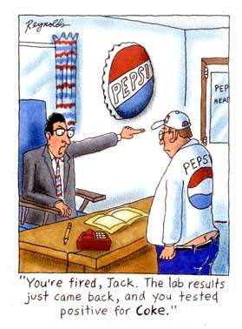

Rotary Club of Kwinana 2025

Nearby Rotary Clubs, Meeting Times

Rockingham Monday 6pm Armadale Tuesday 7pm
Palm beach Wednesday 6.30pm Mandurah Districts Tuesday 6pm
Baldivis Tuesday 6.30pm Pinjarra Thursday 6.45pm
Cockburn Wednesday 6pm Byford & Districts Monday 7pm

