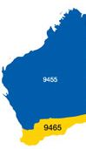

***The Rotary Club of Kwinana Inc.***

**District 9465 Western Australia**

**Chartered: 22 April 1971**

**Team 2019-20**

**President**

**Wendy Cooper**

**Secretary**

**Diane Brown**

**Treasurer**

**Bob Cooper**

**Attendance this week**

**Total Members 26 Apologies 2**

**Make-up 2 Attended 22**

**Honorary Member 1**

**LOA 2**

**Guests**

**Visitors**

**Partners**

92.6 %

**Facts & Figures**

**Raffle**

**Bevan & John W**

**Heads & Tails**

**Brian T**

**Birthdays:**

**Anniversary:**

**Club Anniversary:**

**If you had any we hope you had a good day**

Meets Monday

6 for 6.30pm

At Rotary Hall

Brownell Crescent, Medina

**Visitors always welcome**





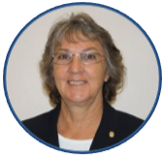

Bulletin

**President Wendy**

**No 20 25th Nov. 2019**

Entertaining meeting tonight, our scheduled Guest Speaker Chris Artemis was unable to attend, President Wendy then came up with a fun quiz to soak up the missing guest speaker spot.

We have a significant number (about 250) Rotary Club banners from clubs around the world located on the wall around Rotary Hall having been collected by club members visiting overseas clubs and from overseas and interstate members and visitors to our club.

Wendy then picked out a symbol or characteristic from a banner and we had to locate the banner from which it came, simplistic yes, but good fun. We then as a table had to locate 10 banners from a single geographical area, again pretty simple but did manage to fill in the time well.

Secretary Diane Brown is currently recovering from surgery she had recently, our good wishes Diane, speedy recovery required.

We are into December from next week, Christmas is almost with us, just a plug for our Christmas meeting, this year to be held in our traditional format at the Kwinana Bowling Club on Monday December 16th (please see flyer below)

PP Max Bird has just arrived in East Timor with a small party working at Baguia, departed Perth 24th November 2019 back around18th December 2019.

**District Governor**

**9465**

**2019/20**

**Wayne Milnes**

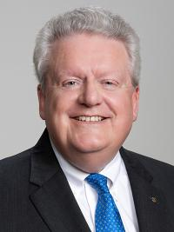

**Rotary International President**

**2019/20**

**Mark Daniel Maloney**

#### Rotary Club of East Nassau



**Coming Events November 2019**

**Rotary Foundation Month**

**Nov 2019**

Mon 25thClub Meeting Chris Artemis an AFL umpire

**Dec 2019**

Mon 2nd Club Meeting COK Waste Minimization Trish Kursar.

Mon 9th Club Meeting

Mon 16th Club Meeting Christmas Meeting

Mon 23rd No Meeting

Mon 30th No Meeting

**Attendance Officer:**

**Greg Williams**  **0435 083 069**

**Apologies by Saturday pm please**





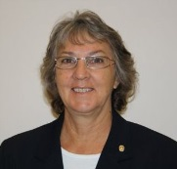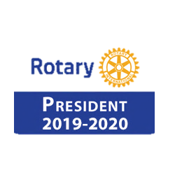

**Wendy Cooper**

President’s Pen

25th November 2019

Our meeting commenced with acknowledgement of the tremendous effort of the Fire Fighters keeping us safe. I had received a message during the afternoon from our Guest Speaker, Chris Artemis, that he had just been called to fight fires in the east. At the same time our sky was thunderous with the noise of 3 helicopters for nearly 4 hours fighting a local fire.

So what to do when your Guest Speaker is unable to

attend. Check out the Rotary website for ideas of

how to fill in. The result was what I called

“Baffling Banners”. Armed with some clues relating

to the banners we have hanging on the walls members

were asked to use the clues to locate a specific banner.



The winners, Bevan Piper,

Stephen Castelli and

Bob Thompson were

thrilled when Chris Oughton

produced fresh leeks from

his garden as prizes.

We talked about who presented some of the banners and where they came from. Then each table spent time finding and listing banners from four locations, WA, USA, UK and Japan.

One of the more colorful traditions of Rotary is the exchange of club banners. Rotarians traveling to distant locations often take banners to exchange at make-up meetings as

a token of friendship.

Many clubs use the decorative banners they have received for attractive displays at club meetings and district events.

By 1959, exchanging banners had become so popular that the RI Board

of Directors was concerned the practice would be a financial burden on

clubs. It urged Rotarians to "exercise discretion, moderation, and

measured judgment in making provision for such exchanges.

" The approximately 20,000 banners in the Rotary History and Archives

collection reflect clubs' hometown pride and their connection with the

international organization. In addition to incorporating the Rotary

emblem, banners often include symbols or imagery of a club's town,

region, or country. Others represent local craftsmanship or cultural

traditions by displaying leatherwork, weaving, embroidery, or

hand-painted designs.

If you're traveling to another state or country,

and want to take a Kwinana banner with you to exchange

(giving your banner to the Club President), see PDG Bob Cooper Our Club Banner

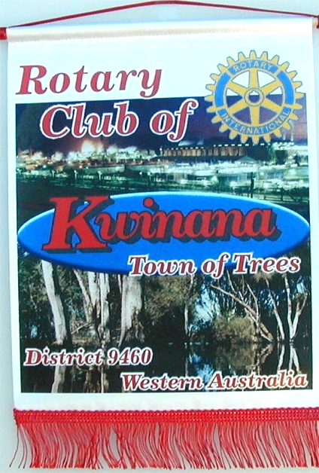



President 2020/21 PE John Iriks

**Club Service report. 18th November 2019**

AGM and elections for 2020/2021

Reviewing our ‘Standing Orders’ compatibility with our recent updated Constitution and By-Laws

AGM date set for 9/12/2019

Club service director and club secretary will prepare for the nomination of elected positions in accordance with constitution and by-laws in time for the AGM meeting.

Looking for a nomination for President for 1921/22, members please give some thought into the possibility of nominating, a recycled President is always a good option, there’s quite a lot of those currently in our club.

Our original club banner from the early 1980s.

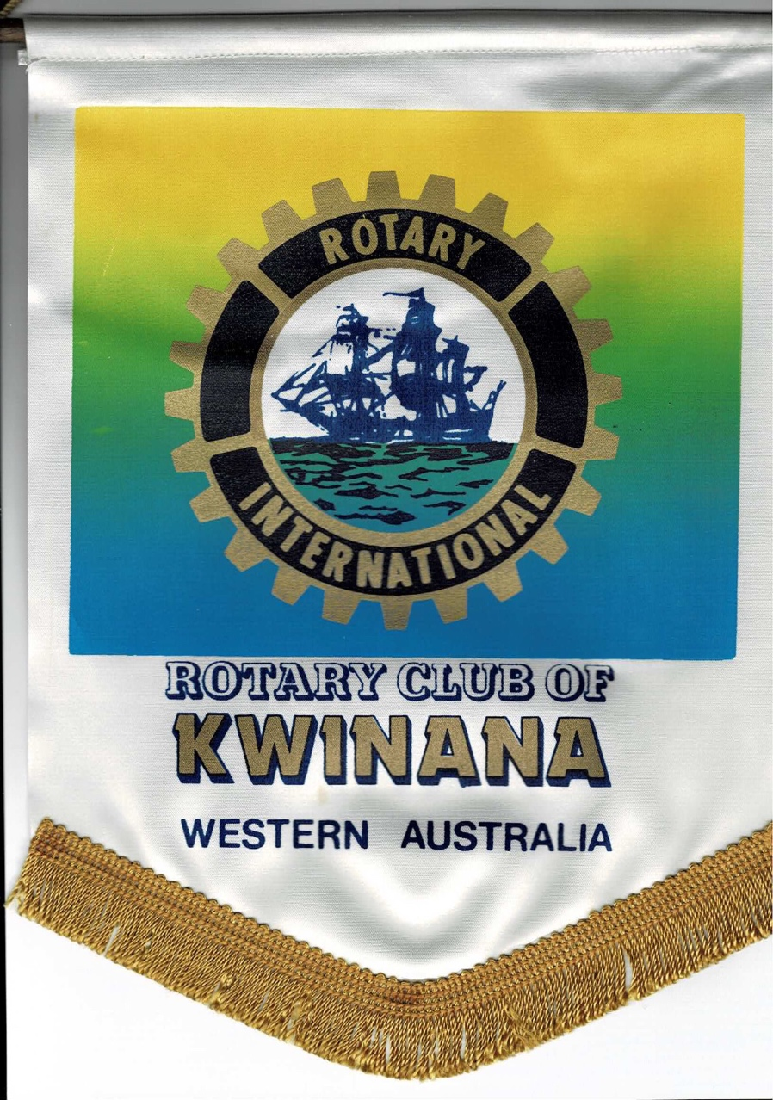

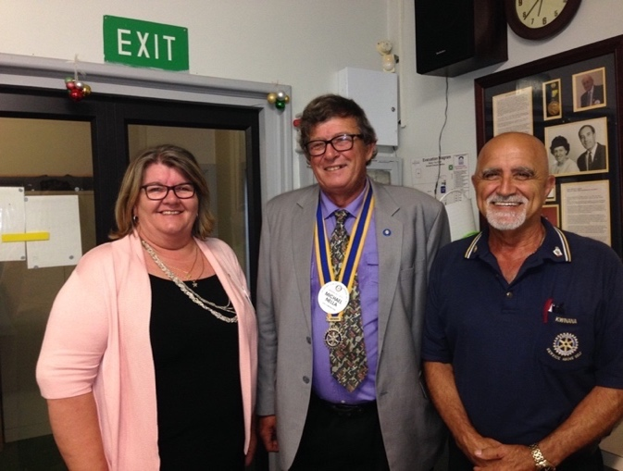

**Rtn Diane Brown**

No Report

Secretary Diane is currently recovering from recent surgery, club members wish you well,

Speedy recovery in order.

Inward Correspondence.

Outward Correspondence.

Would members please note that any correspondence received or posted by yourself, please ensure a copy is forwarded to your Secretary.



**PDG Bob Cooper**

Bills paid, money in the bank.

Receiving ‘Letters of Thanks’ from local schools, after receiving our annual donation for their end of year graduations.

Members are requested to ensure they contact PP Greg Williams by Sunday am with any apology for the next meeting. We are having to pay for meals ordered for you and not used because of non-attendance.

## 

**Treasurer: PDG John Iriks**

* Money in the Bank. Bills paid
* Financial Report to May 30th prepared for inclusion in our Annual Report, financials to June end will then be completed ready to be audited.

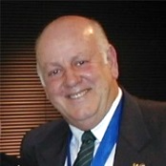

A little, silver-haired lady calls her neighbor and says,

“Please come over here and help me. I have a very difficult jigsaw puzzle, and I can’t figure out how to get started.”

Her neighbor asks, “What is it supposed to be when it’s finished?”

The little lady says, “According to the picture on the box, it’s a rooster.”

Her neighbor decides to go over and help her with the puzzle. When he arrives, the old lady shows him the puzzle spread out all over the table. He studies the pieces for a moment, then looks at the box, then turns to her and says:

“First of all, no matter what we do, we’re not going to be able to assemble these pieces into anything resembling a rooster.” Then he takes her hand and says, “Secondly, I want you to relax. Let’s have a nice cup of tea, and then...” and he says this with a deep sigh...

“Let’s put all the Corn Flakes back in the box.”

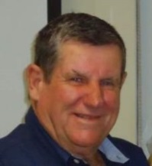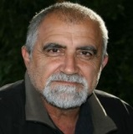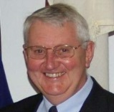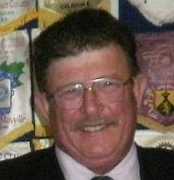



PP Edd Samut

Membership Dir.

PP James Sharkey

Public Relations Dir.

PP Max Bird

Foundation Dir.

Projects Director

PP Mike Nella

Project Director’s Report.

Gentle Road premises now open for business, business steady.

First Lolly-Run meeting at the COK September 17th will be meeting monthly till Christmas.

Looking for a few more volunteers to help out Christmas Day.

Lolly bagging will take place Tuesday 3rd Dec.

Ken Jackman Room, 2.30pm on till finished, everyone welcome to come along and help.

Sleighs to be picked up on 22nd December.

Garage Sale this Saturday 30th November 2016.

**Public Relations:**

We continue to receive exposure on Rotary Out West.

Please continue to advise James of any stories or activities within our club which may be submitted to the local media.

We have a number of Bunnings BBQ’s scheduled over the next 12 Months

Sat. Dec 21st ??

Future dates: Sunday 9th February 2020 & Saturday 21st November 2020

**Membership:**

Ed is currently holidaying in Victoria.

**Community:**

Golf Day completed, thanks to everyone concerned.

**Vocational:**

**International:**

PP Max is currently in East Timor till 18th December.

Plan to hold a Rotary Foundation Function in the not too distant.

Latest meeting minutes available to view on ClubRunner.

**Youth:**

Actively looking for participants for RYPEN, RYLA and Handicamp.

We have 2 candidates for RYLA,

We have a lady Handicamp candidate.

* Visit your club webpage.

<http://www.clubrunner.ca/Portal/Home.aspx?accountid=8106>

or type Kwinana Rotary Club into ‘Search’

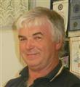

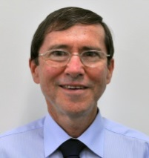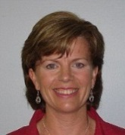

PP Bob Thompson

Vocational

Rtn. Norm Mulcahy

Community

PP. Max Bird

International

PP Genevieve Carr

Youth



**Fine Session:**   **Sgt. Cyril Bennett**

Deputy Bill Rowe.

# 

.

.

Cyril B: Cyril read out a convoluted and detailed explanation of why they missed the bread pick-up last week.

Chris O: Was seen calling Bingo last week?

James S: Has a diary for his Rotary commitments, some noticed its actually last years diary.

John W: Nursing a dislocated/torn shoulder.

Genevieve C: Fined for being 30secs late.

Stephen C: Playing the ‘Waiter’ collecting plates from other tables.

John I: John circulated a Christmas meeting list, John Wallhead was missing.

Stephen C: Called Mike Nella the other day 4 times from his pocket!!!

Chris O: Apparently has difficulty telling butter from cheese.

Mike N: Visited Norm last weekend, walked straight into a patch of wet cement.

### The leaders of the Big Three after the conference in Yalta

After WW2 in 1945 the leaders of the Big Three(USA, UK and the Soviet Union) respectively Roosevelt, Churchill and Stalin met in Yalta for a conference to decide the fate of the world.  
  
After the conference they wanted to have some fun. They decided to try and make the Persian cat in the residence to eat mustard.  
  
Churchill started first. He took a silver spoon with some mustard and tried his best to feed the cat but failed.  
  
-You British people don't understand, it should be done with democracy - said Roosevelt.  
  
He took some chicken and put some mustard on it. The cat sniffed for a moment but walked away with no interest in the food he offered.  
  
Without any hesitation Stalin took the cat and started to spread mustard on the fluffy tail. The cat started meowing loudly and licked the tail to wash out the mustard. Meowed and licked, meowed and licked... Then Stalin said wisely:  
  
-That's how we do everything in our country, voluntarily and with a song.

**Polio This Week 20th November 2019**

US$2.6 billion. That is the amount pledged for polio eradication by global leaders at the Reaching the Last Mile Forum in Abu Dhabi.

**ABU DHABI, 19 November 2019** – Today, global leaders convened at the Reaching the Last Mile (RLM) Forum in Abu Dhabi to affirm their commitment to eradicate polio and pledge US$2.6 billion as part of the first phase of the funding needed to implement the Global Polio Eradication Initiative’s Polio Endgame Strategy 2019-2023.

This pledging event comes on the heels of a major announcement last month that the world has eradicated two of the three wild poliovirus strains, leaving only wild poliovirus type 1 (WPV1) still in circulation. Additionally, Nigeria – the last country in Africa to have cases of wild polio – has not seen wild polio since 2016 and the entire WHO African region could be certified wild polio-free in 2020. Thanks to the dedicated efforts of health workers, governments, donors and partners, wild polio only circulates in two countries: Pakistan and Afghanistan.

Summary of new viruses this week (AFP cases and ES positives): Afghanistan – one WPV1 case and two positive environmental samples;

Pakistan— four WPV1 cases, two WPV1-positive environmental samples and two cVDPV2 cases;

Nigeria – one cVDPV2 case;

Democratic Republic of the Congo (DR Congo)- three cVDPV2 cases; Central African Republic – two cVDPV2 case;

Angola— three cVDPV2 cases.

Pledges are from a diverse array of donors, including: US$160 million from the host of the pledging moment **His Highness Sheikh Mohamed bin Zayed Al Nahyan, Crown Prince of Abu Dhabi;**

Countries, including US$215.92 million from the **United States,**

US$160 million from **the Islamic Republic of Pakistan,**

US$105.05 million from **Germany,**

US$84.17 million from the **Federal Government of** **Nigeria,**

US$10.83 million from **Norway,** US$10.29 million from **Australia,**

US$7.4 million from **Japan,** US$2.22 million from **Luxembourg,**

US$1.34 million from **New Zealand,** US$116,000 from **Spain,** and US$10,000 from **Liechtenstein**;

GPEI partners, including US$1.08 billion from **the Bill & Melinda Gates Foundation** and

US$150 million from **Rotary International**;

Philanthropic organizations, including US$50 million from **Bloomberg Philanthropies**,

US$25 million from **Dalio Philanthropies,** US$15 million from the **Tahir Foundation,** US$6.4 million from the **United Nations Foundation,**

US$2 million from **Alwaleed Philanthropies,** US$1 million from the **Charina Endowment Fund,** and US$1 million from **Ningxia Yanbao Charity Foundation**; and the private sector, including US$1 million from **Ahmed** **Al Abdulla Group,**

US$1 million from **Al Ansari Exchange,** and US$340,000 from **Kasta Technologies**.

Earlier this month, the **United Kingdom** announced it would contribute up to US$514.8 million to the GPEI.







Just a few of the happy faces at our meeting this week





Donald Trump, Theresa May, and Angela Merkel are walking outside after a particularly stressful diplomatic meeting.  
  
As they walk in silence, one of them stumbles on a small rock - but when they investigate, they find it is not a rock at all, but an antique oil lamp.  
  
“Maybe there's a genie,” says Donald. The women seem skeptical, but the three of them pry the lamp from the ground, and together, they rub it.  
  
Sure enough, a genie pops out. The mystical creature floats above them, sweet smelling smoke hanging around him as he smiles down upon the three world leaders.  
  
“You have summoned me,” the genie says. “You may have one wish each.”  
  
The Donald does not hesitate. “The American people voted for me to build a wall,” he says, “So, I want you to build a big, beautiful wall around the USA.”  
  
The genie claps his hand, and a mighty thunderclap sounds. “It is done,” he booms.  
  
Theresa May thinks, then says, “The British people voted for Brexit, so we could have control of our borders,” she says. “I'd like a strong and stable wall around the UK.”  
  
Another clap. “It is done.”  
  
Now, Merkel looks thoughtful. “Before I make my wish - can I ask, what are the walls like?”  
  
The genie says, “Each wall is 500 feet tall. They are 50 feet wide. The foundations go down another 200 feet. And nothing can get in or out.”  
  
“Excellent,” Merkel says, a rare grin crossing her face. “Fill them both with water.”

### What's the difference between watts and ohms?

Watts are a unit of electrical energy. Ohms are where British people live.

An elderly looking gentleman, (mid-nineties) very well dressed, hair well groomed, great looking suit, flower in his lapel, smelling slightly of a good after shave, presenting a well-looked-after image, walks into an upscale cocktail lounge. Seated at the bar is an elderly looking lady. The gentleman walks over, sits alongside her, orders a drink, takes a sip, turns to her and says, “So tell me, do I come here often?”



**Makeup opportunities**

**Rockingham Monday 6pm for 6.30 Rockingham RSL Club**

**Palm beach Wednesday 6pm for 6.30 Ocean Clipper Inn**

**Baldivis 1st & 3rd Mon 6.30pm for 7.00 Peel Manor House**

**Cockburn Thursday 7.15am for 7.30 Cockburn Seniors Centre**

**Byford & Districts Monday 6.15pm for 6.45 Byford Tavern, South W Hwy**

Media Release

For further information please contact

**Marketing and Communications on 08 9439 0435**

**Rotary Club of Kwinana**  **Contributions welcome:** [**eblogg@bigpond.com**](mailto:eblogg@bigpond.com)