

The Rotary Club of Kwinana

District 9423 Western Australia

Chartered: 22 April 1971

Bulletin

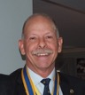
Team 2025/26

President
Stephen Castelli

Secretary
Genevieve Carr

Treasurer
Karen Zabiela

Facts & Figures

No 21 08/12/2025

Rotary Club of Kwinana is 54 years’ old 1971/2025

Quiet meeting tonight, 11 members attended, officiated by VP Terry in the absence of President Stephen who is currently visiting family in Melbourne to welcome the 11th grandchild, “congratulations”.
Youth manager Alan Johnson advises that all the school graduation timeslots are filled and underway.

Next week we have our scheduled Annual General Meeting together with receiving and accepting nominations for executive positions for 2026/27.
We do have a President for 2026/27 in Genevieve Carr, but we do need a nomination for President/Club Service for 2027/28.

We are also without a secretary; PP Genevieve is currently handling both roles so that role needs to be filled not only for 2026/27 but for the rest of this current Rotary year.

Recognising that on December 1st PDG John Iriks has clocked up 46 years’ service to the Kwinana Rotary Club and the Kwinana Community.

Attendance this week
Total Members 26 Apologies
Make-up 5 Attended 11
Guests
Visitors
Partners
66%



District Governor 9423
2025/26

Veronica Lawrance

Rotary Club of Mill Point

Rotary International President
2025/26

Francesco Arezzo

Rotary Club of Ragusa, Italy

Raffle
Max & Yanti

Heads & Tails
Soren


December 2025 – Disease Prevention and Treatment Month

Mon 1st Club Meeting Zoom catchup with Tony Miller

Mon 8th Club Meeting

Sun. 14th Christmas at Golden Ponds 12 noon

Mon 15th Club: Annual General Meeting

Mon 22nd Christmas at the Iriks.

Attendance: Members respond via ‘WhatsApp’



Meets on Monday
6:00 for 6:30 pm
At Rotary Hall
Brownell Crescent
Medina

Visitors are welcome
Contact
0400 837 603








President’s Pen December 8th 2025

The board suggested that each week, we get a member to do a bit of research on an unusual fact about Rotary that could be provided to all attendees as “Rotary Information”
I commenced the weekly presentation with the following:
Rotary’s primary moto is “Service above Self”, but what is Rotary’s secondary moto?
It is in fact “One Profits Most Who Serves Best”
PDG John Iriks will do next week.

Calendar of Events:
There are quite a number of events coming up in December.

15/12 – RC Kwinana AGM. This will be for election of office bearers for the 2026/2027 Rotary year, as well as presentation of the annual financial reports.
Nomination forms for the board positions have been emailed out. We really need to fill each of these positions to ensure that we have a vibrant club moving forward.

The revised Standing Orders (as they stand) have been circulated to the members for their review. The Standing Orders will then go to the board for their review and approval. The final step will be for the revised Standing Orders document to be tabled at the AGM for approval.

Monday 22/12 – No meeting as the Irik’s have invited us to their house for a Christmas Sundowner Evening. Please advise Christine Iriks if you are bringing a salad or a desert.

No meeting 29/12

No meeting 05/01

We are looking at doing a BBQ at the hall during January. Please advise if you can help.

No meeting on Monday 26/01 as this is Australia Day.

John Maskell, Yanti and I assisted the Frank Konecny Community Centre by taking the furniture truck to Foodbank near the airport and collected 250 Christmas Hampers. We estimate that the total weight was 2.5 Tonne and completely filled the back of the truck.
Our backs have been reminding us of this ever since.

I will be away visiting family in Melbourne as we have a new grandchild there (number 11), so will not be in attendance on 08/12.

President Stephen





Three guys died and went up to heaven. St. Peter is at the gate a d tells them that this is a busy time of the year and you must bring something Christmassy to be let in.
So, the first guy digs in his pocket, finds a set of keys and dangles them in front of St. Peter who says, “you mean those are Christmas bells”. Of course, the guy says and Peter tells him to go ahead in.
The second guy digs in his pockets and finds a lighter which he flicks. “You mean Christmas lights” Peter says and tells him to go ahead.
The third guy desperately digs in his pocket and finally pulls out a pair of women’s panties. “What on earth does this have to do with Christmas” Peter asks.
“Oh” he says, “they are Carols”.

A guy bought his wife a beautiful diamond ring for Christmas.
After hearing about this extravagant gift, a friend of his said, "I thought she wanted one of those sporty four-wheel-drive vehicles."
"She did," he replied. "But where was I going to find a fake Jeep?"



Public Relations Report Dec. 2025

Our Club received good positive feedback on our staging of the 2025 Rotary
Kwinana Community Fair.
A meeting was held Tuesday 25 November with James and Tim of Media Engine at
Rockingham and between Bob Thompson and John Iriks.
The meeting discussed the Club's use of Face Book and social media
opportunities and strategies for our Furniture Factory sales and for Rotary
promotion.
A proposal from Media Engine on how they could work with the Club to improve
our advantage through our Face Book and social media presence, together with
the cost to us for their services, will be sent to us soon for the Club's
consideration.

PP Bob Thompson


Genevieve Carr President 2026/27

December 2025

- Christmas function on Sunday 14 December at Golden Ponds Bistro, commencing 12pm: Please advise as soon as possible if you are attending.

- 2025 AGM: Set for Monday 15 December during Club meeting. Nomination forms for Club positions during 2026 – 2027 are available.

- Christmas sundowner at the home of John and Chris Iriks on Monday 22 December. BYO drinks; John and Chris will provide chicken and nibbles. Please advise Chris as soon as possible if you are planning to bring either a salad or dessert

PE Genevieve Carr


Outward Correspondence:

- Card and message of thanks sent to Colin Brown (James Sharkey’s brother-in-law) for his generous donation of $1000 to our Club

- ShelterBox promotion
- Reminder from RI to update Club database by 1 January 2026
- Invitation to RYLA dinner at Serpentine Camping Centre on Wednesday 14 January 2026
- Reminder re District AGM on Wednesday 10 December at 5.30pm (Genevieve will attend)
- Announcement of RISPPO’s new Regional Council Membership Director – PDG David Barton!
- Membership Minute from RI
- RotaryWA Round-Up #41
- RDU Supplies update
- RDU.One
- District Conference Newsletter #3
- Rotary Foundation Annual Report

Inward Correspondence.

PP Genevieve Carr 08th Dec. 2025

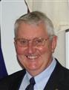

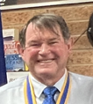


Foundation Dir.
PDG John Iriks

Treasurer
Karen Zabiela
Vice Pres.
Terry Evans
Project Director
PP James Sharkey

Team 2025/26


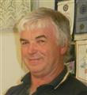

Events Manager
PDG John Iriks

Public Relations
PP Bob Thompson

Membership Dir.
Norm Mulcahy

Meeting at Rotary Hall Monday 8th December 2025

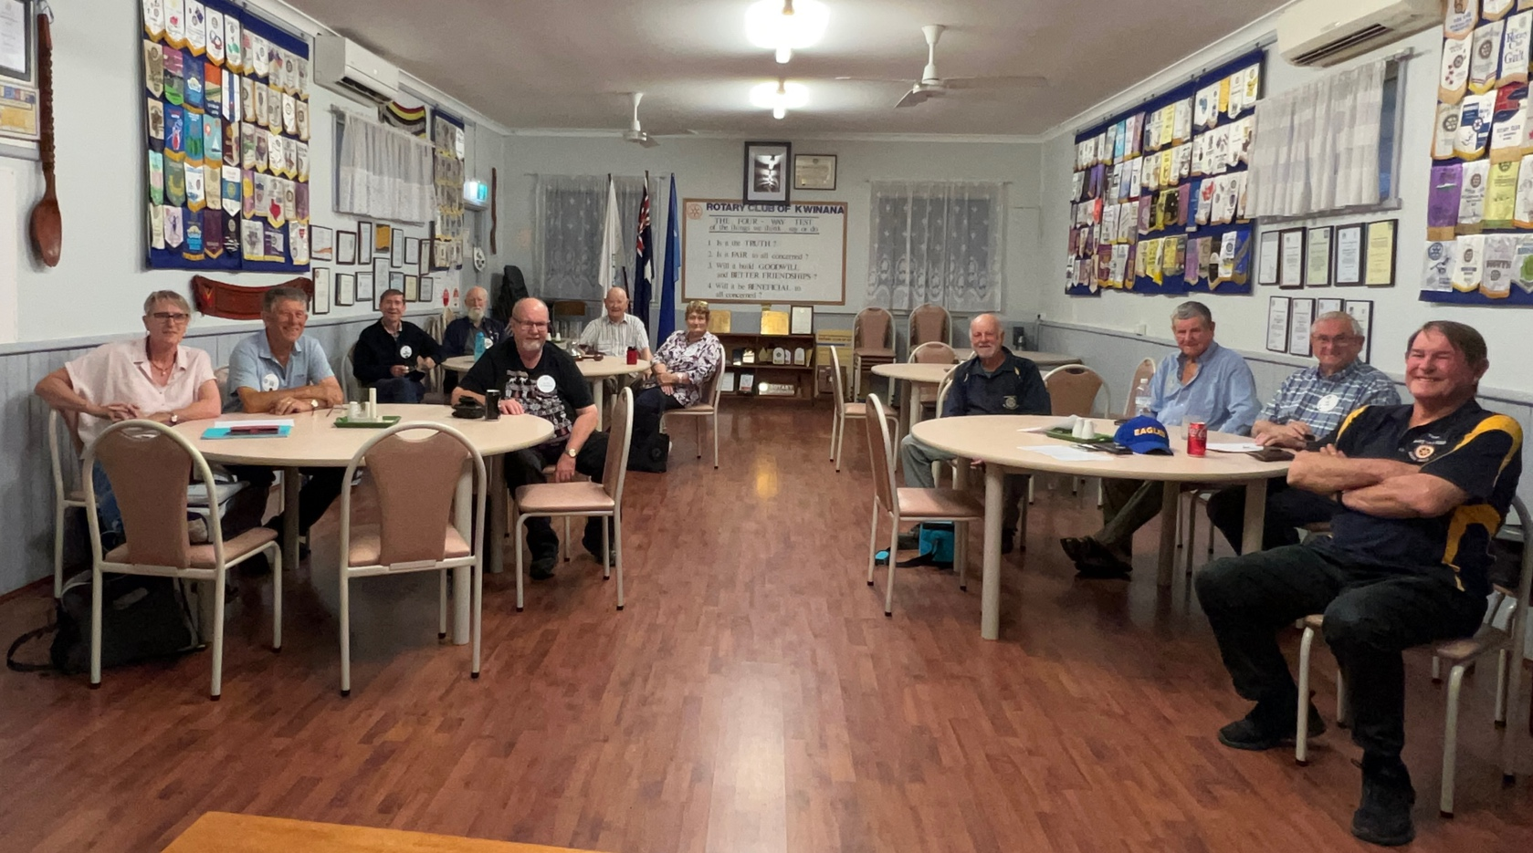

Global leaders have pledged US$1.9 billion in Abu Dhabi to support polio eradication efforts, aiming to protect 370 million children annually and close the funding gap for the Global Polio Eradication Initiative’s 2022–2029 Strategy.
The event, hosted by the Mohamed bin Zayed Foundation for Humanity in partnership with GPEI, brought together international leaders, philanthropists, and health partners. Major contributions include $1.2 billion from the Gates Foundation, $140 million from the Mohamed bin Zayed Foundation, $450 million from Rotary International, and additional support from governments and organisations worldwide.
This renewed commitment will accelerate vaccination campaigns, strengthen health systems, and help reach children in the remaining endemic countries. With wild poliovirus now endemic only in Afghanistan and Pakistan, these efforts are crucial to achieving a polio-free world and safeguarding future generations.





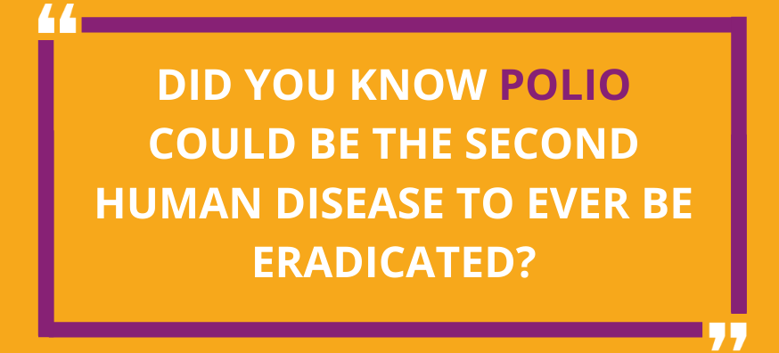

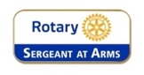

Fine Session: Sergeant Norm Mulcahy
PP Chris Oughton standing-in for Norm
- Partners Night on Monday 28 July: John and Chris Iriks will be guest speakers, speaking about their recent experiences in Timor

- Christmas in August: further details to be provided by President Steve

- Monday 15 September: District Governor’s visit. This will be a partner’s night.

- Sunday 21 September: Brunch with members and partners of the Rotary Club of Harvey (Peter Schulz’s club) at the Curious Cockatoo café in Harvey.

- Friday 24 October: Polio train ride. Good to see that a number of Club members intend of participating. Please ensure that you register via the TryBooking link in order to be covered by Rotary Insurance.

- Sunday 14 December: Looking to have Christmas function at King Road Brewing Company. This is to be confirmed, as the venue will not accept bookings for Christmas until September 2025 onwards.

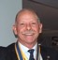
P Stephen Castelli
stand-in when required.

There were a couple of fines this week, unfortunately they weren’t recorded.

Some strange Christmas traditions

Australian Christmas traditions are unique due to the summer season, featuring beach-loving Santas (often on surfboards!),
Christmas lunch with seafood and BBQ, playing backyard cricket, and leaving Santa a cold beer instead of milk, alongside huge community events like Carols by Candlelight and the iconic Boxing Day Test cricket match.

Unique Aussie Twists:
- Surfing Santas & Beach Celebrations: Instead of snow, Aussies hit the beaches in swimwear, with some even dressing as Santa to catch waves.
- Santa's Cold Beer: Santa gets a cold beer and carrots for the reindeer, not milk and cookies.
- Christmas Day Lunch: It's a summer feast of prawns, seafood, ham, salads, and Pavlova, often eaten outdoors or at the beach.
- Cricket Everywhere: Backyard cricket is a staple, with the action often spilling onto quiet streets, sometimes using wheelie bins as stumps.
- Fire Truck Santas: In many neighbourhoods, Santa arrives on a fire truck, throwing lollies to kids.



Polio This Week 8th December 2025

Gavi and GPEI Boards Meet to Boost Immunization and Drive Polio to Zero
The Boards of Gavi and the Global Polio Eradication Initiative met for their second joint session, focusing on one shared mission: reaching the world’s zero-dose and under-immunized children — and keeping the world on track to finish polio for good. More.

Global Polio Certification Experts Meet in Geneva to Assess Progress and Next Steps
The Global Commission for the Certification of Poliomyelitis Eradication (GCC) met in Geneva last week to review the worldwide polio situation, including regional vaccination and surveillance trends. The experts examined current strategies — including the GPEI Action Plan 2026 — and discussed how to accelerate eradication while strengthening protection in polio-free regions.

Integration in Action: Polio Team Helps Stop Latest Ebola Outbreak in DRC
The Democratic Republic of the Congo has officially declared the end of its recent Ebola outbreak — and the polio eradication network played a key role. Working with the Ministry of Health, WHO deployed experienced polio experts to strengthen surveillance, logistics, contact tracing and community engagement in affected areas of Kasai Province. A perfect example of how polio infrastructure protects far more than polio alone. More.

Africa Gets a New Tool for Smarter Health Decisions: The AFRO Geodatabase
WHO’s African Region has launched the new AFRO Geodatabase — a trusted, continent-wide source of verified administrative boundary data designed to improve geospatial governance and support stronger, data-driven public health decision-making in every country. More.

New Rotary Video: How the Global Polio Lab Network Detects and Tracks Poliovirus
A new Rotary educational video takes you inside the Global Polio Laboratory Network — the “eyes and ears” of polio eradication — and shows how labs around the world detect, confirm and genetically track polioviruses to guide outbreak response. More.

Summary of new polioviruses this week:
- Angola: one cVDPV2 case
- Chad: two cVDPV2-positive environmental samples
- DR Congo: two cVDPV2 cases
- Papua New Guinea: seven cVDPV2-positive environmental samples





Birthdays and Anniversaries December 2025

Birthday Congratulations:

Alan Johnson 2nd
Deryl Wallhead 4th
Terry Evans 6th
John Walhead 12th
Lucy Cuplovic 13th
Sam Cuplovic 20th
Sam Winmar 20th
Lynne Bennett 25th
Edd Samut 26th



.


Wedding Anniversaries

Max & Diane 24th 59 years
James & Cathy 20th 56 years

Congratulations
Club Anniversaries:

John Iriks 1st 46 years
Karen Zabiela 1st 3 years
Sam Cuplovic 3rd 18 years
Terry Evans 23rd 23 years since 1st joined RC Kwinana

President Stephen ‘on the go’
Getting acquainted with the 11th grandchild.
Doing my little bit & I scored some socks.

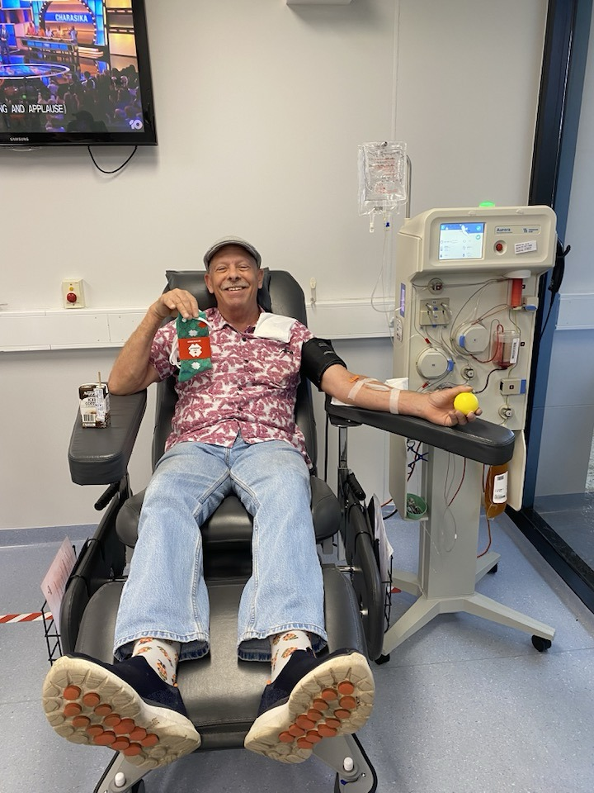
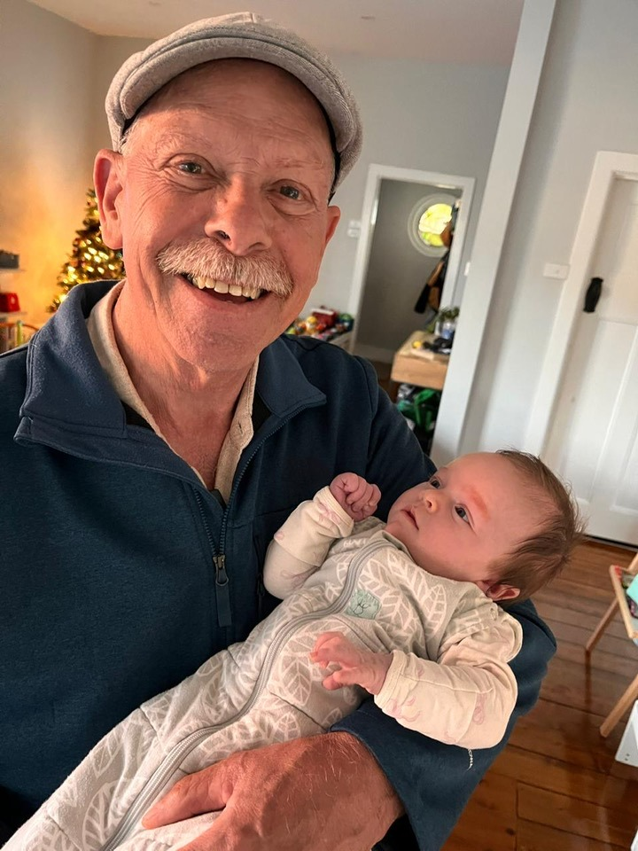





Dec. 8th to Dec. 14th

8th
1854: Pope Pius IX proclaims Immaculate Conception, makes Mary, free of Original Sin
1914: Battle of the Falkland Island: British Royal Navy destroys a German battle squadron
1931: Coaxial cable patented
1941: US and Britain declare war on Japan, US enters World War II

9th
1783: First execution at Newgate Jail in London (now the site of the Old Bailey),
1868: The first traffic lights are installed outside the Palace of Westminster in London
1926: USGA legalizes steel shaft golf clubs
1960: 1st broadcast of "Coronation Street" on British ITV

10th
1768: First part (number) of the Encyclopedia Britannica is published in Edinburgh, Scotland
1799: Metric system first adopted in France
1898: Spain declares war against the United States
1901: First Nobel Peace Prizes awarded to Red Cross founder Jean Henri Dunant & Frederic Passy

11th
1620 Mayflower Pilgrims arrive in Plymouth Bay, traditionally thought to be at Plymouth Rock.
1792: Captain Arthur Phillip, first Governor of the New South Wales colony, returns to England.
1903: The world's first wildlife preservation society is founded.
2015: Australian naturalist and controversial conservationist Harry Butler dies.

12th
1822: Mexico officially recognized as an independent nation by US
1858: 1st Canadian coins circulated (1 cent, 5 cent, 10 cent & 20 cent)
1901: Guglielmo Marconi sends the first transatlantic radio signal
1955: 1st prototype of hovercraft patented by British engineer Christopher Cockerell

13th
1577: Francis Drake sets sail from England on a circumnavigation of the world
1642: Dutch explorer Abel Tasman sights the South Island of present-day New Zealand.
1816: Patent for a dry dock issued to John Adamson, Boston
1974: Malta becomes a republic

14th
1656: Artificial pearls 1st manufactured by M. Jacquin in Paris made of gypsum pellets, fish scales
1751: The 1st military academy in the world, the Theresian Military Academy, is founded in Austria
1798: David Wilkinson of Rhode Island patents a nut & bolt machine
1903: he Wright brothers attempt to fly the Wright Flyer for the first time at Kitty Hawk



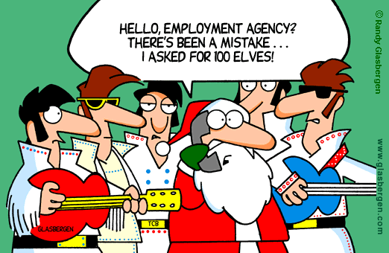

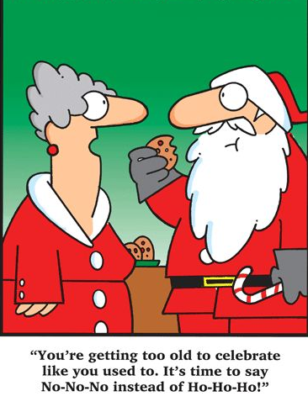
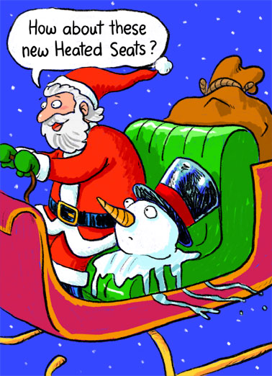
Rotary Club of Kwinana 2025

Nearby Rotary Clubs, Meeting Times

Rockingham Monday 6pm Armadale Tuesday 7pm
Palm beach Wednesday 6.30pm Mandurah Districts Tuesday 6pm
Baldivis Tuesday 6.30pm Pinjarra Thursday 6.45pm
Cockburn Wednesday 6pm Byford & Districts Monday 7pm

