
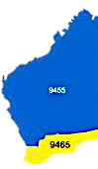

Team 2020-21

President
John Iriks

Secretary
Brian McCallum

Treasurer
Stephen Castelli

Facts & Figures

Attendance this week

Total Members 30 Apologies 2
Make-up 3 Attended 24
Hon. Member
LOA
Guests 2
Visitors
Partners
93.1%

Raffle
John M & Bob T

Heads & Tails
Barry W

Meets Monday
6 for 6.30pm
At Rotary Hall
Brownell Crescent, Medina

Visitors always welcome
The Rotary Club of Kwinana

District 9465 Western Australia

Chartered: 22 April 1971

Bulletin
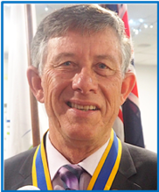

No 22 7th Dec. 2020

Rotary Club of Kwinana is in its 50th year 1971/2021
President John

Pleased to say that I have had no further issues with my cracked head, got the staples out Wednesday, all good. Bit of good hearted humour tonight, John Maskell produced a small step ladder for me to stand on, called Eric’s High Chair, a hard hat and a high-vis jacket to wear while I’m perched on the ladder to take any future photo’s, still very thankful we can all have a laugh a week on. Our Christmas Meeting next Saturday night at the Bowling Club, should be a good night, remember no meeting next Monday the 14th December. WA borders were opened to most of Australia on Tuesday 8th , our son Michael, who lives in Melbourne, wasted no time in coming to see us after almost 12 months, arrives in Perth on Wednesday 9th . We welcomed Rohan Smith, Gilmore College Principle, Rohan has, over the years been quite a regular visitor to our club bringing us up to date on the happenings at Gilmore College, Rohan has a tough task at Gilmore, problems with just a few of the 1200 students always seem to find their way into the media and are usually portrayed in a negative context. Rohan always ooze’s enthusiasm and is dedicated to making a difference at Gilmore. Rohan taking on a new education role from next April, we at the Rotary Club of Kwinana wish him well, the Department of Education WA has gem in Rohan Smith.
On a sad note, learned Thursday night that Bevan’s Trish had passed away, our sincere condolences to Bevan.

District Governor
9465

2020/21

Colin Burns

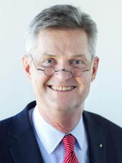
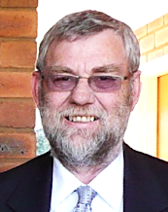
Rotary International President
2020/21
Holger Knaack

Rotary Club of Herzogtum Lauenburg-Mölln, Germany








December 2020: Disease Prevention and Treatment Month
December Coming Events

Sat 12th Christmas Meeting at Kwinana Bowling Club

Mon 14th No Meeting

Mon 21st Club Meeting

Mon 28th No Meeting

Attendance Officer:
Greg Williams 0435 083 069
Apologies by Saturday pm please

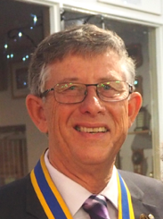

John Iriks

President’s Pen

7th November 2020

Another great meeting with an attendance of 93.1% present to again meet and hear from Rohan Smith from Gilmore College and also welcomed visitor Peter Schulz.

Although there were no exciting displays of acrobatics this week the story continued with our latest inductee John Maskell presenting Eric with a nice safe step ladder with handrail, hard hat and safety vest. I believe he will undertake the “working from heights and platforms” course online.

Great to hear reports that Lorraine Lucas is looking well, we look forward to her return as soon as she is ready.

Australia Day Celebrations are well and truly on hand with a Zoom meeting scheduled for Tuesday 8th December after another meeting with amusement facility operators.

Only 17 days before Santa comes so keep up “being good”

Enjoy Rotary

Enjoy Rotary
John Iriks
President 2020/21

On December 1st PDG John completed 41 years’ service to Rotary, congratulations John, Kwinana Rotary Club was just over 8 years old when John joined in 1979. (ED)







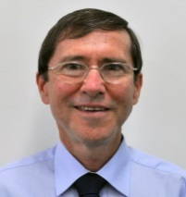
President 2021/22 Bob Thompson

Club Service Report: 7th December 2020

Christmas meeting payment
It is $35 for the meal, plus $10 per member only (not for partners). The $10 extra for members was agreed to at a recent Club meeting. It is instead of a member buying a present for their partner, or for themselves if they hadn’t a partner, to be given out randomly on the night. The $10 will go towards a Club donation to ROMAC. This stands for Rotary Oceania Medical Aid for Children

ROMAC provides surgical treatment for children in Australia and New Zealand from developing countries from our Pacific Region in the form of Life Giving and/or dignity restoring surgery not accessible to them in their home country. With ROMAC 100¢ in every $1 goes directly to giving life to a child. ROMAC is totally voluntary. There are no paid staff.

NOTE that there will be no Club meeting on Monday 14 December

Safety Report
Work continues addressing the concerns noted in Club Safety Officer Ian’s report following his recent inspection. Thanks to those members who have completed jobs or have them in hand to do soon.

Australia Day 26 January 2021
The organizing Committee have already held several meetings, including on site at Calista Oval and progress to ensuring a great Australia Day event is going well.

Bob Thompson
President Elect/Club Service Director

Rotarians in our community. (Thanks Mayor Carol for the pics)
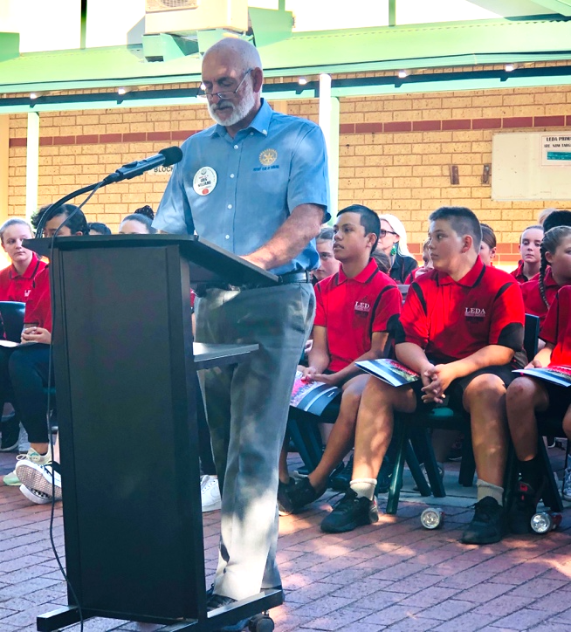

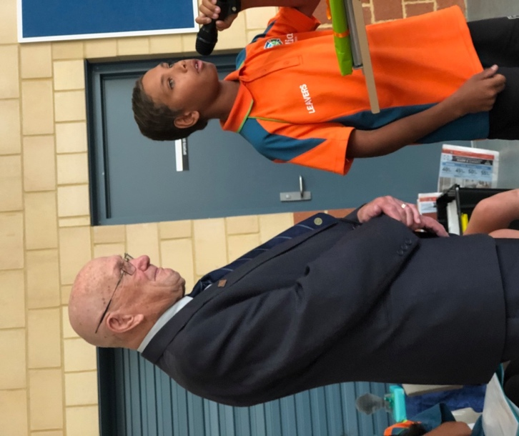

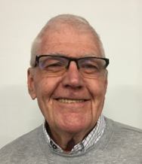


PP Brian McCallum

Inward Correspondence.

Outward Correspondence. NIL.

Would members please note that any correspondence received or posted by yourself, please ensure a copy is forwarded to your Secretary.



PP Stephen Castelli
Treasurer Stephen was pleased to announce that all members are financial.

Treasurer: PDG John Iriks
- Money in the Bank. Bills paid
- Financial Report to May 30th prepared for inclusion in our Annual Report, financials to June end will then be completed ready to be audited.

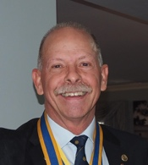

Birthdays and Anniversaries December 2020

Congratulations:

Terry Evans 5th Deryl Wallhead. 4th
John Wallhead 12th Lucy Cuplovic. 13th
Sam Cuplovic 20th Sam Winmar 20th
Ed Samut 28th Lynne Bennett. 25th
Mike Nella 29th

Wedding Anniversary’s

James and Cathy Sharkey. 20th 51 years
Max and Diane Bird 24th 54 years

Club Anniversaries.

John Iriks. 01st 41years







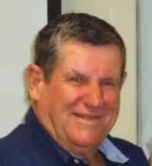


PP Max Bird, International 2020/21
No Report
Max Bird

Very pleased to say I was able to enjoy a bit of frivolity at my own expense on Monday night.
After my unceremonious fall last Monday night, all is well.

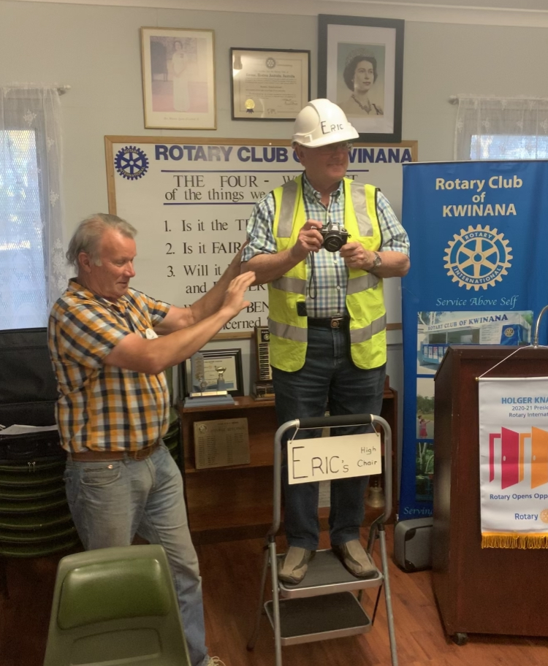

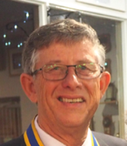
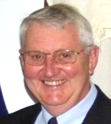
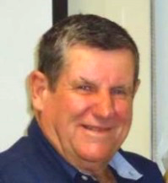
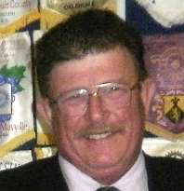


PP James Sharkey
Public Relations Dir.

PDG John Iriks
Membership Dir.
PP Max Bird
Foundation Dir.

Projects Director
PP Mike Nella

Project Director’s Report.
Bunnings Sausage Sizzles have resumed.
New format: min. 6 people, no cash Eftpos only, Bendigo Bank can provide portable Eftpos machine, for a fee.
Garage Sales are an on-going event.
We have a Bunnings Sausage Sizzle booked for Saturday February 20th we must work under the COVID-19 rules, James will elaborate later.

Public Relations:
We continue to receive exposure on Rotary Out West.
Please continue to advise James of any stories or activities within our club which may be submitted to the local media.

Membership:
President John Iriks is Membership Director this year.
Membership Committee: Lee Davis, Bob Thompson and Eric Blogg.
Gavin Denz is still keen to re-join us, still a little busy right now.
Peter Shultz attended his second meeting this week.

Community:
Bread Program up and running well.
Mike is winding down his leadership of the project after Christmas.

Vocational:
4 Way Test Speech Contest, February to April 2021, contacting Gilmore College etc.

International:
Latest meeting minutes available to view on ClubRunner.
View a complete review of my recent trip to Timor on ClubRunner.

Youth:
Application forms for RYPEN and RYLA are open.
RYLA. 18 to 25 year old’s 9th to 16th January 2021
Candidate accepted for RYLA

- Visit your club webpage.

http://www.clubrunner.ca/Portal/Home.aspx?accountid=8106

or type Kwinana Rotary Club into ‘Search’

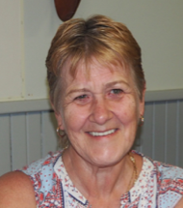

Rtn. Veronica Burns
Community

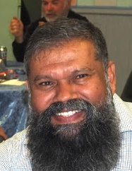

Rtn Barry Winmar
Vocational

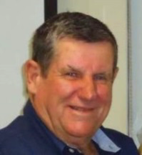

PP. Max Bird
International

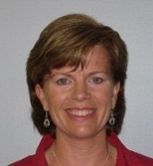

PP Genevieve Carr
Youth

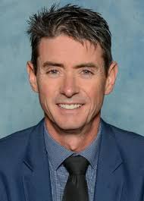


Guest Speaker: : Rohan Smith, Gilmore College

Rohan brought us up to date with some statistics on Gilmore College.
Gilmore College, previously Kwinana High School has been in operation for 64 years.
Student numbers: 1194, attendance 2019 was 80.1%, Regular attendance was 47.3%
6 major Cultural Groups are represented. Total Staff number 129, non-teaching support staff 16
The average age of the teaching staff is 42 years.
Gilmore College Health increased by 12 points placing it in the second quartile of the global benchmark, 2018=60pts, 2019=72, currently in the top decile health with score of 82 points.
Priorities:
- Curriculum and Teaching:
Develop a teaching culture of high expectations and low variability.

- Literacy and Numeracy:
Improve Literacy and Numeracy achievement to match that of “Like” schools.

- Learning Environment:
Establish a positive learning environment conductive to achieving high standards of student learning.

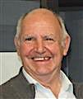
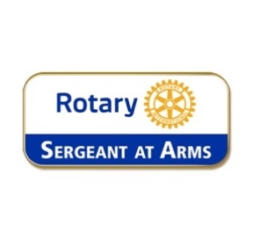
Fine Session: Sergeant Cyril Bennett

Deputy Bill Rowe.

Fines for Monday 7th December 2020

‘No Badge’. Barry, Bob T and Chris.

Lee D: “Falling asleep on the job” late for the Friday meeting at Calista Oval.

ED and Greg: For copying me on Friday. I pulled my ear telling them it was what the ‘Chiro’ did to me to relieve my tinnitus.

John Maskell: For being the chauffeur for Sir Stephen Castelli.

Just about everyone said they would donate a ladder for Eric to stand on, everyone to pay up anyway.

President John to pay a fine for not doing a COVID-19 clean-up after Eric’s blood was spilt on the floor last Monday, I’m sure I can still see blood stains on the floor.

Chris O: Guilty of putting a bottle top in the fines box.

Stephen C: Welcoming his 5th granddaughter.

Greg W: Went to a “Murder Mystery” at Koorliny last Saturday, his table finished last.

Ed S: Greg had to dig Ed out of ‘it’ again, Ed got to Mandurah to see a specialist, then realised he had left the referral at home, Greg to the rescue again.

https://www.tyrrells.com.au/promotional/drink-now-vats-romac/


This is a Tyrrell’s promotion specially for ROMAC.

ROMAC will receive 15% on all sales.

Follow the link above.

RECREATIONAL AND VOCATIONAL FELLOWSHIPS
From stamp collecting to wine appreciation, the hobbies of Rotarians are as diverse as the membership itself.
Yet, among the more than one million Rotarians worldwide, an amateur-radio enthusiast or a chess player is bound to find others who share the same passions.
But Recreational Fellowship members share more than just their common interest in sport diving or Esperanto; they share an interest in fellowship and service and in promoting world understanding.
As such, it's no wonder that the International Skiing Fellowship of Rotarians donates the profits from ski events to The Rotary Foundation or that the Flying Rotarians help ferry medical personnel and supplies.
One has only to look at the types of Vocational Fellowships to recognize how they differ from their recreational counterparts.
With Rotarians united by their shared professional interest in such fields as Hospital Administration and Finance/Banking, it's obvious that Vocational Service is as important a concern as international fellowship to the members of these groups. Members exchange technical information and seek opportunities to employ their expertise in service not just to their own communities and countries, but to their professions as well. For example, the Ophthalmology International Vocational Fellowship organized a professional seminar on the subject of eye surgery in developing countries.

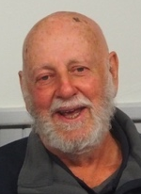


Rotary Information PDG Bob Cooper

Kwinana President John Iriks with Guest Speaker Rohan Smith, Principal at Gilmore College

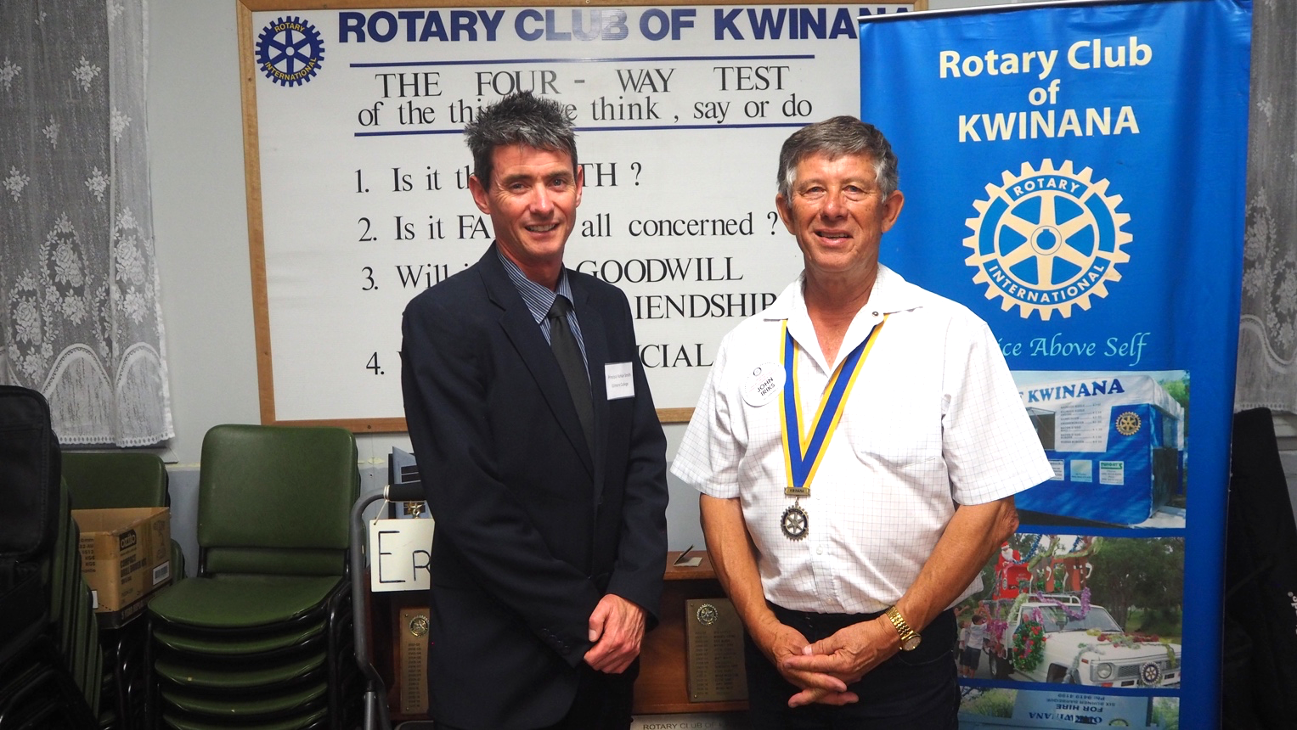

Polio This Week 02nd December 2020
One of the largest polio immunization campaigns in the African Region this year has just concluded in Chad, where over 3.3 million children in 91 districts were vaccinated. This pushes the total number of children vaccinated against polio to over forty million across 16 countries in the Region, since campaigns resumed following a necessary pause in immunizations due to the COVID-19 pandemic.
Get up to date on the latest news, funding updates and cases numbers with the latest edition of Polio News.
Summary of new WPV and cVDPV viruses this week (AFP cases and ES positives):

    - Pakistan: one WPV1 case, 13 WPV1 positive environmental samples and five cVDPV2 positive environmental samples
    - Democratic Republic of the Congo (DR Congo): five cVDPV2 cases
    - Mali: two cVDPV2 cases














In Australia, around the world

December 6th to December 12th

6th
1784: Transportation of convicts from England to Australia is first authorised.
1907: 361 miners are killed in the US's worst coal mining disaster.
1917: Over 1,800 are killed when the Mont Blanc, a French munitions ship, explodes after colliding with another vessel.

7th
1800: James Grant discovers and names Portland Bay and Cape Otway on the southern coast.
1941: Japanese fighters bomb the US navy base at Pearl Harbor, precipitating America's entry into WWII.

8th
1542: Mary, Queen of Scots, is born.
1801: Flinders explores and charts King George's Sound (later Albany) in Western Australia.
1980: Singer, songwriter and former member of "The Beatles", John Lennon, is murdered.

9th
1843: The first Christmas cards are created.
1941: Australia formally declares war on Japan.
1968: The computer mouse makes its public debut.

10th
1582: France adopts the Gregorian calendar.
1859: Today is Proclamation Day, marking Queensland's official separation from New South Wales.
1919: Brothers Ross and Keith Smith win the Australian air race to fly from England to Australia under 30 days.

11th
1792: Captain Arthur Phillip, first Governor of the New South Wales colony, returns to England.
1903: The world's first wildlife preservation society is founded.
2015: Australian naturalist and controversial conservationist Harry Butler dies.

12th
1815: Explorer James Kelly begins his circumnavigation of Tasmania.
1915: American singer and actor Frank Sinatra is born.
1953: Charles Yeager becomes the first person to travel two and a half times the speed of sound.
Chuck Yeager, in 1947 became the first pilot to exceed the speed of sound, Died 7th December 2020.



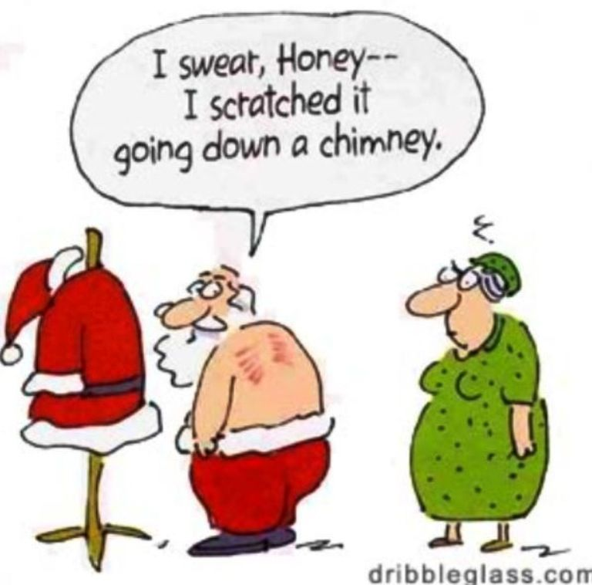


Be kind to your children – they will be choosing your nursing home!

Failure is success if we learn from it

The owner of a garden shop in Kwinana was confused about paying an invoice, so he decided to ask his secretary for some mathematical help. He called her into his office and said, "You graduated from the University of WA and I need some help.
If I were to give you $20,000 minus 14%, how much would you take off?"
The secretary thought a moment, and then replied, "Everything but my earrings."

My wife is on a new diet. Coconuts and bananas. She hasn't lost weight, but can she climb a tree!

Paddy, the electrician, got sacked from the U.S. prison service for refusing to
servicing the electric chair.
He said in his professional opinion it was a death trap!

My wife told me the car wasn't running well, there was water in the carburetor. I asked where the car was, and she told me it was in the lake.



Makeup opportunities

Rockingham Monday 6pm for 6.30 Rockingham RSL Club
Palm beach Wednesday 6pm for 6.30 Ocean Clipper Inn
Baldivis Mon/Fortnightly 6.30pm for 7.00 Peel Manor House
Cockburn Thursday 7.15am for 7.30 Cockburn Seniors Centre
Byford & Districts Monday 6.15pm for 6.45 Byford Tavern, South W Hwy
Rotary Club of Kwinana Contributions welcome: eblogg@bigpond.com

Media Release

For further information please contact
Marketing and Communications on 08 9439 0435

