

The Rotary Club of Kwinana

District 9423 Western Australia

Chartered: 22 April 1971

Bulletin


Team 2025/26

President
Stephen Castelli

Secretary
Genevieve Carr

Treasurer
Karen Zabiela

Facts & Figures

No 27 16/03/2026

Rotary Club of Kwinana is 54 years’ old 1971/2025

Update: good report from by surgeon, freedom restored.

Good meeting, Helen and Andrew joined us for a second meeting.

Guest speakers were Carolyn and Maricor from Enable Nursing Perth.
They are a registered NDIS Provider.

PP Genevieve together with PDG John Iriks and Chris attended the Rotary 9423 District Conference held in Northam.
PDG John gave a glowing report on the weekend’s event, John commented that over the years he has attended over 30+ WA events and would rate this current event as one off the very best, rating the guest speakers and particularly the fellowship as excellent. John also told us that there will be no conference scheduled next year as the RC of Perth are celebrating 100 years Rotary service in WA with a huge event in Forest Place
President Stephen will be away for a couple of weeks, currently in Indonesia, PP James Sharkey will officiate in his absence.

Attendance this week
Total Members 24 Apologies
Make-up Attended 15
Guests
Visitors 4
Partners 2
68.2 %

Raffle
Karen & Chris O



District Governor 9423
2025/26

Veronica Lawrance

Rotary Club of Mill Point

Rotary International President
2025/26

Francesco Arezzo

Rotary Club of Ragusa, Italy

Heads & Tails
Stephen



March 2026 – Water, Sanitation and Hygiene

Mon 2nd No Meeting

Mon 9th Club Meeting Alan Armstrong Men’s Shed

Mon 16th Club Meeting subject: Health

Mon 22nd Club Meeting

Attendance: Members respond via ‘WhatsApp’

Meets on Monday
6:00 for 6:30 pm
At Rotary Hall
Brownell Crescent
Medina

Visitors are welcome
Contact
0400 837 603









President’s Pen March 2026

Just a reminder that we have the following vacancies in our club:

- Public Relations Director
- Programs Manager
- Secretary
- Club Services Director 2026 – 2027 and President Elect for 2027 – 2028

If anyone is able to help with any of these positions, we would love to hear from you.

I still want to have a Blind Wine Tasting at our home potentially in May, and we will invite the members and partners from RC Harvey to join us.

Also looking at a “long table” sundowner at the Green Barista. I have spoken to Dia and Suzy and they have done a number of these events. This would be on a Monday night in lieu of a meeting.

If anyone else has any projects that they feel that the club may be interested in, then please get the details and bring it to the board/club.

President Stephen

Meeting at Rotary Hall Monday 16th March 2026
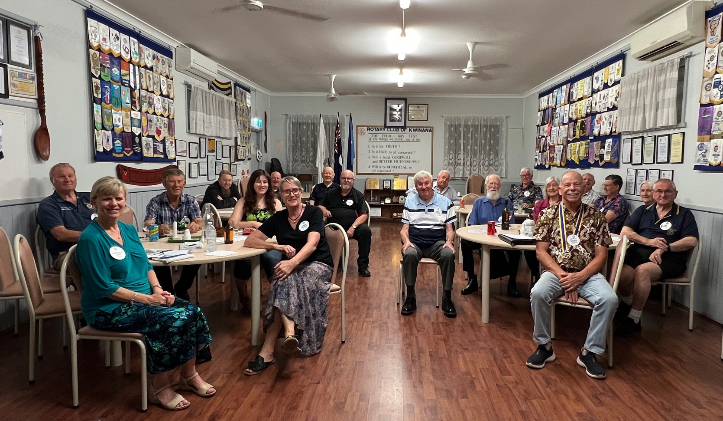

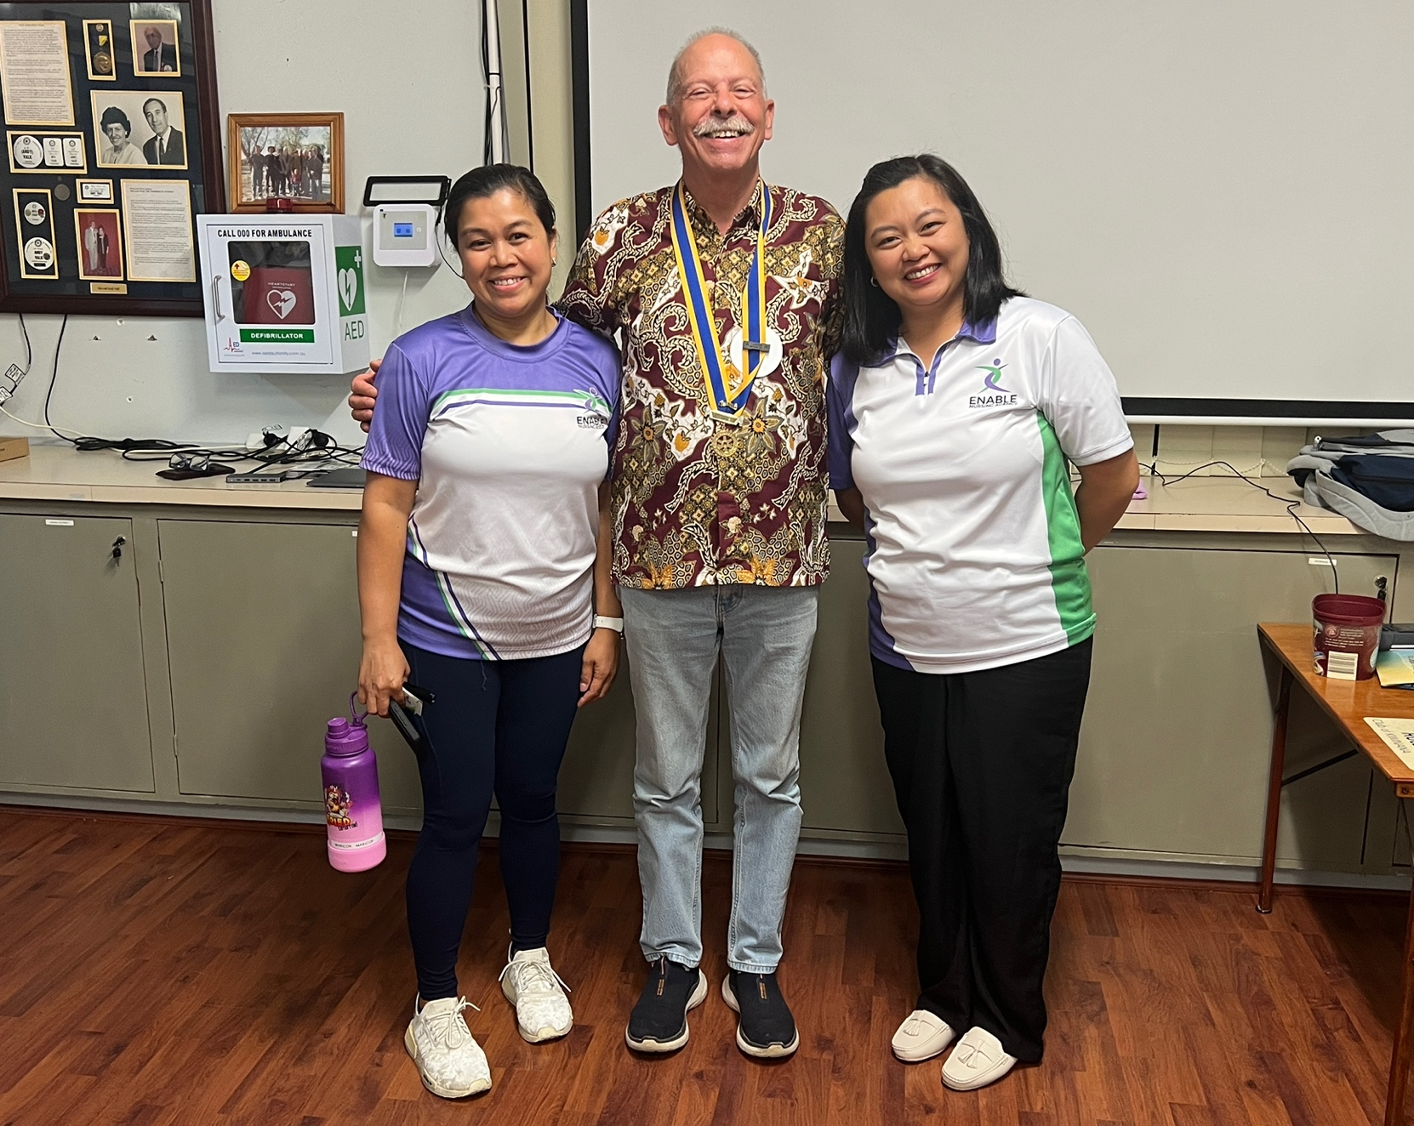
President Stephen with Carolyn and Maricor ‘Enable Nursing’ lady’s.

Bobby

The Rotary Club of Perth is celebrating 100 years of service, having been founded in Western Australia in 1927
A centenary celebration of this milestone, marking a century of community service, is highlighted by events and commemorative initiatives leading into 2027.
The club is a key part of WA's long-standing community service history.
- Centenary (1927–2027): The Rotary Club of Perth (and Rotary WA) was established in 1927, marking 100 years of service in April 2027.
- Celebration Highlights: Events include celebrating 100 years of community service, with planning managed by Rotary WA.
- Commemorative Activities: Commemorative stamps and a book titled "Humanity in Action" have been part of celebrating the Rotary legacy.
- Ongoing Service: The club has continued its focus on community service in the Perth region for a century.
Other organisations in the Perth area that have recently hit or are approaching their 100-year service milestones include:
- City of Perth SLSC: Recently celebrated its own 100 years of service history.
- ABC Radio Perth: Commemorated 100 years of radio in Western Australia in late 2024/early 2025




- District Conference
Held over the weekend 13 – 15 March in Northam. Excellent conference!

- Restaurant Night
Monday 30 March (Matthew Carr’s 21st birthday!): Dinner at the Suburban Restaurant in Bertram; partners welcome. Please advise Genevieve if attending.

- District Assembly
Training for 2026 – 2026 Office Bearers/Board Members
Scheduled to be held on Sunday 12 April at Leederville Football Club

- Monday 20 April:
Have organized for guest speaker from the Salvation Army. Invited members of the Rotary Club of Rockingham to attend. Currently organizing catering for this event.

- Weekend away to Katanning 25 – 27 April 2026
Opportunity to catch up with former members Kim Beciri and Paul Durant. Genevieve has been in contact with Katanning Rotary Club, with a plan to meet up with them for lunch or dinner on Sunday 26 April. Please advise Genevieve if attending, and accommodation needs. Kim and Paul are able to accommodate caravans/tents on their property.

- Monday 11 May 2026 Guest Speaker
Have invited Jeremy Wood to come and speak to us about the Rotary Peace Pole project. As this is a project designed to be implemented within schools, planning to invite teachers from local schools to attend.

- Club Changeover
The District Changeover is scheduled to take place on Saturday 11 July, and so we will need to change the date of our changeover. Now looking to have this on Saturday 4 July (so as not to interfere with members’ football commitments!).

Genevieve Carr President 2026/27

March 2026

If you have food in your fridge, clothes on your back, a roof over your head and a place to sleep you are richer than 75% of the world. If you have money in the bank, your wallet, and some spare change you are among the top 8% of the world’s wealthy. If you woke up this morning with more health than illness you are more blessed than the million people who will not survive this week. If you have never experienced the danger of battle, the agony of imprisonment or torture, or the horrible pangs of starvation you are luckier than 500 million people alive and suffering. If you can read this message you are more fortunate than 3 billion people in the world who cannot read at all."
PE Genevieve Carr


PP Genevieve Carr March 2026

- DG Online February 2026
- ShelterBox Impact Report
- Webinar reminder for Foundation
- District conference newsletter
- ShelterBox appeal
- RotaryWA Round-Up #48
- RDU Supplies update
- Invitation to participate in Age Friendly Kwinana Consultation
- RDU.One
- New guest speaker contact

Inward Correspondence.

Outward Correspondence:

none

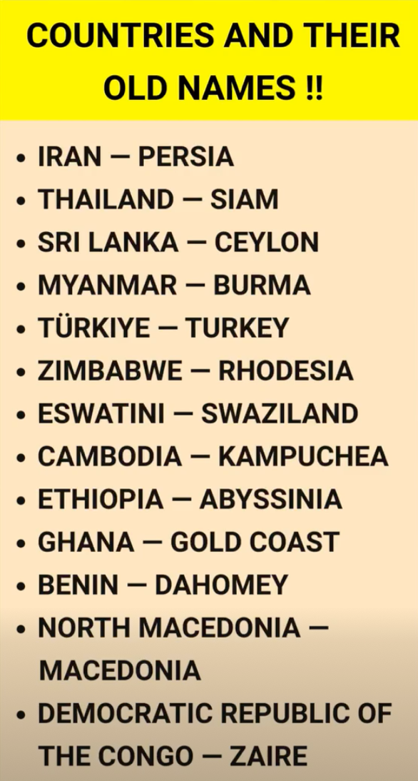
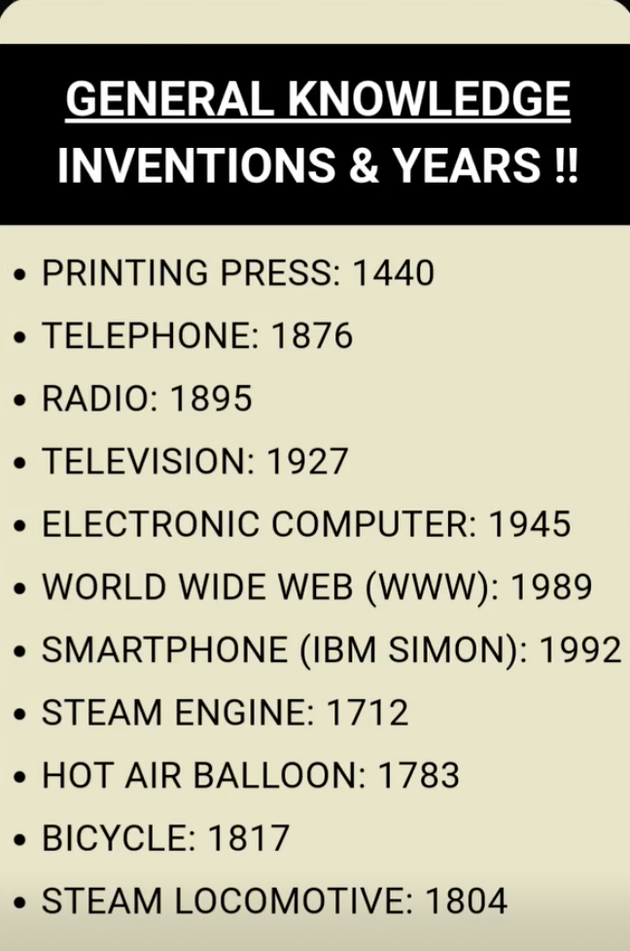

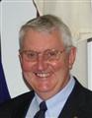

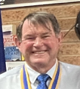
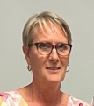

Foundation Dir.
PDG John Iriks

Treasurer
Karen Zabiela
Vice Pres.
Terry Evans
Project Director
PP James Sharkey

Team 2025/26


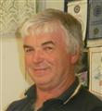

Events Manager
PDG John Iriks

Membership Dir.
Norm Mulcahy



Fine Session: Sergeant Norm Mulcahy
PP Chris Oughton standing-in for Norm

- Partners Night on Monday 28 July: John and Chris Iriks will be guest speakers, speaking about their recent experiences in Timor

- Christmas in August: further details to be provided by President Steve

- Monday 15 September: District Governor’s visit. This will be a partner’s night.

- Sunday 21 September: Brunch with members and partners of the Rotary Club of Harvey (Peter Schulz’s club) at the Curious Cockatoo café in Harvey.

- Friday 24 October: Polio train ride. Good to see that a number of Club members intend of participating. Please ensure that you register via the TryBooking link in order to be covered by Rotary Insurance.

- Sunday 14 December: Looking to have Christmas function at King Road Brewing Company. This is to be confirmed, as the venue will not accept bookings for Christmas until September 2025 onwards.

Member who paid $100 for a photo???

Loud shirts: Chris, Stephen, Helen and Norm.

John M: Being paying $1 for the raffle instead of $2

Bob C: Tender foot.

Chris: Plants scratching ‘mature skin’

John M: Finger pointing to our President!!!

Soren: Sporting a new shirt. Recently 32 metres up in a cherry-picker at Henderson taking down a Beehive.

President: No badge of office visible till later.

Polio This Week 16th JMarch 2026

Rotary at the heart of a polio-free world
During its quarterly face-to-face meeting on 3 March 2026, the Global Certification Commission Containment Working Group (GCC-CWG), was warmly welcomed to White Rock, near Vancouver BC, Canada, by the Rotary Club of White Rock—an inspiring example of Rotary’s grassroots leadership in global health. As the initiator of the Global Polio Eradication Initiative, Rotary continues to play a pivotal role alongside WHO, governments, UNICEF, CDC, Gavi the Vaccine Alliance and the Gates Foundation, in driving progress toward a polio-free world. More.
Women leading polio outbreak response efforts across Africa
Every child protected from polio represents a conversation that worked, a door that opened, a mother reassured, a family reached. Behind each of those moments, in the Democratic Republic of the Congo (DRC), in Ethiopia, in Nigeria, is a woman who is making it happen. Across all three countries, when women are provided genuine authority, trained resources, and institutional recognition, vaccination coverage climbs. The approaches differ by context, culture, and need. The outcome is consistent. More.





Birthdays and Anniversaries March 2026


Birthday Congratulations:
Barry Winmar 12th
Bob Cooper 18th
John Maskell 23rd
Brian Thompson 25th


.
Wedding Anniversaries
John & Deryl 16th 63 years

Club Anniversaries:

Alan Johnson 10th 1 year

Congratulations

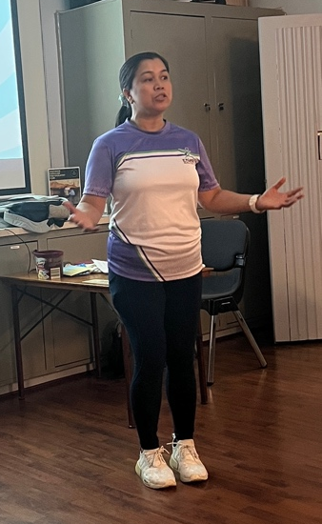

Guest Speaker: Carolyn and Maricor

Enable Nursing Perth


Enable Nursing is a national based company
providing services here in Western Australia
providing both Community and Aged Care services
to the community.

We specialize in temporary and permanent
placements of Registered Nurses, Enrolled Nurses,
and Support Workers.
Whether you need short-notice coverage or long-term support, we tailor our services to meet your unique needs. https://perthenablenursing.com.au/



Staffing Services
We provide skilled and reliable nurses, assistants in nursing, and support workers to hospitals, aged care facilities, and clinics across Perth. Whether you need short-term or long-term coverage, our professional team is ready to support your staffing needs.

Home Health Care Services
Experience quality care in the comfort of your own home. Our team delivers a wide range of medical and personal support services tailored to each individual—ensuring safety, dignity, and independence at every stage of care.

Disability and Elderly Support
We provide tailored in-home support to fit your needs. From respite care, Supported Independent Living, community participation, transport, restorative therapies, to domestic services and warm companionship—all delivered by compassionate and trained professionals.

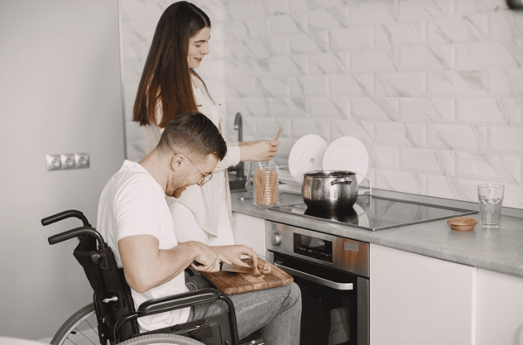




Couple of Conference pics I pirated from Facebook, containing a few familiar faces

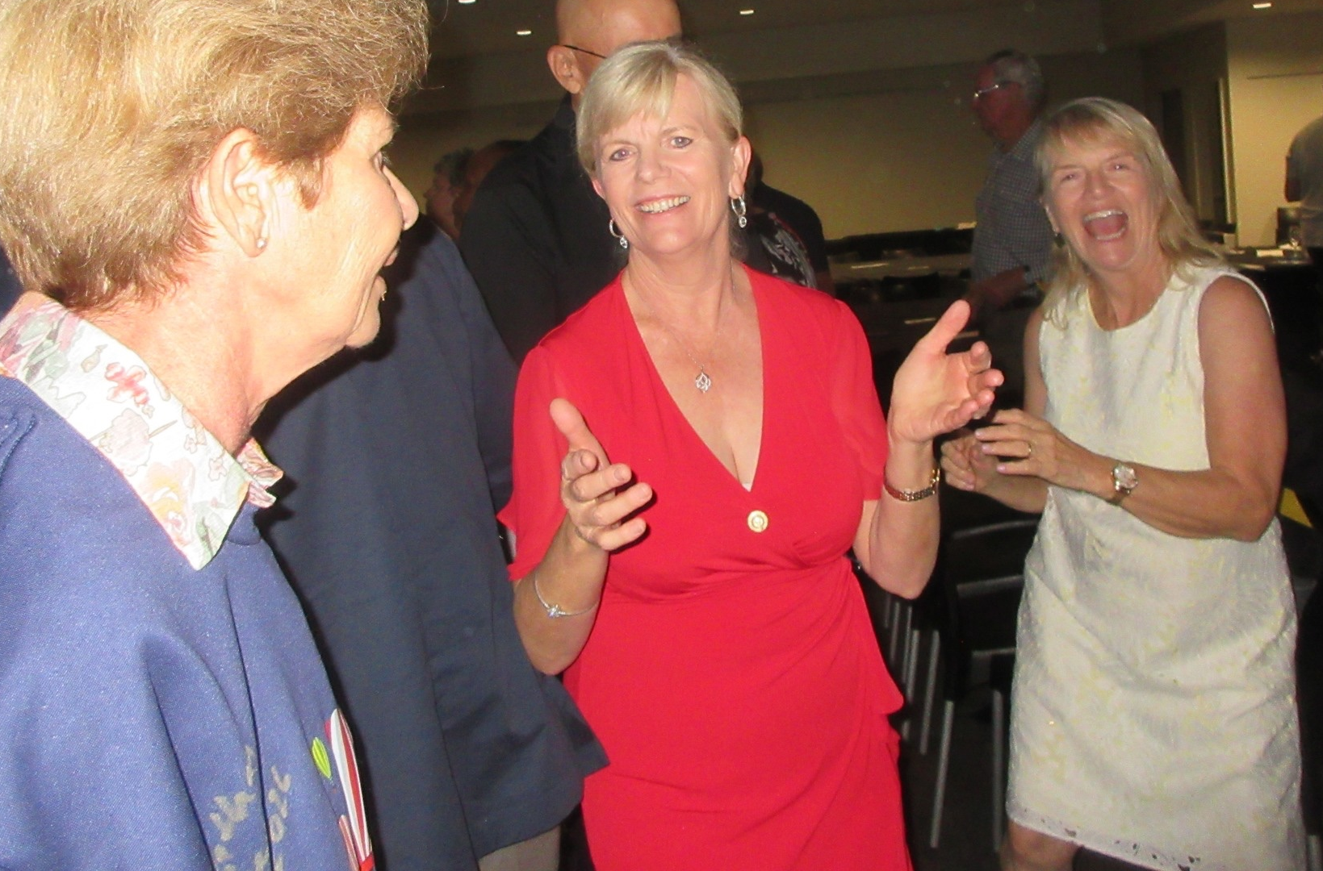





March 16th to March 122nd

16th
1802: 1st US Military Academy at West Point is established
1830: London's re-organised police force (Scotland Yard)
1834: Charles Darwin, aboard HMS Beagle, anchors in the Falklands Islands for the first time
1922: Egypt achieves independence from Britain, but British troops remain

17th
1659: 1st known cheque written (£400), now on display at Westminster Abbey
1852: Studebaker Brothers wagon company established - precursor of the automobile manufacturer
1917: 1st synagogue in 425 years opens in Madrid
1937: DuPont Corp patents nylon, developed by employee Wallace Carothers

18th
1678: John Bunyan's "Pilgrim's Progress" is published in Holborn, London, by Nathaniel Ponder
1876: Direct telegraph link established between Britain and New Zealand
1885: Mark Twain publishes the "Adventures of Huckleberry Finn" in the US
1901: H Cecil Booth patented a dust removing suction cleaner

19th
1878: Thomas Edison is granted a patent for his gramophone (phonograph)
1881: Kansas becomes 1st state to prohibit all alcoholic beverages
1906: W.K. Kellogg, founding the multinational food manufacturer Kellogg's
1942: About 150 Japanese warplanes attack the Australian city of Darwin

20th
1472: Orkney and Shetland are left by Norway to Scotland, due to a dowry payment.
1673: 1st recorded wine auction held in London
1872: Hydraulic electric elevator patented by Cyrus Baldwin
1962: John Glenn becomes the 1st American to orbit the Earth, aboard Friendship 7

21st
1797: Trinidad, West Indies, a Spanish colony, surrenders to the British
1842: 1st known sewing machine patented in US by John Greenough of Washington, D.C.
1857: Congress outlaws’ foreign currency as legal tender in US
1947: Polaroid Camera, demonstrated by Edwin Land at the Optical Society of America in NYC

22nd
1774: British House of Lords rules authors do not have perpetual copyright
1797: The Last Invasion of Britain, by the French during the Revolutionary Wars, Fishguard, Wales
1825: Russia & Britain establish Alaska-Canada boundary
1928: 1st solo flight from England to Australia lands in Darwin, by Australian aviator Bert Hinkler



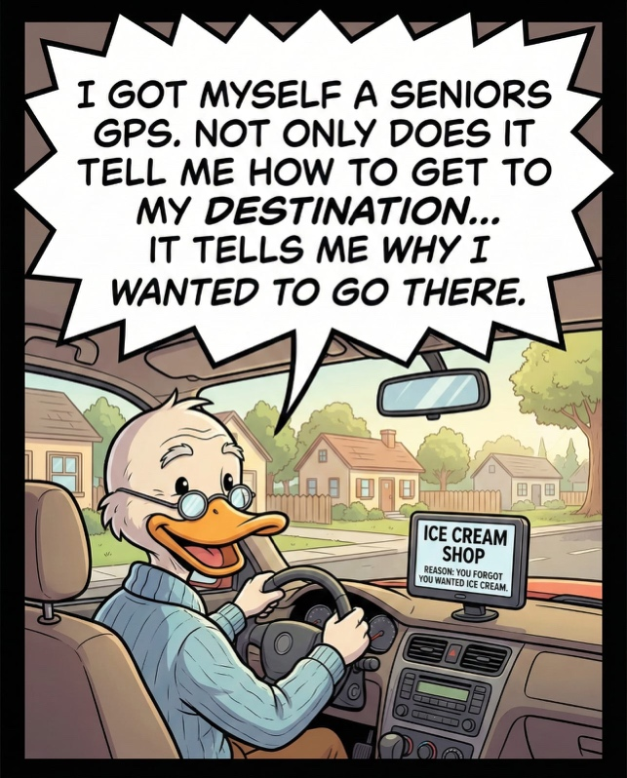





Rotary Club of Kwinana 2026

Nearby Rotary Clubs, Meeting Times

Rockingham Monday 6pm Armadale Tuesday 7pm
Palm beach Wednesday 6.30pm Mandurah Districts Tuesday 6pm
Baldivis Tuesday 6.30pm Pinjarra Thursday 6.45pm
Cockburn Wednesday 6pm Byford & Districts Monday 7pm

When I got home last night, my wife insisted that I take her out to somewhere expensive... so, I took her to a fuel station.
That’s when the fight started.

