

The Rotary Club of Kwinana

District 9423 Western Australia

Chartered: 22 April 1971

Bulletin

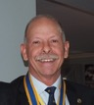
Team 2025/26

President
Stephen Castelli

Secretary
Genevieve Carr

Treasurer
Karen Zabiela

Facts & Figures

No 29 13/04/2026

Rotary Club of Kwinana is 55 years’ old 1971/2025

Back after the Easter break, business meeting tonight, some light discussion followed.

Helen Souter, Alan Armstrong and Andrew Soulter have all been accepted for membership, going through the required process, I see inductions on the agenda.

Alan Armstrong, recently accepted for membership, gave an insight into his thoughts and aspirations on the proposed future community developments planned for council land in Abercrombie Road. Alan’s vision is a community building housing his ‘Men’s Shed’ and new premises for a relocated Kwinana Rotary Club. Alan would then like to see the present Brownell Cres location turned into a community memorial park.
Alan is acutely aware that this will not happen ‘tomorrow’ but is passionate about planning for the future.

As Secretary Genevieve revealed in her report, we have received a sizable donation from Colin Brown. Colin, a brother-in-law to PP James Sharkey is from Scotland and has visited WA on several occasions and always attends our club meetings.
A huge thank-you for such a generous gesture.

Attendance this week
Total Members 24 Apologies
Make-up Attended 15
Guests
Visitors 2
Partners
71.4 %

Raffle
Terry & Alan J



District Governor 9423
2025/26

Veronica Lawrance

Rotary Club of Mill Point

Rotary International President
2025/26

Francesco Arezzo

Rotary Club of Ragusa, Italy

Heads & Tails
James



April - Maternal and Child Health

Mon 6th Club Meeting No Meeting

Mon 13th Club Meeting Business

Mon 20th Club Meeting Salvation Army/partners inv.

Mon 27th Club Meeting

Attendance: Members respond via ‘WhatsApp’

Meets on Monday
6:00 for 6:30 pm
At Rotary Hall
Brownell Crescent
Medina

Visitors/New members
always welcome
Contact
0400 837 603









President’s Pen April 2026

Tonight was a business meeting with good attendance from members (68%) as well as our guests, which included Alan Armstrong and Graham Davies both from the ‘Men’s Shed.
Alan then spoke on a thought bubble that he had regarding the development of a new multi-use sports and club centre on Abercrombie Road. He also indicated that once this is completed (maybe 10 years), and after the Rotary Club has relocated to this new venue, then the existing Rotary Club, club rooms may be demolished and the site turned into a memorial site with an eternal flame.
There are many steps that need to be completed before all of this happens.

Just a reminder that we have the following vacancies in our club:

• Public Relations Director
• Programs Manager
• Secretary
• Club Services Director 2026 – 2027 and President Elect for 2027 – 2028

If anyone is able to help with any of these positions, we would love to hear from you.

I will be attending the Gilmore College ANZAC day assembly on Wed 22/04 to represent the Rotary Club.

The meeting discussed the Furniture Factory and the constant and ongoing need to include more people and to improve the current process.
New member Alan Armstrong put his hand up to lead the process of documenting the furniture in the Storage unit behind the Rotary Hall and maintaining such list so that prospective customers can see what is available in our storage area.
Thank you Alan.

A Furniture Factory Committee meeting will be held soon with the goal of understanding and improving the current processes. Anyone else who is not a committee person is welcome to come along and have their say.

If anyone else has any projects that they feel that the club may be interested in, then please get the details and bring it to the board/club.

The 3 blue bins that the “empties” go into have been “exchanged” at Containers for Change, and the money should appear in the Rotary account soon.

President Stephen

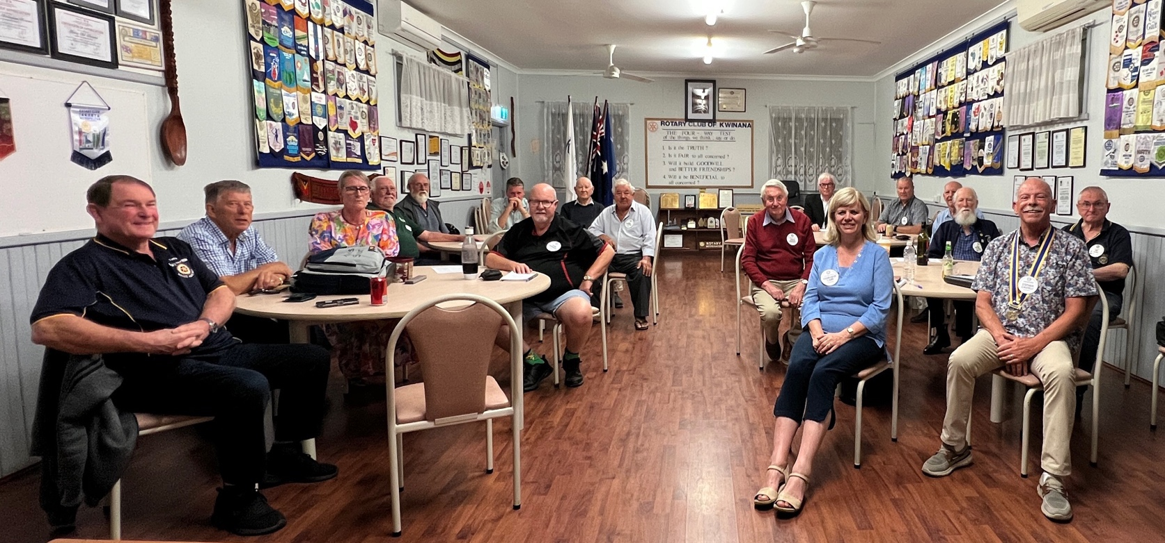

Meeting at Rotary Hall Monday 13th April 2026


- Restaurant Night
Monday 30 March (Matthew Carr’s 21st birthday!): Thanks to all those who attended and contributed to a night of great fellowship.

- District Assembly
Held on Sunday 12 April at East Perth Football Club; Genevieve attended this, together with prospective member Andrew Aulton.

- Monday 20 April:
Have organized for guest speaker from the Salvation Army. Invited members of the Rotary Club of Rockingham to attend; unfortunately, they were unable to attend due to other commitments. Have organized a caterer for this event.

- Weekend away to Katanning 25 – 27 April 2026
Opportunity to catch up with former members Kim Beciri and Paul Durant. Genevieve has been in contact with Katanning Rotary Club, with a plan to meet up with them for lunch on Sunday 26 April. Please advise Genevieve if attending, and accommodation needs.
Kim and Paul are able to accommodate caravans/tents on their property.

- Monday 11 May 2026 Guest Speaker
Have invited Jeremy Wood to come and speak to us about the Rotary Peace Pole project. As this is a project designed to be implemented within schools, planning to invite teachers from local schools to attend. Caterer organized.

- Club Changeover
The District Changeover is scheduled to take place on Saturday 11 July, and so we will need to change the date of our changeover. Now looking to have this on Saturday 4 July (so as not to interfere with members’ football commitments!).

Genevieve Carr President 2026/27

April 2026

PE Genevieve Carr



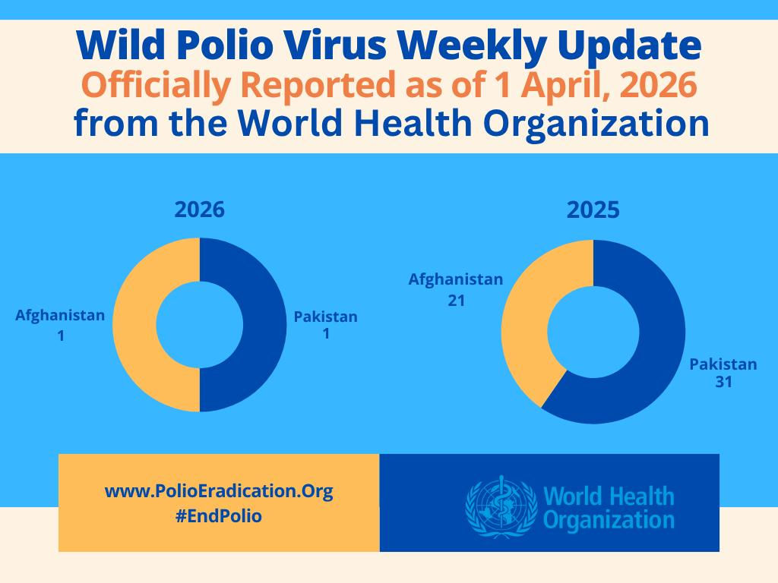

Outward Correspondence:
- Card sent to Greg and Marge Williams to congratulation them on their recent 60th wedding anniversary
- RAWCS Project Audit Report

- ROMAC e-news update
- Rotary Club of Perth newsletter
- Rotary barbeques promotion
- World Immunisation Week promotion
- RDU Supplies update
- Brand news update
- Polio Plus update
- Membership survey
- Request for support from PDG Pushpa Pushpalingham
- ShelterBox request for support for Lebanon
- Membership update
- Request for Club details for insurance purposes
- RotaryWA Round-Up #50
- RDU.One
- Invoice for Fathering Project

Most notably, we have received a very generous donation of £2000 ($3800 AUD) from Mr Colin Brown, brother-in-law of James Sharkey.
Board to discuss the most appropriate use of these funds.

Inward Correspondence.

PE Genevieve Carr March 2026

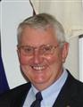

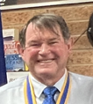


Foundation Dir.
PDG John Iriks

Treasurer
Karen Zabiela
Vice Pres.
Terry Evans
Project Director
PP James Sharkey

Team 2025/26


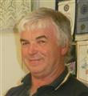

Events Manager
PDG John Iriks

Membership Dir.
Norm Mulcahy



Fine Session: Sergeant Norm Mulcahy
PP Chris Oughton standing-in for Norm

- Partners Night on Monday 28 July: John and Chris Iriks will be guest speakers, speaking about their recent experiences in Timor

- Christmas in August: further details to be provided by President Steve

- Monday 15 September: District Governor’s visit. This will be a partner’s night.

- Sunday 21 September: Brunch with members and partners of the Rotary Club of Harvey (Peter Schulz’s club) at the Curious Cockatoo café in Harvey.

- Friday 24 October: Polio train ride. Good to see that a number of Club members intend of participating. Please ensure that you register via the TryBooking link in order to be covered by Rotary Insurance.

- Sunday 14 December: Looking to have Christmas function at King Road Brewing Company. This is to be confirmed, as the venue will not accept bookings for Christmas until September 2025 onwards.

Eric: Running around like a 16-year-old, sporting 2 new bionic hips.

No name: Wearing the same suit to two parties

Alan J: Wearing shorts!!

Member not wearing a suit jacket??

Stephen and Cyril: Bottle of port from neither!!

Karen: No badge.

Soren: Driving a BMW.

Alan Armstrong: Drinking from a ‘Silver goblet’ Alan says its 40 years old.

Norm: Claimed to be ‘well dressed tonight’ Chris O commented “and wearing crocs??”

On the 11th May Pres. Stephen, Norm M and John M head off to Jakarta to renovate 3 more schools.

Next week on the 21st April our Rotary Club is 55 years old.

Australia, Belgium and Hungary achieve poliovirus containment certification
Global poliovirus containment efforts significantly advanced this last quarter as facilities in Australia, Belgium, Hungary, Canada, France and Indonesia were awarded Certificates of Containment by the Global Commission for the Certification of Poliomyelitis Eradication. These certifications confirm full compliance with the WHO Global Action Plan for Poliovirus Containment (GAPIV) and reflect growing global momentum to ensure poliovirus materials are managed safely and securely.
Applications open for 2026 Polio Advanced Course in Vaccinology
Applications are currently open for the 2026 editions of the Polio Advanced Course in Vaccinology in Doha and Dakar. Designed for early and mid-career professionals from Africa, Asia, and the Middle East, the course offers a specialized training programme, networking, and tools to shape the next generation of leaders in polio. The application deadline is 27 April 2026.
Celebrating Impact on World Health Day
GPEI partners marked World Health Day on 7 April with posts celebrating the role of key donors, local partners and communities in the global polio eradication effort. The theme, “Together for health. Stand with science”, underscores how science-driven partnerships can build a healthier, safer future for all.
Before the Outbreak: Global Dispatches Podcast on Disease Surveillance
Many of the best tools the world has to detect disease outbreaks were put in place for specific diseases like malaria and polio. Today, those platforms are used to respond to disease outbreaks of all kinds. Listen to the latest episode of the “Before the Outbreak” podcast, produced in partnership with the United Nations Foundation, featuring Dr Hamid Jafari, former Director of Polio Eradication for the WHO Eastern Mediterranean Region.

Summary of new polioviruses this week:
- Afghanistan: four WPV1-positive environmental samples
- Pakistan: seven WPV1-positive environmental samples
- DR Congo: one cVDPV2 case
- Nigeria: three cVDPV2 cases and one cVDPV2-positive environmental sample
- Somalia: one cVDPV2 case
- Sudan: five cVDPV2-positive environmental samples

Polio This Week 13th April 2026

.





Birthdays and Anniversaries April 2026

Birthday Congratulations:
Stephen Castelli 6th
Cyril Bennett 10th
Karen Zabiela 28th



Wedding Anniversaries
Norm & Karen 1st 35 years
Cyril & Lynne 5th 30 years


Club Anniversaries:

Pam Brookes 10th 3 years

Congratulations

Meeting held on the 30th of March at the Suburban Tavern, Bertram
Meeting celebrated the 21st Birthday of Mathew Carr

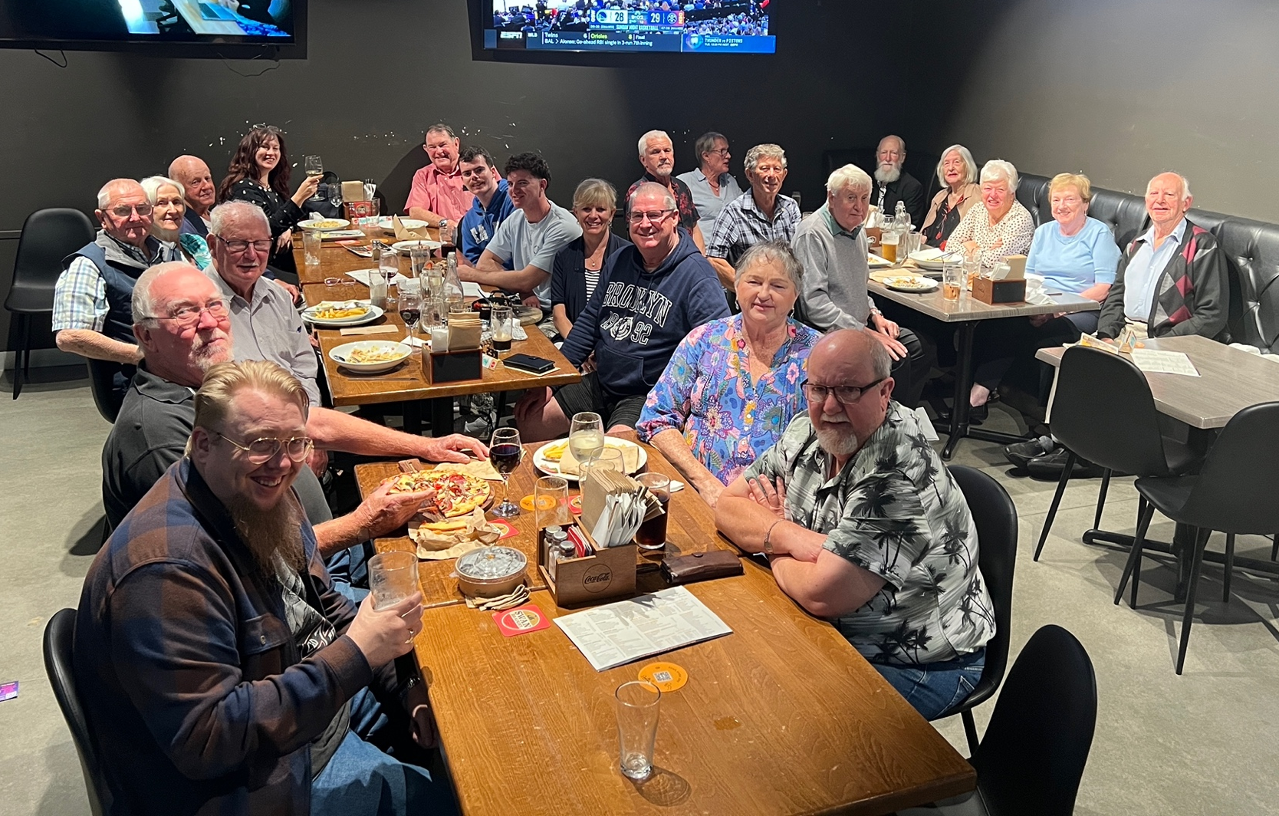





April 13th to April 19th

13th
1787: Arthur Phillip sets sails with 11 ships of criminals to Botany Bay, Australia
1909: First Giro d'Italia takes place in Milan - Italian cyclist Luigi Ganna is the winner
1913: 1st four-engined aircraft built and flown (Igor Sikorsky, Russia)
1949: 1st British-produced jet bomber, the Canberra, makes its 1st test flight

14th
1607: English colonists establish the 1st permanent English settlement in America at Jamestown
1702: England & Netherlands declare war on France & Spain
1787: Delegates gather in Philadelphia to draw up US constitution
1908: 1st passenger flight in an airplane

15th
1602: Cape Cod discovered by English navigator Bartholomew Gosnold
1800: King George III survives a second assassination attempt
1841: First emigrant wagon train to make it to California after a 1,730-mile journey
1905: Las Vegas founded in Nevada

16th
1220: King Henry III lays the foundation stone , to start the rebuilding of Westminster Abbey
1792: Denmark abolishes slave trade
1881: World's 1st electric tram enters service in Lichterfelder (near Berlin)
1920: French heroine Joan of Arc is canonized as a saint by Pope Benedict XV

17th
1536: Anne Boleyn's 4 "lovers" executed shortly before her own beheading
1590: Anne of Denmark is crowned Queen of Scotland
1689: English King William III declares war on France in support of the Dutch Republic
1859: Australian Rules Football first 'laws of the game' published

18^{h}
1565: Turkish Armada arrives to begin the Great Siege of Malta,
1756: Great Britain declares war on France at the start of the Seven Years' War
1843: United Free Church of Scotland forms
1952: Professor WF Libby says Stonehenge dates back to 1848 BC

19th
1770: British explorer Captain James Cook first sights Australia.
1839: Treaty of London constitutes Belgium an independent kingdom
1904: Much of Toronto destroyed by fire
1948: Chiang Kai-shek elected President of Nationalist China






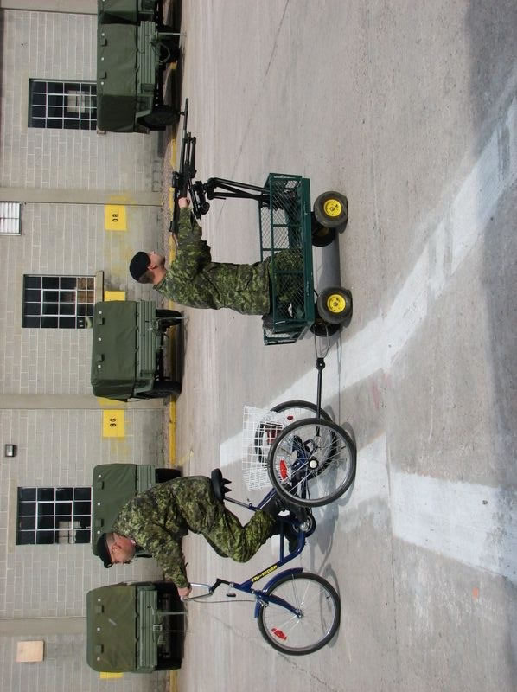
Rotary Club of Kwinana 2026

Nearby Rotary Clubs, Meeting Times

Rockingham Monday 6pm Armadale Tuesday 7pm
Palm beach Wednesday 6.30pm Mandurah Districts Tuesday 6pm
Baldivis Tuesday 6.30pm Pinjarra Thursday 6.45pm
Cockburn Wednesday 6pm Byford & Districts Monday 7pm

The Army could run out of fuel! Don’t worry we have a ‘back-up plan

