

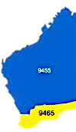
Rotary
The Rotary Club of Kwinana

District 9465 Western Australia

Chartered: 22 April 1971

Team 2021-22

President
Bob Thompson

Secretary
Genevieve Carr

Treasurer
Stephen Castelli

Facts & Figures

Attendance this week

Bulletin

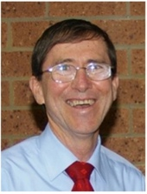

No 33 14/03/2022

President Bob

Rotary Club of Kwinana is almost 51 years’ old 1971/2022

Interesting meeting tonight, PP Max Bird brought us up to date by explaining his current involvement with Disaster Aid Australia, Max is currently the WA joint district representative for DAA. A role which Max is actively seeking a suitable person to succeed him in this role, with the offer of a return trip to Melbourne to attend suitable training for the role. Disaster Aid Australia began as a project of the Rotary Club of Endeavour Hills in 2010.

Serious planning is now underway for the 2022 Kwinana Community Fair to be held at Calista Oval on Saturday 5th November, an initial community planning meeting has been arranged for Tuesday 15th March 2022 at Rotary Hall at 7pm with all interested parties invited to attend. Social media has become the vehicle of choice to promote and publicise events such as our fair, Rtn. Kim B is providing the expertise to make this happen.

Big talking point recently is the escalating price of fuel, predictions that the price will go even higher in the short term, spare a thought for the ‘grey nomads’ flitting around Australia at present. Driving their V8 Land Cruiser towing a 22 foot+ caravan, their day to day costs have just skyrocketed, hopefully there will be some relief in the not too distant future.

Total Members 29 Apologies
Make-up 3 Attended 22
Hon. Member
LOA 4
Guests
Visitors
Partners
92.6%

Raffle
Genevieve & Mike

District Governor
9465

2021/22

Pat Schraven

Rotary International President
2021/22
Shekar Mehta

Rotary Club of
Calcutta- Mahanagar

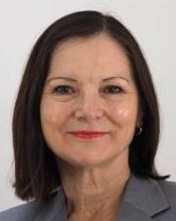
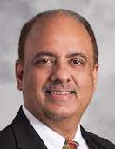

Heads & Tails
John M



March 2022: Water and Sanitation Month
Coming Events




Meets Monday
6 for 6.30pm
At Rotary Hall
Brownell Crescent, Medina

Visitors always welcome



Attendance Officer:
Paul Durant 0402 794 323
Apologies by Saturday 4 pm please

March 2022:

Mon 7th No meeting, Public Holiday
Mon 14th Club Meeting. PP Max Bird, Disaster Aid Aus.
Sat 19th Guess Who’s Coming to Dinner. Club Event
Mon 21st. Club Meeting, AG Rick Dawson
Mon 28th Club Meeting, Nora Peake, RYLA 2022

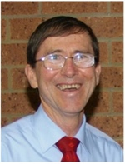

Bob Thompson
14th March 2022
President’s Pen

Paul Harris Fellow Nominations

The Club Board will soon be considering if the Club will be awarding any Paul Harris Fellow recognitions for this 2021-2022 rotary year. Our Standing Order 3.4 requires that;-
When it is proposed that the Club nominate or endorse a person for any award, recognition or position of office, the nomination must have the prior support of the Board before it is actioned. Examples of such nominations include, a Paul Harris Fellow, RI Certificate of Appreciation, City of Kwinana Award nomination, or as a Club representative on a community committee.
Any member who wishes to nominate a person for PHF recognition, (from within the Club or from our community), please forward this to me ASAP, together with the relevant information in support of their nomination.

Funding Support Encouraged
Rotary has recently emailed members seeking
funding support. The Rotary Foundation through
the Disaster Response Fund is seeking financial
donations to go to Ukraine and RAWCS National
is seeking financial donations to help with the
floods on the east coast.

Stronger Communities Grant
The Club’s application for funds under the
Stronger Communities Grant Program, Round 7
is still being processed. A call this week for the
Club to provide additional information was
responded to and a final yes or no decision is
expected soon.

President Bob with Guest Speaker
PP Max Bird speaking on
Disaster Aid Australia

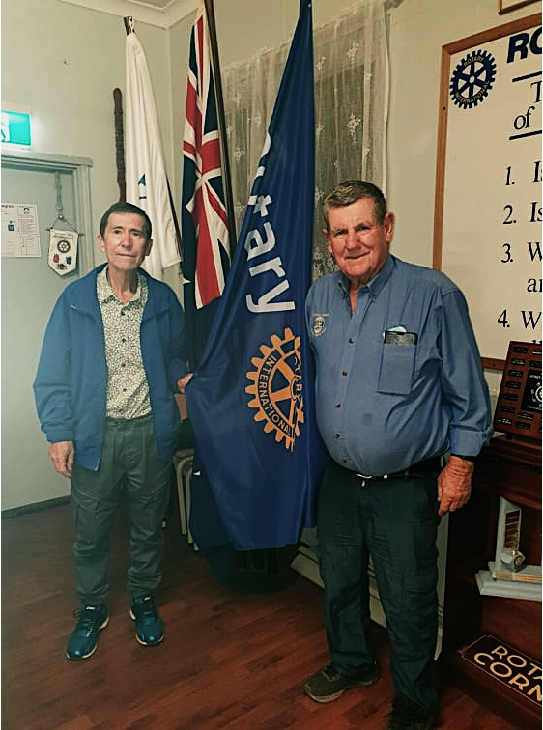



With all the sadness and trauma going on in the world at the moment, it is worth reflecting on the death of a very important person which went almost un-noticed last week. Larry La Prise, the man who wrote "The Hokey Pokey" died peacefully aged 83. The most traumatic part for his family was getting him in the coffin. They put his left leg in - and things just started to go wrong from there!

Bob Thompson
President 2021/22

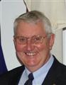

President 2022/23 James Sharkey
Club Service Report: 14/03/2022

Attendance Officer
Please put Paul’s mobile number in your mobile phone contacts list, 0402 794 323. Please text Paul with apologies or to order a meal for Monday meetings by 4.00pm Saturday.

Soft drinks and water
A selection of soft drinks and bottled water is available from the kitchen fridge. Cost will be $1.00 per can or bottle.

Partner’s Social Event 19th March 2022
A “Guess who is coming to dinner” Club social has been arranged for Saturday 19th March.

Rotary Hall Cleaning
We now have 3 teams for cleaning the Rotary Hall, kitchen and toilets on a weekly basis. The teams are James and Greg,
Bob T and Grace, Brian T and Ian. Thank you to all who volunteered. More volunteers would be most welcome.

President Elects training Seminar
I participated in an online President Elects Training Seminar on Sunday 27th February via zoom meeting.

James Sharkey
Club Service Director

PP Greg and PP Bevan display our recently acquired Rotary Flag
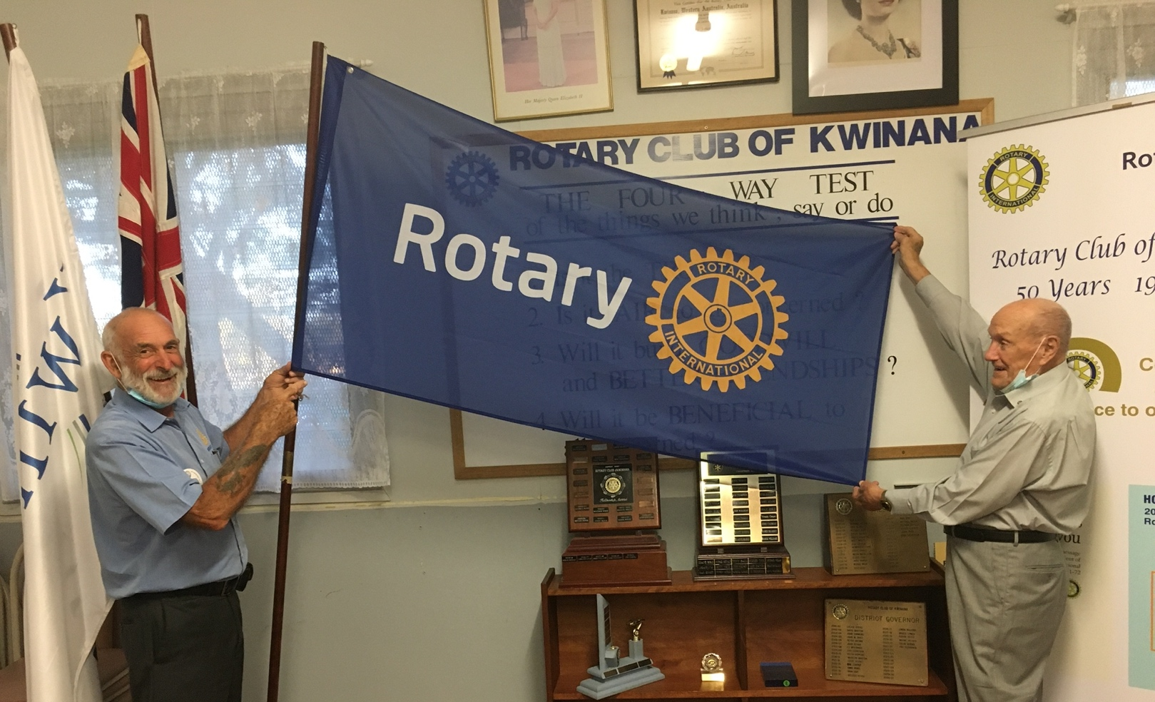

PP Genevieve Carr


Inward Correspondence.
- Report and results of Indigenous Health scholar Lucy Variakojis
- Notification from Rotary International regarding support for Ukraine crisis
- Rotary Out West
- District 9465 eDigest
- Rotary Foundation Australia – “Supercharge Your Project”
- Final Report for Australia Day – outcome letter
- Acknowledgement from Rotary Foundation of International Women’s Day
- Notification from RDU: 2022 – 2023 theme badges Imagine Rotary now available for purchase
- RAWCS – Project Audit report
- Water Corporation bills for Brownell Crescent, 1 Gentle Road
- Synergy bill (currently in credit)
- ShelterBox: Rotary Impact Report

14/03/2022

Outward Correspondence Nil.

Would members please note that any correspondence received or posted by yourself, please ensure a copy is forwarded to your secretary.




2021/22 PP Stephen Castelli
Bills paid, money in the bank.
Rotary Down Under Magazine now comes to you electronically.

Treasurer: PDG John Iriks
- Money in the Bank. Bills paid
- Financial Report to May 30th prepared for inclusion in our Annual Report, financials to June end will then be completed ready to be audited.

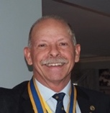

Bring your empty drink containers, we have collection bins.


2021/22 PP Genevieve Carr

Youth Services Report. 14/03/2022

Our RYLA Candidate, Laura Peake will be attending Club meeting as guest speaker on Monday 28 March.

2. Next RYPEN weekend is scheduled for Friday 20 May – Sunday 22 May; open to 14-17 year old. Applications due 1st May.



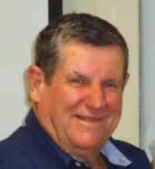
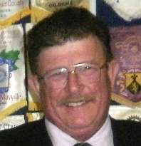



Kim Beciri
Public Relations Dir.

PP Max Bird
Foundation Dir.
PDG John Iriks
Membership Dir.

Project Director’s Report.
Club members encouraged to assist any time, see Mike for info. Furniture-0n-Line, 2022 has started well, my sincere thanks to all who are assisting.
We are in desperate need of the use of a large shed to store the donated furniture.

Public Relations:
We continue to receive exposure on Rotary Out West.
Kim is promoting our club on Facebook.
Kwinana Community Fair 2022, Saturday 5th November at Calista Oval, planning already underway, being promoted on Facebook.

To March 16th, 3168 reached, 259 responses, 86 last 7 days
Suggestion we could promote Rotary on local Radio.

Membership:
President John Iriks is Membership Director
Committee: Bob Thompson, Ed Samut and Eric Blogg.
Still the best option to invite new members, “ask someone”
Grace Obidike was welcomed into our club Monday 25th October
Kertrina Riordan was inducted on January 17th

Community:
Bread Program running well, underway again.
Still looking for more helpers, please come along.
Stronger Communities Grant applied for. More later.
Been noted that the ‘bread cutter’ is not performing to expectations.

Vocational:

International:
Max reports that 5 Hydro filters and 6 Sewing machines are on their wat to Timor. Max looking forward to being able to travel to Timor to continue assistance.

Youth: Report above.

- Visit your club webpage.

http://www.clubrunner.ca/Portal/Home.aspx?accountid=8106

or type Kwinana Rotary Club into ‘Search’

Projects Director
PP Mike Nella

Community

Vocational

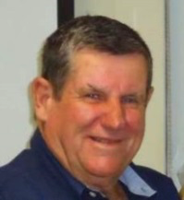

PP. Max Bird
International

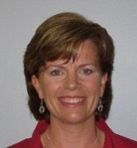



About Disaster Aid Australia.

Our Mission
To provide, and assist, in delivering sustainable humanitarian aid relevant to people affected by natural and other disasters, including safe water and shelter’.

Smart Aid We respond to disasters in our region such as earthquakes, typhoons and tsunamis with our ‘Smart Aid‘ program. This involves us in consulting the affected communities to find out what they want; and then deliver using local sources as much as possible. Typically, we have helped people rebuild their homes, and provided safe clean water.

Safe Water for every child We respond to the ongoing disaster of contaminated water with
‘Safe Water for Every Child‘ program. SkyHydrant water filters are used to
protect; communities; schools and medical facilities. The SkyHydrants
provides clean, bacteria free drinking water at a cost of $1 per person per year.

A Charity Disaster Aid Australia is an Australian charity registered with the Australian Charities and Not for Profits Commission. ABN 55 129 338 825

Guest Speaker: PP Max Bird
WA District Coordinator,
Disaster Aid Australia








Background
- A project of the Rotary Club of Greater Dandenong and Endeavour Hills.
- Has members/volunteers from across Australia;
- A member of Disaster Aid International, a Rotary Collaborating Organisation comprising Disaster Aid organisations in many countries all dedicated to providing Humanitarian Aid.
- Trains volunteers in administering humanitarian relief and aid;
- Provides education and training in aspects of disaster relief to individuals, community groups, businesses, schools and other organisations; and
- Works in partnership on humanitarian projects funded by other organisations, including Rotary Clubs and Rotary districts and Non-Rotary organisations.

https://www.disasteraidaustralia.org.au/

Disaster affected people typically want
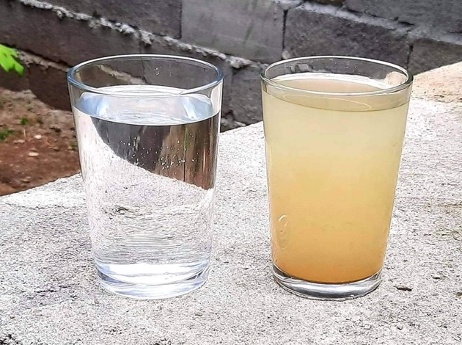
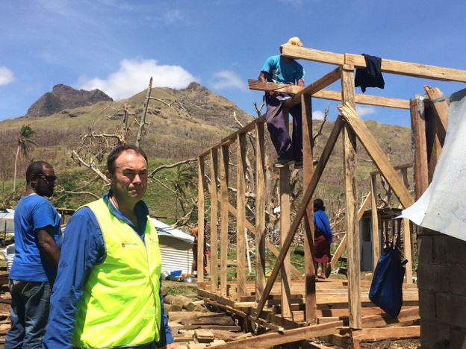

Help Rebuilding Homes
Clean Water

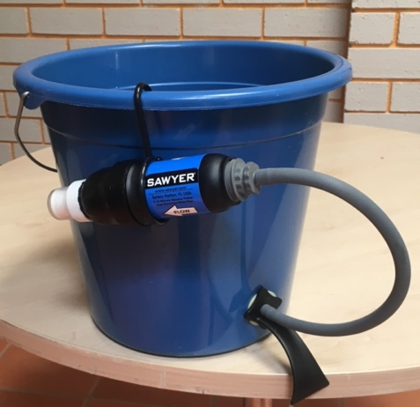


We Started Providing Building Materials and Sawyer Filters

We developed

Why We Started using SkyHydrants

- Highly effective bacteria removal
- Moderate initial cost ($5,000 installed) Less than $1 per person per year
- Serve communities of up to 700, or a school of 1,000
- No Power cost
- Treats without chemicals
- Minimal ongoing costs, membranes lasts 10 years
- Simple and reliable
- Use local organisations for information and liaison.
- Find out what people want.
- Buy materials as locally as possible.
- Expect the people helped to contribute effort -
- We aim to ‘Manage’ rather than ‘Do’
Replacing a Home for $1,000
A village temporary water supply for $2,500

Typical SkyHydrant Installation

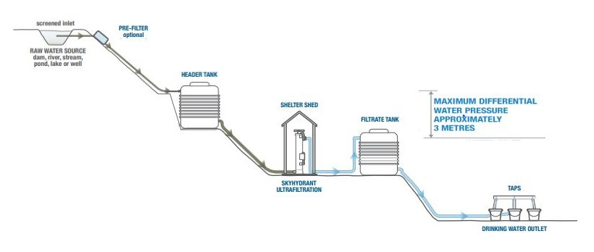

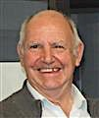

Fine Session: Sergeant Cyril Bennett

Stand-in: John Maskell
Deputy Bill Rowe.
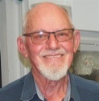

The usual, no badgers and winners fined.

John I: Winning at golf and bragging about it.

Bevan P: Celebrated another birthday recently.

John M: Nicking off for a holiday.

John I: John and Chris went along to Koorliny Art Centre for the show last Saturday night, unfortunately Chris forgot her Vac. ID, did John do the gentlemanly thing and drive home to get it, sadly no! Chris went.

Last week John I was fined for a milo misdemeanour at the Breakfast club, this week Chris outdid him by making an even bigger mess.

Pictured in 1955 is an IBM 5-megabyte hard disk being loaded onto a truck.
IBM charged the customer $US 3,000 per month to hire. 5 meg, couple of photos today.



Birthdays and Anniversaries March 2022

Birthday Congratulations:
Bevan Piper. 7th
Barry Winmar. 12th
Bob cooper. 16th
John Maskell. 23rd
Brian Thompson. 25th




Wedding Anniversary’s
John & Deryl Wallhead. 16th 59 years
Greg & Marge Williams 29th 56 years


Club Anniversaries.

Polio this week
9th March 2022
On Monday 7 March 2022, a case of circulating vaccine-derived poliovirus type 3 (cVDPV3) was confirmed in an unvaccinated girl aged three years and nine months in Israel. The girl had developed acute flaccid paralysis and upon testing of her stool, poliovirus was confirmed…Read more
International Women’s Day was marked on 8 March and among several online activities, the GPEI released a video featuring the voices of some of the women involved in the polio eradication effort in Pakistan. Spanish Minister for Foreign Affairs, European Union and Cooperation and Gender Champion for Polio Eradication José Manuel Albares also paid tribute to all the women in polio eradication.
Summary of new WPV and cVDPV this week (AFP cases and ES positives):
– Côte d’Ivoire: one cVDPV2 positive environmental sample
– DR Congo: one cVDPV2 case
– Israel: one cVDPV3 case and six positive environmental samples
– Mauritania: one cVDPV2 positive environmental sample
– Nigeria: one cVDPV2 case
– Occupied Palestinian territory: eight cVDPV3 positive environmental samples











Mar 13th to Mar 19th

13th
1894: J L Johnstone of England invents horse racing starting gate
1900: In France the length of the working day for women and children is limited by law to 11 hours.
1923: American inventor Lee de Forest demonstrates his sound-on-film moving pictures (NYC)
1935: Driving tests introduced in Great Britain

14^{h}
1794: Eli Whitney patents the cotton gin machine revolutionizing the cotton industry
1880: Salvation Army of England starts work in the US at Harry Hill's Variety Theatre in NYC
1885: Gilbert & Sullivan's comic opera "Mikado" premieres in London at the Savoy Theatre
1913: John D. Rockefeller gives $100 million to Rockefeller Foundation

15th
44BC: Julius Caesar is stabbed to death by Brutus, Cassius and several other Roman senators.
1493: Christopher Columbus returns to Spain after his first voyage to the New World
1778: Vancouver Island discovered by Captain James Cook
1877: Cricket's inaugural Test match commences as Australia plays England at the MCG

16th
1802: 1st US Military Academy at West Point is established (opened July 4, 1802)
1830: London's re-organised police force (Scotland Yard)
1834: Charles Darwin, aboard HMS Beagle, anchors in the British-acquired Falklands Islands
1922: Egypt achieves independence from Britain, but British troops remain

17th
1521: Portuguese navigator Ferdinand Magellan reaches the Philippines
1756: St. Patrick's Day is first celebrated in NYC at the Crown & Thistle Tavern
1845: Bristol man Henry Jones patents self-raising flour
1845: Rubber band patented by Stephen Perry of London

18th
1532: English parliament bans payments by English church to Rome
1662: First public bus service begins in Paris
1834: 6 farm labourers from, Dorset, England are sentenced to be transported to Australia for forming a trade union
1891: Britain is linked to the continent by Telephone

19th
1571: Spanish troops occupy Manila
1775: 4 people buried by avalanche for 37 days, 3 survive (Italy)
1918: US Congress authorizes time zones & approves daylight saving time
1932: The Sydney Harbour Bridge is opened in Sydney, Australia

Blast from the past

Zone President’s 2004/05
Rockingham: Ron Hurdle AG Eric Blogg Kwinana: Michael Bird
Safety Bay: Melanie Hume and Palm Beach: Charles Griffiths (RIP)

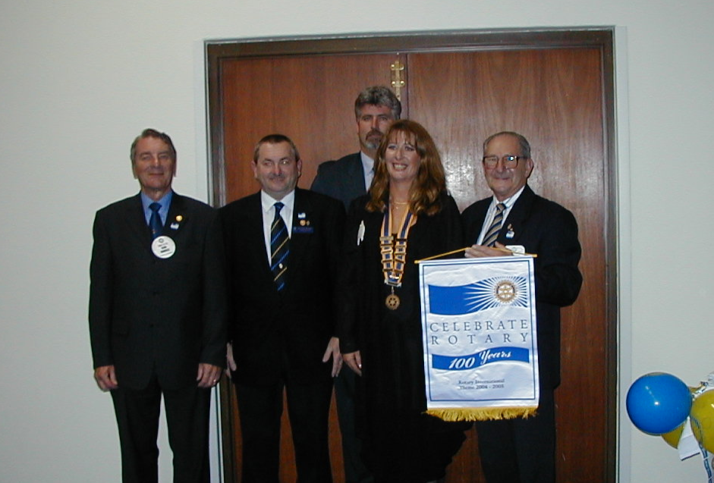

January 2004, Exchange Student Patricia Von Borries from Bolivia is greeted at Perth Airport by
Kwinana President Eric Blogg, Wendy Cooper and Gladys Blogg, PP Bob Cooper took the picture

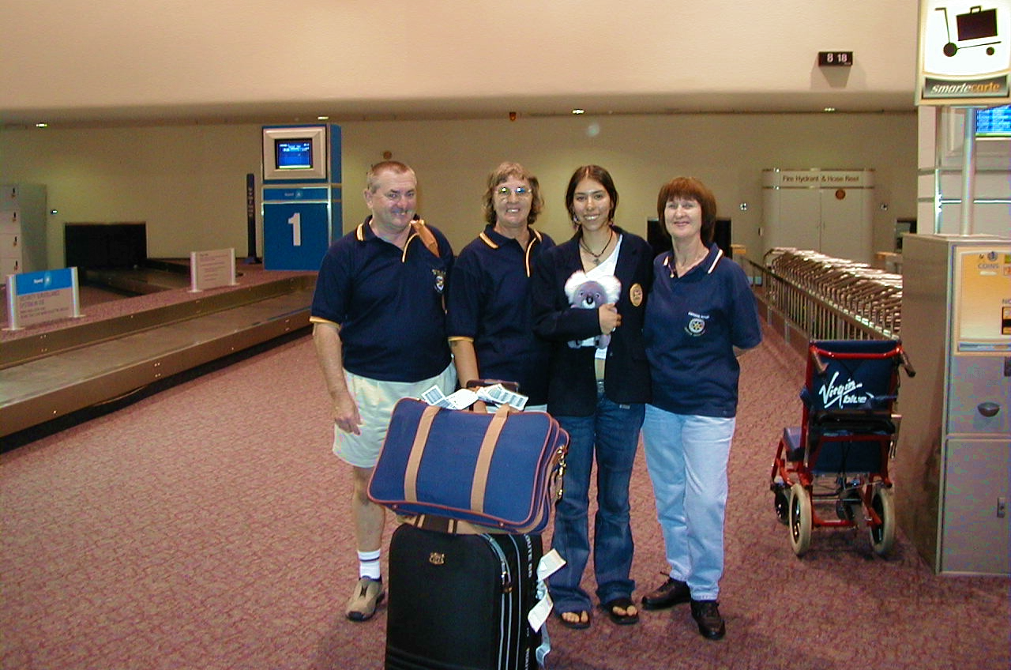

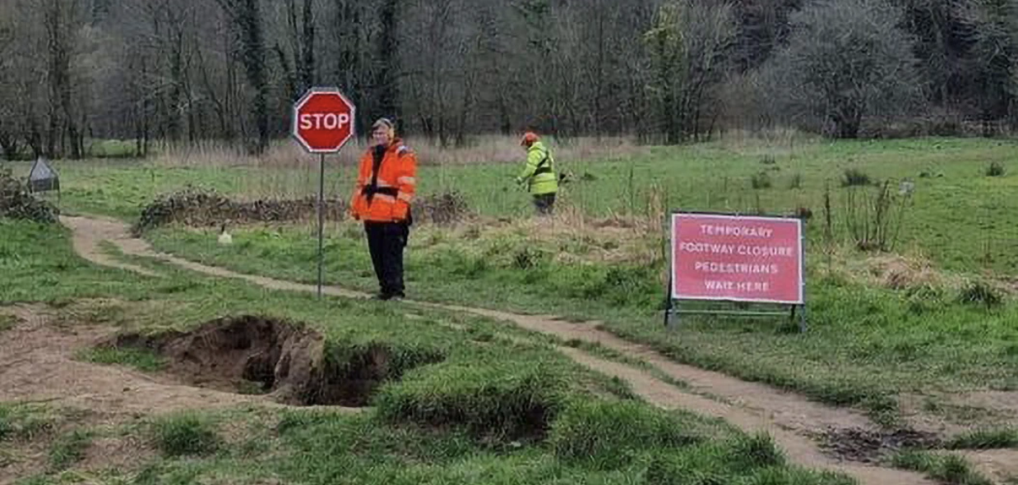

Latest Bathroom decor




Makeup opportunities

Rockingham Monday 6pm for 6.30 Rockingham RSL Club
Palm beach Wednesday 6pm for 6.30 Ocean Clipper Inn
Baldivis Mon/Fortnightly 6.30pm for 7.00 Peel Manor House
Cockburn Thursday 7.15am for 7.30 Cockburn Seniors Centre
Byford & Districts Monday 6.15pm for 6.45 Byford Tavern, South W Hwy

Rotary Club of Kwinana Contributions welcome: eblogg@bigpond.com

Media Release

For further information please contact
Marketing and Communications on 08 9439 0435

