

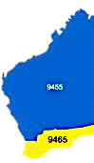
Rotary
The Rotary Club of Kwinana

District 9465 Western Australia

Chartered: 22 April 1971

Team 2021-22

President
Bob Thompson

Secretary
Genevieve Carr

Treasurer
Stephen Castelli

Facts & Figures

Attendance this week

Bulletin

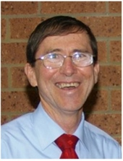

No 34 21/03/2022

President Bob

Rotary Club of Kwinana is almost 51 years’ old 1971/2022

Well attended meeting tonight for a ‘Club Forum’ Assistant Governor Rick Dawson was to attend tonight’s meeting but had to cancel because COVID managed to infiltrate his family forcing him to isolate.

Club Forum was the vehicle to evaluate the proposal to significantly extend the back shed to accommodate stock for the Rotary Kwinana Furniture Factory and to take advantage of any further opportunities to let out space in the future.
PDG John outlined the proposal, it’s benefits, financial considerations, future benefits for our club both now and into the future. A number of members had suggestions and comments during the debate, when our discussion moderator PP Chris asked for a show of hands to gauge support the result showed that members present were in full support.
The Board now will look at a number of quotes received and evaluate the way forward. I also understand that there is some urgency involved as the Furniture Factory has the offer of a large amount of very good stock and requires space to store the items.

Another successful Guess Who’s Coming to Dinner was held last Saturday evening
PE James thanked everyone who took part for their time and effort in participating.

Total Members 29 Apologies
Make-up 3 Attended 21
Hon. Member
LOA 4
Guests
Visitors
Partners
92.3%

Raffle
Edd & Terry

District Governor
9465

2021/22

Pat Schraven

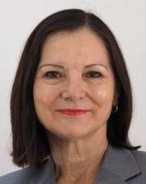
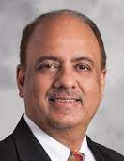
Rotary International President
2021/22
Shekar Mehta

Rotary Club of
Calcutta- Mahanagar

Heads & Tails
John W



March 2022: Water and Sanitation Month
Coming Events




Meets Monday
6 for 6.30pm
At Rotary Hall
Brownell Crescent, Medina

Visitors always welcome



Attendance Officer:
Paul Durant 0402 794 323
Apologies by Saturday 4 pm please

March 2022:

Sat 19th Guess Who’s Coming to Dinner. Club Event
Mon 21st. Club Meeting, Club Forum
Mon 28th Club Meeting, Nora Peake, RYLA 2022

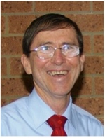

Bob Thompson
21st March 2022
President’s Pen

Board Funding Support Decisions
At the 16 March Board meeting, (March being designated by RI as Water, Sanitation and Hygiene Month) the Board resolved to make the following donations from accumulated Club funds.
Disaster Aid – International Disaster $ 5,000
Timor Leste – Water project 5,000
Timor Leste 2021-22 Club Budget 3,000
Rotary International Appeal for Ukraine 2,500 through the Disaster Response Fund
Rotary International End Polio Now 2,500
Rotary Eastern States Flood Appeal 2,500 through RAWCS National
$20,500

District Conference via Zoom Saturday 26 March 2022

Please seriously consider registering and attending our District Conference. It’s very easy and cheap.
This Saturday 26 March from 8.30 am to 2.30 pm via Zoom.
Cost is only $35. An email invite has already been forwarded to you via District.
See me if you want more info or help to register.

Guess who’s Coming to Dinner
This social partners’ night last Saturday was a great success. Thanks to Club Service Director James for the organising and to the 3 host couples.

Palm beach Club 40th Birthday
Neighboring Club Palm Beach is holding its 40th Birthday meeting at the Ocean Clipper on Wednesday 13 April 2022. I have congratulated them on reaching this milestone.

`

Bob Thompson
President 2021/22

Morris, an 82-year-old man, went to the doctor to get a physical.
A few days later, the doctor saw Morris walking down the street with a gorgeous young woman on his arm.
A couple of days later, the doctor spoke to Morris and said, 'You're really doing great, aren't you?'
Morris replied, 'Just doing what you said, Doc: 'Get a hot mamma and be cheerful'
'The doctor said, 'I didn't say that. I said, 'You've got a heart murmur; be careful.'

A man was telling his neighbour, 'I just bought a new hearing aid. It cost me four thousand dollars, but it's state of the art. It's perfect.'
'Really,' answered the neighbour. 'What kind is it?'
' Twelve thirty.'

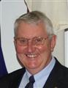

President 2022/23 James Sharkey
Club Service Report: 21/03/2022

Attendance Officer
Please put Paul’s mobile number in your mobile phone contacts list, 0402 794 323. Please text Paul with apologies or to order a meal for Monday meetings by 4.00pm Saturday.

Soft drinks and water
A selection of soft drinks and bottled water is available from the kitchen fridge. Cost will be $1.00 per can or bottle.

Partner’s Social Event 19th March 2022
A “Guess who is coming to dinner” Club social was held last Saturday evening. A very enjoyable evening was had by one and all.

Rotary Hall Cleaning
We now have 3 teams for cleaning the Rotary Hall, kitchen, and toilets on a weekly basis. The teams are James and Greg,
Bob T and Grace and Brian T and Ian. Thank you to all who volunteered. More volunteers would be most welcome.

Rotary Virtual Conference – District 9465
The virtual conference will be held on Saturday 26th March 2022 from 9.00am until 2.30pm.
The cost is $35.00 per person
You will need to register by 5.00pm on Thursday 24th March 2022.

The line-up includes:
- Craig Challen SC OAM, a member of the international team that successfully rescued 12 boys and their coach from a flooded cave in Chiang Rai, Thailand
- Stan Grant; respected and renowned journalist. Delve into the reasons to focus on diversity, equity and inclusion
- Evan Burrell; be engaged and disrupted by sometimes controversial but always thought-provoking presenter, Evan Burrell. He will get us thinking about our image and how we can better promote ourselves
- Katrina Porter, OAM, an Australian Paralympic swimmer
- Fleur Massey, Founder of Blue Guardians
- A selection of Rotary presenters showcasing just a few of the very many worthy projects we support in our District as we serve to Change Lives.

Anyone interested please email me and I will send you the registration details.

Rotary District Club Officer training
Club officer training will be held via zoom this year on Sunday 3rd April 2022 commencing at 1.00pm.
Incoming Club officers for the 2022-23 Rotary year are cordially invited to attend.
In Particular Secretary, Club Service/President Elect, Public Relations, Membership, foundation, and Projects Directors.
This will be a joint training program and I urge you all to attend.
This maybe a good opportunity for our incoming board members to gather in one venue and undertake the training together.
During this training session there will also be a breakout session to discuss and vote on the District 9465 budget for 2022-23.

James Sharkey
Club Service Director

PP Genevieve Carr


21/03/2022

Inward Correspondence.
- Receipt for $625 donation towards ARH Indigenous Health Scholarship Program
- Old Flames newsletter
- RYPEN application form
- Rotary Out West
- Letter of introduction from SES Association of WA
- Report from Australian Alzheimer’s Research Foundation
- Badges and invoice from Imprint Plastic

Outward Correspondence
- RYPEN application forms sent to Gilmore College, Peter Carnley Anglican Community School, The Kings College, Kolbe Catholic College

Would members please note that any correspondence received or posted by yourself, please ensure a copy is forwarded to your secretary.

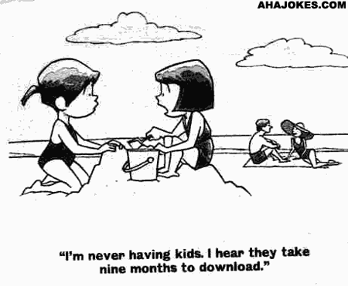


2021/22 PP Stephen Castelli
Bills paid, money in the bank.

Treasurer: PDG John Iriks
- Money in the Bank. Bills paid
- Financial Report to May 30th prepared for inclusion in our Annual Report, financials to June end will then be completed ready to be audited.

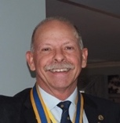

Rotary Down Under Magazine now comes to you electronically.
Bring your empty drink containers, we have collection bins. Concerns that the most recent water bill was 3 times the normal amount?


2021/22 PP Genevieve Carr

Youth Services Report. 21/03/2022

- RYLA: Have confirmed that Laura Peake, our sponsored RYLA candidate, will attend Club meeting on Monday 28 March as guest speaker

- RYPEN: Application forms sent to local schools, seeking potential candidates

- Activ Industries: Have liaised with Debbie Cormack, employment coordinator at Activ Industries in Rockingham; we are welcome to visit the premises as a vocational visit but must go in small groups of 4-6 due to COVID-19 restrictions, other safety issues.

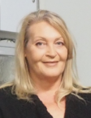
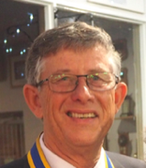
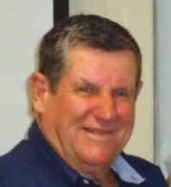
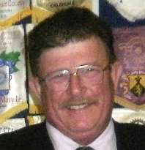



Kim Beciri
Public Relations Dir.

PP Max Bird
Foundation Dir.
PDG John Iriks
Membership Dir.

Project Director’s Report.
Furniture-0n-Line, 2022 going really well, my sincere thanks to all who are assisting.
Club members encouraged to assist any time, see Mike for info.
We are in desperate need of the use of a large shed to store the donated furniture.
Meeting with COK to consider funding for Anzac Day Breakfast.

Public Relations:
We continue to receive exposure on Rotary Out West.
Kim is promoting our club on Facebook.
Kwinana Community Fair 2022, Saturday 5th November at Calista Oval, planning already underway, being promoted on Facebook.

To March 24th, 3381 reached, 279 responses, 224last 7 days
Suggestion we could promote Rotary on local Radio.

Membership:
President John Iriks is Membership Director
Committee: Bob Thompson, Ed Samut and Eric Blogg.
Still the best option to invite new members, “ask someone”
Grace Obidike was welcomed into our club Monday 25th October
Kertrina Riordan was inducted on January 17th

Community:
Bread Program running well, underway again.
Still looking for more helpers, please come along.
Stronger Communities Grant applied for. More later.

Vocational:

International:
Max reports that 5 Hydro filters and 6 Sewing machines are on their wat to Timor. Max looking forward to being able to travel to Timor to continue assistance.

Youth: Report above.

- Visit your club webpage.

http://www.clubrunner.ca/Portal/Home.aspx?accountid=8106

or type Kwinana Rotary Club into ‘Search’

Projects Director
PP Mike Nella

Community

Vocational

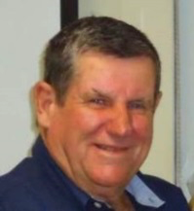

PP. Max Bird
International

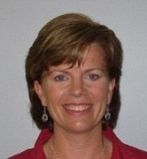
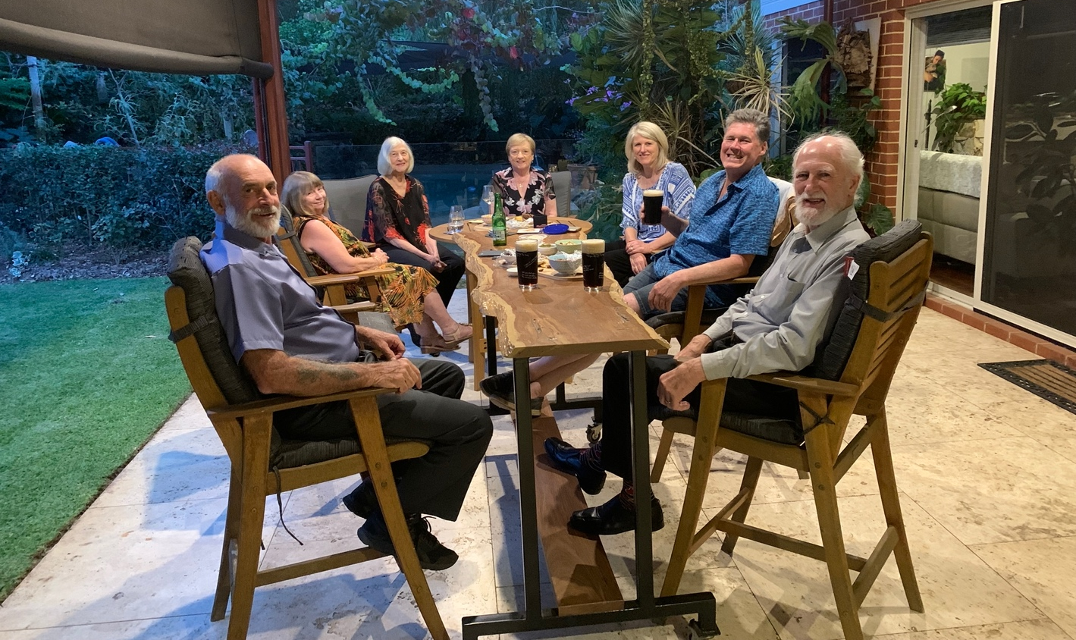
Guess Who’s Coming to Dinner. Saturday 19th March 2022



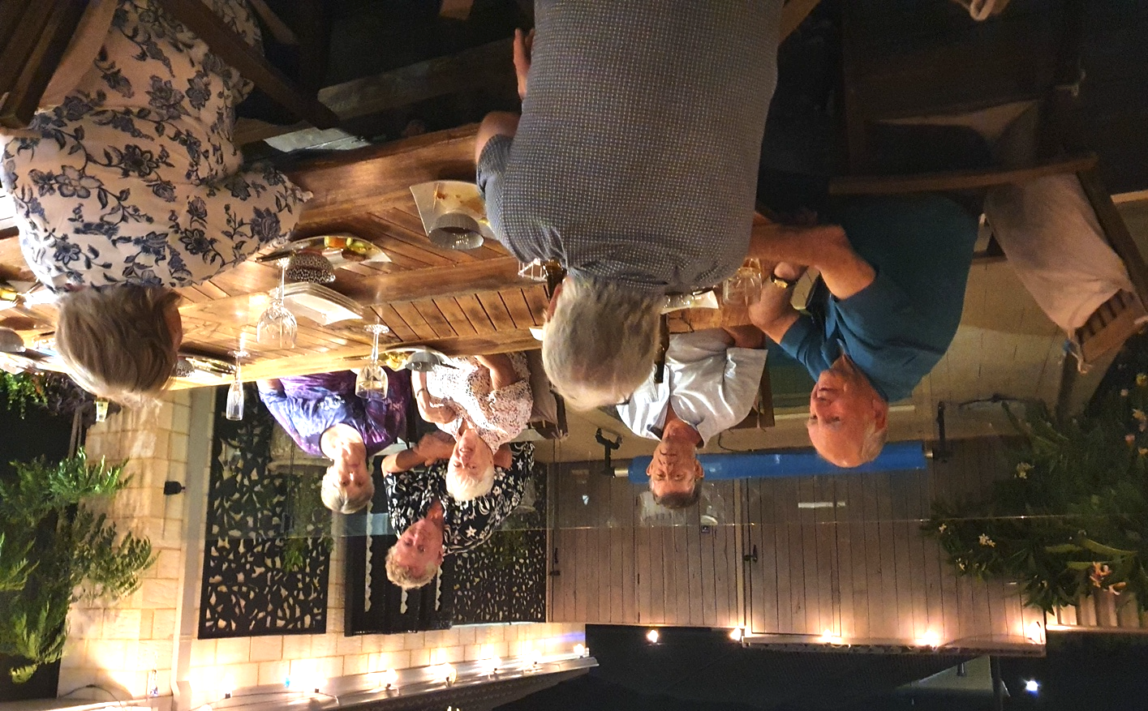

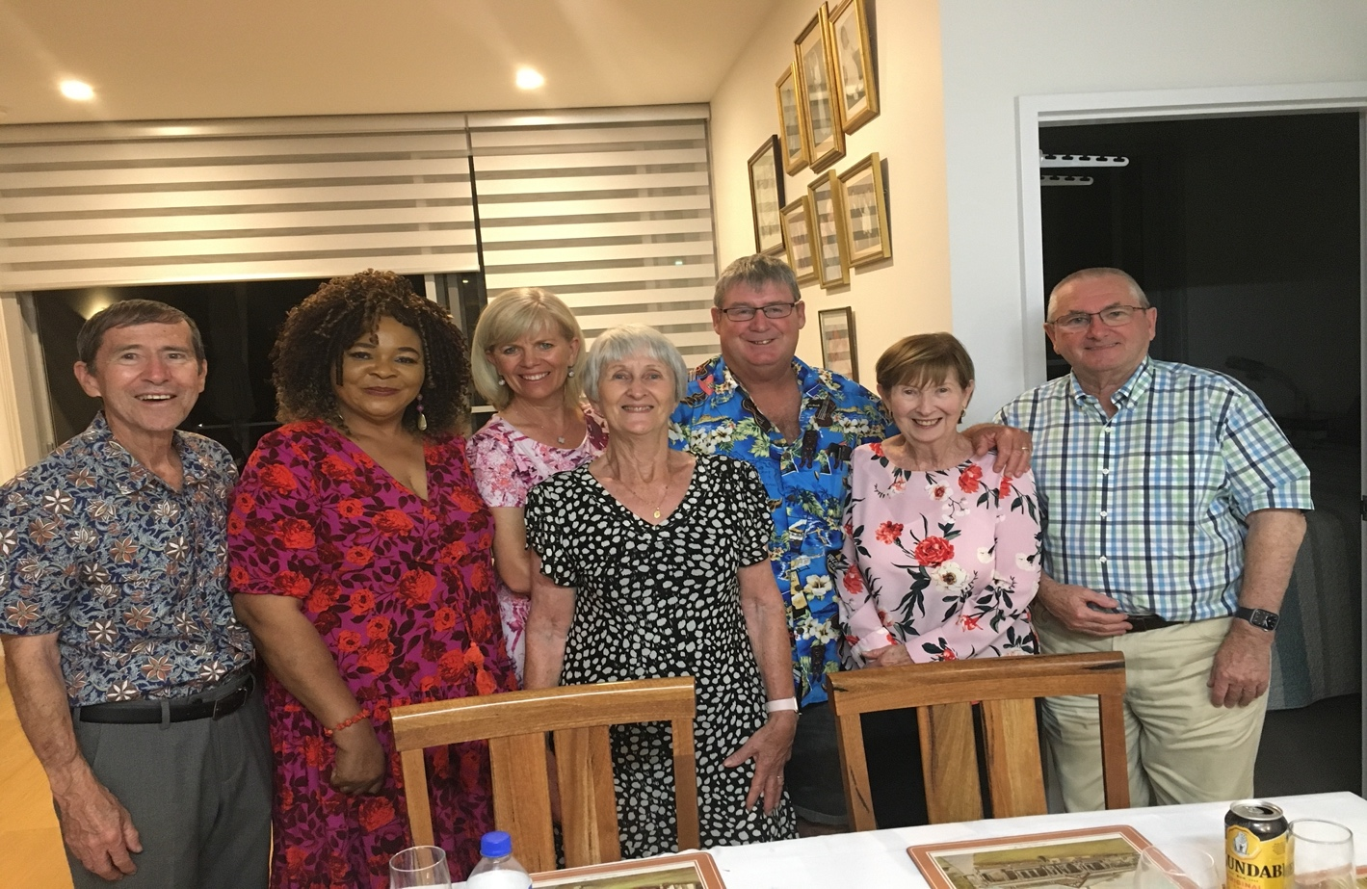

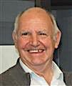
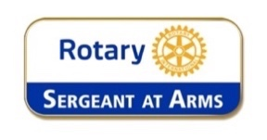
Fine Session: Sergeant Cyril Bennett

Stand-in: John Maskell
Deputy Bill Rowe.
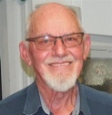

Pres. Bob: Managed to send an email to members with contents upside down.

Edd and Stephen: “Are you available”

Those members not wearing a face mask had to pay up.

Chris O fined Genevieve for taking off her face mask to kiss him.

Stephen C: Out delivering rubbish to Millar Road Tip, managed to fall of the truck.

Rotary Club of Kwinana, meeting at Rotary Hall Monday 21st March 2022

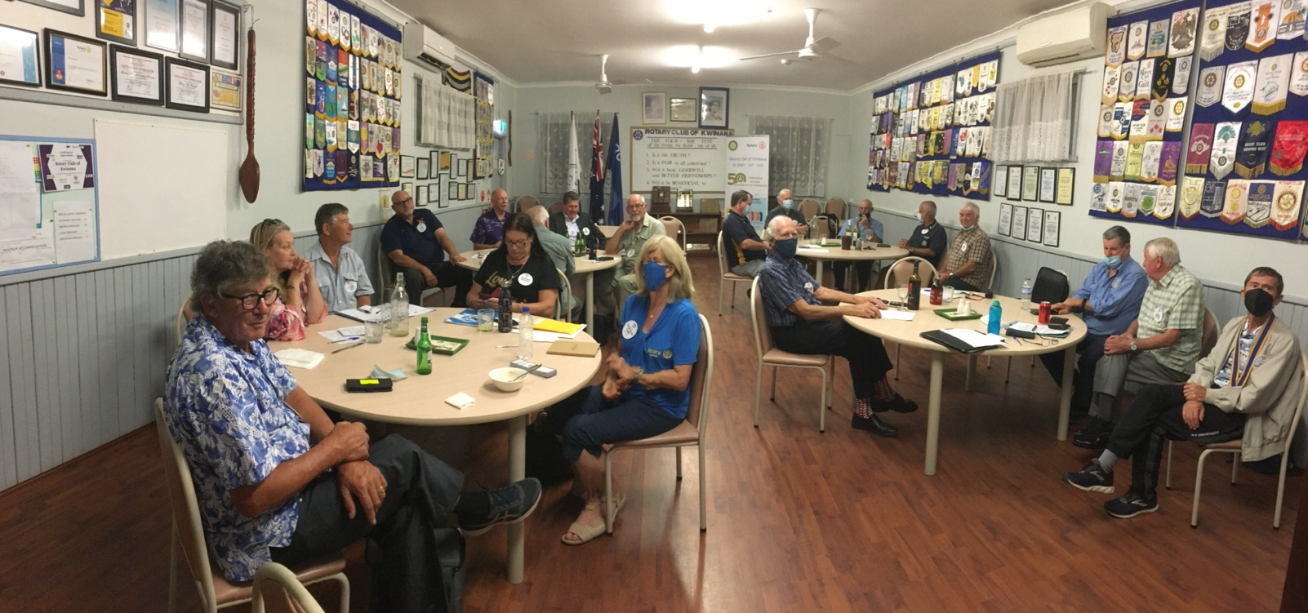

1) How long did the Hundred Years War last? - 116 years
2) Which country makes Panama hats? - Ecuador
3) From which animal do we get cat gut? - Sheep and Horses
4) In which month do Russians celebrate the October Revolution? - November
5) What is a camel's-hair-brush made of? - Squirrel fur
6) The Canary Islands in the Pacific are named after what animal? - Dogs
7) What was King George VI's first name? - Albert
8) What color is a purple finch? - Crimson
9) Where are Chinese gooseberries from? - New Zealand
10) What is the color of the black box in a commercial airplane? - Orange

Birthdays and Anniversaries March 2022

Birthday Congratulations:
Bevan Piper. 7th
Barry Winmar. 12th
Bob Cooper. 16th
John Maskell. 23rd
Brian Thompson. 25th




Wedding Anniversary’s
John & Deryl Wallhead. 16th 59 years
Greg & Marge Williams 29th 56 years


Club Anniversaries.

Polio this week
16th March 2022
The thirty-first meeting of the Emergency Committee under the International Health Regulations (2005) (IHR) on the international spread of poliovirus was convened by the WHO Director-General on 28 February 2022. The Emergency Committee reviewed the data on wild poliovirus (WPV1) and circulating vaccine-derived polioviruses (cVDPV). Technical updates were received about the situation in the following State Parties: Afghanistan, Djibouti, Democratic Republic of the Congo (DR Congo), Malawi, Mozambique, Nigeria, Pakistan, Somalia and Yemen. Read the statement here.
Summary of new WPV and cVDPV this week (AFP cases and ES positives):
– DR Congo: three cVDPV2 cases
– Nigeria: one cVDPV2 case






The optimist proclaims that we live in the best of all possible worlds; and the pessimist fears this is true.

Our greatest glory is not in never falling, but in getting up every time we do.

Cynics regarded everybody as equally corrupt... Idealists regarded everybody as equally corrupt, except themselves.






Mar 20th to Mar 26th

20th
1602: United Dutch East Indian Company (VOC) forms
1616: Walter Raleigh released from Tower of London to seek gold in Guyana
1800: Alessandro Volta reports his discovery of the electric battery
1930: American fast food restaurant chain "KFC" [Kentucky Fried Chicken] is founded

21st
1824: Fire at Cairo ammunitions dump kills 4,000 horses
1943: Assassination attempt on Adolf Hitler fails
1951: 2,900,000 US soldiers in Korea
1961: The Beatles' first appearance at the Cavern Club in Liverpool

22nd
1778: Captain James Cook sights Cape Flattery, now in Washington state
1888: English Football League established
1903: Niagara Falls runs out of water due to a drought
1960: 1st patent for lasers granted to Arthur Schawlow & Charles Townes

23rd
1687: France & England form alliance against Spain; England gets Dunkirk
1840: Draper takes 1st successful photo of the Moon (daguerreotype)
1857: Elisha Otis installs his 1st elevator at 488 Broadway in New York City
1903: The Wright brothers 1st file a patent for a flying machine, which is granted 3 years later

24th
1837: Canada gives its black citizens the right to vote
1883: 1st telephone call between NY & Chicago
1906: "Census of the British Empire" shows Great Britain rules 1/5th of the world
1955: 1st seagoing oil drill rig placed in service

25th
0421: Friday at 12 PM - city of Venice founded
1807: First fare-paying, passenger railway service in the world established in Swansea, Wales
1807: British Parliament abolishes slave trade throughout the British Empire.
1954: RCA manufactures 1st colour TV set (12½" screen at $1,000)

26th
1668: England takes control of Bombay, India
1780: 1st British Sunday newspaper appears (British Gazette & Sunday Monitor)
1845: Patent awarded for adhesive medicated plaster, precursor of band-aid
1885: 1st modern, legal cremation held in England at Woking, Surrey

Blast from the past
Raising of the Apex Time Capsule 18th February 2004

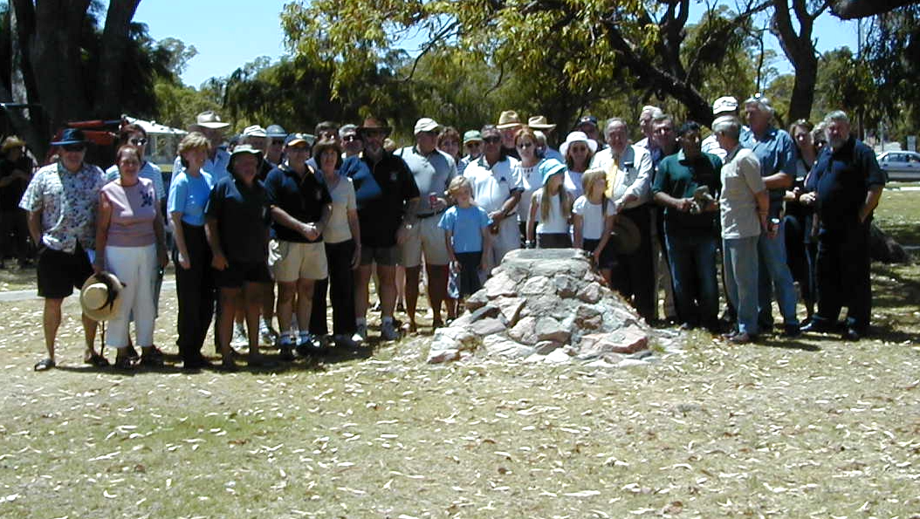

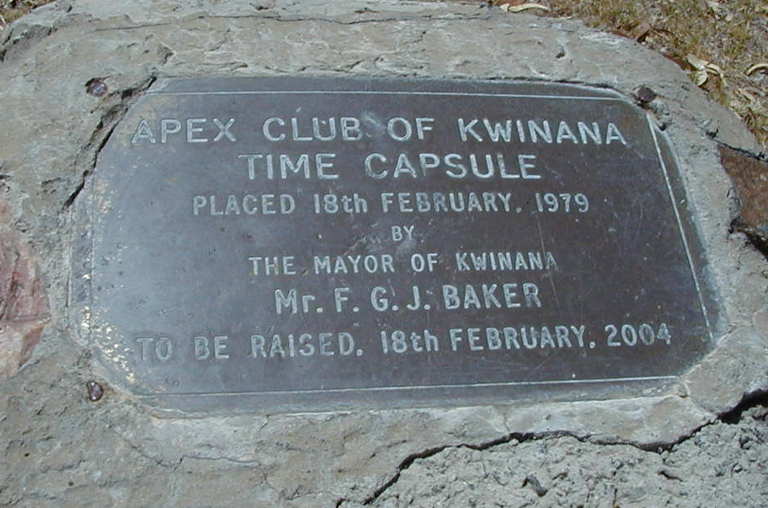

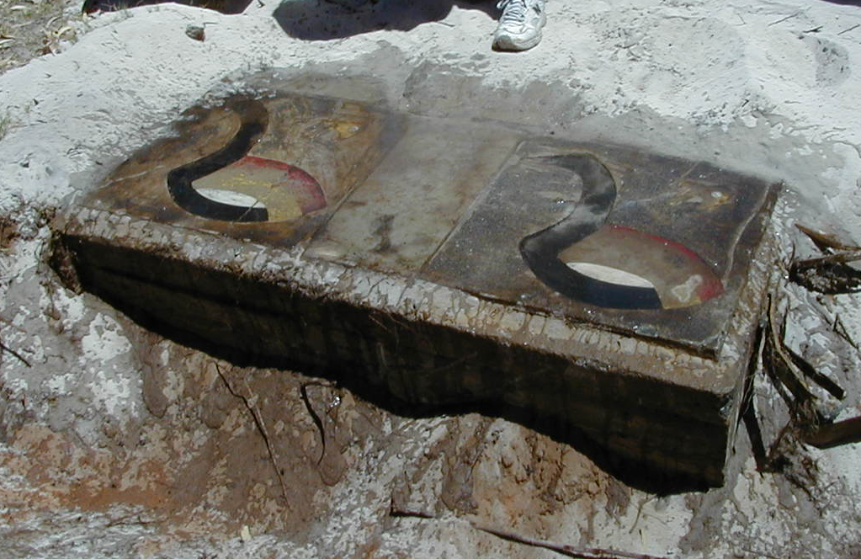
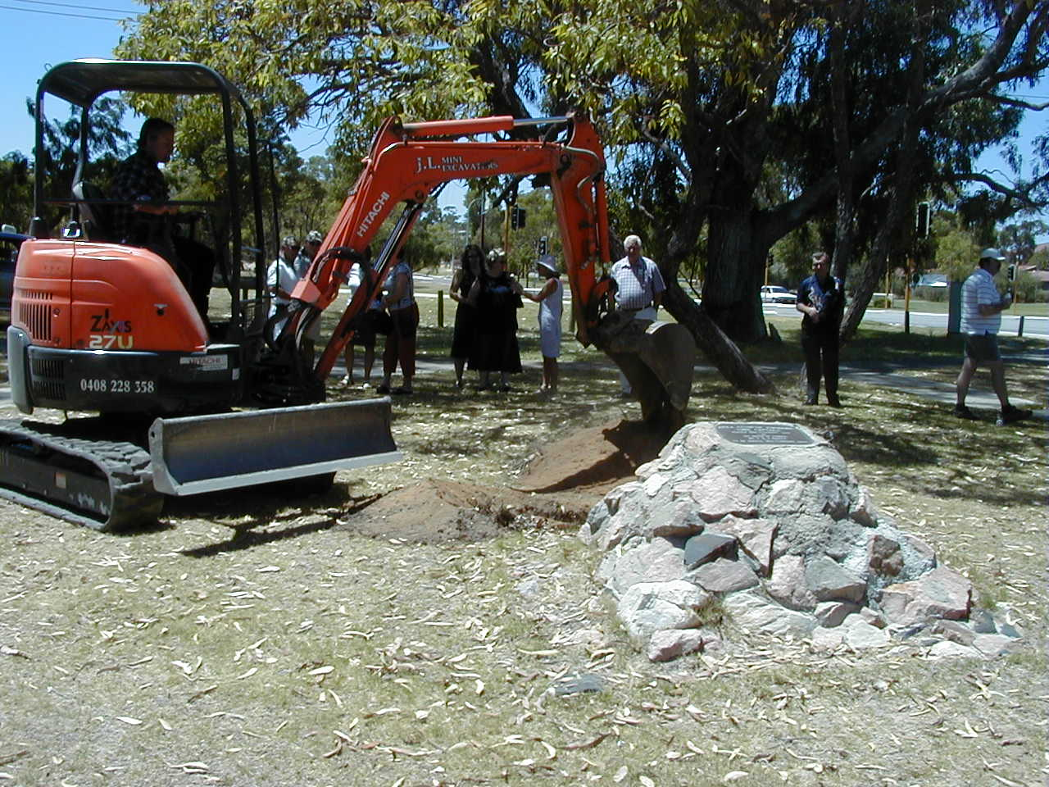

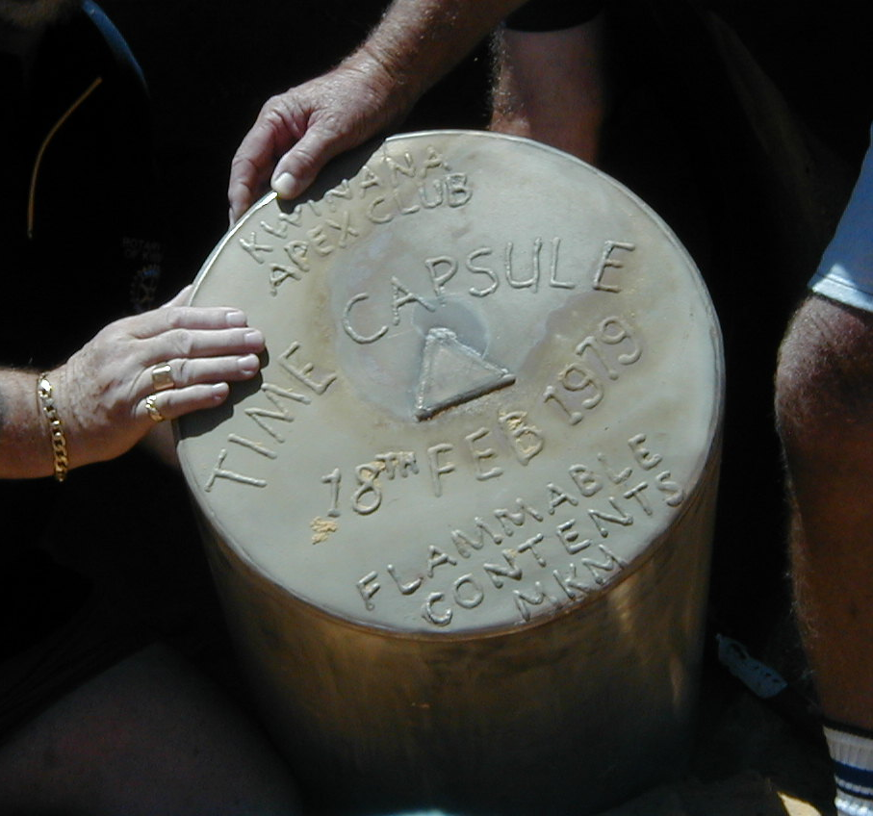
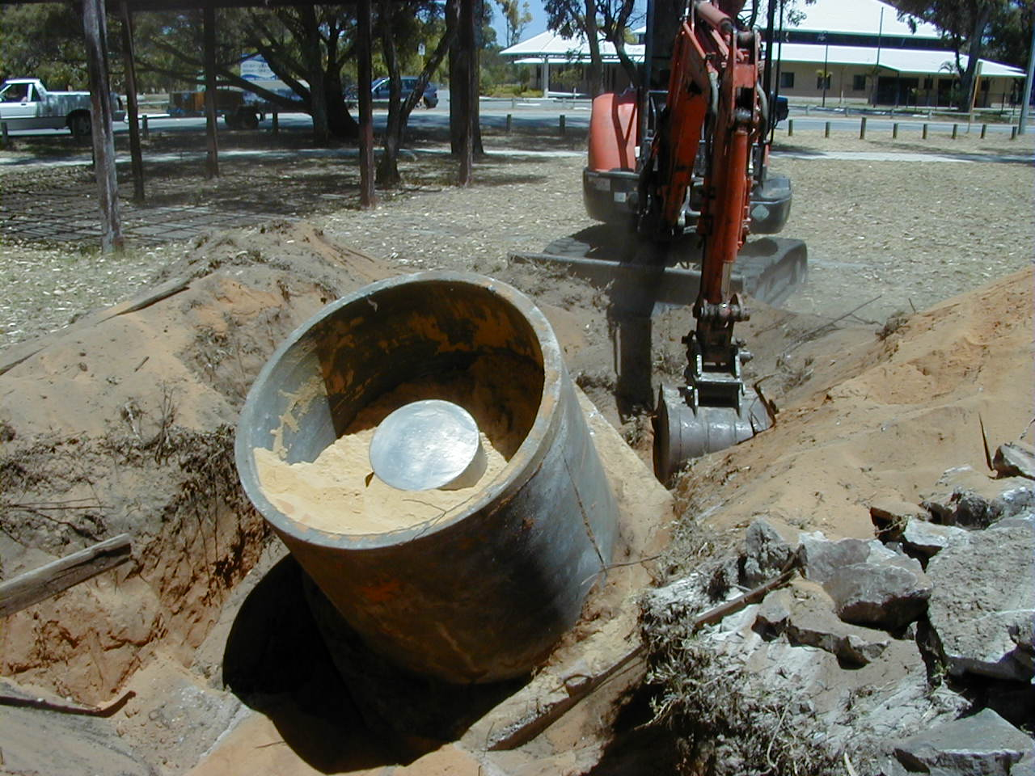

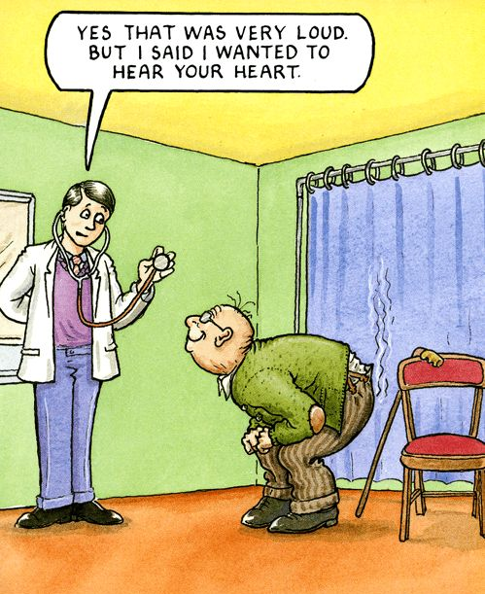


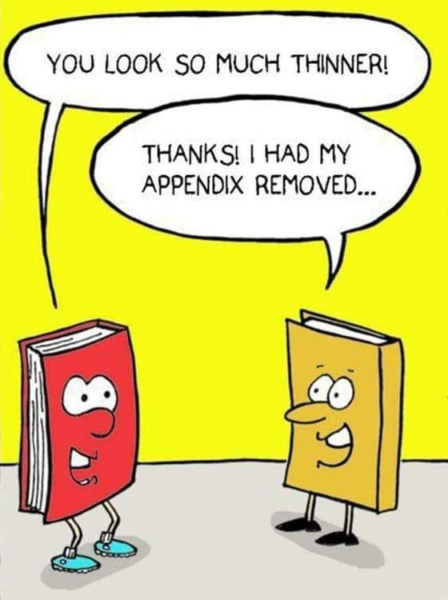


Makeup opportunities

Rockingham Monday 6pm for 6.30 Rockingham RSL Club
Palm beach Wednesday 6pm for 6.30 Ocean Clipper Inn
Baldivis Mon/Fortnightly 6.30pm for 7.00 Peel Manor House
Cockburn Thursday 7.15am for 7.30 Cockburn Seniors Centre
Byford & Districts Monday 6.15pm for 6.45 Byford Tavern, South W Hwy

Rotary Club of Kwinana Contributions welcome: eblogg@bigpond.com

Media Release

For further information please contact
Marketing and Communications on 08 9439 0435

