
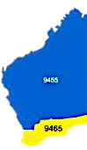

Team 2020-21

President
John Iriks

Secretary
Brian McCallum

Treasurer
Stephen Castelli

Facts & Figures

Attendance this week

The Rotary Club of Kwinana

District 9465 Western Australia

Chartered: 22 April 1971

Bulletin
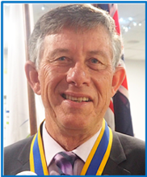

No 34 12/04/2021

Rotary Club of Kwinana is in its 50th year 1971/2021
President John

Saturday 17th is now upon us, we will be celebrating 50 years of service to Rotary International, the community both local, national and International by the Rotary Club of Kwinana.
Our book printing job has been picked-up from the printers, first impressions are very good.
Our book will be launched by President John on Saturday night, attendance looks to be about 70 including a number of special guests, former members partners and some family members.
We will have two picture history compilations running, one from 2000 to 2011 and the other from 2012 to the present plus a video taken from footage shot by PP Andy Valk during the 90s.

The good news is that PP Mike now has the option of inviting the public to view and purchase the recycled furniture he has on display in Gentle Road, Medina. The site will be open Thu, Fri and Saturday, President John is asking that any member who can give an hour or two on any of those days to contact him and a roster will be put together.

Living in this ‘recycle’ world, I wonder if we could possibly have former President who would like to be recycled, if so please contact PE Bob T.

Total Members 31 Apologies
Make-up Attended 22
Hon. Member 1
LOA 1
Guests 1
Visitors
Partners
86.1 %

Raffle
Norm & Brian Mc

District Governor
9465

2020/21

Colin Burns



Rotary International President
2020/21
Holger Knaack

Rotary Club of Herzogtum Lauenburg-Mölln, Germany

Heads & Tails
Chris O








Attendance Officer:
Greg Williams 0435 083 069
Apologies by Saturday pm please

April 2021 Maternal and Child Health Month
Coming Events
April:
Mon 5th No Meeting: Easter Monday

Mon 12th Club Meeting. Rick Dawson. Carnaby Cockies

Sat 17th Club 50th Anniversary

Mon 19th No Meeting

Mon 26th No Meeting Anzac Day Holiday

Meets Monday
6 for 6.30pm
At Rotary Hall
Brownell Crescent, Medina

Visitors always welcome



John Iriks

President’s Pen

12th April 2021

Our 50th Celebrations are all coming together with our book being collected from the printers, thanks Eric, our exhibition in place at the Darius Wells Library and Resource Centre thanks to
Bob Thompson and the library staff and some heavy lifting from Paul and Greg.
Celebration night on 17th thanks to our hard working subcommittee of Bob and Jo, Eric and Gladys, Cyril and Lynne, Chris and Greg.

Thanks also to those who have volunteered to sit at the display between now and the 22nd April 2021. It seems to be a great opportunity to explain Rotary to potential members. Club Service Director /President Elect Bob has a busy few months for us so please check out his report.

Congratulations to Michael, the Rotary Furniture Factory has approval as a “showroom” and is available for public opening from Monday to Saturday 9 am to 3 pm.
Mike suggests we start opening Thursday to Saturday and see how that works out.
Please see him about volunteering a few hours. The work is easy you just have to smile and greet people, Mike and his team of “guys who can lift heavy things” will do the rest.

See you at the party Saturday night,

Enjoy Rotary

Yours in Rotary Service
John

We usually have a picture of our Guest Speaker and our President together, Rick disappeared too quickly.
Instead we have one from an earlier meeting, this one with PE Bob T
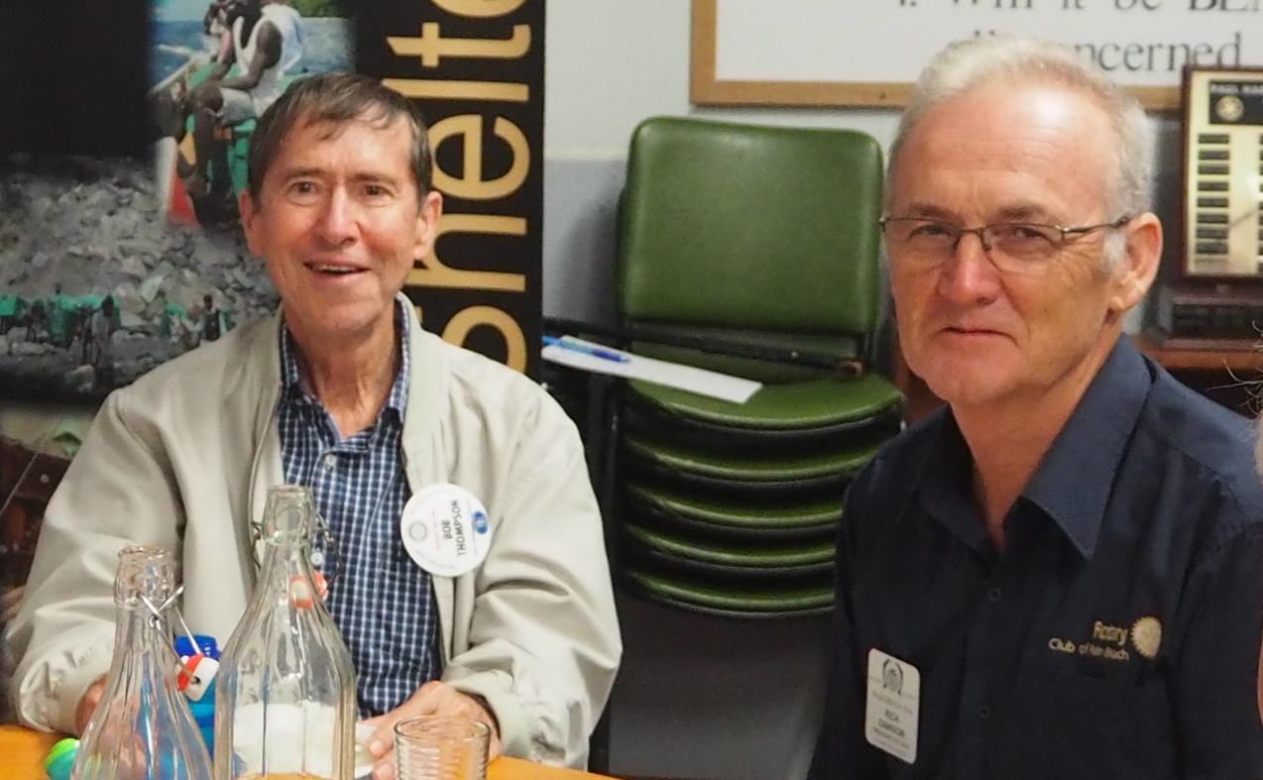

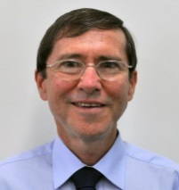

President 2021/22 Bob Thompson

Club Service Report: 12th April 2021

Metro Assembly
Incoming Club Officers, please make sure it’s in your diary. Sunday morning 30 May 2021
The venue was confirmed this weekend at PETS to be at North Lake Senior High School.
Very important that members taking office in 2021-2022 attend this Rotary learning opportunity.

50th Update
It is all go for this Saturday.

Guess Who is Coming to Dinner
Will be held on Saturday night 22 May 2021. Good news is that we have four members and their partners that have offered to be hosts for the evening. A big thanks to them who will remain nameless at this point in the preparations. One more willing to host would be good. First time hosts would be very welcome. A list will be circulating soon asking for a yes or a no for host planning purposes.

April Club Meetings
Saturday night 17 April is our Club’s 50th Anniversary meeting.
Because of our Saturday meeting we will not hold our usual Club meeting on Monday 19 April.
Monday 26 April is another Public Holiday (Anzac Day) so no Club meeting.

Club Changeover Meeting Apologies for yet another change of date advice. Confirming that the date is Saturday 10 July 2021 at Kwinana Bowls Club.

DG Changeover for Pat Schraven is Saturday 3 July at Royal Perth Golf Club.
DG Pat will be conducting her official visit to Kwinana on Monday 6 September 2021.

50th Exhibition is up and running at the Kwinana Library foyer area till 22 April.
Thanks to President John, Paul and Greg for assisting with the setting up of our exhibition.

Grounds and Hall Maintenance
Sent off a thank you shout out to the City tree maintenance crew. They responded to a call to some tree branches down on our NW boundary with girl guides and to a small dead tree by our main entrance. They attended to both quickly and did great job.
The City have also checked out our reports to them on the condition of our Hall toilet doors and have agreed to replace them. This will happen shortly.

PETS
Last weekend I attended the District organised training for 2021-2022 year Club Presidents. Held at Rockingham it was very well presented and was worth while attending. The strategy is to ensure that incoming Presidents are preparing themselves for the task and for them to be assured of the ongoing support available to them and to their Clubs through the District leadership and support teams.
It was a pre-requisite that PETS attendees complete the President Elect training modules available free from the RI Learning Centre site. This is a great site for a wide range of training modules for members to up skill their leadership and general life coping skills, as well as finding more about our RI organisation.

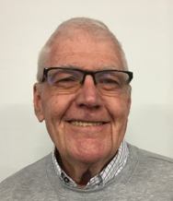


PP Brian McCallum

Inward Correspondence.

Outward Correspondence.

Would members please note that any correspondence received or posted by yourself, please ensure a copy is forwarded to your Secretary.

PP Stephen Castelli
Treasurer Stephen was pleased to announce that all members are financial.
Treasurer Stephen also very happy our power bill is still in credit, thank you COVID
Bring your empty drink containers, we have collection bins.
Our sincere thanks to PP Stephen for organising the printing of our programs for Saturday night.

Treasurer: PDG John Iriks
- Money in the Bank. Bills paid
- Financial Report to May 30th prepared for inclusion in our Annual Report, financials to June end will then be completed ready to be audited.


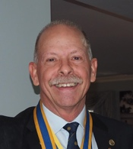

Birthdays and Anniversaries April 2021

Congratulations:
Stephen Castelli 6th
Cyril Bennett 10th
Kim Beciri 29th

Ann Samut. 02nd
Natalie Rowe. 10th
Marge Williams. 25th

Wedding Anniversary’s
Norm and Karen. 1st 30 years
Cyril and Lynne. 6th 25 years

Club Anniversaries.




Congratulations
Two of our members both reached significant milestones this month of April 2021
Pictures below courtesy of Facebook.
Norm and Karen Mulcahy celebrated 30 years of marriage on the 1st April
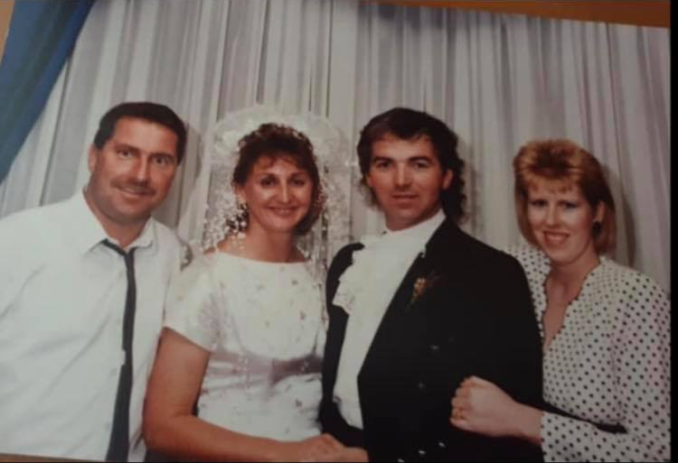

Cyril and Lynne Bennett celebrated 25 years of matrimonial bliss on the 6th April 2021
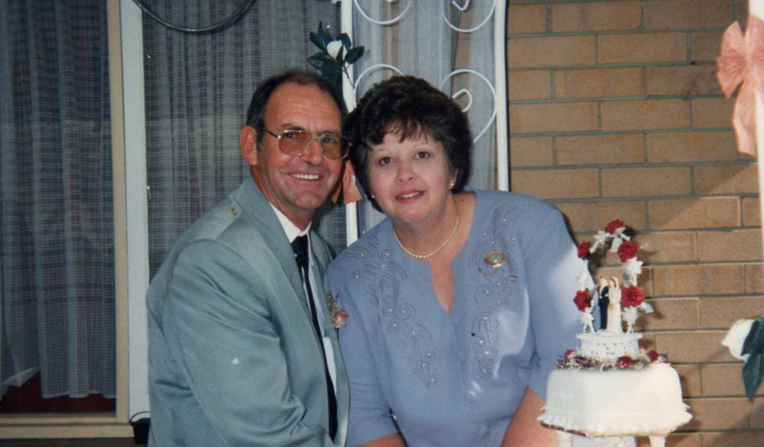

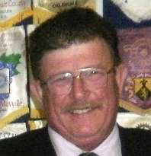

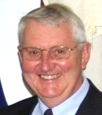

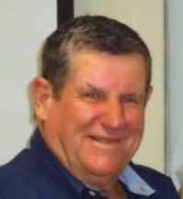


PP Max Bird
Foundation Dir.
PDG John Iriks
Membership Dir.
PP James Sharkey
Public Relations Dir.

Projects Director
PP Mike Nella

Project Director’s Report.
Garage Sales are an on-going event.
Club members encouraged to assist any time, see Mike for info.
Furniture-0n-Line, good weekend, shop almost full of stock.
Showroom status now means we can invite customers to view and purchase our stock. Help needed Thu, Fri and Saturday,
Bread project, now delivering to 5 local schools.

Public Relations:
We continue to receive exposure on Rotary Out West.
Sound Telegraph approached to assist in promoting our 50th.

Membership:
President John Iriks is Membership Director this year.
Membership Committee: Lee Davis, Bob Thompson and Eric Blogg.
Still the best option to invite new members, “ask someone”

Community:
Bread Program running well, 5 schools now on board.
Still looking for more helpers, please come along.
Offers to participate in a Coastal Tree Planting project received. Are we interested ?

Vocational:
4 Way Test Speech Contest, February to April 2021, contacted Gilmore College, favorable response.

International:
Max promoted Disaster Aid Australia at the Optus Conference Venue.
ShelterBox and Disaster Aid part of our display at the Darius.

Youth:
RYPEN 2021, 14th -16th May. 2022 Applications are now open,
close 1st May, actively seeking participants.

- Visit your club webpage.

http://www.clubrunner.ca/Portal/Home.aspx?accountid=8106

or type Kwinana Rotary Club into ‘Search’

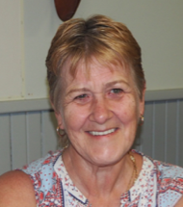

Rtn. Veronica Burns
Community

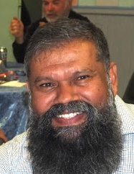

Rtn Barry Winmar
Vocational

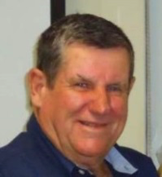

PP. Max Bird
International

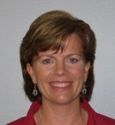

PP Genevieve Carr
Youth


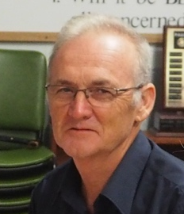

Guest Speaker: Rick Dawson

Fresh hope for Carnaby's black cockatoo numbers 'increase dramatically' with artificial hollows

Rick paid tribute to the tireless assistance provided by The Rotary Club of Palm Beach with installing/repairing and monitoring hollows in the field.

Artificial nesting hollows are helping revive the numbers of the critically endangered Carnaby's black cockatoo, after it lost part of its breeding heartland to bushfire in Western Australia.
The largest known nestling ground for the Australian bird species is in woodlands at a farm in Coomallo near Badgingarra, about 200 kilometres north of Perth. In late 2009, a bushfire swept through part of the site, killing young birds and destroying nesting hollows, which can take more than a century to form. Competition for the remaining hollows was fierce, so conservationists decided to make new homes for the birds.

We put our first artificial hollows in in late 2010, Since that day the numbers have increased dramatically. After analysing almost 3,000 natural tree hollows, and after trial and error, we have created a near-perfect home for the birds. As soon as we put these new hollows up, these big ones, the birds just took to them straight away and the success has gone through the roof. The nestlings that are actually making it out of the hollows have actually increased from 50 to 75 per cent The striking birds are actually choosing artificial over natural hollows, and are breeding more quickly than ever recorded. We think that is because we have got so many hollows and the availability means these young females have got the opportunity to breed. When we first started monitoring seriously we were only 40 or 50 breeding pairs reliably located. Now we are up to 128 There are a lot of threatened species that are very difficult to find out what exactly you can do to make a significant different to their conservation status. And for something as simple and relatively easy to achieve artificial hollows work well in an existing breeding site.

Artificial nests replicate natural hollows The hollows are 1.2 metres deep and attached to trees, about four metres off the ground.
"We have made these artificial hollows exactly like what the most successful natural hollows are,"

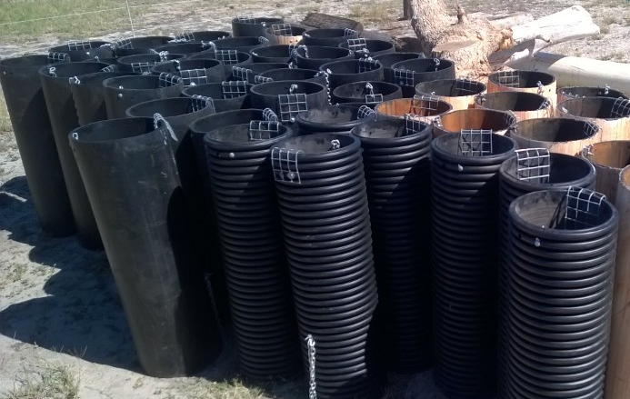

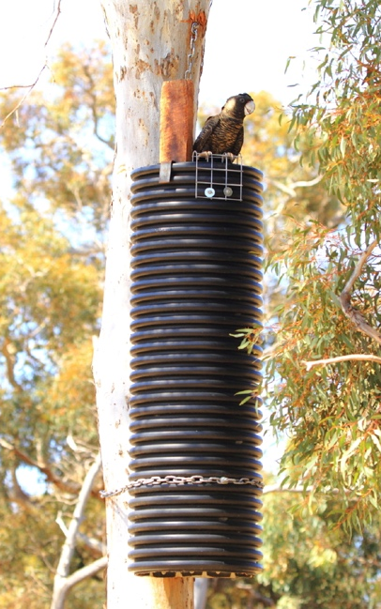

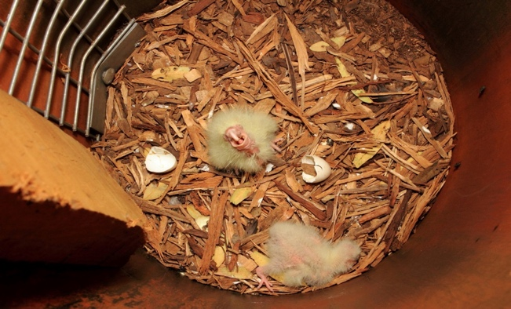

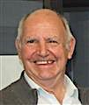
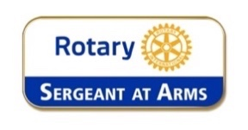
Fine Session: Sergeant Cyril Bennett

Stand-in Deputy Bill Rowe.

No Badge: Only caught out a couple.

Chris O: Fined for wearing his badge sideways.

John I: Misplacing his notebook and having to ring me from Nanga to cover his bread commitment.

Myself, Greg and Paul: For leaving a table and 5 chairs behind after the party on Saturday.

John M: Alleged to have paid $350 for a ‘Hooka’ supposedly a piece of diving equipment.

Terry E: For leaving Tish in the car while he was in Rotary Hall enjoying himself ?

Mike N: Claims he doesn’t eat much, sergeant thinks he need an appointment with Jenny Craig.

Norm Mc. No top button on his shirt, tried to hide it by wearing a tie.

Chris O: Received an email about the change of date for our changeover, immediately went home and told Carol that the date of our 50th had changed.

Bob C: The last two to leave last Friday, alarm set, door shut. No Bob, in the toilet.

Ian C: Can’t decide whether the Dockers flag should be up or down.

True story
Off Newfoundland, Canada
US Ship: Please divert your course 0.5 of a degree to the south to avoid a collision.
Coastguard: We recommend you divert your course 15 degrees to the south to avoid a collision.
US Ship: This is the Captain of a US Navy Ship. I say again, divert YOUR course.
Coastguard: No. I say again, you divert YOUR course!
US Ship: THIS IS THE AIRCRAFT CARRIER USS CORAL SEA. WE ARE A LARGE WARSHIP OF THE US NAVY. DIVERT YOU COURSE NOW!!
Coastguard: This is a lighthouse. It's your call.

I don't know the key to success, but the key to failure is trying to please everybody

Polio this week
7^{h} April 2021

The GPEI has published a new document meant to provide guidance on tOPV temperature management procedures, which differ from those used in mOPV2 response to poliovirus type 2 events and outbreaks. The document is available here.

Summary of new WPV and cVDPV viruses this week (AFP cases and ES positives):

Afghanistan: five cVDPV2 cases and eight cVDPV2 positive environmental samples
Pakistan: two WPV1 and three cVDPV2 positive environmental samples
Burkina Faso: one cVDPV2 case
Côte d’Ivoire: four cVDPV2 positive environmental samples
Liberia: one cVDPV2 positive environmental sample
Sierra Leone: one cVDPV2 case







Success is not the result of spontaneous combustion. You must set yourself on fire

No act of kindness, no matter how small, is ever wasted.

Speak when you are angry--and you will make the best speech you'll ever regret.






April 11th to April 17th

11th
1689: King William III and Queen Mary II crowned as joint rulers of England, Scotland and Ireland
1783: Hostilities formally cease in the American Revolutionary War
1968: US President Lyndon B. Johnson signs 1968 Civil Rights Act

12th
1606: England adopts the Union Flag, replaced in 1801 by current Union Flag, also known as the Union Jack
1911: 1st non-stop London-Paris flight (Pierre Prier in 3h56m)
1919: British Parliament passes a 48-hour work week with a minimum wage
1937: Sir Frank Whittle tests the first jet engine designed to power an aircraft at Rugby, England.

13th
837: The best view of Halley's Comet in 2,000 years
1741: Royal Military Academy forms at Woolwich, England
1912: Royal Flying Corps forms (later Royal Air Force)
1928: 1st trans-Atlantic flight Europe-US (Fitzmaurice-von Hunefeld-Köhl)

14th
1471: Wars of the Roses: Yorkists defeat the Lancastrians and kill the Earl of Warwick
1871: Canada sets denominations of currency as dollars, cents
1903: Dr Harry Plotz discovers a vaccine against typhoid (NYC)
1927: The first Volvo car premieres in Gothenburg, Sweden

15th
1654: England & Netherlands sign peace treaty
1793: Bank of England issues first £5 note
1912: RMS Titanic sinks at 2:27 AM off Newfoundland
1923: Insulin becomes generally available for diabetics
16th
1797: Spithead Mutiny begins: British Royal Navy sailors protest over living and working conditions
1853: 1st passenger railway opens in India, from Bori Bunder (Bombay) to Thane (34 km)
1924: 1st radio-transmission of wireless: Mattheus Passion
1945: Colditz Castle, the high-security prisoner of war camp, is liberated by American troops

17th
1875: Modern Snooker invented by Sir Neville Chamberlain, a bored British officer in Jabalpur, India
1941: British troop land in Iraq
1945: 8th Air Force bombs Dresden
1964: Ford Mustang formally introduced (US$2,368 base)



...and that's how the fight started

One year, I decided to buy my mother-in-law a cemetery plot as a Christmas gift...
The next year, I didn't buy her a gift.
When she asked me why, I replied,
"Well, you still haven't used the gift I bought you last year!"
And that's how the fight started.....

My wife and I were watching Who Wants To Be A Millionaire while we were in bed.
I turned to her and said, 'Do you want to have Sex?'
'No,' she answered. I then said,
'Is that your final answer?'
She didn't even look at me this time, simply saying, 'Yes..'
So I said, "Then I'd like to phone a friend."
And that's when the fight started...
My wife and I were sitting at a table at her school reunion, and she kept staring at a drunken man swigging his drink as he sat alone at a nearby table.
I asked her, "Do you know him?"
"Yes", she sighed,
"He's my old boyfriend.
I understand he took to drinking right after we split up those many years ago, and I hear he hasn't been sober since." "My God!" I said, "Who would think a person could go on celebrating that long?"
And then the fight started...

My wife sat down next to me as I was flipping channels.
She asked, "What's on TV?"
I said, "Dust."
And then the fight started...

Saturday morning I got up early, quietly dressed, made my lunch, and slipped quietly into the garage. I hooked up the boat up to the van and proceeded to back out into a torrential downpour. The wind was blowing 50mph, so I pulled back into the garage, turned on the radio, and discovered that the weather would be bad all day.
I went back into the house, quietly undressed, and slipped back into bed. I cuddled up to my wife's back; now with a different anticipation, and whispered, "The weather out there is terrible." My loving wife of 5 years replied, "And, can you believe my stupid husband is out fishing in that?"
And that's how the fight started....

Makeup opportunities

Rockingham Monday 6pm for 6.30 Rockingham RSL Club
Palm beach Wednesday 6pm for 6.30 Ocean Clipper Inn
Baldivis Mon/Fortnightly 6.30pm for 7.00 Peel Manor House
Cockburn Thursday 7.15am for 7.30 Cockburn Seniors Centre
Byford & Districts Monday 6.15pm for 6.45 Byford Tavern, South W Hwy

Rotary Club of Kwinana Contributions welcome: eblogg@bigpond.com

Media Release

For further information please contact
Marketing and Communications on 08 9439 0435

