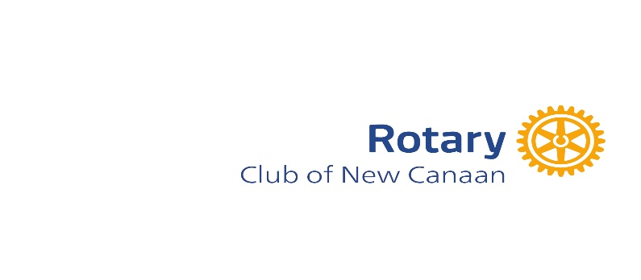

2026 GRANT APPLICATION TO THE ROTARY CLUB OF NEW CANAAN
Grant Applications are due by Tuesday, March 31, 2026

- Name of Non-Profit:

- IRS Registration Number and year founded:

- Contact:

- Rotary Grant Focus Area: [Select One]

      - Food insecurity
      - Mental Health
      - Maternal-Child health
      - Education
      - Community Medical services
      - Literacy
      - Workforce development
      - Arts and Culture
      - Environment

- Organization’s history, mission, and major accomplishments in past 2 years:

- Population served (please include number of seniors, children and/or vulnerable populations if applicable):

- Dollar amount and purpose of request: (Please note that to be eligible for a $5000 grant, the program must relate to food insecurity, mental health, or maternal-child health.)

- Will the funds cover the whole project? If not, please identify sources of the remaining funds.

- How do program participants benefit?

- Is there an opportunity for Rotarians to volunteer?

- Do you have an endowment, will funds be used for this project? If not, why not?

Please attach FY 2025 actuals and FY 2026 budget.

All materials should be scanned and emailed as a single packet to ncrotarygrants@gmail.com. If you have any questions, please call Nancy Geary at 617-733-5474.

