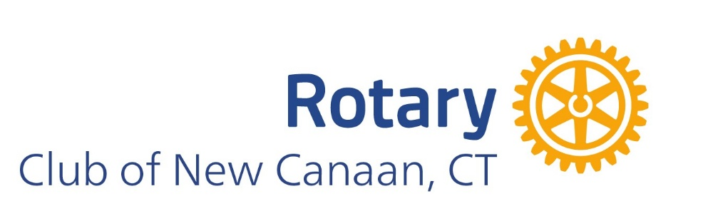

Rotary Club of New Canaan: 2026 Grant Applications
This year the Rotary Club of New Canaan is adding an important opportunity to its annual grants program.
In addition to our long-standing program of awarding grants up to $1,500 to not-for-profit organizations serving a wide range of needs, we will also be making five special high-impact grants of $5,000 each to organizations that are best addressing top-priority needs in the community.
This year, our members have identified these priorities as: food insecurity, mental health, and maternal-child health.
Organizations serving these needs who are not selected for the special grants may still receive grants under our regular program.
If you have been a recipient of funds in the past, or you work in other important areas such as education, work force training, health and wellness, arts and culture, environmental or other important spaces, you may still apply under the regular grant program for a grant of up to $1,500.
Please take a moment to review the new grant application, which now requires submission of your organization’s financials.
Grant submissions are due by Tuesday, March 31, 2026.
If you have questions, please reach out to Nancy Geary at ncrotarygrants@gmail.com.

