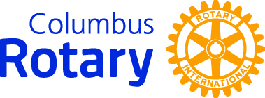
Middle School Student Service Above Self Program

Annual Project Launch Meeting
October 17, 2019
CCS Southland Building – 3700 S. High St., 43207
9:30-11:30
RSVP
due via email by October 11, 2019
to Rick Studer, Program Coordinator. rickstuder@columbusrotary.org.

School: ________________________________________________________

Principal: ________________________________________________________

Project Advisor(s) Name(s) & Title(s) (school personnel designated as the primary contact(s) for project activities):
Name_________________________________ Title/position________________________

Phone Number: ________________ Email:______________________________

Name_________________________________ Title/position________________________

Phone Number: ________________ Email:______________________________

Student Participants – Name & Grade: (4 student limit)
- ___________________________________

- ___________________________________

- ___________________________________

- ___________________________________

Do your students and you have a relatively specific issue or issues in mind to address with your community service project(s)? If YES, please describe the issue(s) here:
_____________________________________________________________________________
_____________________________________________________________________________

If NO, that’s perfectly ok. You will by the end of the launch meeting.

