Funding Request Application | 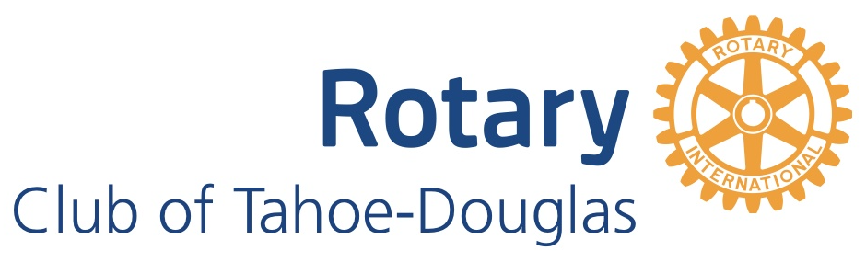

Who is Rotary?
Rotary International brings together a network of community leaders who dedicate their time and talent to tackle the world’s most humanitarian challenges. Rotary’s mission is to provide service to others, promote integrity, and advance world understanding, goodwill and peace. Rotary connects 1.2 million members from more than 200 countries and geographical areas. Their work impacts lives at both local and international levels.

Tahoe-Douglas Rotary Club is a trusted group of volunteer leaders drawn together by fellowship and passion to strengthen the South Lake Tahoe Community and improve humanity world-wide. The club’s core values are service to others, fun, commitment to youth and integrity. The club assists worthy organizations with hands on support as well as financial funding for programs and projects that promote Rotary’s mission and ideals.

Instructions

Submitting the Request
Submit the following information by email to president@tdrotary.com.
- Completed application
- List of organization board of directors
- Previous year financial report
- Annual budget
- Any other supporting documents

Required Follow Up
Within six months of project completion or twelve months after funding, grant recipient must provide Tahoe-Douglas Rotary with a summary of project status, how funds were used, and impact of these funds. Compliance ensures future consideration for donations. At the discretion of the Rotary Club, a presentation to members may also be required.

Organization Information
Name
Address
Web site
Contact name
Contact title
Phone number
Email address
501(c) Tax Exempt

Mission statement & how you benefit the community

Project Information
Name
Location
Planned start date
Planned completion date
Other involved organizations
Rotary has volunteers!

Project description

Project’s community benefit

Project implementation plan

Project maintenance plan

Project measurement of success

Project Funding
Total budget
Amount requested from Tahoe Douglas Rotary
Amount requested from other sources (include sources and amounts)
Desired funding date

Document version September 21, 2024

