“Give a girl a kit, teach her her body, stand with her voice and she becomes change.”

Hello Rotarians!
Our program for the week of October 27 features an organization that has so deeply moved the projects committee that we chose it to be our Fall Fundraiser.
Since 2008, Days for Girls has been promoting menstrual equity throughout the world. By increasing access to menstrual care and education we can help shatter the stigma of menstruation and keep girls in school who might leave or be forced to leave.
We are embracing one of their ongoing projects in Nepal which has a funding need of $29,400. We have pledged to raise $2,500 towards their goal. Hopefully, we can raise more!
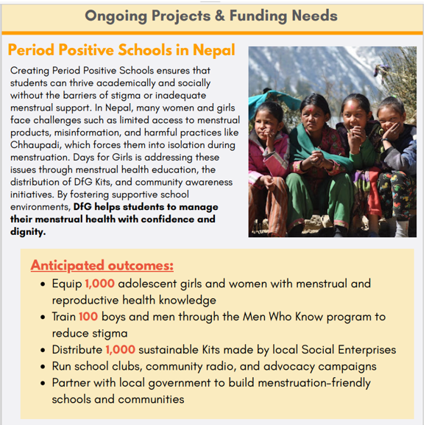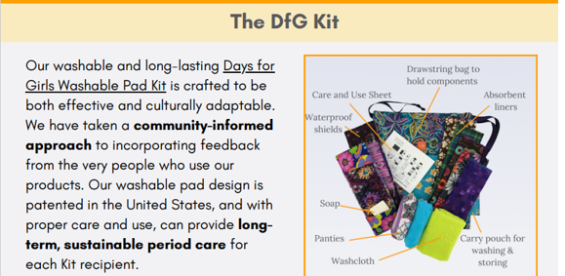
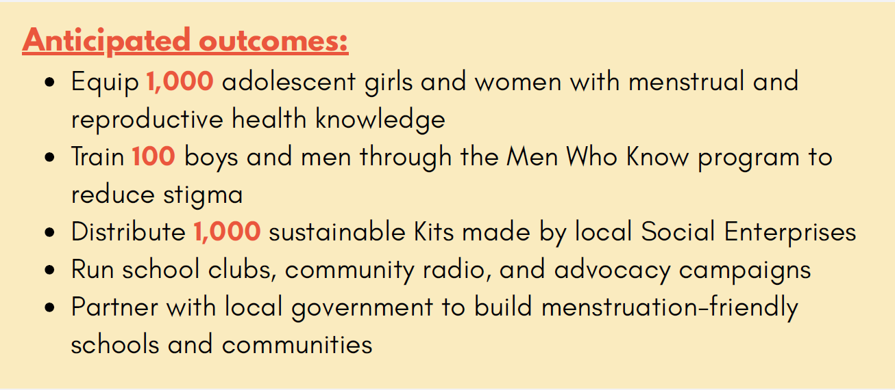
You can also be a part of this effort by sharing a story of an inspiring woman in your life. Our weekly bulletin will feature these stories to celebrate the positive impact of women supporting others.
Click here to donate!

