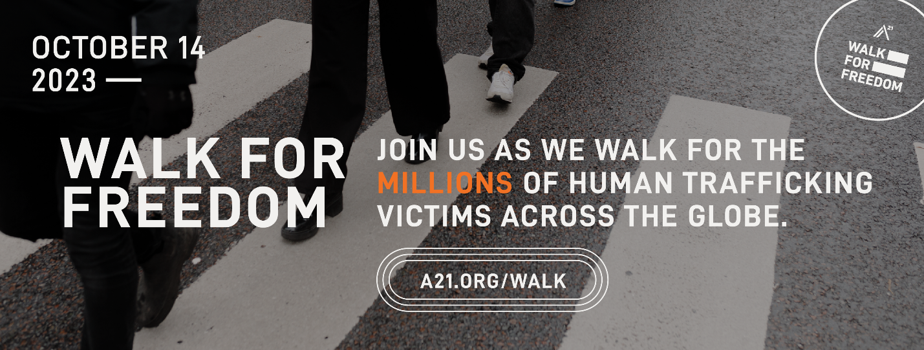

What: Rotary District 6420 Task Force Against Human Trafficking is hosting an A21 Walk for Freedom. This is a WORLDWIDE event, single file, silent walk. We encourage walkers to wear black. We will have signage and posters available to take on the walk. T-shirts are available to purchase online when you register for this FREE walk.
When: Saturday, October 14th at 10:00am
Where: Start at the base of pedestrian walkway in Moline OR Bettendorf and walk across the new 74 bridge. You can go one way or both, your choice. Each way across is 1-mile.
Why: Awareness is key for eradication of this heinous crime. Please join us to help spread awareness throughout the Quad Cities and surrounding areas. Your attendance is all that is needed- no fees to walk!
Please register today for this FREE walk:
A21.org/moline

