July 2019

Rotary Fellowship Month
ROTARY CLUB OF SMITH VALLEY
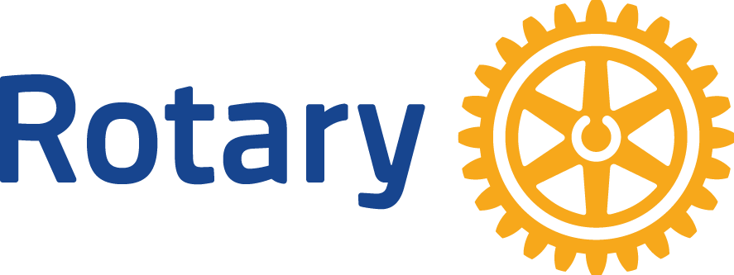

Upcoming Events
July 18th 2019 RYLA Participants at the Heyday
August 10th – Lamb Shish Kabob Event
October 5th and 6th – Fundays!!
October 24th World Polio Day

SAVE THE DATE
June 11th – Board Meeting at the Heyday
First Thursday of Each Month
Board meeting – all members welcome, only board members can vote!
Members will be notified if this changes.

PO BOX 357
WELLINGTON, NV 89444
OUR NEXT MEETING WILL BE AT 7:00 July 18th AT THE HEYDAY
This Club,
Everyone who helped kick the Spring Barbeque off….and clean up, deserves congratulations on a job very well done. This event was a challenge having no Grange kids to help. Rotarians dug in and got the job done. I personally heard numerous compliments and the number one comment was people had FUN!
The hand off of the Club President is now official from Greg Hunewill to Steve Bohler. We want to thank Greg. This was a tough year for him to take on the responsibility.
Let’s get behind Steve and help make this another great year.
AND remember that we are a leadership organization of local business, professional and civic leaders who meet regularly to get to know each other, form close friendships, and through that, we are able to get things done that others can’t.

Our Rotary International President Mark Daniel Maloney’s Theme for 2019-20
ROTARY CONNECTS THE WORLD
He asks Rotarians to strengthen the many ways that Rotary Connects the World, building the connections that allow talented, thoughtful, and generous people to unite and take meaningful action through Rotary service

Important News
Meeting Location
For now, we will be holding our meetings at the Heyday.
Club President Elect
The club is in dire need of a new President Elect. Please contact Steve Bohler.
RYLA
Rotary Youth Leadership Awakening (RYLA) is a week-long program designed to enhance personal development, leadership skills and good citizenship. The program is held at the Grizzly Creek Ranch located near Portola, CA.
I was lucky enough to take part in picking the young folk up and bringing them back and I can tell everyone that this program matters!!!
Lamb Shish Kabob Feast
The flyers are completed and being distributed.
Both Facebook and our Rotary website have the event posted with links to buy tickets on line.

One of the things we want to focus on with this event is strengthening the communities support by helping them understand that the money they spend at our events comes back to them many-fold.
Avenues of Service
Did you know Rotary has five Avenues of Service? These support the Object of Rotary: Club Service, Vocational Service, Community Service, International Service, New Generations Service.
Club Grant
The Pavilion is coming together beautifully. It still needs some finishing touches but if you haven’t stopped by the Museum and taken a good look then you should. The materials and construction are beautiful with real skill and though coming through in all of the details. We need to thank:
John Walters
Dr. Robin Titus
Jerry Rosse
John and Barb Brooks
Mike Barrette

