NOVEMBER 2018

ROTARY FOUNDATION MONTH
ROTARY CLUB OF SMITH VALLEY

Upcoming Events
November 15th – Thanksgiving at Rosie’s
December 13th – Rotary Children’s Christmas Party at the Heyday
December 20th – Rotary Christmas Party at the Heyday

New Members
Our Smith Valley Rotary Club is very happy to welcome our new member:
Joel Parker who was sponsored by Don Hudson
Congratulations and welcome aboard!

PO BOX 357
WELLINGTON, NV 89444
WE MEET EVERY THURSDAY AT THE HEYDAY IN AT 7:00 PM
This Club,
This month was our big event!! I want to thank each of you who committed so much of your time and energy towards making this year’s Fundays a success. It was very well attended and we received many compliments from attendees.
A special thanks to Jerry Rosse for his great work bringing in the Horse Drawn Wagon venue, the Pine Needlers for their great quilt display, Dan Smith as always for the Tractor Pull, Phil Gangwish for the Car Show, Denise Terry for the Dog Agility show, Barb Brooks for helping with the booths, Joe Frye for the Trail Trials, our great Grange kids for the Pancake Breakfast, the Chelone’s for doing what they do, and all of the members of the club that pitched in to help pull our event off!!

Important News
LEADERSHIP STUDENTS WILL BE IN ATTENDANCE
Starting this month Abbie Acciari, President and Collin Unruh, Vice President of the Smith Valley Student Body will be attending meetings once a month. The two students will keep our club updated on activities at the school and showcase students and school accomplishments. This will be a great opportunity benefitting both our local school and our club.

DISTRICT GOVERNOR’S VISIT
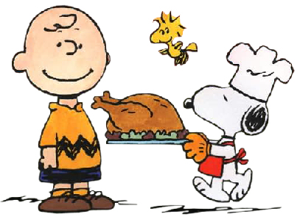

SAVE THE DATE

November 15
Thanksgiving at Rosie’s

December 7
Smith Valley Kids Christmas Party

December 21
Club Christmas Party at the Heyday
April 6 2019
District Leadership Assembly
First Thursday of Each Month
Board meeting – all members welcome, only board members can vote!
Members will be notified if this changes.

We had a great visit with the District Governor, Tina Spencer-Mulhern. She spent time with our board and enjoyed a great dinner with our club and members. We inducted a new member Joel Parker, Joel was brought to our club thanks to Don Hudson. Paul Harris Fellows were given to Sandi Smolin and Dave Dahl. Steve Bohler received the Most Valuable Player pin and Adrienne Hicks received the Quiet Rotarian Award. Also, DG Tina gave a special Most Valuable Player award to PDG Gail Ellingwood for her support with the District Conference.
DISTRICT GRANT
Our District Service Grant has been approved and will be funded soon. Each year our club has the opportunity to apply for a Service Grant though the Foundation. Donations we make each year go to The Foundation, three years later half of that money is returned to our District to be used for various grants. We will receive $2,000 which the club will match. This year we will be building a gazebo on the property by the Old Schoolhouse Museum.

District Leadership Assembly – Saturday, April 6
This event is NOT just for board member, it is for all members. Club Leadership Assembly is all about preparing our Club for a great year ahead with a full day of learning opportunities. This will be held at the Nugget in Reno.
Sustaining Member – Rotary Direct
For the past few years our club has had 100% Sustaining members. Greg has asked that the club accomplishes this again. What this means is that each member has contributed $100 or more to The Rotary Foundation. Half of what we donate is returned to the District in three years and is distributed in the form of grants. Also, for every dollar donated the member will receive one recognition point.

