Officious Newsletter of Yerington Rotarians

January 5, 2019

Meetings:
Tuesday Evening 7:00 PM
Dini’s Lucky Club



Ann Rudolph, Sec.
463-5803
Kathie Mann, Pres.
463-4265

Programs:
Jan. 8 – Board meeting report
Jan. 15 – Student of the month
Jan. 22 –
Jan. 29 –
Feb. 5 –

Events:
Feb. 3 – Super Bowl Party
Mar. 2 – Friends of NRA dinner
Mar. 9 – Snyder Bull Sale
Apr. 6 – Spring Barn Dance
(tentative)
Greeters:
Jan. 8 – Laura Lane & Ted Rudolph
Jan. 15 – Candy LoBue & Ann Rudolph
Jan. 22 – Jenn Scott & Lucy Rechel
Jan. 29 – Terry Scott & Dennis Rechel
Feb. 5 – Judy Price & Jan Recanzone
Feb. 12 – Tom Price & Willie Schroch

Programs: Remember programs for the January-March quarter are primarily dependent on the following members: Tom Price, Jan
Recanzone, Jay Recanzone, Dennis Rechel, Lucy Rechel, Ann Rudolph, Ted Rudolph, Steve Rye, James Schreiber and Steve Singer.

Board of Directors meeting: This Tuesday (Jan. 8) is the second Tuesday of the month so our Board of Directors will be meeting at 5:30 PM in Dini’s Poker Room. Finalizing details for the Super Bowl Party will definitely be on the agenda.

Super Bowl Party: Super Bowl Sunday is Feb. 3. We don’t make a lot of money at this event, but it is a pretty easy one to put on as long as lots of people help and it is fun to do. Tickets and advertising posters will be available at the meeting Tuesday. We have to sell all 100 tickets and we need lots of volunteers for making and serving appetizers as well as the tri-tip dinner. We have to setup the room and clean it up afterwards. Be ready to volunteer to help.

Want a program on using our website? Earlier this year there seemed to be some interest in learning about the features of our website. If this interest still exists I will look into doing it.

How well do you know our projects: Where was the picture shown below taken? What was Rotary doing there? What other project did Rotary do that year at that same location?

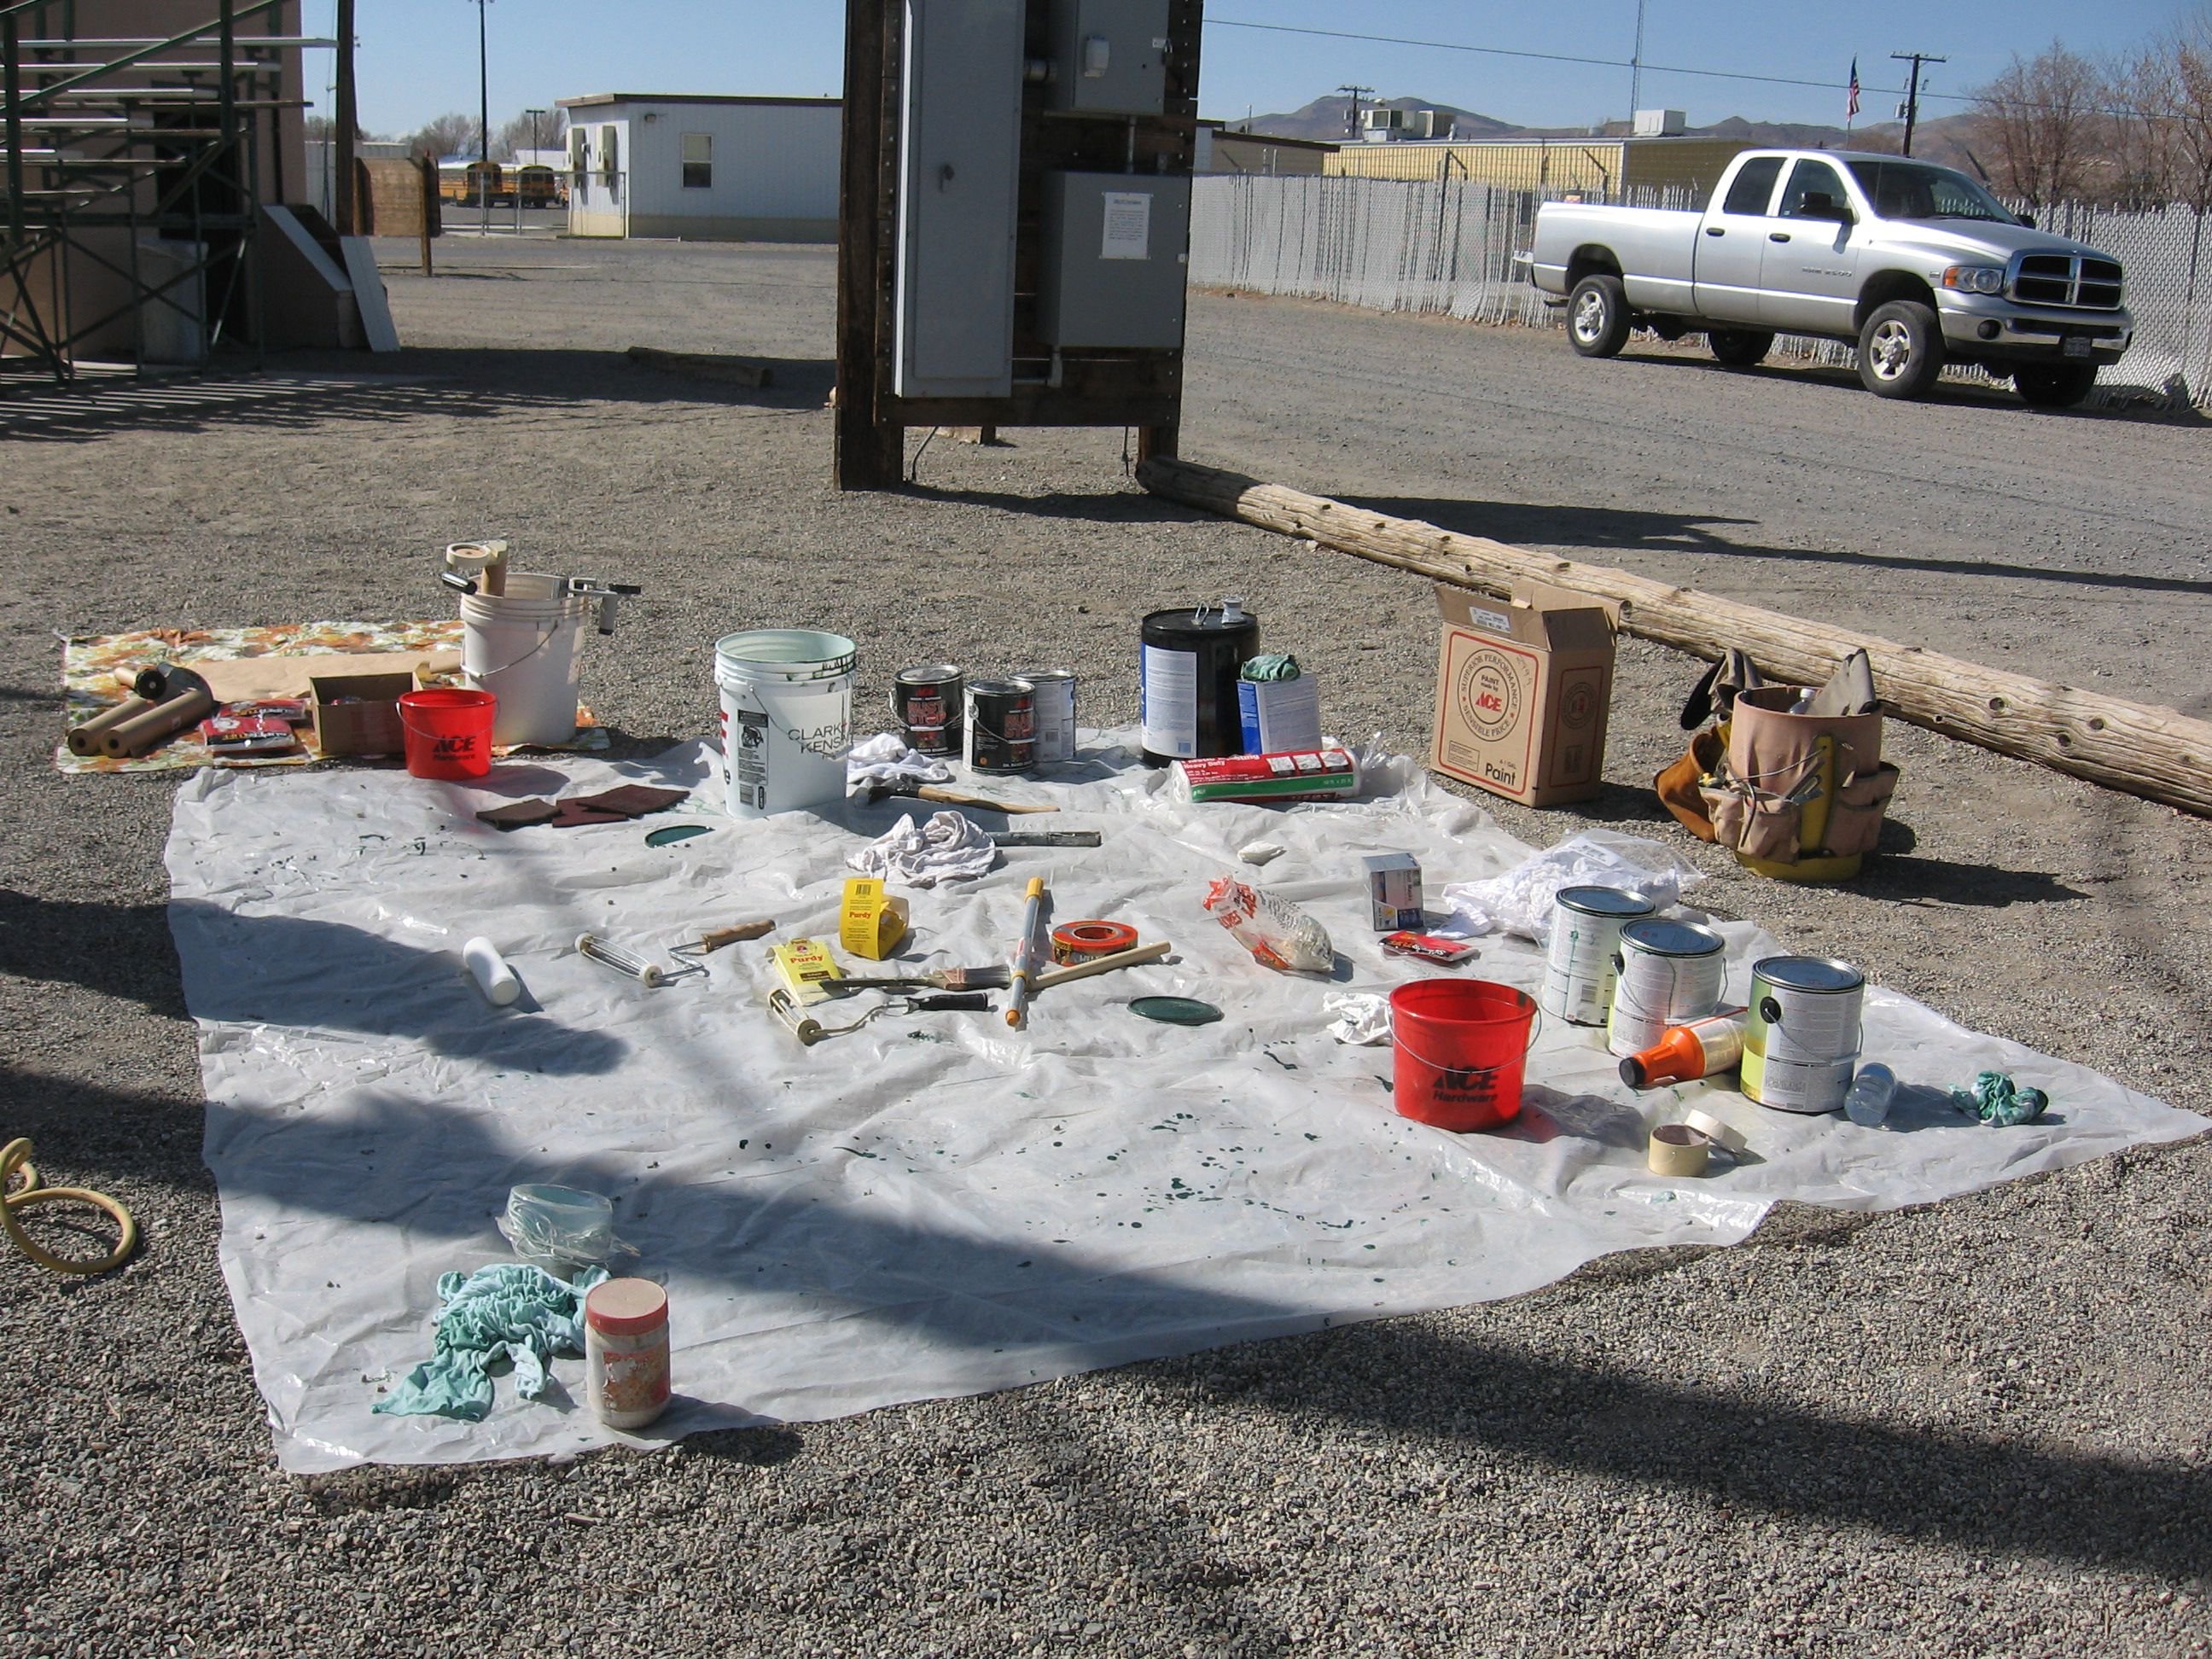

Remember the November Newsletter and its project question? Well here is my description of that project.

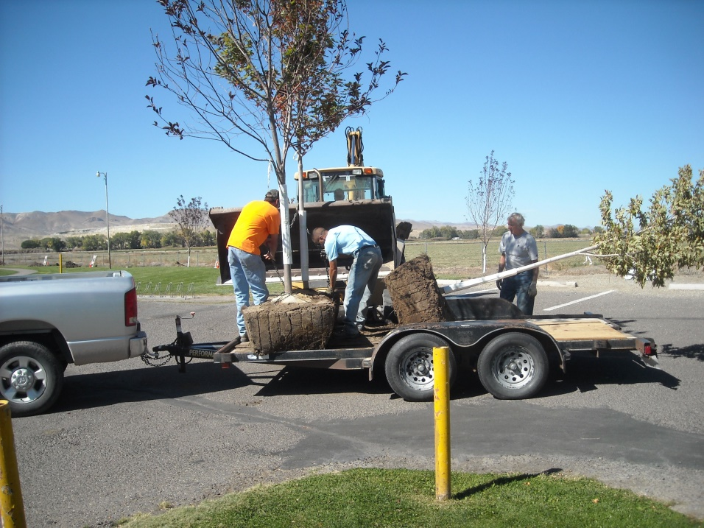

This photo was taken 10/10/2014. This work day was the second half of a tree planting project at Mountain View Park. This part consisted of planting about 10 or 12 Red Maple trees along the North border of the Park. The first half of the project was carried out in the Spring of 2014 and consisted of planting about 10 or 12 Flowering Pear trees along the West border of the Park. The trees came from the Open Waters Nursery in Smith Valley (Gary LaFleur, owner, gave us a
good price on these large trees). I could only fit 3 trees on Kathie’s trailer so it took lots of trips to get them all to the Park.

Rotary had purchased some bare root cottonwood trees and planted them there many years earlier, but lack of a watering system lead that attempt to failure. The City put in a watering system for the trees as part of this project and they dug the holes for planting the trees (they needed to be big holes too). Member Craig Stevens brought his tractor with back hoe to move the first batch of trees from the trailer to the holes and the City brought a back hoe to move the second batch of trees.
Club Treasurer: Club President-Elect Club Foundation Directors:
Candy LoBue Ted Rudolph Skip Bolton, Pres.
Judy Price, Sec.
Club Membership Chair: Rotary Foundation Chair: Steve Rye, VP
Nora Stevens Skip Bolton James Neely
Gary Hardesty
Club Board of Directors: Gerry Boschert
Term ending 6/30/19 Term ending 6/30/20 Candy LoBue
James Schreiber John Garry Kathie Mann, Club Pres.
Gary Hardesty Cheryl Giomi Ted Rudolph, Club PE
Dale Theiss Peggy Bitler Tom Price, Treas.
Amy Geddes Jay Recanzone

More recently we have replaced a few of the trees along those park borders.

.
