Officious Newsletter of Yerington Rotarians

March 1, 2019

Meetings:
Tuesday Evening 7:00 PM
Dini’s Lucky Club



Ann Rudolph, Sec.
463-5803
Kathie Mann, Pres.
463-4265

Programs:
Mar. 5 –
Mar. 12 – YHS, D. Mattice
Mar. 19 – Club Speech & Music Contests
Mar. 26 –
Apr. 2 – Jane Montalbano – Antiques

Events:
Mar. 2 – Friends of NRA dinner
Mar. 9 – Snyder Bull Sale
Apr. 6 – Spring Barn Dance
Apr. 13 – Area 10 Speech & Music Contests
Apr. 27 – Foundation Dinner – Fernley

Greeters:
Mar. 5 – John Diekmann & Bill Swirsky
Mar. 12 – Rich Ernst & Nora Stevens
Mar. 19 – Cheryl Giomi & Jim Snyder
Mar. 26 – Gary Hardesty & Steve Singer
Apr. 2 – Oscar Hernandez & Amy Geddes

Upcoming events, workers needed.
We have three events in the near future. This Saturday (March 2) we need a BBQ crew to do the steaks for the Friends of NRA dinner. Oscar is in charge of that crew. Friday Peggy will be seasoning the steaks and Saturday we need a few people to help Mary (The Bakery Gallery) run the buffet lines to serve the dinner. (Mary does a lot of gratuitous work for us, this is a chance for us to help her out.) I think Oscar and Peggy have volunteers signed up so, if you are one of them, don’t forget.

Next Saturday (March 9) is the 25th anniversary of the Snyder Livestock Bull Sale. In addition to the special anniversary it is being combined with a fundraiser for the “Western Nevada CattleWomen’s” Scholarship program. We have a lot of work to do to support Lucy on this event. Some signup sheets have been circulated already and there will probably be another one at Tuesday’s meeting. Rotary will be handling food and drinks for 300 to 400 people. Two weeks in a row serving several hundred steak dinners. Rotary is much more heavily involved with Lucy’s event than the Friends of NRA dinner. We will need lots of volunteers to make this work. Talk to Lucy and Oscar about how you can help.

Final upcoming event is our Spring Dinner/Dance Saturday April 6. Amy has flyers and tickets printed up. If you have or know of a place to display a flyer get one from Amy. We need advertising for this event. It is a fun event but people have to know about it. Holding it at Snyder’s Onion Barn is a big draw. There will be lots of work as the event gets closer, but let’s get ticket sales going. $50 for steak dinner (including two drinks and a raffle ticket) plus an evening of live music supplied by Sierra Express is a pretty good deal.

Foundation Board vacancies: The Board of Directors of the Yerington Rotary Club Foundation has two members whose terms expire June 30. Skip Bolton, who has served as President of the Board since its formation, is required by the bylaws to be off the Board for at least one year. Gary Hardesty is completing his first four year term on the Board and is eligible for a second 4 year term.

The Foundation Board is recommending Gary Hardesty for a second term and they voted to not fill Skip’s position. As is specified in their bylaws, they are soliciting additional nominations from the Club and Club Board of Directors for filling the vacancy.
To be eligible to serve on the Foundation Board you must have been a member of the Yerington Rotary Club for at least 3 years and attend meetings regularly and participate in Club activities and fund raising. Anyone interested should let Judy Price know before March 19. The Foundation’s final recommendation will be presented to the Club Board at their May meeting.

How well do you know our projects? Hopefully, everyone can guess what this next project was, though the date might be less well known. Rotary has done some other projects on Main Street. Can you name at least two others?
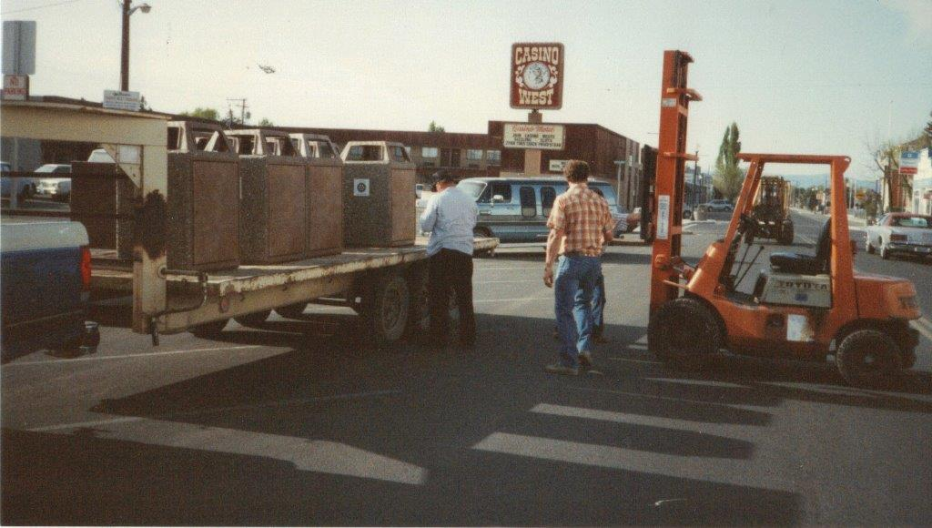
Last issue Project: The “before” photo below shows a little of the area cleaned up as part of a Rotary work day in March of 2003. This general area is located off Cremetti Lane. It is one canyon further than the entrance to the old Lyon County land fill. It had been misused for years as an illegal dumping ground. The project was organized by Rotarian Mike Walters and D & S Waste provided containers for hauling off some of the trash picked up. The day before the scheduled cleanup, Mike and a couple others went out to the area and picked up a dump truck load of mattresses. They also dragged out a couple of abandoned vehicles. The Saturday work day was primarily spent picking up smaller stuff (e.g. washing machines, televisions, dishwashers, furniture etc.) as well as lots and lots of really small stuff. Much of what we picked up was hauled off in Rotarian owned pickup trucks, but we also filled a big trailer for D & S Waste to haul off.
Club Treasurer: Club President-Elect Club Scholarship Committee:
Candy LoBue Ted Rudolph Lucy Rechel, Chair.
Kathie Mann
Club Board of Directors: Dale Theiss
Term ending 6/30/19 Term ending 6/30/20 Gerry Boschert
John Garry Skip Bolton
Gary Hardesty Cheryl Giomi Jim Sanford
Dale Theiss Peggy Bitler Ann Rudolph
Amy Geddes Jay Recanzone
Terry Scott
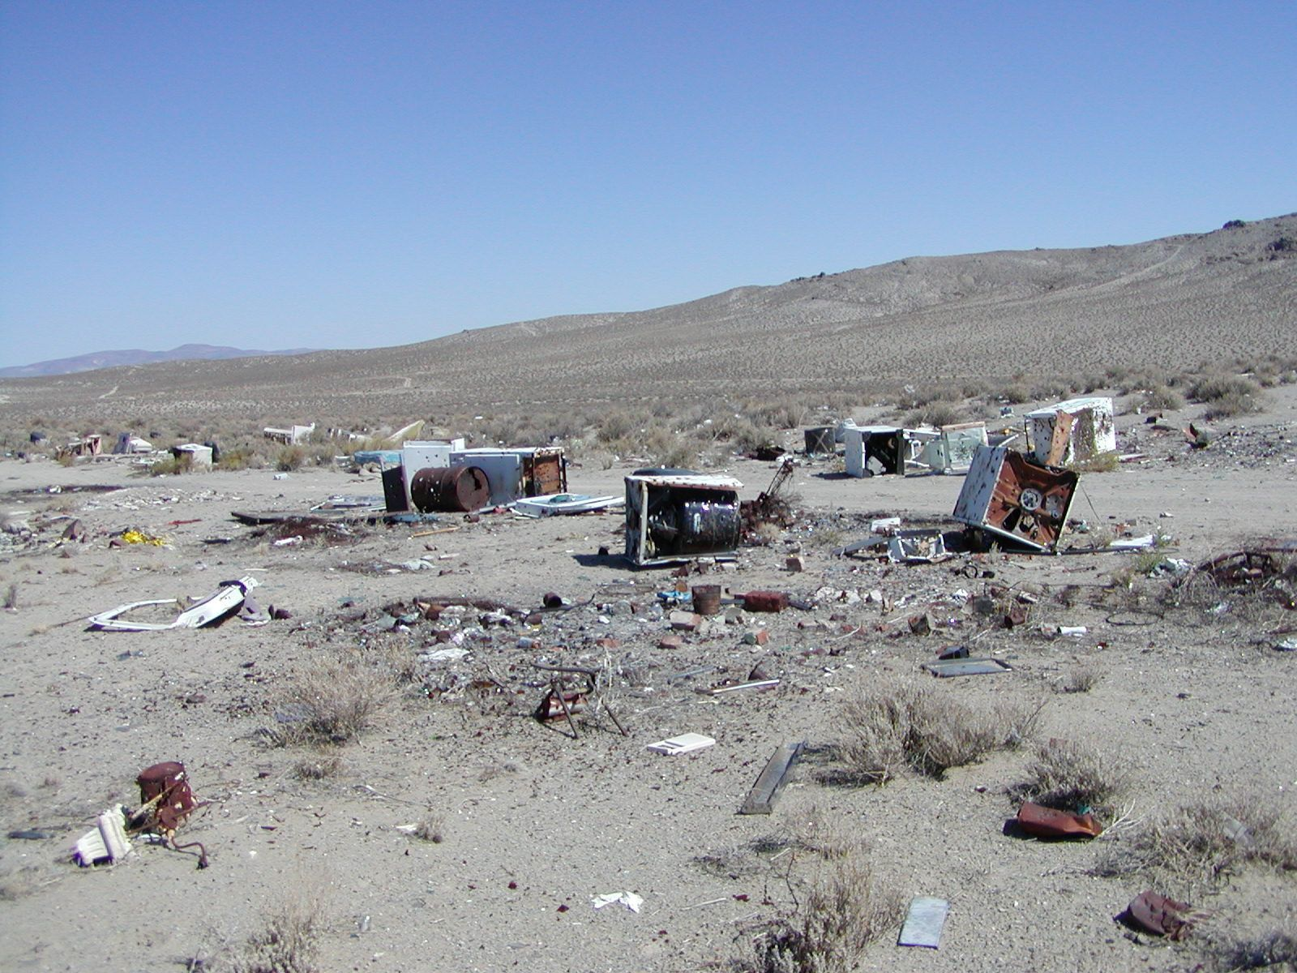
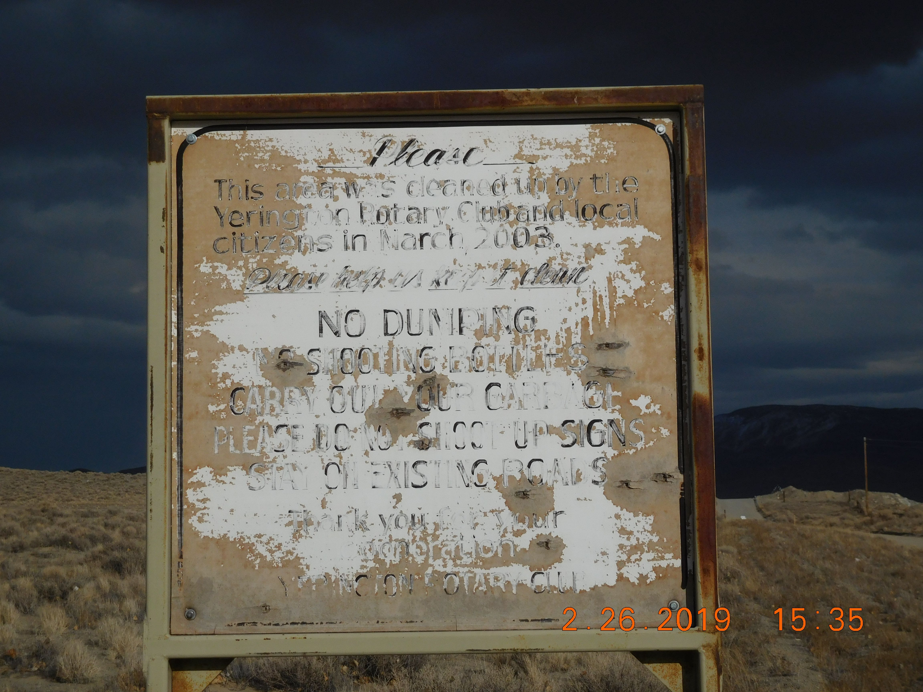

I took a quick look at the area recently and it still looks pretty good. It has not been used as a dump ground like before. The sign that was erected after our cleanup is still there (see below), but much of the paint has pealed off, making it hard to read.

