Officious Newsletter of Yerington Rotarians

April 13, 2019

Meetings:
Tuesday Evening 7:00 PM
Dini’s Lucky Club



Ann Rudolph, Sec.
463-5803
Kathie Mann, Pres.
463-4265

Programs:
Apr. 16
Apr. 23
Apr. 30

Events:
Apr. 27 - ?Rotarians at Work Day?
Apr. 27 – Foundation Dinner – Fernley
May 11 – Dinner & Dance – Smith Valley
May 17,18,19 District 5190 Convention
June 1 – Walker River Foundation Dinner
July 26,27 – Night in the Country
Aug. 15,16,17,18 – Lyon County Fair
Sept. 22 – 4th Annual Giomi Golf Tournament

Greeters:
Apr. 16 – Laura Lane & Ted Rudolph
Apr. 23 – Candy LoBue & Ann Rudolph
Apr. 30 – Jenn Scott & Lucy Rechel
May 7 – Terry Scott & Dennis Rechel
May 14 – Judy Price & Jan Recanzone

Upcoming events commments: The Foundation Dinner at Fernley is an Area 10 event to raise money for The Rotary Foundation (TRF). We have sponsored this event in the past as have other Area 10 clubs. I think we have been asked to supply a silent auction item, but we are not very heavily involved with the event. It would be nice if several of our members attended.

The Dinner/Dance at Smith Valley is purely a Smith Valley event, I don’t believe we are involved at all with it. Again it would be nice if several of our members attended it as support for our neighbors.

The Walker River Basin Communities Foundation dinner on June 1, is a fundraiser for them and they have helped us pay for some of our projects. In particular, they paid half the $20,000 cost of the Centennial Clock. For many years our Rotary Club has provided a BBQ crew to do the steaks for their dinner. We have been asked to do that again this year. This is a community service project for us (we get no money, directly at least).

Hopefully you are familiar with our involvement with the County Fair, Night in the Country and the Giomi Memorial Golf Tournament (one of our most productive fundraisers) and will be ready to help when the time comes.

Area 10 Speech and Music Contest: YHS Freshman Miley Page won the Speech Contest. Fernley Senior Kennedy Lyon-Lindersmith won the Area 10 Music Contest.

Spring Dinner/Dance: Last weekend capped a very busy Spring schedule. It may have seemed at times that disaster was upon us, but when time came to perform we did a pretty good job. Candy is expecting a net gain of over $6,000. That would be great. We sold 189 dinner tickets and 164 of those people attended the event. In past years we have sold over 300 tickets.

Jim Snyder’s Photo shop idea will probably gain us well over $1,000. The Raffle and Bar are a little harder to figure because much of their income is included in the Dinner ticket cost, but each will contribute $1,000 (including tips along with the drink tickets. These figures are preliminary, but probably pretty accurate. We owe a lot to Snyder’s for their contribution of the facilities and their staff who did a lot of the setup work and cleanup work. We have held this event at several different locations recently and Snyder’s is definitely the most popular.
Lucy’s proposal: Following last month’s Snyder Bull Sale and last weekend’s Spring Dinner/Dance Lucy Rechel brought a very interesting proposal to the Yerington Rotary Board of Directors last Tuesday. Rotary has struggled in recent years to find a good time and location for it’s Sweetheart Dinner/ Spring Dinner. Last year as planning time was running out Lucy took over at the “last minute” got us moving and made things work. This year’s event pretty much followed last year’s pattern.
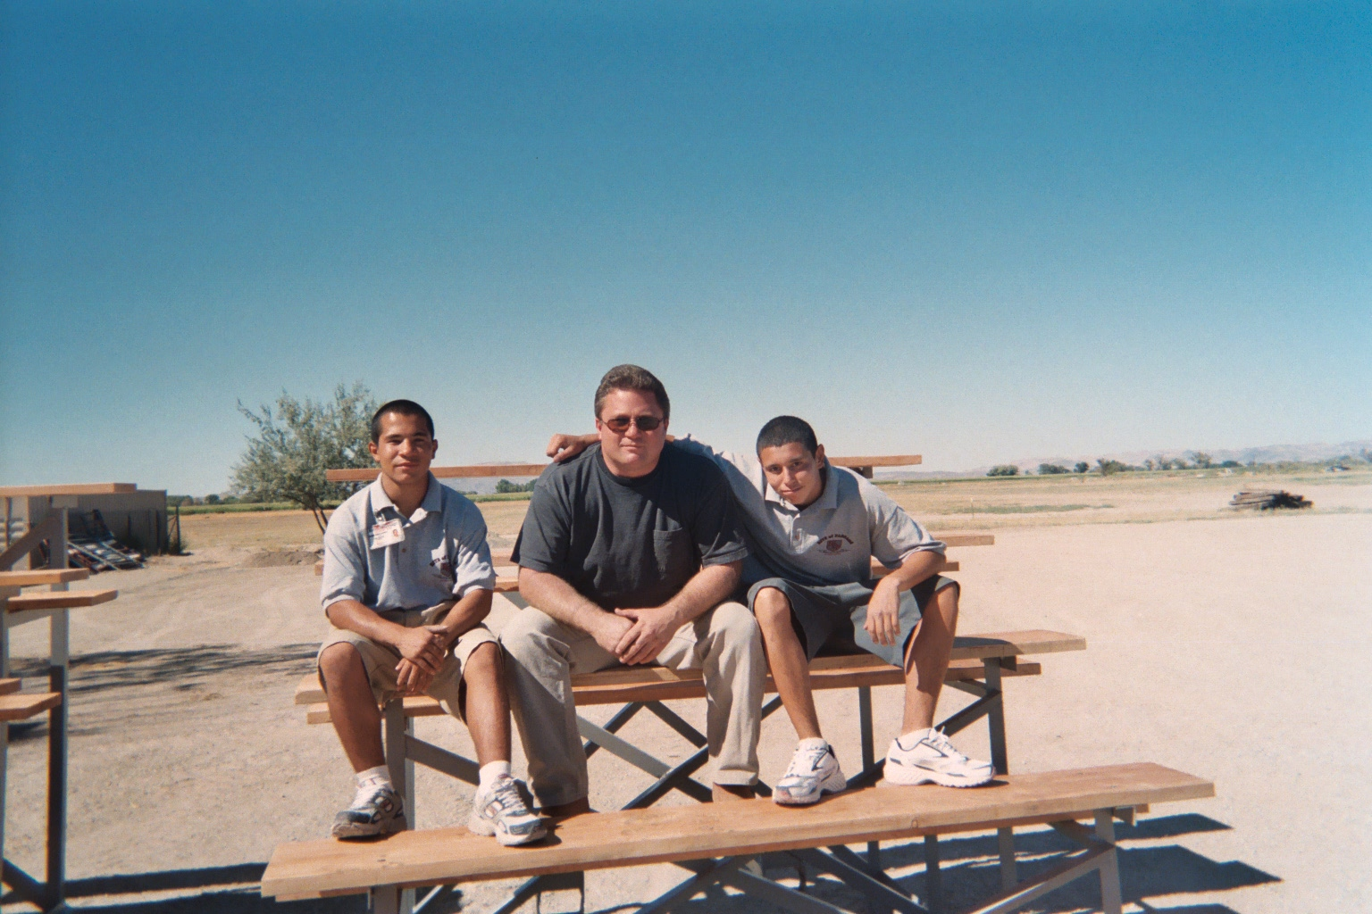
Basically, Lucy is proposing that Rotary join with Snyder Livestock and hold the two events on one weekend (the second weekend in March, because that is when Snyder’s Bull sale fits into the regional schedule of Bull sales). There are, of course, advantages and disadvantages to combining these events, but it is definitely something Yerington Rotary should discuss soon. I believe Lucy will be presenting this proposal at one of our meetings soon. It is something that must be decided soon, not next Spring.

Taste of the Valley: For several years Yerington Rotary has helped The Yerington Theatre of the Arts (YTA) with their Taste of the Valley fundraiser, which is held in mid-September. Dini’s Restaurant has sponsored a ravioli dinner on Friday night and Rotary has provided a variety of dinners for Saturday night. YTA has arranged the general setup and music/dancing for both nights. Rotary is given a fixed price for each dinner ticket sold (although there is considerable discussion as to how many meals are actually provided versus tickets sold) and any profit we make is determined by how much we spend for the food served. Rotary profits from this event have been very slim compared to the amount of work required and compared to other events we do.

This year schedules are causing a major problem. The Taste of the Valley event is scheduled for Sept. 20 and 21. Rotary has a major fundraising event, The Joe Giomi Memorial Golf Tournament, scheduled for Sept. 22. A considerable number of Rotarians would probably be needed for each of these events. At its April meeting the Yerington Rotary Board of Directors decided they could not commit the membership to doing both events and the golf tournament is far more important to our scholarship program. In other words the Board decided we will not be doing the Taste of the Valley Saturday night dinner.

How well do you know our projects:

This was part of a Spring 2006 project at the Lyon County Fair Grounds. Rotary paid for all the materials used and ROP students, under the guidance of their instructors, did all the work. This photo shows welding instructor Ron Stock and two of his students sitting on one of the four bleacher sections they designed and built. These bleachers are designed so they can be easily moved with a fork lift. ROP building instructor Harold Whalin had his class design and build three vendor sheds. This project was done in the early days of Night in the Country and at changing times for the County Fair. The bleacher sections were used for several years at the Fair, but the vendor sheds sat unused for several years. We have used one of them the past two or three years for beer sales at the County Fair Mexican Dance.

How about this project? Know what is going on here?
