Officious Newsletter of Yerington Rotarians

May 11, 2019

Meetings:
Tuesday Evening 7:00 PM
Dini’s Lucky Club



Ann Rudolph, Sec.
463-5803
Kathie Mann, Pres.
463-4265

Programs:
May 14 – ROP tour & dinner
May 21 – Student of the Month
May 28 – RYE student Chanakan
June 4 -

Events:
May 11 – Dinner & Dance – Smith Valley
May 11 – Lions Club Nut Feed
May 17,18,19 District 5190 Convention
June 1 – Walker River Foundation Dinner
June 8 – YHS Class of 1979 reunion dinner
Sept. 22 – 4th Annual Giomi Golf Tournament

Greeters:
May 14 – Judy Price & Jan Recanzone
May 21 – Tom Price & Willie Schroch
May 28 – Chaz Hunter & Carrie Gilmore
June 4 – Peggy Bitler & Sheri Van Ness
June 11 – Skip Bolton & Dale Theiss

ROP tour and dinner: ROP is giving us a chance again this year to visit their facility and learn more about their program. Last year’s visit was very informational about the program and the students as well as providing a very tasty dinner prepared by the students. This year’s visit (May 14) should be similar. Tours will begin about 5:00 PM and dinner will be served about 6:30 PM.

The ROP facility is located North of Yerington off Highway 95A. To get there, go North on Highway 95A to Campbell Lane. Go West on Campbell Lane to Rosaschi Road then follow Rosaschi Road North to the school.

See you there Tuesday.

Hope you already know about these: Smith Valley Rotary is sponsoring a dinner and dance program today at their Community Hall. Drinks and appetizers at 5:30 PM and Dinner followed by dancing at 6:30 PM.

Yerington Lions Club is sponsoring their annual Nut Feed Dinner and dance today at the Lyon County Fair Grounds. Festivities begin about 5:30 PM.

Be Ready to HELP:

Walker River Foundation Dinner: Saturday June 1. This is an easy one. All we have to do is have a BBQ crew ready to do our magic on about 200 steaks.

YHS Class of 1979 Reunion: Saturday June 8. This is not an official Rotary event, but Peggy has promised the Class of 1979 some dinner for their 40th reunion and the Board agreed to let her use some Rotarians and Rotary equipment. She is planning a pretty simple tri-tip dinner (salad, beans, tri-tip sandwiches and dessert).. She will need some help to carry this off. If you can help her be sure to let her know as soon as possible.

New equipment at Dini’s: For years now we have been negotiating with George Dini to put a permanent movie screen in the dining room where we meet. Our Board of Directors has approved a new idea: a large TV on the wall behind the “Head Table”. This is a better idea than the movie screen. Hopefully it will really happen this time.
How well do you know our projects:

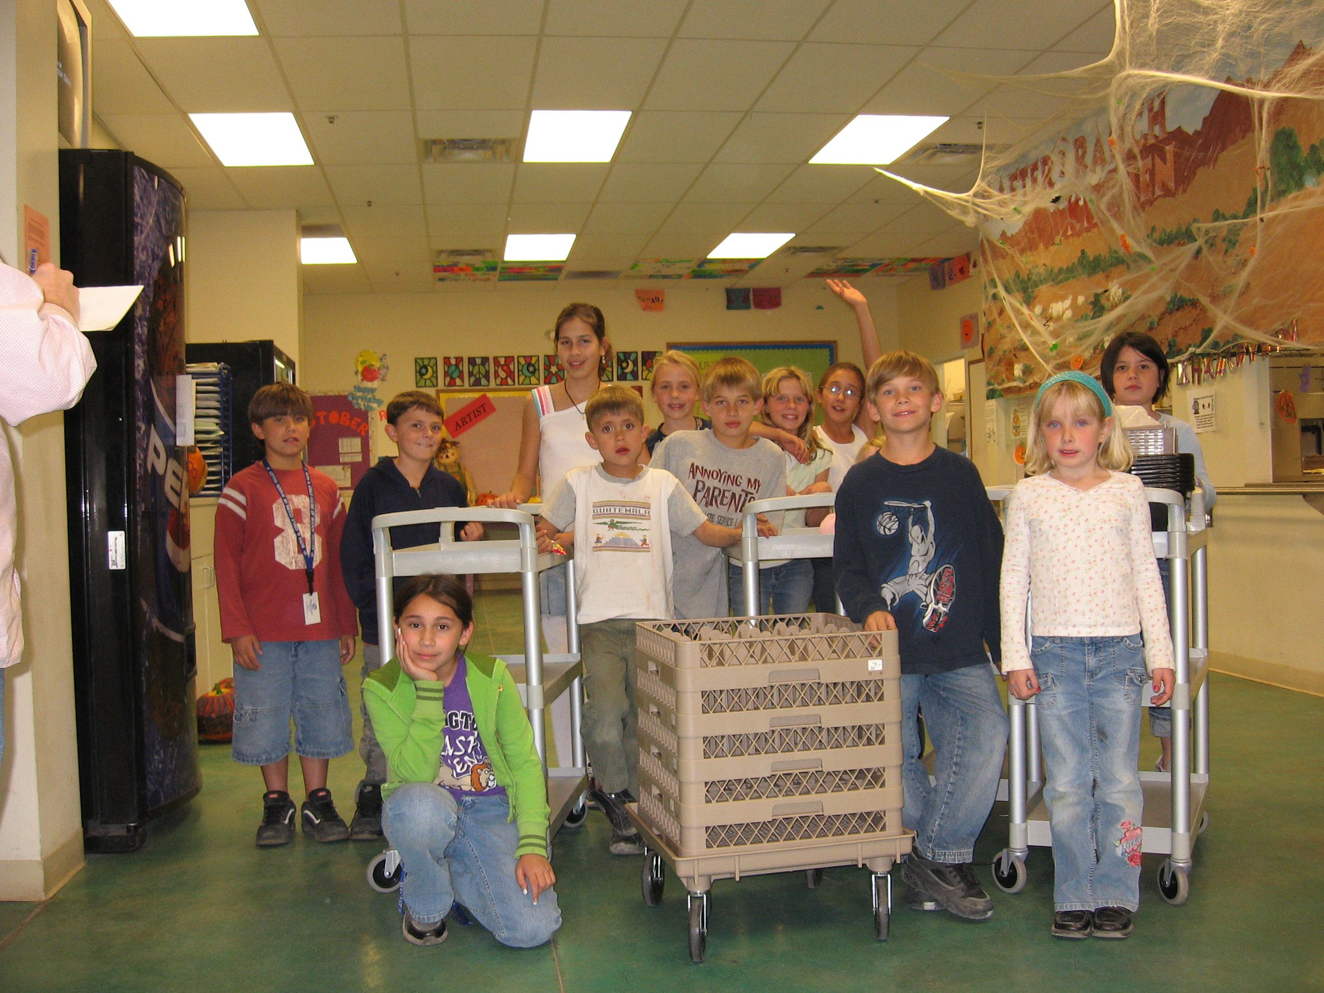
This is a picture from 2006 following several donations to help Boys and Girls Club stock their new kitchen with necessary equipment. We donated four bussing carts, several dish racks for the dish washer, 300 10” dinner plates and 300 salad bowls. Earlier, Yerington Rotary also obtained a grant to pay for installing the original gym flooring when the building was opened as a Boys and Girls Club .

For a couple of years, Yerington Rotary sponsored a “Duck Race” for Boys and Girls Club attendees with each child receiving a duck and the boy and girl whose duck won the race down the Walker River receiving a bicycle. One year the District 5190 RYLA camp provided several bikes for the Yerington Boys and Girls Club attendees.

Club Treasurer: Club President-Elect Club Scholarship Committee:
Candy LoBue Ted Rudolph Lucy Rechel, Chair.
Kathie Mann
Club Board of Directors: Dale Theiss
Term ending 6/30/19 Term ending 6/30/20 Gerry Boschert
John Garry Skip Bolton
Gary Hardesty Cheryl Giomi Jim Sanford
Dale Theiss Peggy Bitler Ann Rudolph
Amy Geddes Jay Recanzone
Terry Scott

When we purchased the salad bowls, they were shipped via UPS to our home. Salad bowls being somewhat fragile they came well protected with bubble wrap. The photo below shows Judy unpacking the bowls. The UPS driver was certainly curious about the 15 or 20 boxes he delivered over several days.
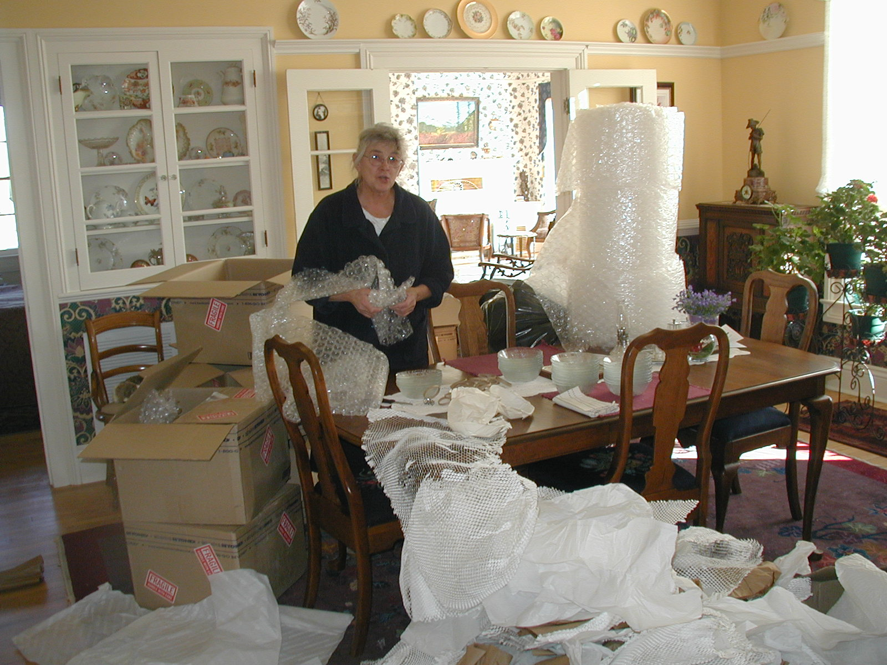
How about this project?

