Officious Newsletter of Yerington Rotarians

August 5, 2018

Meetings:
Tuesday Evening 7:00 PM
Dini’s Lucky Club



Ann Rudolph, Sec.
463-5803
Kathie Mann, Pres.
463-4265

Programs:
Aug. 7
Aug. 14 – NV Copper
Aug. 21 – Picnic at Jon Hill’s Pottery
workshop
Aug. 28

Events:
Aug. 12 Joe Giomi Golf Tournament
Aug. 16,17,18,19 Lyon County Fair
Sept. 15 Taste of the Valley Dinner
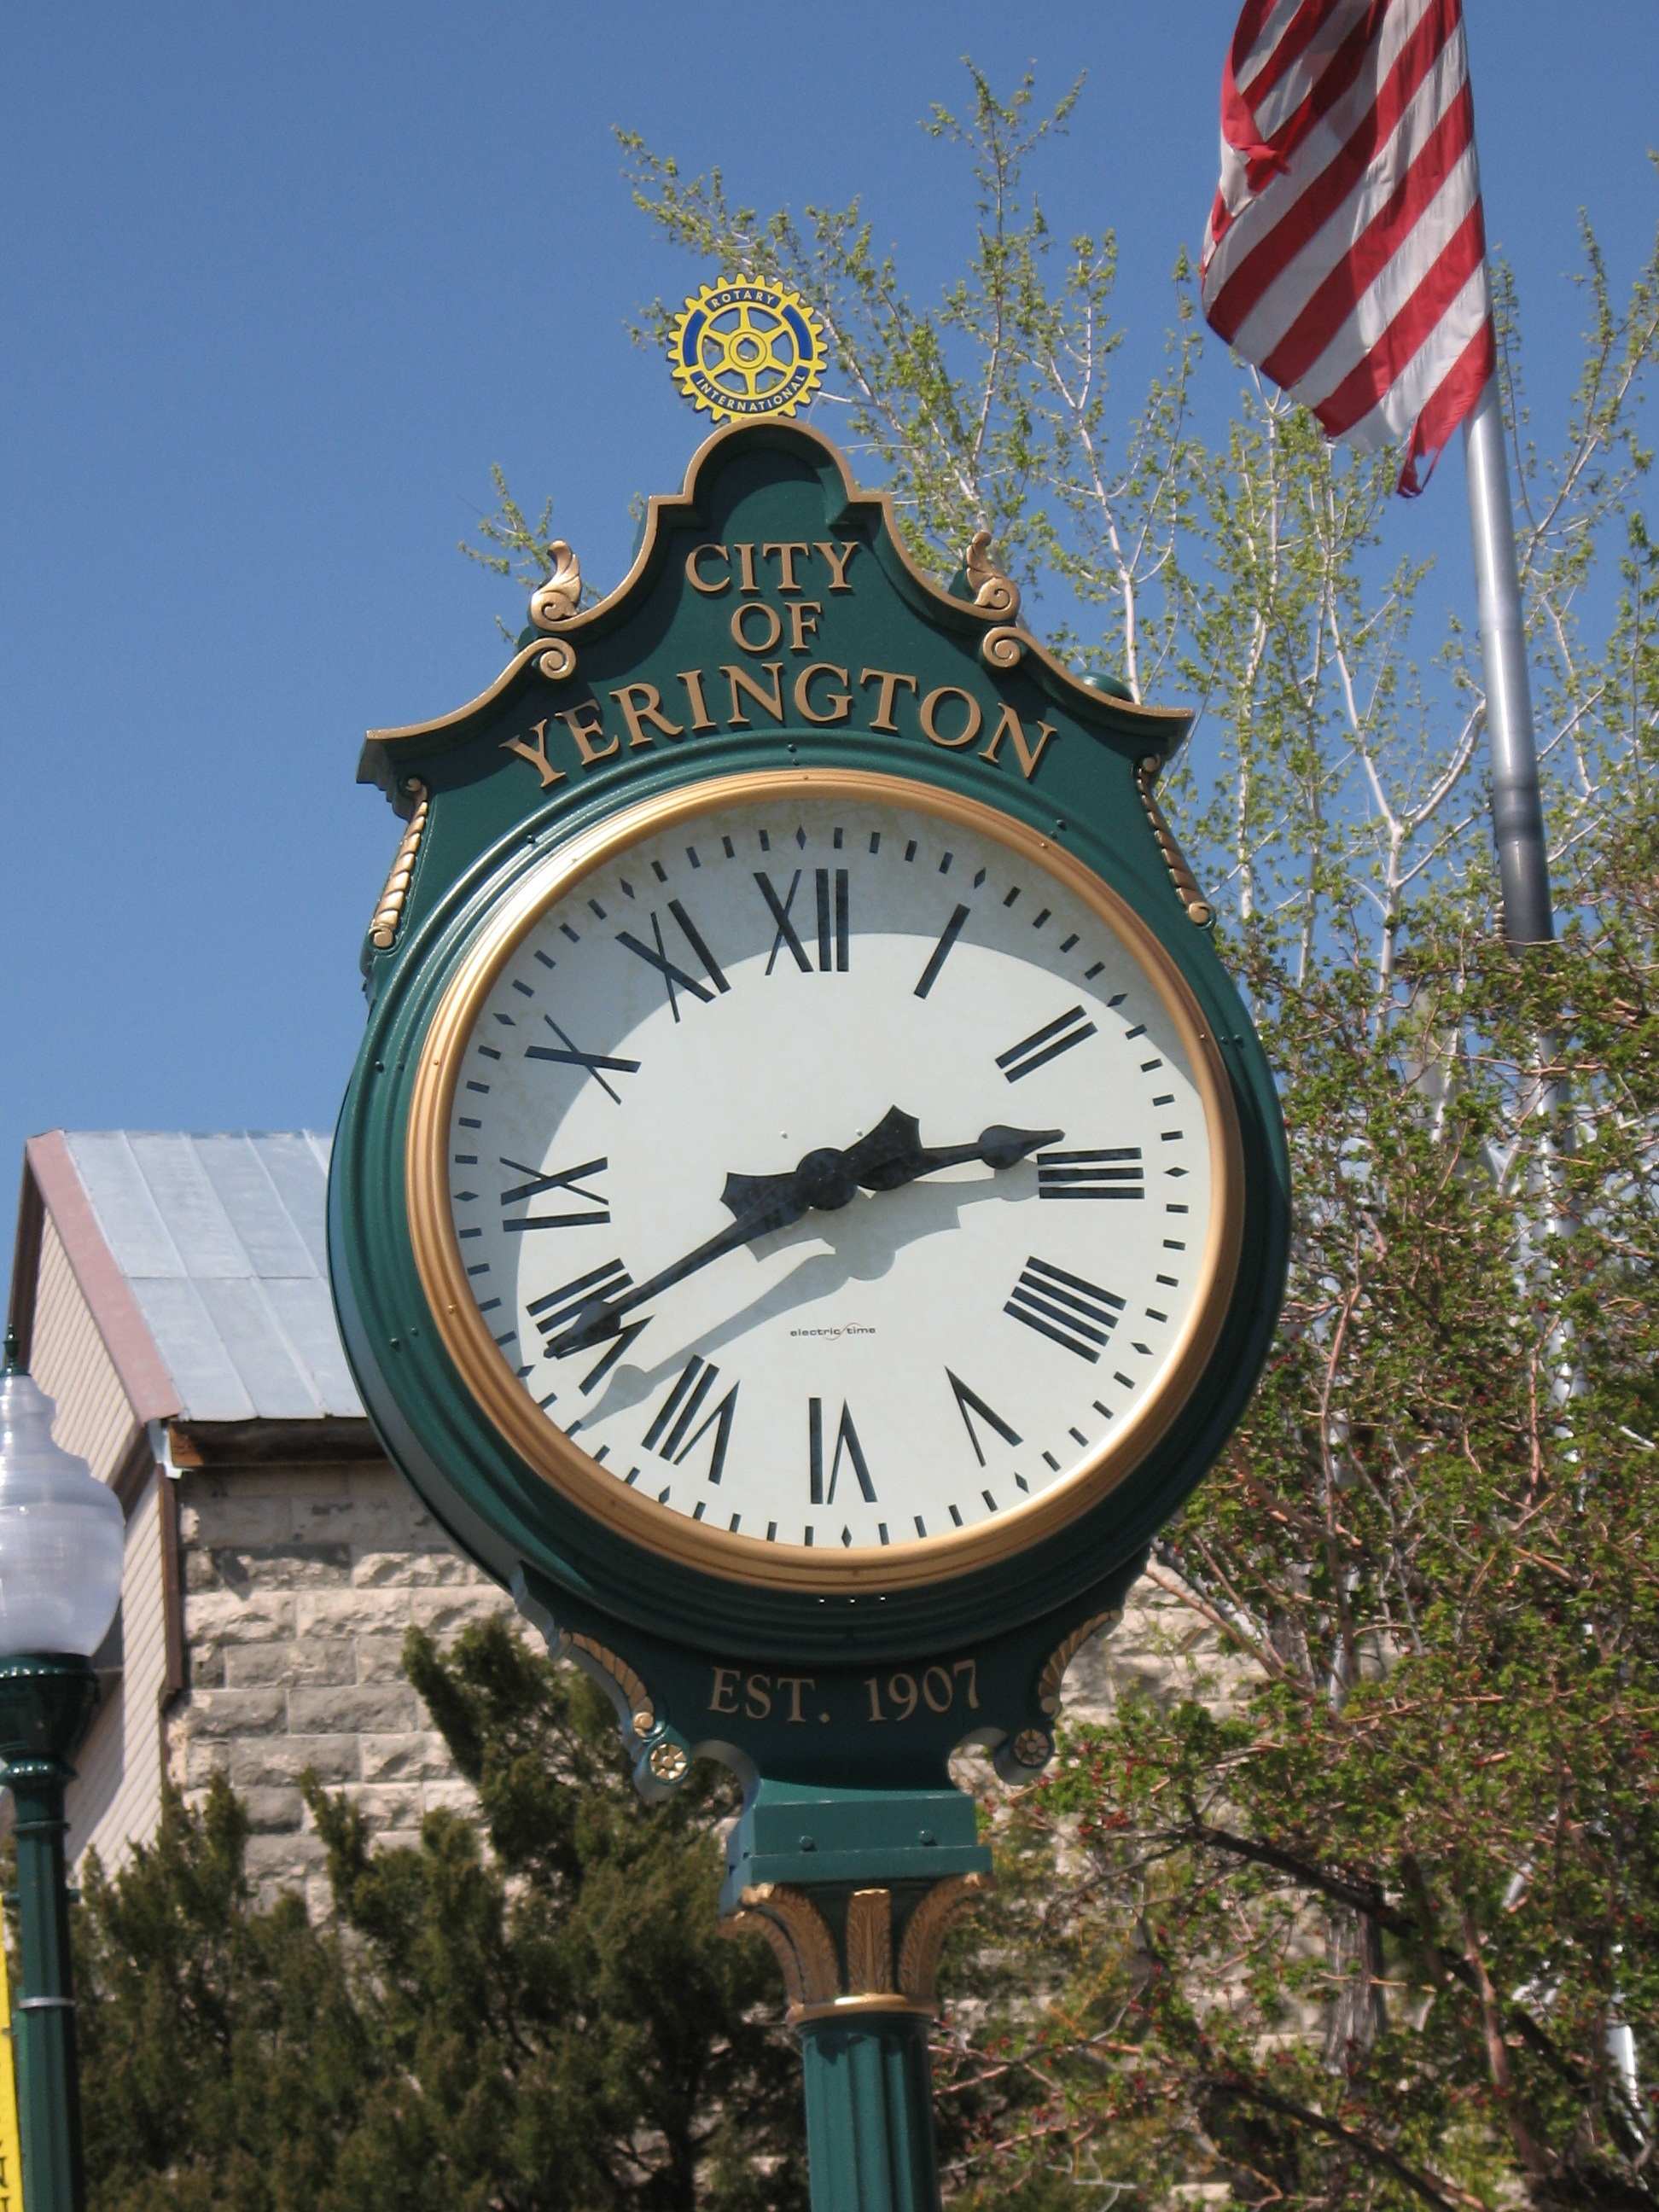

Busy summer: Night in the Country is over. A lot of Rotarians (and friends) put in a lot of hours at NITC and I think we did a good job. I have heard that there was supposed to be a third group of beer sellers (besides Rotary and Shriners) that opted not to participate. That left Rotary and Shriners pretty busy but we handled it well. I was there Saturday for that four hour stretch of constant sales and I know people were exhausted when the fireworks finally went off. Hopefully Boys and Girls Club knows and appreciates the effort that went into the beer sales.
What were some of the problems (permissions and construction) that had to be addressed to complete the Centennial Clock project? Which Rotarians solved those problems?

Next Sunday (August 12) is the 3rd Annual Joe Giomi Golf Tournament at the Fernley Golf Course. We need a little help Sunday morning getting things setup and about noon serving lunch, but nothing as demanding as NITC. This event is a significant contributor to funding our scholarship program so we need this to be a successful event.

The week following the Golf Tournament is the Lyon County Fair and Rodeo. Rotary has the beer selling concession. This means having our booth cleaned up and ready for action on Thursday, Friday, Saturday and Sunday (Aug. 16-19). That is a lot of hours to cover, but it is

a much more reasonable pace than NITC. This event is one of the best sources of income to support our activities and projects. James Schreiber will be bringing details and signup sheets to the next couple of meetings. Be ready to volunteer to help.

Greeters and Programs: The Greeters program has gotten off to a good start. Peggy Bitler and Sheri Van Ness certainly welcomed attendees on July 24 and Skip Bolton followed up on July 31 (although Skip did get distracted from time to time). Here is the list of greeters for the next few weeks. Kathie has a more extensive list.
8/7 –John Diekman & Bill Swirsky
8/14 – Rich Ernst & Nora Stevens
8/21 – Cheryl Giomi & Jim Snyder
8/28 – Gary Hardesty & Steve Singer
9/4 – Oscar Hernandez & James Schreiber
Remember that if you are scheduled to be a greeter it is your responsibility to show up and do it or find someone to do it for you. We don’t expect the exuberance or flamboyance of a Peggy, but it is nice to receive a hearty welcome to the meeting and especially have someone to greet guests.

President Kathie has also made a list of members responsible for arranging programs for our meetings. Everyone is encouraged to arrange programs anytime, but try a little harder during your assigned quarter. For the first quarter of the year (July, August and September) the program responsibility belongs to: Leon Aberasturi, Peggy Bitler, Skip Bolton, Gerry Boschert, John Diekmann, Rich Ernst, John Garry, Amy Geddes and Carrie Gilmore. Good informative and entertaining programs are important to maintaining our value to the community. We need to know what is going on and what needs to be done.

August 21 Picnic Meeting: Notice that our 8/21 meeting will not be held at Dini’s. Jon Hill has done programs about his photography and travels for us in the past, but this one is about his pottery skills. It will be held at his workshop on Hwy 208 just before getting to Wilson Canyon. The exact address will be announced later, but it will be well marked and easy to find.

Inbound RYE Student: Our new exchange student will be arriving this week. Chanakan Suepsimma comes from the Northeast part of Thailand. Unlike Pedro, our last RYE student,

Club Treasurer: Club President-Elect Club Scholarship Comm.
Candy LoBue Ted Rudolph Lucy Rechel, Chair.
Kathie Mann
Club Board of Directors: Dale Theiss
Term ending 6/30/19 Term ending 6/30/20 Gerry Boschert
James Schreiber John Garry Skip Bolton
Gary Hardesty Cheryl Giomi Jim Sanford
Dale Theiss Peggy Bitler
Amy Geddes Jay Recanzone

this is Chanakan’s first trip out of Thailand. He is expected to arrive in Reno this Wednesday (8/8). Chanakan enjoys sports but is also described as a smart, polite, attentive student and gets along well with other students. We look forward to meeting Chanakan and getting to know him during the year. Plan on meeting him and even inviting him to your home for a dinner sometime. He will be met in Reno by Skip and Kelly Bolton. They will host him for a couple of weeks while Steve Singer is out of town, then he will stay with Singer’s. We need a couple more families to host him during the year. Talk to Steve Singer if you, or someone you know, can do that. It is a very enjoyable experience to host an RYE student.

How much do you know about our projects? The last issue photo and question involved the Centennial Clock project (as does this issues’ photo and question). The pedestal in the center of the photo is, of course, the base of the clock. This photo was taken well after the clock was first unveiled at the Yerington Centennial celebration. The occasion here was the addition of the brass plaque giving credit to the two organizations that organized and funded the project. The people in the photo are (left to right): Sam Ross, Judy Price, Bob Smith, Tom Price, Dick Roberson and George O’Keefe. Sam and Dick are not Rotarians (although Sam was a Rotarian at one time). The project was initiated, organized and carried out by the Rotary Club. The cost of the clock was $20,000 and that cost was split evenly by the Rotary Club and The Walker River Basin Communities Foundation. Sam and Dick were representing that organization.

